Reaction mechanisms in organic synthesis

Passage

Organic chemistry is a vast field focused on the structure, properties, and reactions of organic compounds, primarily those containing carbon. Understanding reaction mechanisms, which detail the step-by-step process of bond breaking and bond formation, is crucial for predicting reaction outcomes and designing synthetic pathways. Nucleophilic acyl substitution is a common and important class of reactions involving carboxylic acid derivatives. These reactions proceed through a tetrahedral intermediate and are often influenced by the leaving group's stability and the nucleophile's strength.

Consider the synthesis of esters from carboxylic acids. One common method involves the Fischer esterification, an acid-catalyzed reaction between a carboxylic acid and an alcohol. This equilibrium reaction can be driven to completion by removing water, a byproduct of the reaction. The mechanism typically involves protonation of the carboxylic acid's carbonyl oxygen, making the carbonyl carbon more electrophilic. The alcohol then acts as a nucleophile, attacking the activated carbonyl carbon. A proton transfer then occurs, followed by the elimination of water, reforming the carbonyl and yielding the ester product.

Another important reaction for forming esters, particularly from more reactive carboxylic acid derivatives, is transesterification. This involves the reaction of an ester with an alcohol, where one alkoxy group is exchanged for another. This reaction can be catalyzed by either acid or base. For example, if a methyl ester is reacted with ethanol in the presence of a base, the ethoxide anion will act as a nucleophile, attacking the carbonyl carbon of the methyl ester. A tetrahedral intermediate is formed, followed by the expulsion of the methoxide leaving group, leading to the formation of the ethyl ester.

The reactivity of carboxylic acid derivatives in nucleophilic acyl substitution reactions follows a general trend. Acid chlorides are the most reactive, followed by acid anhydrides, esters, and amides, in decreasing order of reactivity. This order is largely dictated by the leaving group's ability to depart with a negative charge. A good leaving group is a weak base, meaning it is stable once it departs. For example, chloride is a very stable anion (weak base), making acid chlorides highly reactive. Conversely, the amide anion is a very strong base, making amides the least reactive of the common carboxylic acid derivatives.

Multiple choice questions

1. Which of the following best describes the role of the alcohol in a Fischer esterification?

A. Electrophile  
B. Leaving group  
C. Nucleophile  
D. Catalyst

2. Based on the information provided, which of the following carboxylic acid derivatives would be the *least* reactive towards nucleophilic acyl substitution?

A. Acid chloride  
B. Acid anhydride  
C. Ester  
D. Amide

3. During the transesterification of a methyl ester with ethanol in the presence of a base, which species acts as the leaving group?

A. Methoxide anion  
B. Ethoxide anion  
C. Hydroxide anion  
D. Methyl radical

Applying a smart strategy\*\*

1. Read the passage strategically: Start by reading the passage quickly to grasp the main topic (organic reaction mechanisms, specifically nucleophilic acyl substitution and ester formation) and identify the different types of reactions discussed (Fischer esterification, transesterification). Pay attention to the factors that influence reactivity (leaving group stability, nucleophile strength, solvent). Highlight key terms like "nucleophilic acyl substitution", "tetrahedral intermediate", "Fischer esterification", "transesterification", "leaving group", and the reactivity order. This initial read-through helps to establish a mental framework for the passage's content.

2. Attack the questions:

* Question 1:
  + Analyze the Question: The question asks for the role of the alcohol in Fischer esterification. Look for the description of this reaction in the passage.
  + Reference the Passage: The passage states: "The alcohol then acts as a nucleophile, attacking the activated carbonyl carbon."
  + Evaluate Answer Choices:
    - A. Incorrect. The carbonyl carbon is the electrophile.
    - B. Incorrect. Water is the leaving group in Fischer esterification.
    - C. Correct. The passage explicitly states the alcohol acts as a nucleophile.
    - D. Incorrect. An acid is the catalyst.
  + Select the Best Answer: C.
* Question 2:
  + Analyze the Question: The question asks for the *least* reactive carboxylic acid derivative towards nucleophilic acyl substitution based on the information provided.
  + Reference the Passage: The passage states: "The reactivity of carboxylic acid derivatives in nucleophilic acyl substitution reactions follows a general trend. Acid chlorides are the most reactive, followed by acid anhydrides, esters, and amides, in decreasing order of reactivity". It further explains that "amides... are the least reactive".
  + Evaluate Answer Choices:
    - A. Incorrect. Acid chlorides are the most reactive.
    - B. Incorrect. Acid anhydrides are highly reactive, second only to acid chlorides.
    - C. Incorrect. Esters are more reactive than amides.
    - D. Correct. The passage identifies amides as the least reactive.
  + Select the Best Answer: D.
* Question 3:
  + Analyze the Question: This question asks to identify the leaving group in a specific transesterification reaction (methyl ester with ethanol in the presence of a base).
  + Reference the Passage: The passage describes this specific reaction: "If a methyl ester is reacted with ethanol in the presence of a base, the ethoxide anion will act as a nucleophile, attacking the carbonyl carbon of the methyl ester. A tetrahedral intermediate is formed, followed by the expulsion of the methoxide leaving group, leading to the formation of the ethyl ester."
  + Evaluate Answer Choices:
    - A. Correct. The passage explicitly states that the methoxide anion is the leaving group.
    - B. Incorrect. The ethoxide anion is the nucleophile.
    - C. Incorrect. Hydroxide is a strong base, but methoxide is the leaving group in this specific reaction.
    - D. Incorrect. Methyl radical is not involved in this reaction.
  + Select the Best Answer: A.

Passage: The Diels-Alder Reaction

The Diels-Alder reaction is a powerful pericyclic reaction in organic chemistry used to form six-membered rings. It involves the reaction between a conjugated diene and a substituted alkene, known as the dienophile. The reaction proceeds in a concerted manner, meaning that all bond formations and bond breaking occur simultaneously in a single transition state.

The stereochemistry of the starting materials is preserved in the product. For instance, a cis-dienophile will yield a product with cis-substituted groups on the newly formed ring, and a trans-dienophile will result in trans-substituted groups. Furthermore, the relative positions of substituents on the diene (endo vs. exo) also influence the stereochemistry of the product. End-addition is often favored kinetically and corresponds to a transition state where the dienophile is oriented such that its π system.

The reaction is generally favored by electron-donating groups on the diene and electron-withdrawing groups on the dienophile, increasing the reactivity of both reactants. This combination optimizes the Frontier Molecular Orbital (FMO) overlap, with the Highest Occupied Molecular Orbital (HOMO) of the diene interacting with the Lowest Unoccupied Molecular Orbital (LUMO) of the dienophile, leading to a lower activation energy and a faster reaction rate.

Multiple Choice Questions

Question 1

Which of the following reaction conditions would likely *decrease* the rate of a Diels-Alder reaction?

a) Increasing the temperature  
b) Using a diene with electron-withdrawing groups  
c) Using a dienophile with electron-donating groups  
d) Performing the reaction in a polar aprotic solvent

Answer and Explanation

**Answer: c) Using a dienophile with electron-donating groups**

**Explanation:** The Diels-Alder reaction is facilitated by electron-donating groups on the diene and electron-withdrawing groups on the dienophile because it increases the HOMO-LUMO energy gap, making the reaction less favorable and slowing down the reaction rate. [According to UWorld Grad School](https://gradschool.uworld.com/mcat/sections-subjects/organic-chemistry/) and [Reddit](https://www.reddit.com/r/Mcat/comments/1bxkmbn/organic_chemistry_content_high_yield_topics/). Increasing the temperature generally increases reaction rates. Polar aprotic solvents can sometimes influence reaction rates, but it's not a general trend to decrease the Diels-Alder rate.

Question 2

A Diels-Alder reaction between (2E,4E)-2,4-hexadiene and maleic anhydride is performed. Which of the following statements regarding the product's stereochemistry is correct?

a) The product will have trans-substituted methyl groups.  
b) The product will have cis-substituted methyl groups.  
c) The product will exhibit a mixture of endo and exo isomers.  
d) The product's stereochemistry cannot be determined from the given information.

Answer and Explanation

**Answer: b) The product will have cis-substituted methyl groups.**

**Explanation:** The Diels-Alder reaction preserves the stereochemistry of the starting materials. In (2E,4E)-2,4-hexadiene, the methyl groups are trans to the double bonds. Maleic anhydride is a cis-dienophile, meaning the substituents on the dienophile are cis to each other. Therefore, the resulting cyclohexene ring will have the methyl groups in a cis configuration, arising from the endo addition. The product will predominantly exhibit endo stereochemistry due to kinetic control.

Question 3

Consider the reaction of 1,3-cyclopentadiene with acrylonitrile. Which of the following best describes the role of acrylonitrile in this reaction?

a) It acts as the diene.  
b) It acts as the dienophile.  
c) It acts as a solvent.  
d) It acts as a catalyst.

Answer and Explanation

**Answer: b) It acts as the dienophile.**

**Explanation:** In a Diels-Alder reaction, the diene is a conjugated system with four π electrons. 1,3-cyclopentadiene is a conjugated diene, and acrylonitrile (CH2=CH-CN) is a substituted alkene with an electron-withdrawing nitrile group. Therefore, acrylonitrile acts as the dienophile in this reaction.

Question 4

What type of bonding is involved in the transition state of a Diels-Alder reaction?

a) Ionic bonding  
b) Covalent bonding  
c) Hydrogen bonding  
d) Dipole-dipole interactions

Answer and Explanation

**Answer: b) Covalent bonding**

**Explanation:** The Diels-Alder reaction is a pericyclic reaction, meaning it proceeds through a concerted mechanism involving the simultaneous formation and breaking of multiple covalent bonds in a cyclic transition state. There are no ions or significant charge separation in the transition state. Hydrogen bonding and dipole-dipole interactions are intermolecular forces and do not describe the bonding within the reacting molecules during the formation of the new ring system.

Nucleophilic acyl substitution is a key reaction in organic chemistry involving the attack of a nucleophile at the carbonyl carbon of a carboxylic acid derivative, followed by the expulsion of a leaving group. This process effectively replaces one group bonded to the acyl carbon with another, leading to the formation of a new carboxylic acid derivative. Common carboxylic acid derivatives that undergo this reaction include acid halides, acid anhydrides, esters, amides, and carboxylic acids themselves.

The mechanism typically involves two steps: first, nucleophilic addition to the carbonyl carbon forms a tetrahedral intermediate, and second, the leaving group departs from this intermediate. The reactivity of different carboxylic acid derivatives towards nucleophilic acyl substitution varies significantly and is primarily determined by two factors: the stability of the carbonyl compound and the leaving group ability of the group attached to the acyl carbon. Better leaving groups are generally weaker bases, for instance, chloride is a better leaving group than an alkoxide.

Acid halides are the most reactive carboxylic acid derivatives due to the good leaving group ability of the halide and the destabilizing inductive effect of the halogen on the carbonyl carbon. Amides, on the other hand, are the least reactive due to the strong resonance stabilization provided by the nitrogen atom, which reduces the electrophilicity of the carbonyl carbon. Esters and anhydrides fall in between, with anhydrides being more reactive than esters. Chemistry LibreTexts says "Acid Halide is most reactive towards nucleophilic acyl substitution, followed by anhydrides, esters, amides and carboxylate ions"

Multiple Choice Questions

Question 1

Which of the following carboxylic acid derivatives would be the most reactive towards nucleophilic acyl substitution?

a) Amide  
b) Ester  
c) Acid Chloride  
d) Carboxylic Acid

Answer and Explanation

Answer: c) Acid Chloride

Explanation: Acid halides (like acid chlorides) are the most reactive carboxylic acid derivatives towards nucleophilic acyl substitution. Their reactivity is due to the halide ion being an excellent leaving group and the electron-withdrawing inductive effect of the halogen on the carbonyl carbon. Amides are the least reactive due to resonance stabilization from the nitrogen atom, while esters and carboxylic acids have intermediate reactivities.

Question 2

What is the role of the nucleophile in a nucleophilic acyl substitution reaction?

a) To act as a leaving group.  
b) To form a covalent bond with the carbonyl carbon.  
c) To abstract a proton from the alpha-carbon.  
d) To donate electrons to the carbonyl oxygen.

Answer and Explanation

Answer: b) To form a covalent bond with the carbonyl carbon.

Explanation: In a nucleophilic acyl substitution, the nucleophile attacks the carbonyl carbon and forms a new bond to it, leading to a tetrahedral intermediate. This intermediate then expels a leaving group.

Question 3

Why are amides less reactive than esters in nucleophilic acyl substitution reactions?

a) Amides have a better leaving group than esters.  
b) The nitrogen atom in amides is more electronegative than the oxygen atom in esters.  
c) The carbonyl carbon in amides is less electrophilic due to resonance stabilization.  
d) Esters have a more stable tetrahedral intermediate.

Answer and Explanation

Answer: c) The carbonyl carbon in amides is less electrophilic due to resonance stabilization.

Explanation: Amides are less reactive because the nitrogen atom in amides is more effective at donating electrons by resonance than the oxygen in esters, which reduces the electrophilicity of the carbonyl carbon. You can find more information on the resonance effect of nitrogen compared to oxygen in amides and esters in the referenced web document.

Question 4

Which of the following is NOT a good leaving group in nucleophilic acyl substitution?

a) Chloride ion (Cl⁻)  
b) Alkoxide ion (RO⁻)  
c) Hydroxide ion (OH⁻)  
d) Carboxylate ion (RCOO⁻)

Answer and Explanation

Answer: c) Hydroxide ion (OH⁻)

Explanation: Good leaving groups are weak bases. Hydroxide (OH⁻) is a strong base and thus a poor leaving group. Chloride (Cl⁻) is a good leaving group, while alkoxide (RO⁻) and carboxylate (RCOO⁻) ions can act as leaving groups, but are less effective than halides. More details about good leaving groups can be found in the referenced web document.

Elimination reactions are a fundamental class of organic reactions where two substituents are removed from adjacent carbon atoms, leading to the formation of a pi bond (usually a double bond). These reactions are typically categorized into two main types: E1 and E2, each with a distinct mechanism, kinetics, and stereochemical outcome.

The E1 mechanism is a two-step process. In the first and rate-determining step, the leaving group departs to form a carbocation intermediate. This step is unimolecular, meaning its rate depends only on the concentration of the substrate. The carbocation then undergoes deprotonation at an adjacent carbon by a weak base, forming the double bond. [LabXchange](https://www.labxchange.org/library/items/lb:LabXchange:85a1ff33:html:1" \t "_blank) and [Chemistry LibreTexts](https://chem.libretexts.org/Bookshelves/Organic_Chemistry/Map%3A_Organic_Chemistry_(Wade)_Complete_and_Semesters_I_and_II/Map%3A_Organic_Chemistry_(Wade)/07%3A_Alkyl_Halides-_Nucleophilic_Substitution_and_Elimination/7.15%3A_Characteristics_of_the_E1_Reaction). E1 reactions generally favor the formation of the more substituted alkene (Zaitsev's rule) and do not require a specific anti-periplanar arrangement of the departing groups because the carbocation intermediate is planar, allowing for rotation.

In contrast, the E2 mechanism is a concerted, single-step process. The base removes a proton from a carbon adjacent to the leaving group, the electrons from the C-H bond simultaneously form a new pi bond, and the leaving group departs. [Wikipedia](https://en.wikipedia.org/wiki/Elimination_reaction) and [Chemistry LibreTexts](https://chem.libretexts.org/Bookshelves/Organic_Chemistry/Map%3A_Organic_Chemistry_(Wade)_Complete_and_Semesters_I_and_II/Map%3A_Organic_Chemistry_(Wade)/07%3A_Alkyl_Halides-_Nucleophilic_Substitution_and_Elimination/7.13%3A__Characteristics_of_the_E2_Reaction). This bimolecular process means the rate depends on the concentrations of both the substrate and the base. A crucial requirement for E2 reactions is that the leaving group and the hydrogen being removed must be in an anti-periplanar conformation (180° apart) to allow for proper orbital overlap during double bond formation. [Chemistry LibreTexts](https://chem.libretexts.org/Bookshelves/Organic_Chemistry/Map%3A_Organic_Chemistry_(Wade)_Complete_and_Semesters_I_and_II/Map%3A_Organic_Chemistry_(Wade)/07%3A_Alkyl_Halides-_Nucleophilic_Substitution_and_Elimination/7.13%3A__Characteristics_of_the_E2_Reaction) and [Chemistry Steps](https://www.chemistrysteps.com/stereoselectivity-e2-reactions/). Strong bases and higher temperatures generally favor E2 over E1 reactions.

The nature of the substrate also plays a significant role. Tertiary substrates favor E1 due to the stability of the carbocation formed, whereas E2 is possible for primary, secondary, and tertiary substrates, with tertiary generally reacting fastest due to increased alkene stability. [Chemistry LibreTexts](https://chem.libretexts.org/Bookshelves/Organic_Chemistry/Map%3A_Organic_Chemistry_(Wade)_Complete_and_Semesters_I_and_II/Map%3A_Organic_Chemistry_(Wade)/07%3A_Alkyl_Halides-_Nucleophilic_Substitution_and_Elimination/7.15%3A_Characteristics_of_the_E1_Reaction) and Chemistry LibreTexts.

Multiple Choice Questions

Question 1

Which of the following statements correctly describes a key difference between E1 and E2 reactions?

a) E1 reactions are favored by strong bases, while E2 reactions are favored by weak bases.  
b) E2 reactions proceed through a carbocation intermediate, while E1 reactions do not.  
c) E1 reactions exhibit first-order kinetics, and E2 reactions exhibit second-order kinetics.  
d) E2 reactions result in a mixture of stereoisomers, while E1 reactions are stereospecific.

Answer and Explanation

Answer: c) E1 reactions exhibit first-order kinetics, and E2 reactions exhibit second-order kinetics.

Explanation: E1 reactions are unimolecular, meaning the rate-determining step depends on only one species (the substrate), leading to first-order kinetics. [LabXchange](https://www.labxchange.org/library/items/lb:LabXchange:85a1ff33:html:1" \t "_blank). E2 reactions are bimolecular, with the rate depending on both the substrate and the base, resulting in second-order kinetics. Strong bases favor E2, while weak bases favor E1. E1 reactions form a carbocation intermediate, and E2 reactions are concerted and do not involve an intermediate. E2 reactions are stereospecific (requiring anti-periplanar geometry), whereas E1 reactions are not due to the carbocation intermediate.

Question 2

A tertiary alkyl halide is subjected to elimination conditions with a weak base in a polar protic solvent. Which mechanism is most likely to be favored?

a) SN1  
b) SN2  
c) E1  
d) E2

Answer and Explanation

Answer: c) E1

Explanation: Tertiary alkyl halides form stable carbocations, a key intermediate in E1 reactions. [Wikipedia](https://en.wikipedia.org/wiki/Elimination_reaction). Weak bases and polar protic solvents, like those mentioned, tend to favor the E1 mechanism by stabilizing the carbocation intermediate. Strong bases are required for E2 reactions, and SN2 reactions are hindered by steric bulk in tertiary substrates. SN1 is a substitution pathway that competes with E1, but the question specifically asks about elimination.

Question 3

In an E2 reaction, what is the required spatial relationship between the leaving group and the hydrogen being removed?

a) Syn-periplanar  
b) Gauche  
c) Anti-periplanar  
d) Eclipsed

Answer and Explanation

Answer: c) Anti-periplanar

Explanation: The E2 mechanism requires the leaving group and the hydrogen being removed to be in an anti-periplanar (180° apart) conformation. [Chemistry LibreTexts](https://chem.libretexts.org/Bookshelves/Organic_Chemistry/Map%3A_Organic_Chemistry_(Wade)_Complete_and_Semesters_I_and_II/Map%3A_Organic_Chemistry_(Wade)/07%3A_Alkyl_Halides-_Nucleophilic_Substitution_and_Elimination/7.13%3A__Characteristics_of_the_E2_Reaction). This geometry allows for the optimal overlap of orbitals as the C-H bond breaks, a new C-C pi bond forms, and the C-X bond breaks, all in a single, concerted step. Syn-periplanar would be an eclipsed conformation which is energetically unfavorable.

Question 4

Which factor primarily governs the regioselectivity (which alkene is formed) in E1 elimination reactions?

a) The strength of the base  
b) The steric bulk of the leaving group  
c) The stability of the carbocation intermediate  
d) The anti-periplanar requirement

Answer and Explanation

Answer: c) The stability of the carbocation intermediate

Explanation: E1 reactions form a carbocation intermediate which can rearrange to a more stable form (e.g., tertiary carbocation). [Number Analytics](https://www.numberanalytics.com/blog/e1-reaction-mechanisms-deep-dive) and [Chemistry LibreTexts](https://chem.libretexts.org/Bookshelves/Organic_Chemistry/Map%3A_Organic_Chemistry_(Wade)_Complete_and_Semesters_I_and_II/Map%3A_Organic_Chemistry_(Wade)/07%3A_Alkyl_Halides-_Nucleophilic_Substitution_and_Elimination/7.15%3A_Characteristics_of_the_E1_Reaction). Deprotonation then occurs at the carbon that leads to the most substituted and thus most stable alkene product, following Zaitsev's rule. The other options play more significant roles in E2 reactions or the overall reaction outcome but are not the primary drivers of regioselectivity in E1.

Passage: The SN1 Reaction

The SN1 (Substitution, Nucleophilic, unimolecular) reaction is a common type of nucleophilic substitution in organic chemistry. It involves a two-step mechanism, [BYJU'S](https://byjus.com/chemistry/sn1-reaction-mechanism/) unlike the concerted (one-step) SN2 reaction. The rate-determining step, and the characteristic feature of the SN1 mechanism, is the slow, unimolecular dissociation of the leaving group to form a carbocation intermediate. The rate of the reaction is therefore dependent only on the concentration of the substrate (alkyl halide) and is independent of the nucleophile's concentration, [Chemistry LibreTexts](https://chem.libretexts.org/Bookshelves/Organic_Chemistry/Organic_Chemistry_(Morsch_et_al.)/11%3A_Reactions_of_Alkyl_Halides-_Nucleophilic_Substitutions_and_Eliminations/11.04%3A_The_SN1_Reaction) unlike the SN2 reaction which is bimolecular.

The SN1 reaction is favored by the formation of stable carbocation intermediates. This means that tertiary alkyl halides react fastest by the SN1 mechanism, followed by secondary, and then primary, which are generally unreactive towards SN1 due to the instability of primary carbocations. Resonance-stabilized carbocations, such as allylic and benzylic carbocations, also readily undergo SN1 reactions. The stability of carbocations increases with the number of alkyl groups attached to the positively charged carbon, which can donate electron density through hyperconjugation and inductive effects.

Stereochemistry is an important consideration in SN1 reactions. Since the carbocation intermediate is sp2 hybridized and planar, KPU Pressbooks nucleophilic attack can occur from either face of the carbocation. This can lead to a racemic mixture of enantiomers if the reaction occurs at a chiral center. However, in many cases, incomplete racemization or even an excess of inversion products can be observed due to the temporary "shielding" effect of the departing leaving group or the formation of ion pairs. [Chemistry Steps](https://www.chemistrysteps.com/stereochemistry-sn1-reaction-mechanism/) Carbocation rearrangements, such as 1,2-hydride or alkyl shifts, can also occur to form a more stable carbocation, leading to unexpected products.

The choice of solvent also significantly impacts the SN1 reaction rate. Polar protic solvents, like water or alcohols, are preferred as they stabilize the carbocation intermediate and the anionic leaving group through hydrogen bonding and dipole interactions, thereby lowering the activation energy for the rate-determining step. Weak nucleophiles, like water and alcohols (which are also often the solvent in SN1 reactions), favor the SN1 mechanism because the carbocation intermediate is so reactive that even a weak nucleophile can successfully attack it.

Multiple Choice Questions

Question 1

Which of the following factors would most favor an SN1 reaction over an SN2 reaction?

a) A strong nucleophile  
b) A primary alkyl halide  
c) A polar protic solvent  
d) A polar aprotic solvent

Answer and Explanation

Answer: c) A polar protic solvent

Explanation: SN1 reactions are favored by polar protic solvents because they effectively stabilize the carbocation intermediate formed in the rate-determining step. [Chemistry LibreTexts](https://chem.libretexts.org/Courses/Brevard_College/CHE_202%3A_Organic_Chemistry_II/04%3A_Substitution_and_Elimination_reactions/4.07%3A_Factors_Affecting_the_SN1_Reaction) Strong nucleophiles and polar aprotic solvents favor SN2 reactions, and primary alkyl halides are generally unreactive towards SN1 due to carbocation instability.

Question 2

A chiral tertiary alkyl halide undergoes an SN1 reaction. Which of the following is the most likely stereochemical outcome at the reaction center?

a) Complete inversion of configuration.  
b) Complete retention of configuration.  
c) Predominantly inversion with some retention (excess of inversion).  
d) A racemic mixture of products.

Answer and Explanation

Answer: d) A racemic mixture of products.

Explanation: While some studies show an excess of inversion product, the planar carbocation intermediate formed in SN1 reactions allows for nucleophilic attack from both sides, leading to racemization, or the formation of a racemic mixture of enantiomers, particularly with highly stabilized carbocations where the leaving group diffuses away quickly.

Question 3

Why are tertiary alkyl halides the most reactive substrates in SN1 reactions?

a) They have the least steric hindrance.  
b) They form the most stable carbocation intermediates.  
c) They are the most susceptible to backside attack.  
d) They have the best leaving groups.

Answer and Explanation

Answer: b) They form the most stable carbocation intermediates.

Explanation: The stability of the carbocation intermediate is the primary factor determining SN1 reactivity. Tertiary carbocations are the most stable due to the electron-donating effects (hyperconjugation and inductive effects) of the alkyl groups, lowering the activation energy for the rate-determining step. Steric hindrance and backside attack are more relevant to SN2 reactions, and the leaving group's quality is important for both SN1 and SN2 but doesn't explain the tertiary substrate preference in SN1.

Question 4

What is the rate-determining step in an SN1 reaction?

a) Nucleophilic attack on the substrate.  
b) Deprotonation of the intermediate by the solvent.  
c) Formation of the carbocation intermediate.  
d) Rearrangement of the carbocation.

Answer and Explanation

Answer: c) Formation of the carbocation intermediate.

Explanation: The slowest step in an SN1 reaction, which determines the overall rate, is the unimolecular dissociation of the leaving group to form the carbocation intermediate. The other steps (nucleophilic attack and deprotonation) are much faster and do not affect the rate. Carbocation rearrangement can occur, but it is not the rate-determining step itself.

Passage: The SN2 Reaction

The SN2 (Substitution, Nucleophilic, bimolecular) reaction is a fundamental mechanism in organic chemistry characterized by a single, concerted step. This process involves a nucleophile attacking an electrophilic carbon atom simultaneously as a leaving group departs. The rate of an SN2 reaction depends on the concentrations of both the substrate (alkyl halide) and the nucleophile, indicating its bimolecular nature.

A key feature of the SN2 reaction is its stereochemical outcome. The nucleophile attacks from the backside, opposite the leaving group. This backside attack results in an inversion of configuration at the electrophilic carbon. If the carbon is a chiral center, this leads to a complete inversion of stereochemistry, known as Walden inversion.

Steric hindrance significantly impacts SN2 reaction rates. The reaction slows down as the bulk around the electrophilic carbon increases. Bulky substituents impede the nucleophile's approach. Consequently, methyl halides react fastest, followed by primary and then secondary halides, while tertiary alkyl halides are typically unreactive via the SN2 pathway due to severe steric hindrance.

The reaction rate is also influenced by the nucleophile, leaving group, and solvent. Strong nucleophiles are crucial, and polar aprotic solvents (like DMSO, DMF, acetone) enhance their reactivity by not solvating them as strongly as polar protic solvents. Effective leaving groups are also necessary, as they must stabilize the electron density after the bond breaks.

Multiple Choice Questions

Question 1

Which of the following reaction conditions would favor an SN2 reaction?

a) Tertiary alkyl halide with a weak nucleophile in a polar protic solvent  
b) Primary alkyl halide with a strong nucleophile in a polar aprotic solvent  
c) Secondary alkyl halide with a weak nucleophile in a polar protic solvent  
d) Tertiary alkyl halide with a strong nucleophile in a polar protic solvent

Answer and Explanation

Answer: b) Primary alkyl halide with a strong nucleophile in a polar aprotic solvent

Explanation: SN2 reactions are favored by unhindered alkyl halides (methyl or primary), strong nucleophiles, and polar aprotic solvents. Tertiary alkyl halides are too sterically hindered, weak nucleophiles react slowly, and polar protic solvents hinder nucleophile reactivity through hydrogen bonding.

Question 2

A chiral primary alkyl bromide undergoes an SN2 reaction with a strong nucleophile. What is the stereochemical outcome at the carbon where substitution occurs?

a) Retention of configuration  
b) Racemization  
c) Inversion of configuration  
d) Formation of a mixture of diastereomers

Answer and Explanation

Answer: c) Inversion of configuration

Explanation: SN2 reactions involve a backside attack, resulting in complete inversion of configuration at the reaction center. The nucleophile attacks from the side opposite the leaving group.

Question 3

Why are tertiary alkyl halides unreactive in SN2 reactions?

a) They form unstable carbocation intermediates.  
b) They lack suitable leaving groups.  
c) They are too sterically hindered for backside attack.  
d) They are more likely to undergo E1 elimination.

Answer and Explanation

Answer: c) They are too sterically hindered for backside attack.

Explanation: Tertiary alkyl halides have significant steric hindrance that prevents the required backside attack by the nucleophile in an SN2 mechanism. While they may undergo E1 elimination and form stable carbocation intermediates (favoring SN1), steric hindrance is the primary reason for their unreactivity in SN2 reactions.

Question 4

Which of the following is considered a good leaving group in an SN2 reaction?

a) Hydroxide ion (OH⁻)  
b) Fluoride ion (F⁻)  
c) Alkoxide ion (RO⁻)  
d) Iodide ion (I⁻)

Answer and Explanation

Answer: d) Iodide ion (I⁻)

Explanation: Good leaving groups are weak bases that can stabilize the negative charge upon departure. Iodide (I⁻) is a good leaving group due to its weak basicity, large size, and high polarizability. Hydroxide, fluoride, and alkoxide ions are stronger bases and poorer leaving groups.

Passage: Electrophilic Addition to Alkenes

Alkenes, characterized by their carbon-carbon double bonds, readily undergo a variety of addition reactions where the pi bond breaks, and new sigma bonds form to the carbons of the former double bond. Among the most common and important of these are electrophilic addition reactions. In these reactions, the electron-rich pi bond of the alkene acts as a nucleophile, attacking an electrophile.

The first step in electrophilic addition is the attack of the alkene's pi bond on an electrophile, leading to the formation of a carbocation intermediate. This carbocation is planar and allows for attack by the nucleophile from either face, leading to potential stereochemical outcomes. The stability of the carbocation formed dictates the rate of this first step; more substituted carbocations are more stable and thus form more readily. Chemistry LibreTexts

A classic example is the hydrohalogenation of alkenes (addition of HX, where X is a halogen). In this reaction, the hydrogen acts as the initial electrophile, adding to the less substituted carbon of the double bond to form the more stable carbocation on the more substituted carbon. This regioselectivity, where the hydrogen adds to the carbon with more hydrogens and the halogen adds to the carbon with fewer hydrogens, is known as Markovnikov's rule. Master Organic Chemistry The subsequent attack by the halide ion (nucleophile) on the carbocation yields the final product.

Other common electrophilic addition reactions include halogenation (addition of X2), hydration (addition of H2O), and hydroboration-oxidation (which shows anti-Markovnikov regioselectivity). These reactions are vital for synthesizing a wide array of organic compounds and are central to understanding alkene reactivity.

Multiple Choice Questions

Question 1

What is the role of the alkene's pi bond in an electrophilic addition reaction?

a) To act as an electrophile.  
b) To act as a leaving group.  
c) To act as a nucleophile.  
d) To undergo oxidation.

Answer and Explanation

Answer: c) To act as a nucleophile.

Explanation: In electrophilic addition, the electron-rich pi bond of the alkene donates electrons to an electrophile, thereby acting as a nucleophile. Chemistry LibreTexts

Question 2

Which of the following describes the carbocation intermediate formed during the hydrohalogenation of an alkene?

a) It is sp hybridized and linear.  
b) It is sp2 hybridized and planar.  
c) It is sp3 hybridized and tetrahedral.  
d) It is resonance stabilized and pyramidal.

Answer and Explanation

Answer: b) It is sp2 hybridized and planar.

Explanation: Carbocations are sp2 hybridized, meaning the central carbon atom forms three sigma bonds and has an empty p-orbital. This hybridization results in a planar geometry around the positively charged carbon.

Question 3

According to Markovnikov's rule, in the addition of HBr to 2-methylpropene, where will the hydrogen atom add?

a) To the carbon with the most methyl groups.  
b) To the carbon with the fewest methyl groups.  
c) To the carbon with the most hydrogen atoms.  
d) To the carbon with the fewest hydrogen atoms.

Answer and Explanation

Answer: c) To the carbon with the most hydrogen atoms.

Explanation: Markovnikov's rule states that in the electrophilic addition of HX to an unsymmetrical alkene, the hydrogen atom adds to the carbon atom of the double bond that already has the greater number of hydrogen atoms. This leads to the formation of the more stable carbocation. Master Organic Chemistry In 2-methylpropene, one carbon of the double bond has two hydrogen atoms, and the other has zero.

Question 4

What type of intermediate is formed in the electrophilic addition of bromine (Br2) to an alkene?

a) Carbocation  
b) Carbanion  
c) Bromonium ion  
d) Hydride

Answer and Explanation

Answer: c) Bromonium ion

Explanation: In the electrophilic addition of halogens like bromine to alkenes, a cyclic halonium ion (in this case, a bromonium ion) intermediate is formed. This three-membered ring intermediate then undergoes backside attack by the halide nucleophile. Carbocations are formed in reactions like hydrohalogenation or hydration. Carbanions are negatively charged carbon species, and hydrides are not relevant intermediates in this context.

Passage: Oxidation and Reduction in Organic Chemistry

Oxidation and reduction reactions are fundamental transformations in organic chemistry, enabling the interconversion of various functional groups and playing a critical role in the synthesis of complex molecules. While the general chemistry definitions of oxidation (loss of electrons) and reduction (gain of electrons) apply, in organic chemistry, these concepts are often simplified and readily observed by looking at the change in bonding patterns around a carbon atom. The University of Texas at Dallas

Specifically, oxidation of an organic compound can be recognized by a net decrease in the number of carbon-hydrogen (C-H) bonds or a net increase in the number of carbon-heteroatom bonds (e.g., C-O, C-N, C-Cl). Conversely, reduction corresponds to a net increase in C-H bonds or a net decrease in carbon-heteroatom bonds. For example, the oxidation of a primary alcohol to an aldehyde involves the loss of two C-H bonds and the formation of a C=O bond, representing an increase in the oxidation state of the carbon atom. The subsequent oxidation of an aldehyde to a carboxylic acid further increases the carbon's oxidation state by forming another C-O bond. Chemistry LibreTexts

A wide variety of reagents facilitate these transformations. Common oxidizing agents include potassium permanganate (KMnO4), chromium trioxide (CrO3), and pyridinium chlorochromate (PCC). Number Analytics PCC is a milder oxidant and is often used to selectively oxidize primary alcohols to aldehydes, preventing over-oxidation to carboxylic acids which can occur with stronger oxidants in the presence of water. Chemistry Steps Reducing agents commonly used include lithium aluminum hydride (LiAlH4), sodium borohydride (NaBH4), and hydrogen gas with a metal catalyst (e.g., H2/Pd). Number Analytics NaBH4 is a milder reducing agent than LiAlH4, capable of reducing aldehydes and ketones but typically not esters or carboxylic acids. Master Organic Chemistry

It is important to note that oxidation and reduction always occur in tandem; if one compound is oxidized, another must be simultaneously reduced. Chemistry LibreTexts Understanding these redox principles and the selectivity of various reagents is crucial for designing efficient synthetic routes in organic chemistry.

Multiple Choice Questions

Question 1

Which of the following transformations represents an oxidation reaction?

a) Converting an aldehyde to a primary alcohol.  
b) Converting a ketone to a secondary alcohol.  
c) Converting a secondary alcohol to a ketone.  
d) Converting an alkene to an alkane.

Answer and Explanation

Answer: c) Converting a secondary alcohol to a ketone.

Explanation: Oxidation involves an increase in the number of carbon-heteroatom (C-O in this case) bonds or a decrease in C-H bonds. Converting a secondary alcohol to a ketone involves the loss of a C-H bond and the formation of an additional C-O pi bond, thus increasing the oxidation state of the carbon and classifying it as an oxidation. Master Organic Chemistry The other options represent reduction reactions.

Question 2

Which of the following reagents would be most suitable for selectively oxidizing a primary alcohol to an aldehyde without further oxidizing it to a carboxylic acid?

a) Potassium permanganate (KMnO4)  
b) Chromium trioxide (CrO3)  
c) Pyridinium chlorochromate (PCC)  
d) Lithium aluminum hydride (LiAlH4)

Answer and Explanation

Answer: c) Pyridinium chlorochromate (PCC)

Explanation: PCC is a mild oxidizing agent that is specifically used for the selective oxidation of primary alcohols to aldehydes without further oxidation to carboxylic acids, especially in the absence of water. Chemistry Steps KMnO4 and CrO3 are stronger oxidants that would oxidize the primary alcohol to the carboxylic acid. LiAlH4 is a reducing agent.

Question 3

Why are tertiary alcohols generally resistant to oxidation?

a) They are too sterically hindered for the attacking reagent.  
b) They do not have a hydrogen atom on the carbon bearing the hydroxyl group.  
c) They form unstable carbocation intermediates upon oxidation.  
d) They have strong C-C bonds that are difficult to break.

Answer and Explanation

Answer: b) They do not have a hydrogen atom on the carbon bearing the hydroxyl group.

Explanation: The oxidation of alcohols typically involves the removal of an α-hydrogen (a hydrogen attached to the carbon bearing the hydroxyl group). Tertiary alcohols lack this α-hydrogen, making it difficult for the common oxidation mechanisms to proceed. Chemistry Steps

Question 4

Which of the following is true regarding the use of NaBH4 as a reducing agent compared to LiAlH4?

a) NaBH4 is a stronger reducing agent.  
b) NaBH4 can reduce esters and carboxylic acids, while LiAlH4 cannot.  
c) NaBH4 is milder and can selectively reduce aldehydes and ketones to alcohols.  
d) NaBH4 is more reactive with water and alcohols than LiAlH4.

Answer and Explanation

Answer: c) NaBH4 is milder and can selectively reduce aldehydes and ketones to alcohols.

Explanation: NaBH4 is a milder reducing agent compared to LiAlH4. It is effective for reducing aldehydes and ketones to alcohols but does not typically reduce esters and carboxylic acids under normal conditions. Master Organic Chemistry LiAlH4 is a stronger reducing agent that can reduce a wider range of functional groups. NaBH4 is also less reactive with protic solvents than LiAlH4, making it easier to handle.

Passage: Oxidation of Alkenes: Dihydroxylation and Cleavage

Alkenes, owing to their electron-rich π bond, are susceptible to a variety of oxidation reactions beyond electrophilic addition. These reactions allow for the introduction of oxygen-containing functional groups or the complete cleavage of the double bond, leading to smaller molecules. Two important types of alkene oxidation are dihydroxylation (formation of 1,2-diols or glycols) and oxidative cleavage. [Chemistry LibreTexts](https://chem.libretexts.org/Bookshelves/Organic_Chemistry/Organic_Chemistry_(Morsch_et_al.)/08%3A_Alkenes-_Reactions_and_Synthesis/8.07%3A_Oxidation_of_Alkenes_-_Epoxidation_and_Hydroxylation)

Dihydroxylation

Dihydroxylation involves the addition of two hydroxyl (-OH) groups across the double bond. This can occur with either *syn* or *anti* stereochemistry. [Chemistry LibreTexts](https://chem.libretexts.org/Bookshelves/Organic_Chemistry/Map%3A_Organic_Chemistry_(Wade)_Complete_and_Semesters_I_and_II/Map%3A_Organic_Chemistry_(Wade)/09%3A_Reactions_of_Alkenes/9.13%3A_Dihydroxylation_of_Alkenes)

* Syn Dihydroxylation: This occurs when both hydroxyl groups are added to the same face of the alkene. [Fiveable](https://library.fiveable.me/key-terms/organic-chem/syn-dihydroxylation" \t "_blank) Common reagents include cold, dilute, alkaline potassium permanganate (KMnO4) or osmium tetroxide (OsO4) followed by a reducing workup (like NaHSO3 or H2S). [Chemistry LibreTexts](https://chem.libretexts.org/Bookshelves/Organic_Chemistry/Map%3A_Organic_Chemistry_(Wade)_Complete_and_Semesters_I_and_II/Map%3A_Organic_Chemistry_(Wade)/09%3A_Reactions_of_Alkenes/9.13%3A_Dihydroxylation_of_Alkenes) Both reactions proceed via a cyclic intermediate (manganate ester or osmate ester) that ensures the *syn* addition. [JoVE](https://www.jove.com/science-education/v/11781/oxidation-of-alkenes-syn-dihydroxylation-with-osmium-tetraoxide" \t "_blank)
  + KMnO4: While capable of *syn* dihydroxylation, KMnO4 is a strong oxidizing agent and can lead to overoxidation and cleavage of the diol, especially under harsher conditions (hot or acidic), [Chemistry Steps](https://www.chemistrysteps.com/syn-dihydroxylation-alkenes-kmno4-oso4/) resulting in lower yields of the desired diol.
  + OsO4: Osmium tetroxide provides excellent yields of *syn* diols. However, it is highly toxic and expensive. [Chemistry LibreTexts](https://chem.libretexts.org/Bookshelves/Organic_Chemistry/Map%3A_Organic_Chemistry_(Wade)_Complete_and_Semesters_I_and_II/Map%3A_Organic_Chemistry_(Wade)/09%3A_Reactions_of_Alkenes/9.13%3A_Dihydroxylation_of_Alkenes) It is often used catalytically with a co-oxidant (e.g., NMO or H2O2) to regenerate OsO4 and minimize its use.
* Anti Dihydroxylation: This involves the addition of hydroxyl groups to opposite faces of the alkene. This is typically achieved by first forming an epoxide (using a peroxyacid like *m*-CPBA), followed by acid-catalyzed or base-catalyzed ring opening with water. [Chemistry LibreTexts](https://chem.libretexts.org/Courses/SUNY_Potsdam/Book%3A_Organic_Chemistry_II_(Walker)/19%3A_Oxidation_and_Reduction/19.07%3A_Oxidation_of_alkenes) The epoxide opening is an SN2-type process, where the nucleophile attacks from the backside of the carbon-oxygen bond, leading to the *anti* addition.

Oxidative Cleavage

Stronger oxidizing conditions can lead to the complete cleavage of the carbon-carbon double bond. The nature of the products depends on the substituents on the alkene. [Chemistry LibreTexts](https://chem.libretexts.org/Bookshelves/Organic_Chemistry/Organic_Chemistry_I_(Liu)/10%3A_Alkenes_and_Alkynes/10.07%3A_Oxidation_Reactions_of_Alkenes)

* Ozonolysis (O3 then DMS or Zn/CH3COOH): This reaction uses ozone followed by a reductive workup. It cleaves the double bond and forms carbonyl compounds. Disubstituted carbons yield ketones, monosubstituted carbons yield aldehydes, and unsubstituted carbons yield formaldehyde (HCHO). KPU Pressbooks
* Hot, Concentrated KMnO4: This also cleaves the double bond. Disubstituted carbons yield ketones. Monosubstituted carbons are oxidized further to carboxylic acids, and unsubstituted carbons are completely oxidized to CO2 and H2O. [Chemistry LibreTexts](https://chem.libretexts.org/Bookshelves/Organic_Chemistry/Organic_Chemistry_I_(Liu)/10%3A_Alkenes_and_Alkynes/10.07%3A_Oxidation_Reactions_of_Alkenes)

Multiple Choice Questions

Question 1

Which of the following reagents would result in the *syn* dihydroxylation of an alkene?

a) *m*-CPBA followed by H2O/H+  
b) O3 followed by DMS  
c) Cold, dilute KMnO4/OH-  
d) Br2 followed by H2O

Answer and Explanation

Answer: c) Cold, dilute KMnO4/OH-

Explanation: Cold, dilute, alkaline KMnO4 (Baeyer's reagent) achieves *syn* dihydroxylation by forming a cyclic manganate ester intermediate, which then hydrolyzes to the *syn*-diol. *m*-CPBA followed by H2O/H+ leads to *anti* dihydroxylation. Ozonolysis (O3 followed by DMS) cleaves the alkene, and Br2 followed by H2O yields a bromohydrin.

Question 2

What is the stereochemical relationship between the two hydroxyl groups added to an alkene during *anti* dihydroxylation?

a) They are on the same face of the original double bond.  
b) They are on opposite faces of the original double bond.  
c) Their relative orientation cannot be determined.  
d) One is axial, and the other is equatorial.

Answer and Explanation

Answer: b) They are on opposite faces of the original double bond.

Explanation: Anti dihydroxylation, typically achieved via epoxide ring opening, involves the attack of the nucleophile (water) from the opposite side of the epoxide ring. This results in the two hydroxyl groups being on opposite faces of the former double bond.

Question 3

An alkene is reacted with O3 followed by DMS. The products isolated are propanal and acetone. What was the structure of the starting alkene?

a) 2-methyl-2-pentene  
b) 2-methyl-1-butene  
c) 2,3-dimethyl-2-butene  
d) 2-methyl-1-pentene

Answer and Explanation

Answer: a) 2-methyl-2-pentene

Explanation: Ozonolysis cleaves the double bond and forms carbonyl compounds based on the substitution pattern of the alkene. KPU Pressbooks

* Propanal (CH3CH2CHO) comes from a monosubstituted carbon (CH-CH2CH3).
* Acetone ((CH3)2CO) comes from a disubstituted carbon (C(CH3)2).  
  Therefore, the starting alkene must have been 2-methyl-2-pentene (CH3CH2CH=C(CH3)2).

Question 4

Which of the following reagents is expensive and highly toxic but provides excellent yields for *syn* dihydroxylation?

a) Cold, dilute KMnO4  
b) Osmium tetroxide (OsO4)  
c) Hydrogen peroxide (H2O2)  
d) Pyridinium chlorochromate (PCC)

Answer and Explanation

Answer: b) Osmium tetroxide (OsO4)

Explanation: Osmium tetroxide (OsO4) is known for its effectiveness in producing high yields of *syn* diols, [JoVE](https://www.jove.com/science-education/v/11781/oxidation-of-alkenes-syn-dihydroxylation-with-osmium-tetraoxide" \t "_blank) but it is both expensive and highly toxic. [Chemistry LibreTexts](https://chem.libretexts.org/Bookshelves/Organic_Chemistry/Map%3A_Organic_Chemistry_(Wade)_Complete_and_Semesters_I_and_II/Map%3A_Organic_Chemistry_(Wade)/09%3A_Reactions_of_Alkenes/9.13%3A_Dihydroxylation_of_Alkenes) Cold, dilute KMnO4 also performs *syn* dihydroxylation but can lead to overoxidation. H2O2 can be used as a co-oxidant with OsO4 but is not the primary dihydroxylating agent itself. PCC is an oxidizing agent for alcohols, not alkenes.

Passage: Acidity and Basicity in Organic Chemistry

Acidity and basicity are fundamental concepts in organic chemistry, governing a wide array of reactions and influencing molecular properties. In the Brønsted-Lowry definition, acids are proton donors, while bases are proton acceptors. The strength of an acid is quantitatively measured by its pKa value. A lower pKa indicates a stronger acid, meaning it more readily donates a proton, [Chemistry Steps](https://www.chemistrysteps.com/pka-acid-strength-organic-chemistry/). Conversely, a higher pKa indicates a weaker acid and thus a stronger conjugate base. Basicity is inversely related to acidity: a stronger base has a weaker conjugate acid.

Several factors influence the acidity and basicity of organic compounds, including electronegativity, size, resonance, inductive effects, and hybridization.

* Electronegativity: Across a row of the periodic table, acidity increases with increasing electronegativity of the atom bonded to the acidic hydrogen. For example, the acidity of H-X increases from C to N to O because the increasing electronegativity better stabilizes the negative charge of the conjugate base.
* Size: Down a group of the periodic table, acidity increases with increasing size of the atom bonded to the acidic hydrogen. For instance, HCl is more acidic than HF, and HBr is more acidic than HCl. The larger size allows for better delocalization of the negative charge in the conjugate base, increasing stability.
* Resonance: Delocalization of the negative charge in a conjugate base through resonance significantly increases acidity. For example, carboxylic acids are more acidic than alcohols because the carboxylate anion is resonance-stabilized. Phenols are also more acidic than alcohols due to the resonance stabilization of the phenoxide ion.
* Inductive Effects: Electron-withdrawing groups (EWGs) stabilize a conjugate base through the inductive effect, pulling electron density away from the negatively charged atom via sigma bonds. This stabilization increases the acidity of the compound. For example, chloroacetic acid is more acidic than acetic acid, and the acidity increases with the number of chlorine atoms and their proximity to the carboxyl group. Conversely, electron-donating groups (EDGs) destabilize conjugate bases and decrease acidity.
* Hybridization: The s-character of the orbital holding the lone pair in a conjugate base also influences acidity. An sp hybridized carbon (e.g., in a terminal alkyne) is more acidic than an sp2 hybridized carbon (alkene), which is more acidic than an sp3 hybridized carbon (alkane). This is because the higher s-character in an sp orbital places the electrons closer to the nucleus, making the conjugate base more stable.

Understanding these factors is crucial for predicting the outcomes of organic reactions and designing synthetic strategies.

Multiple Choice Questions

Question 1

Which of the following would be the strongest acid?

a) Ethane (CH3CH3)  
b) Acetylene (HC≡CH)  
c) Ethylene (CH2=CH2)  
d) Water (H2O)

Answer and Explanation

Answer: b) Acetylene (HC≡CH)

Explanation: The acidity of C-H bonds increases with increasing s-character of the carbon orbital. Acetylene (sp hybridized) has the most s-character, making its terminal C-H bond the most acidic among the options. [Master Organic Chemistry](https://www.masterorganicchemistry.com/2010/09/22/five-key-factors-that-influence-acidity/) Ethane is the least acidic, followed by ethylene, then water. Acetylene's conjugate base, the acetylide anion, has the negative charge in an sp orbital, which is more stable than in sp2 or sp3 orbitals due to the closer proximity to the nucleus.

Question 2

Why is phenol more acidic than cyclohexanol?

a) Phenol has a stronger inductive effect.  
b) The conjugate base of phenol is resonance-stabilized.  
c) Cyclohexanol has more steric hindrance.  
d) Phenol has more hydrogen atoms.

Answer and Explanation

Answer: b) The conjugate base of phenol is resonance-stabilized.

Explanation: Phenol's conjugate base, the phenoxide ion, is resonance-stabilized by delocalizing the negative charge into the aromatic ring. This stabilization makes phenol a stronger acid than cyclohexanol, where the negative charge on the alkoxide ion cannot be delocalized by resonance.

Question 3

Which of the following factors would increase the basicity of an amine?

a) The presence of an electron-withdrawing group (EWG) near the nitrogen.  
b) Resonance delocalization of the lone pair on nitrogen.  
c) Increased steric hindrance around the nitrogen.  
d) The presence of an electron-donating group (EDG) near the nitrogen.

Answer and Explanation

Answer: d) The presence of an electron-donating group (EDG) near the nitrogen.

Explanation: Basic strength is related to the availability of the lone pair of electrons on the nitrogen for donation. Electron-donating groups (EDGs) push electron density towards the nitrogen, increasing the availability of the lone pair and thus enhancing basicity. EWGs decrease basicity by pulling electron density away. Resonance delocalization also decreases basicity by making the lone pair less available. Steric hindrance can also decrease basicity by hindering the approach of a proton.

Question 4

Rank the following in order of increasing acidity (weakest to strongest):  
I. Acetic Acid (CH3COOH)  
II. Trifluoroacetic Acid (CF3COOH)  
III. Trichloroacetic Acid (CCl3COOH)

a) I < II < III  
b) I < III < II  
c) II < III < I  
d) III < II < I

Answer and Explanation

Answer: b) I < III < II

Explanation: The acidity of these carboxylic acids is influenced by the inductive effect of the substituents on the methyl group. [Chemistry Steps](https://www.chemistrysteps.com/inductive-and-resonance-mesomeric-effects/) Electron-withdrawing groups (halogens) stabilize the conjugate base, increasing acidity. The inductive effect is directly related to the electronegativity of the halogen, with fluorine being more electronegative than chlorine. Therefore, the order of increasing acidity is: Acetic Acid (no EWG) < Trichloroacetic Acid < Trifluoroacetic Acid.

Passage: Grignard Reagents and Their Reactions

Grignard reagents, represented as RMgX (where R is an alkyl or aryl group and X is a halogen), are a crucial class of organometallic compounds in organic synthesis. Wikipedia These reagents are formed by the reaction of an organic halide with magnesium metal, usually in an ethereal solvent like diethyl ether or tetrahydrofuran (THF). University of Wisconsin–Madison The carbon-magnesium bond in Grignard reagents is highly polarized, giving the carbon a partial negative charge and making it a powerful nucleophile. Master Organic Chemistry

The primary application of Grignard reagents is in forming new carbon-carbon bonds, particularly through their reactions with carbonyl compounds (aldehydes, ketones, esters, etc.) to synthesize alcohols. Chemistry LibreTexts The Grignard reagent, acting as a nucleophile, attacks the electrophilic carbonyl carbon, breaking the C=O pi bond and forming a new C-C sigma bond. eCampusOntario Pressbooks Subsequent protonation of the alkoxide intermediate with an acid (often during workup) yields the alcohol. eCampusOntario Pressbooks

The type of alcohol produced depends on the starting carbonyl compound:

* Formaldehyde (methanal) yields primary alcohols.
* Other aldehydes yield secondary alcohols.
* Ketones yield tertiary alcohols.

Grignard reagents are also strong bases and are incompatible with compounds containing acidic protons, such as water, alcohols, carboxylic acids, and amines. If present, the Grignard reagent will deprotonate these acidic groups instead of acting as a nucleophile, destroying the reagent and preventing the desired reaction. [Master Organic Chemistry](https://www.masterorganicchemistry.com/2011/10/14/reagent-friday-grignard-reagents/) Therefore, reactions involving Grignard reagents must be carried out under anhydrous conditions and often in an inert atmosphere. [Wikipedia](https://en.wikipedia.org/wiki/Grignard_reagent) They are also unreactive with alkyl halides under normal conditions but can participate in coupling reactions with metal catalysts. Additionally, Grignard reagents can add to epoxides to form primary alcohols with two additional carbons and react with carbon dioxide (CO2) to form carboxylic acids after acid workup.

Multiple Choice Questions

Question 1

Which of the following would be the most suitable solvent for the preparation and reaction of a Grignard reagent?

a) Water  
b) Ethanol  
c) Diethyl Ether  
d) Acetic Acid

Answer and Explanation

Answer: c) Diethyl Ether

Explanation: Grignard reagents are extremely sensitive to protic solvents (like water, ethanol, and acetic acid) because they contain acidic protons that will react with and destroy the Grignard reagent. Master Organic Chemistry Ethers like diethyl ether are aprotic and are commonly used solvents for Grignard reactions. [University of Wisconsin–Madison](https://www2.chem.wisc.edu/deptfiles/OrgLab/grignard/CHEM%20344%20Chapter%2014%20Grignard%20Reaction.pdf)

Question 2

What type of alcohol is formed when a Grignard reagent reacts with a ketone followed by an acidic workup?

a) Primary alcohol  
b) Secondary alcohol  
c) Tertiary alcohol  
d) Aldehyde

Answer and Explanation

Answer: c) Tertiary alcohol

Explanation: Ketones have two alkyl or aryl groups attached to the carbonyl carbon. When a Grignard reagent adds to a ketone, it adds a third alkyl/aryl group to that carbon, resulting in a tertiary alcohol after protonation. eCampusOntario Pressbooks

Question 3

Which of the following compounds would react with a Grignard reagent as a base rather than a nucleophile?

a) Acetone  
b) Formaldehyde  
c) Ethanol  
d) Methyl benzoate

Answer and Explanation

Answer: c) Ethanol

Explanation: Ethanol contains an acidic hydroxyl (-OH) proton. Grignard reagents are strong bases and will react with this acidic proton, deactivating themselves and preventing nucleophilic addition to a carbonyl or other electrophile. [Chemistry LibreTexts](https://chem.libretexts.org/Bookshelves/Organic_Chemistry/Organic_Chemistry_(Morsch_et_al.)/17%3A_Alcohols_and_Phenols/17.05%3A_Alcohols_from_Carbonyl_Compounds_-_Grignard_Reagents) Acetone, formaldehyde, and methyl benzoate are carbonyl compounds that would undergo nucleophilic addition with a Grignard reagent.

Question 4

What is the primary synthetic utility of Grignard reagents?

a) Reducing alkenes to alkanes.  
b) Forming carbon-halogen bonds.  
c) Creating new carbon-carbon bonds.  
d) Oxidizing alcohols to ketones.

Answer and Explanation

Answer: c) Creating new carbon-carbon bonds.

Explanation: The key synthetic value of Grignard reagents lies in their ability to act as powerful carbon-based nucleophiles, allowing for the formation of new carbon-carbon bonds through reactions with electrophiles like carbonyl compounds. [ScienceDirect.com](https://www.sciencedirect.com/topics/chemistry/grignard-reagent) They are not primarily used for reducing alkenes, forming carbon-halogen bonds, or oxidizing alcohols.

Passage: Aromaticity and Hückel's Rule

Aromaticity is a special property of certain cyclic, conjugated molecules that exhibit exceptional stability compared to their acyclic counterparts. This enhanced stability, often referred to as resonance energy, stems from the delocalization of π electrons within a planar ring system. [en.wikipedia.org](https://en.wikipedia.org/wiki/H%C3%BCckel%27s_rule) To be considered aromatic, a compound must satisfy a set of criteria known as Hückel's Rule.

The four main criteria for aromaticity are:

1. Cyclic: The molecule must have a ring structure.
2. Planar: All atoms in the ring must lie in the same plane. This allows for optimal overlap of p orbitals.
3. Fully Conjugated: Every atom in the ring must possess a p orbital (or an orbital with p character) that can participate in the delocalized π system. This often means each ring atom is sp2 or sp hybridized, Chemistry LibreTexts but it can also include atoms with lone pairs or empty p orbitals if they can contribute to the conjugation.
4. Hückel's Rule (4n+2 π electrons): The cyclic, conjugated system must contain a specific number of π electrons, which can be calculated using the formula 4n + 2, where 'n' is a non-negative integer (0, 1, 2, 3...). [Number Analytics](https://www.numberanalytics.com/blog/ultimate-guide-huckels-rule-organic-chemistry) This means that aromatic compounds typically have 2, 6, 10, 14, etc., π electrons. This rule arises from molecular orbital theory, where these specific electron counts fill all bonding molecular orbitals with paired electrons, leading to a stable, closed-shell configuration.

If a cyclic, planar, fully conjugated system contains 4n π electrons (where n is an integer, e.g., 4, 8, 12, etc.), it is considered antiaromatic. [Chemistry LibreTexts](https://chem.libretexts.org/Bookshelves/Organic_Chemistry/Supplemental_Modules_(Organic_Chemistry)/Fundamentals/Bonding_in_Organic_Compounds/Identifing_Aromatic_and_Anti-Aromatic_Compounds) Antiaromatic compounds are highly unstable and exhibit increased reactivity. [Master Organic Chemistry](https://www.masterorganicchemistry.com/2017/03/27/antiaromaticity/) If any of the first three criteria (cyclic, planar, fully conjugated) are not met, the compound is classified as nonaromatic and does not possess the special stability or instability associated with aromaticity or antiaromaticity.

Benzene is the most well-known example of an aromatic compound, satisfying all the criteria with a cyclic, planar structure, full conjugation, and 6 π electrons (n=1). Other examples include the cyclopentadienyl anion, which is aromatic with 6 π electrons, Chemistry LibreTexts and pyridine, where the lone pair on nitrogen is not part of the aromatic system but the ring still achieves aromaticity with 6 π electrons. Heterocyclic compounds like furan and thiophene are also aromatic.

Multiple Choice Questions

Question 1

Which of the following conditions is not a requirement for a compound to be classified as aromatic according to Hückel's Rule?

a) The molecule must be cyclic.  
b) The molecule must be planar.  
c) The molecule must have a continuous ring of p orbitals.  
d) The molecule must have 4n π electrons.

Answer and Explanation

Answer: d) The molecule must have 4n π electrons.

Explanation: Aromatic compounds must have 4n + 2 π electrons, not 4n π electrons. Compounds with 4n π electrons that meet the other criteria are considered antiaromatic, which are highly unstable. [Master Organic Chemistry](https://www.masterorganicchemistry.com/2017/03/27/antiaromaticity/)

Question 2

Why is benzene considered an aromatic compound?

a) It is a cyclic compound.  
b) It has 6 π electrons.  
c) It is planar.  
d) All of the above.

Answer and Explanation

Answer: d) All of the above.

Explanation: Benzene is the quintessential example of an aromatic compound because it meets all the criteria: it is cyclic, planar, fully conjugated, and has 6 π electrons (a Hückel number).

Question 3

A molecule is cyclic, planar, and fully conjugated, but it contains 8 π electrons. How would this molecule be classified?

a) Aromatic  
b) Antiaromatic  
c) Nonaromatic  
d) Nonplanar

Answer and Explanation

Answer: b) Antiaromatic

Explanation: A cyclic, planar, fully conjugated system with 4n π electrons (8 in this case, where n=2) is classified as antiaromatic. [Chemistry LibreTexts](https://chem.libretexts.org/Bookshelves/Organic_Chemistry/Supplemental_Modules_(Organic_Chemistry)/Fundamentals/Bonding_in_Organic_Compounds/Identifing_Aromatic_and_Anti-Aromatic_Compounds) Such compounds are characterized by their high instability. [Master Organic Chemistry](https://www.masterorganicchemistry.com/2017/03/27/antiaromaticity/)

Question 4

Which of the following statements about the role of lone pairs in determining aromaticity is correct?

a) All lone pairs on heteroatoms in a ring count as π electrons.  
b) Lone pairs only count as π electrons if the heteroatom is sp3 hybridized.  
c) Only one lone pair on a heteroatom in a ring can count as π electrons if it enables aromaticity.  
d) Lone pairs never contribute to the π electron count in determining aromaticity.

Answer and Explanation

Answer: c) Only one lone pair on a heteroatom in a ring can count as π electrons if it enables aromaticity.

Explanation: When a heteroatom (like N, O, or S) is part of a cyclic conjugated system, one of its lone pairs can occupy a p orbital and contribute to the π system if it helps the system achieve aromaticity (i.e., fulfill the 4n+2 rule). The other lone pairs, if present, remain localized in the plane of the ring. For instance, in furan, one lone pair on oxygen contributes, making it aromatic with 6 π electrons, while the other lone pair does not.

Passage: The Wittig Reaction

The Wittig reaction is a powerful synthetic method in organic chemistry used to convert aldehydes and ketones into alkenes. This transformation involves the reaction of a carbonyl compound with a phosphorus ylide (also known as a Wittig reagent), forming an alkene and triphenylphosphine oxide as a byproduct. The reaction was discovered by Georg Wittig, who was awarded the Nobel Prize in Chemistry in 1979 for this work.

The phosphorus ylide is prepared in two steps: first, triphenylphosphine reacts with a primary alkyl halide in an SN2 reaction to form a phosphonium salt; second, this phosphonium salt is deprotonated with a strong base (such as n-butyllithium) to generate the ylide. The carbon of the ylide carries a negative charge and acts as a potent nucleophile.

The mechanism involves the nucleophilic attack of the ylide carbon on the electrophilic carbonyl carbon of the aldehyde or ketone. This initial addition can form a dipolar intermediate called a betaine, which then cyclizes to a four-membered ring known as an oxaphosphetane. In many cases, the formation of the oxaphosphetane may proceed through a concerted [2+2] cycloaddition. The oxaphosphetane then undergoes a fragmentation (reverse [2+2] cycloaddition) to yield the alkene and the stable byproduct triphenylphosphine oxide, which provides the driving force for the reaction.

A significant advantage of the Wittig reaction is the predictable placement of the new double bond, forming it precisely at the position where the carbonyl group was originally located. This contrasts with elimination reactions, which often yield mixtures of constitutional isomers. The stereoselectivity of the Wittig reaction (formation of E or Z alkenes) depends on the nature of the ylide and the reaction conditions. Unstabilized ylides (with alkyl groups on the ylide carbon) generally favor the formation of Z-alkenes, while stabilized ylides (with electron-withdrawing groups, like esters, conjugated to the ylide carbon) typically lead to E-alkenes with high selectivity. The reaction tolerates a variety of functional groups in the starting materials, such as ethers and even some esters. However, highly hindered ketones may react slowly and with poor yields, and aldehydes can be prone to self-condensation or decomposition. Variations like the Horner–Wadsworth–Emmons (HWE) reaction or the Schlosser modification can be employed to control stereoselectivity or overcome some limitations. The Wittig reaction is widely used in organic synthesis, including the preparation of pharmaceuticals and natural products.

Multiple Choice Questions

Question 1

Which of the following intermediates is formed during the Wittig reaction?

a) Carbocation  
b) Carbanion  
c) Oxaphosphetane  
d) Radical

Answer and Explanation

Answer: c) Oxaphosphetane

Explanation: The Wittig reaction proceeds through the formation of a four-membered cyclic intermediate called an oxaphosphetane. This intermediate then breaks down to form the alkene and triphenylphosphine oxide. While the ylide itself has carbanion character, a stable carbanion intermediate in the traditional sense is not formed during the reaction process. Carbocations and radicals are not characteristic intermediates of the Wittig reaction.

Question 2

What type of stereoselectivity is typically observed when using a stabilized Wittig reagent (ylide with an electron-withdrawing group) in a Wittig reaction?

a) Predominantly Z-alkene  
b) Predominantly E-alkene  
c) A racemic mixture of alkenes  
d) No alkene product is formed

Answer and Explanation

Answer: b) Predominantly E-alkene

Explanation: Stabilized Wittig reagents, which have an electron-withdrawing group on the ylide carbon, lead to the formation of predominantly E-alkenes with high selectivity. Unstabilized ylides are more likely to give Z-alkenes.

Question 3

Which of the following compounds is a necessary reagent for the preparation of a Wittig reagent?

a) Triphenylphosphine  
b) Lithium aluminum hydride  
c) Sodium borohydride  
d) Acetic acid

Answer and Explanation

Answer: a) Triphenylphosphine

Explanation: Wittig reagents are prepared by first reacting an alkyl halide with triphenylphosphine via an SN2 reaction to form a phosphonium salt, which is then deprotonated to yield the ylide. Lithium aluminum hydride and sodium borohydride are reducing agents, while acetic acid is a source of acidic protons and would destroy the ylide.

Question 4

What is the main driving force for the Wittig reaction?

a) The formation of a stable carbocation.  
b) The formation of a very stable phosphine oxide.  
c) The release of a good leaving group.  
d) The resonance stabilization of the ylide.

Answer and Explanation

Answer: b) The formation of a very stable phosphine oxide.

Explanation: The Wittig reaction is driven forward by the formation of the highly stable triphenylphosphine oxide (Ph3P=O) byproduct, [Chemistry LibreTexts](https://chem.libretexts.org/Bookshelves/Organic_Chemistry/Supplemental_Modules_(Organic_Chemistry)/Aldehydes_and_Ketones/Reactivity_of_Aldehydes_and_Ketones/The_Wittig_Reaction) which is expelled from the oxaphosphetane intermediate. While the ylide is resonance stabilized, this is important for its formation and reactivity, not the driving force for the reaction itself. The other options are not correct explanations for the driving force of the Wittig reaction.

Passage: Carbocations and Their Rearrangements

Carbocations, transient species with a positively charged carbon atom, are crucial intermediates in numerous organic reactions, particularly SN1 and E1 reactions, brainly.com as well as in electrophilic addition to alkenes. They are sp2 hybridized, making them trigonal planar with an empty p orbital, Chemistry LibreTexts which is highly electrophilic. Carbocation stability follows the order: tertiary > secondary > primary > methyl. This stability is attributed to electron-donating inductive effects from alkyl groups and hyperconjugation, YouTube where electrons from adjacent C-H or C-C sigma bonds overlap with the empty p orbital, delocalizing the positive charge.

A significant aspect of carbocation chemistry is the possibility of rearrangements. periodicchemistry.com When a less stable carbocation is formed, it can often rearrange to a more stable carbocation through the migration of an adjacent atom or group. These rearrangements occur rapidly and are driven by the formation of a more stable (lower energy) intermediate. The most common types of carbocation rearrangements are 1,2-hydride shifts and 1,2-alkyl shifts. periodicchemistry.com

* 1,2-Hydride Shift: In this rearrangement, a hydrogen atom along with its bonding pair of electrons (a hydride, H-) migrates from an adjacent carbon to the positively charged carbon, resulting in the formation of a more stable carbocation. This is frequently observed when a secondary carbocation can rearrange to a more stable tertiary carbocation. Chemistry LibreTexts
* 1,2-Alkyl Shift: Similar to a hydride shift, an entire alkyl group can migrate from an adjacent carbon to the positively charged carbon. This is often seen when a more stable carbocation can be formed by rearranging a tertiary carbocation or relieving ring strain. Chemistry LibreTexts

Carbocation rearrangements can lead to the formation of unexpected products in substitution and elimination reactions, as well as in electrophilic addition reactions. Therefore, when a carbocation intermediate is involved in a reaction, it is essential to consider the possibility of rearrangement to predict the major products accurately. Ring expansion rearrangements are also possible, particularly with strained rings like cyclobutanes, where expanding the ring alleviates angle strain. Chemistry Steps The pinacol rearrangement is another example where a diol forms a carbocation-like intermediate, which then rearranges to a carbonyl compound. Chemistry Steps

Multiple Choice Questions

Question 1

Which of the following carbocations is the most stable?

a) Primary carbocation  
b) Secondary carbocation  
c) Tertiary carbocation  
d) Methyl carbocation

Answer and Explanation

Answer: c) Tertiary carbocation

Explanation: Tertiary carbocations are the most stable due to the electron-donating effects of three alkyl groups, which stabilize the positive charge through induction and hyperconjugation. YouTube This order of stability (tertiary > secondary > primary > methyl) is a fundamental principle in carbocation chemistry. Chemistry LibreTexts

Question 2

What type of rearrangement is depicted by the movement of a hydrogen atom and its bonding electrons from one carbon to an adjacent, positively charged carbon?

a) 1,2-Alkyl shift  
b) 1,2-Hydride shift  
c) Ring expansion  
d) Pinacol rearrangement

Answer and Explanation

Answer: b) 1,2-Hydride shift

Explanation: A 1,2-hydride shift specifically describes the migration of a hydrogen atom with its electron pair (hydride ion) from an adjacent carbon to the carbocation center, resulting in the formation of a more stable carbocation. periodicchemistry.com

Question 3

Why are carbocation rearrangements important to consider in organic reactions?

a) They always lead to the formation of less stable products.  
b) They change the hybridization of the carbocation.  
c) They can lead to the formation of unexpected products.  
d) They only occur in elimination reactions.

Answer and Explanation

Answer: c) They can lead to the formation of unexpected products.

Explanation: Carbocation rearrangements occur to form more stable carbocations, which then react further to form products. This means the structure of the final product may differ from what would be expected if no rearrangement occurred. Chemistry LibreTexts They do not necessarily lead to less stable products. While the hybridization can change upon rearrangement (e.g., from sp3 to sp2 for the migrating group's original carbon), the rearrangement's primary significance is its effect on the final product structure. Rearrangements can occur in both substitution and addition reactions.

Question 4

Which of the following reactions is least likely to involve a carbocation rearrangement?

a) SN1 reaction of a tertiary alkyl halide  
b) E1 reaction of a secondary alkyl halide  
c) Electrophilic addition of HBr to a secondary alkene  
d) SN2 reaction of a primary alkyl halide

Answer and Explanation

Answer: d) SN2 reaction of a primary alkyl halide

Explanation: Carbocation rearrangements occur in reactions that proceed through carbocation intermediates, such as SN1, E1, and electrophilic addition reactions to alkenes. brainly.com SN2 reactions, on the other hand, are concerted (one-step) mechanisms and do not involve a carbocation intermediate. brainly.com Therefore, rearrangements are not observed in SN2 reactions. SN1 reactions of tertiary alkyl halides are unlikely to rearrange because a tertiary carbocation is already very stable, but secondary alkyl halides in E1 or electrophilic addition to alkenes can readily rearrange to form a more stable carbocation intermediate.

Passage: Acidity and Basicity of Amines

Amines, which are organic derivatives of ammonia (NH3), are characterized by the presence of a nitrogen atom containing a lone pair of electrons. This lone pair makes amines basic and nucleophilic, allowing them to accept protons (Brønsted bases) or donate electron pairs to electrophiles (Lewis bases). Chemistry LibreTexts The basicity of an amine is quantified by the pKa of its conjugate acid (often denoted as pKaH); a higher pKaH value indicates a stronger base. Master Organic Chemistry

Several factors influence the basicity of amines:

* Inductive Effects: Alkyl groups are electron-donating by the inductive effect, meaning they push electron density towards the nitrogen atom. Rawsource This increases the electron density on the nitrogen, making the lone pair more available for protonation and thus increasing basicity. Consequently, in the gas phase, tertiary amines are generally more basic than secondary, which are more basic than primary amines. Rawsource
* Resonance Effects: When the lone pair on nitrogen can be delocalized into an adjacent π system via resonance, it becomes less available for protonation, reducing the amine's basicity. Rawsource Aromatic amines, like aniline, are significantly less basic than aliphatic amines because the nitrogen's lone pair is conjugated with the aromatic ring. JoVE Similarly, amides are much weaker bases than amines because the nitrogen lone pair is involved in resonance with the carbonyl group. Chemistry LibreTexts
* Hybridization: The hybridization of the nitrogen atom also plays a role. As the s-character in the hybrid orbital increases (sp3 < sp2 < sp), the electrons are held closer to the nucleus, making the nitrogen more electronegative and the lone pair less available for donation. Thus, sp3-hybridized nitrogens (as in typical amines) are more basic than sp2-hybridized nitrogens (as in imines or pyridine), which are more basic than sp-hybridized nitrogens (as in nitriles). Master Organic Chemistry
* Solvation Effects: In solution, particularly in protic solvents like water, the basicity order can be influenced by the solvation of the protonated amine (ammonium ion). Filo Stronger solvation stabilizes the ammonium ion. While more alkyl groups increase inductive stabilization, they also increase steric hindrance, which can impede solvation by solvent molecules. Rawsource For instance, in water, secondary amines are often slightly more basic than primary, while tertiary amines might be less basic than secondary due to unfavorable solvation effects outweighing the inductive effect. Filo This is why the basicity order in the gas phase (no solvation) can differ from the order in solution.

Multiple Choice Questions

Question 1

Which of the following amines would be the least basic?

a) Aniline (C6H5NH2)  
b) Methylamine (CH3NH2)  
c) Ethylamine (CH3CH2NH2)  
d) Ammonia (NH3)

Answer and Explanation

Answer: a) Aniline (C6H5NH2)

Explanation: Aniline is an aromatic amine, meaning its nitrogen lone pair is delocalized into the benzene ring via resonance. This resonance stabilization makes the lone pair less available for protonation, significantly reducing its basicity compared to aliphatic amines like methylamine, ethylamine, and ammonia, where the lone pair is localized. JoVE

Question 2

Which of the following describes the effect of alkyl groups on the basicity of amines in the gas phase?

a) Alkyl groups decrease basicity due to steric hindrance.  
b) Alkyl groups increase basicity due to inductive effects.  
c) Alkyl groups have no significant effect on basicity in the gas phase.  
d) Alkyl groups stabilize the conjugate base through resonance.

Answer and Explanation

Answer: b) Alkyl groups increase basicity due to inductive effects.

Explanation: In the gas phase, where solvation effects are absent, the basicity of amines is primarily determined by the inductive effects of alkyl groups. Chegg Alkyl groups are electron-donating, increasing the electron density on the nitrogen and making it a stronger base. Steric hindrance becomes more significant in solution.

Question 3

Why are amides significantly less basic than amines?

a) Amides have a stronger inductive effect than amines.  
b) The lone pair on the amide nitrogen is resonance-stabilized by the carbonyl group.  
c) Amides form less stable conjugate acids.  
d) Amides are typically insoluble in water.

Answer and Explanation

Answer: b) The lone pair on the amide nitrogen is resonance-stabilized by the carbonyl group.

Explanation: Amides are much less basic because the nitrogen's lone pair is delocalized through resonance with the adjacent carbonyl group. Chemistry LibreTexts This delocalization makes the lone pair less available to accept a proton, reducing the basicity.

Question 4

In aqueous solution, the observed order of basicity for some aliphatic amines (e.g., secondary > primary > tertiary) deviates from the gas-phase order (tertiary > secondary > primary). What is the primary reason for this discrepancy?

a) Inductive effects are stronger in solution.  
b) Resonance stabilization is more significant in solution.  
c) Steric hindrance affects the solvation of the ammonium ion.  
d) The hybridization of the nitrogen atom changes in solution.

Answer and Explanation

Answer: c) Steric hindrance affects the solvation of the ammonium ion.

Explanation: While inductive effects are important, in aqueous solution, the solvation of the resulting ammonium ion significantly influences basicity. Water molecules can stabilize the positive charge on the ammonium ion through hydrogen bonding. Bulky alkyl groups in tertiary amines hinder this solvation, reducing the stability of the protonated form and, consequently, decreasing the observed basicity in solution.

Passage: Stereochemistry: Enantiomers, Diastereomers, and Meso Compounds

Stereochemistry is the study of how the 3D arrangement of atoms in molecules influences their properties and reactions [1]. Stereoisomers are molecules with the same formula and connections but different spatial arrangements [2]. The two main types are enantiomers and diastereomers [2].

Enantiomers are stereoisomers that are non-superimposable mirror images, like hands [3]. Chirality, which allows for enantiomers, requires the absence of certain symmetry elements [3]. Often, a chiral center (carbon bonded to four different groups) causes chirality [3]. Enantiomers have identical physical properties but differ in their interaction with polarized light (optical activity) and other chiral molecules [4, 5].

Diastereomers are stereoisomers that are not mirror images and are non-superimposable [6]. They have different physical and chemical properties [6]. They can have multiple chiral centers, with at least one having an opposite configuration between the isomers [7]. Geometric isomers (cis/trans or E/Z) are a type of diastereomer [7].

A meso compound is a stereoisomer with chiral centers that is achiral due to internal symmetry [8]. Because of this symmetry, it is superimposable on its mirror image and is optically inactive [8].

Understanding stereoisomers is vital in fields like medicinal chemistry, as different enantiomers of a drug can have vastly different biological effects [9]. The thalidomide tragedy highlights this, where one enantiomer was a sedative and the other caused birth defects [9].

Multiple Choice Questions

Question 1

Which of the following statements about enantiomers is incorrect?

a) They are non-superimposable mirror images.  
b) They have identical boiling points and melting points.  
c) They rotate plane-polarized light in the same direction.  
d) They react differently with other chiral molecules.

Answer and Explanation

Answer: c) They rotate plane-polarized light in the same direction.

Explanation: Enantiomers rotate plane-polarized light in opposite directions but with equal magnitude [10]. They are non-superimposable mirror images with identical physical properties, except for how they interact with plane-polarized light [6, 10]. They also react differently with other chiral substances, like enzymes [5].

Question 2

A compound contains two chiral centers, and its mirror image is superimposable on the original molecule. This compound is best described as a:

a) Enantiomer  
b) Diastereomer  
c) Meso compound  
d) Racemic mixture

Answer and Explanation

Answer: c) Meso compound

Explanation: A meso compound has chiral centers but is achiral because it has internal symmetry [8]. An enantiomer is a chiral molecule that is not superimposable on its mirror image [3]. Diastereomers are not mirror images [6]. A racemic mixture is an equal mix of two enantiomers, which is optically inactive overall, but the individual molecules are chiral [11].

Question 3

Which of the following pairs represents diastereomers?

a) (R)-2-butanol and (S)-2-butanol  
b) cis-1,2-dimethylcyclohexane and trans-1,2-dimethylcyclohexane  
c) (R,R)-tartaric acid and (S,S)-tartaric acid  
d) D-glucose and L-glucose

Answer and Explanation

Answer: b) cis-1,2-dimethylcyclohexane and trans-1,2-dimethylcyclohexane

Explanation: Diastereomers are stereoisomers that are not mirror images [6]. Cis/trans isomers are an example of diastereomers [7]. (R)-2-butanol and (S)-2-butanol are enantiomers as they are non-superimposable mirror images [3]. (R,R)-tartaric acid and (S,S)-tartaric acid are enantiomers. D-glucose and L-glucose are also enantiomers.

Question 4

What is a chiral center?

a) An atom bonded to four identical groups.  
b) A carbon atom involved in a double bond.  
c) An sp2 hybridized carbon atom.  
d) A carbon atom bonded to four different groups.

Answer and Explanation

Answer: d) A carbon atom bonded to four different groups.

Explanation: A chiral center is an atom, usually carbon, bonded to four distinct groups [12]. This gives a tetrahedral shape, allowing for chirality [3, 12].

Passage: Carboxylic Acids and Their Derivatives: Reactivity and Synthesis

Carboxylic acids and their derivatives are fundamental functional groups in organic chemistry, characterized by the acyl group (RC=O) bonded to an atom other than carbon (usually oxygen, nitrogen, or a halogen). These derivatives include acid halides, acid anhydrides, esters, and amides, each possessing distinct reactivity profiles and synthetic applications. Their interconversion is a central theme in organic synthesis, allowing for the strategic construction of complex molecules.

The characteristic reaction of carboxylic acid derivatives is nucleophilic acyl substitution. In this process, a nucleophile attacks the electrophilic carbonyl carbon, forming a tetrahedral intermediate, followed by the expulsion of the leaving group (the atom attached to the carbonyl other than the carbonyl oxygen and the R group). The relative reactivity of these derivatives towards nucleophilic acyl substitution follows a predictable order: acid halides > anhydrides > esters > amides. This reactivity order is largely governed by the stability of the carbonyl and the effectiveness of the leaving group, with better leaving groups being weaker bases. For example, chloride is a better leaving group than an alkoxide, making acid chlorides highly reactive. Amides, being the least reactive, require more strenuous conditions for reactions like hydrolysis due to the strong resonance stabilization of the nitrogen lone pair with the carbonyl group.

Carboxylic acids themselves can be converted into these derivatives. For example, reacting a carboxylic acid with thionyl chloride (SOCl2) yields an acid chloride. Esters can be formed through the Fischer esterification (reacting a carboxylic acid with an alcohol in the presence of an acid catalyst). Amides can be synthesized by reacting carboxylic acids with amines using activating agents like DCC to overcome the basicity of amines and poor leaving group ability of hydroxide.

Hydrolysis, the reaction with water, is a crucial reaction for all carboxylic acid derivatives, ultimately yielding the parent carboxylic acid. The conditions required for hydrolysis vary with the derivative's reactivity. Acid chlorides hydrolyze readily, while amides require strong acid or base and heat. Ester hydrolysis can be acid-catalyzed or base-catalyzed (saponification), with acid-catalyzed hydrolysis being reversible and base-catalyzed hydrolysis (which yields a carboxylate salt) being irreversible.

The ability to interconvert carboxylic acid derivatives and their unique reactivity patterns make them indispensable tools in organic synthesis, playing a vital role in the creation of pharmaceuticals, polymers, and other important chemical compounds.

Multiple Choice Questions

Question 1

Which of the following correctly lists the carboxylic acid derivatives from least to most reactive towards nucleophilic acyl substitution?

a) Acid halides, anhydrides, esters, amides  
b) Amides, esters, anhydrides, acid halides  
c) Esters, amides, acid halides, anhydrides  
d) Anhydrides, acid halides, amides, esters

Answer and Explanation

Answer: b) Amides, esters, anhydrides, acid halides

Explanation: The reactivity order of carboxylic acid derivatives is determined by the quality of the leaving group and the electrophilicity of the carbonyl carbon. Amides are the least reactive due to resonance stabilization of the nitrogen lone pair with the carbonyl, which reduces electrophilicity and makes -NH2 a poor leaving group. Acid halides are the most reactive due to the excellent leaving group ability of the halide and the destabilizing inductive effect. Esters and anhydrides fall in between.

Question 2

What is the general mechanism for the reaction of carboxylic acid derivatives with nucleophiles?

a) Electrophilic addition  
b) Nucleophilic addition  
c) Elimination reaction  
d) Nucleophilic acyl substitution

Answer and Explanation

Answer: d) Nucleophilic acyl substitution

Explanation: The characteristic reaction of carboxylic acid derivatives is nucleophilic acyl substitution, [Chemistry LibreTexts](https://chem.libretexts.org/Bookshelves/Organic_Chemistry/Organic_Chemistry_(Morsch_et_al.)/21%3A_Carboxylic_Acid_Derivatives-_Nucleophilic_Acyl_Substitution_Reactions/21.S%3A_Carboxylic_Acid_Derivatives_(Summary)) which involves a nucleophile attacking the carbonyl carbon, forming a tetrahedral intermediate, and then expelling a leaving group.

Question 3

Why are amides resistant to hydrolysis under neutral conditions?

a) They are insoluble in water.  
b) The C-N bond is very strong.  
c) The nitrogen lone pair is involved in resonance with the carbonyl group.  
d) They have a very good leaving group.

Answer and Explanation

Answer: c) The nitrogen lone pair is involved in resonance with the carbonyl group.

Explanation: The resonance between the nitrogen lone pair and the carbonyl group in amides delocalizes the lone pair, making it less available for protonation. This resonance also makes the carbonyl carbon less electrophilic, hindering nucleophilic attack by water and thus making amides more resistant to hydrolysis compared to other derivatives.

Question 4

In the acid-catalyzed hydrolysis of an ester, what is the role of the acid catalyst?

a) To act as a nucleophile.  
b) To protonate the alcohol formed.  
c) To protonate the carbonyl oxygen, making it more electrophilic.  
d) To stabilize the leaving group after it departs.

Answer and Explanation

Answer: c) To protonate the carbonyl oxygen, making it more electrophilic.

Explanation: In acid-catalyzed ester hydrolysis, the acid catalyst protonates the carbonyl oxygen of the ester. [Chemistry LibreTexts](https://chem.libretexts.org/Courses/Sonoma_State_University/SSU_Chem_335B/Material_for_Exam_1/Chapter_22%3A_Carboxylic_Acids_and_Their_Derivatives_Nucleophilic_Acyl_Substitution/22.10_Reactions_of_Carboxylic_Acids) This makes the carbonyl carbon more electrophilic and more susceptible to nucleophilic attack by water.

Passage: Aldehydes and Ketones: Structure, Properties, and Reactions

Aldehydes and ketones are crucial classes of organic compounds characterized by the presence of a carbonyl group (C=O). In aldehydes, at least one hydrogen atom is bonded to the carbonyl carbon, while in ketones, the carbonyl carbon is bonded to two alkyl or aryl groups. This structural difference leads to distinct reactivity patterns. The carbonyl carbon is sp2 hybridized and planar, with the oxygen being more electronegative than carbon, making the C=O bond highly polarized and the carbonyl carbon electrophilic. Chemistry LibreTexts

The most characteristic reaction of aldehydes and ketones is nucleophilic addition. Master Organic Chemistry A nucleophile attacks the electrophilic carbonyl carbon, and the electrons of the C=O pi bond shift to the oxygen, creating an alkoxide intermediate. Subsequent protonation typically leads to an alcohol. Aldehydes are generally more reactive than ketones towards nucleophilic addition due to both electronic and steric factors. The carbonyl carbon of an aldehyde is less sterically hindered, allowing for easier attack by the nucleophile. Electronically, the aldehyde carbonyl carbon is also more electrophilic as it has fewer electron-donating alkyl groups to stabilize the partial positive charge.

Several important reactions involve nucleophilic addition to aldehydes and ketones:

* Hydration: Addition of water yields a geminal diol (hydrate). Chemistry LibreTexts
* Cyanohydrin Formation: Addition of hydrogen cyanide (HCN) forms a cyanohydrin.
* Grignard Reactions: Addition of Grignard reagents (RMgX) leads to alcohols. This is a vital carbon-carbon bond-forming reaction. eCampusOntario Pressbooks
* Acetal Formation: Reaction with alcohols under acid catalysis forms acetals. Hemiacetals are intermediates. Chemistry Steps
* Imine/Enamine Formation: Reaction with primary amines yields imines, while reaction with secondary amines yields enamines. These reactions involve a condensation step.
* Wittig Reaction: Reaction with phosphorus ylides to form alkenes, as discussed in a previous passage.

Aldehydes and ketones can also undergo reactions involving the α-hydrogens (hydrogens on the carbon adjacent to the carbonyl). These hydrogens are acidic due to the electron-withdrawing effect of the carbonyl and the resonance stabilization of the resulting enolate anion. This acidity allows for reactions like aldol condensations and the formation of enolates, which are important carbon nucleophiles.

Furthermore, aldehydes, but not ketones, can be readily oxidized to carboxylic acids using mild oxidizing agents like Tollens' reagent (Ag2O/NH3) or stronger ones like KMnO4. Chemistry Steps Ketones require much harsher conditions for oxidation and typically cleave the carbon chain. Both aldehydes and ketones can be reduced to alcohols using reagents like LiAlH4 or NaBH4. Chemistry LibreTexts

Multiple Choice Questions

Question 1

Which of the following best describes the most characteristic reaction of aldehydes and ketones?

a) Electrophilic addition  
b) Nucleophilic addition  
c) Elimination reaction  
d) Radical substitution

Answer and Explanation

Answer: b) Nucleophilic addition

Explanation: Aldehydes and ketones are distinguished by their electrophilic carbonyl carbon, which readily undergoes nucleophilic addition reactions. Master Organic Chemistry The other reactions are characteristic of other functional groups or occur under different conditions.

Question 2

Why are aldehydes generally more reactive than ketones towards nucleophilic addition?

a) Aldehydes have more electron-donating groups, making the carbonyl carbon more electrophilic.  
b) Aldehydes are more sterically hindered, facilitating nucleophilic attack.  
c) Aldehyde carbonyl carbons are less sterically hindered and more electrophilic.  
d) Aldehydes form more stable tetrahedral intermediates.

Answer and Explanation

Answer: c) Aldehyde carbonyl carbons are less sterically hindered and more electrophilic.

Explanation: Aldehydes are more reactive due to a combination of steric and electronic factors. They are less sterically hindered than ketones, allowing nucleophiles easier access to the carbonyl carbon. Additionally, the aldehyde carbonyl carbon is more electrophilic due to having only one alkyl group (or no alkyl groups in formaldehyde), which is less effective at stabilizing the partial positive charge compared to the two alkyl groups in a ketone.

Question 3

What is the product of the reaction between an aldehyde and a Grignard reagent (RMgX), followed by an acidic workup?

a) Primary alcohol  
b) Secondary alcohol  
c) Tertiary alcohol  
d) Carboxylic acid

Answer and Explanation

Answer: b) Secondary alcohol

Explanation: When a Grignard reagent reacts with an aldehyde (other than formaldehyde), the Grignard adds an alkyl group to the carbonyl carbon. Subsequent protonation yields a secondary alcohol. Formaldehyde yields primary alcohols, and ketones yield tertiary alcohols. eCampusOntario Pressbooks

Question 4

Which of the following reagents can be used to distinguish between an aldehyde and a ketone?

a) Lithium aluminum hydride (LiAlH4)  
b) Sodium borohydride (NaBH4)  
c) Tollens' reagent (Ag2O/NH3)  
d) Grignard reagent (RMgX)

Answer and Explanation

Answer: c) Tollens' reagent (Ag2O/NH3)

Explanation: Tollens' reagent is a mild oxidizing agent that selectively oxidizes aldehydes to carboxylic acids, while ketones are generally unreactive under these conditions. The reaction is accompanied by the formation of a silver mirror on the inside of the reaction vessel, providing a visual test to distinguish between aldehydes and ketones. Chemistry LibreTexts LiAlH4 and NaBH4 reduce both aldehydes and ketones to alcohols. Grignard reagents react with both.

Passage: The Aldol Condensation

The Aldol condensation is a fundamental carbon-carbon bond-forming reaction in organic chemistry that combines two carbonyl compounds (aldehydes or ketones) to form a larger molecule. The overall process involves two main steps: the aldol addition and the subsequent dehydration. ScienceDirect.com

The reaction mechanism typically begins under basic conditions with the deprotonation of an α-hydrogen from one of the carbonyl compounds by a base (like NaOH or KOH). Chemistry LibreTexts This creates a resonance-stabilized enolate anion, a powerful carbon nucleophile. KPU Pressbooks This enolate then attacks the electrophilic carbonyl carbon of a second carbonyl molecule in a nucleophilic addition step, leading to the formation of a β-hydroxy aldehyde or β-hydroxy ketone, commonly known as an "aldol" (aldehyde + alcohol). Sigma-Aldrich This aldol addition step is generally reversible. Chemistry LibreTexts

The "condensation" aspect refers to the second step: the dehydration of the β-hydroxy carbonyl compound. Upon heating or under basic or acidic conditions, the aldol product loses a molecule of water (or alcohol in some cases) to form an α,β-unsaturated carbonyl compound. ScienceDirect.com This dehydration step is often irreversible, driven by the increased stability gained from forming a conjugated double bond system. Chemistry LibreTexts

The Aldol condensation can occur between identical carbonyl compounds (self-condensation) or between two different carbonyl compounds (crossed aldol condensation). Chemistry LibreTexts In crossed aldol reactions, a mixture of products can be obtained if both reactants have α-hydrogens. However, if one carbonyl compound lacks α-hydrogens (e.g., formaldehyde, benzaldehyde), it can only act as the electrophile, leading to a more selective reaction, JoVE sometimes referred to as the Claisen-Schmidt condensation. Chemistry LibreTexts Intramolecular aldol condensations, where a single molecule containing two carbonyl groups forms a ring, are particularly favorable if a five- or six-membered ring can be formed. Chemistry Steps

The Aldol condensation is an indispensable tool in organic synthesis for building complex molecules, including natural products and pharmaceuticals, Sigma-Aldrich and demonstrates the importance of α-hydrogen acidity and nucleophilic carbon species. Study.com

Multiple Choice Questions

Question 1

What is the defining characteristic of a carbonyl compound that can act as the nucleophile in an Aldol condensation?

a) It must be an aldehyde.  
b) It must be a ketone.  
c) It must possess at least one α-hydrogen.  
d) It must be in the enol form.

Answer and Explanation

Answer: c) It must possess at least one α-hydrogen.

Explanation: In the base-catalyzed Aldol condensation, the first step is the deprotonation of an α-hydrogen to form a nucleophilic enolate. Therefore, any carbonyl compound acting as the nucleophile must have at least one α-hydrogen. [Chemistry LibreTexts](https://chem.libretexts.org/Bookshelves/Organic_Chemistry/Supplemental_Modules_(Organic_Chemistry)/Reactions/Organic_Reactions/Aldol_Condensation),

Question 2

What is the driving force for the dehydration step in the Aldol condensation?

a) Formation of a stable carbocation.  
b) Generation of a less hindered product.  
c) Creation of a conjugated π system.  
d) Release of a strong leaving group.

Answer and Explanation

Answer: c) Creation of a conjugated π system.

Explanation: The dehydration of the β-hydroxy carbonyl product yields an α,β-unsaturated carbonyl compound. The formation of this conjugated π system is more stable than the aldol product, thus driving the dehydration step forward, particularly with heating. [Chemistry LibreTexts](https://chem.libretexts.org/Bookshelves/Organic_Chemistry/Supplemental_Modules_(Organic_Chemistry)/Reactions/Organic_Reactions/Aldol_Condensation),

Question 3

In a crossed Aldol condensation between two different aldehydes, both containing α-hydrogens, what is the most likely outcome without special conditions?

a) Formation of a single, desired product.  
b) Preferential formation of the more stable aldehyde.  
c) Formation of a mixture of self-condensation and crossed-condensation products.  
d) No reaction will occur.

Answer and Explanation

Answer: c) Formation of a mixture of self-condensation and crossed-condensation products.

Explanation: If both carbonyl compounds possess α-hydrogens, both can form enolates and act as nucleophiles, and both can also act as electrophiles. This leads to a mixture of products from the self-condensation of each starting material and the desired crossed-condensation product, making the reaction less synthetically useful. [JoVE](https://www.jove.com/science-education/v/13065/crossed-aldol-reactions-overview" \t "_blank),

Question 4

Under basic conditions, what intermediate is formed when the α-hydrogen of an aldehyde or ketone is removed?

a) Carbocation  
b) Alkoxide  
c) Enolate anion  
d) Radical

Answer and Explanation

Answer: c) Enolate anion

Explanation: In base-catalyzed Aldol condensation, the base removes an α-hydrogen, generating a resonance-stabilized enolate anion. KPU Pressbooks This enolate anion acts as the nucleophile in the subsequent addition step. Carbocations are formed in E1 and SN1 reactions, alkoxides are formed after nucleophilic attack on a carbonyl, and radicals are involved in radical reactions.

Passage: Enols and Enolates: Acidity, Tautomerism, and Reactivity

Aldehydes and ketones possess a special type of hydrogen atom, known as an α-hydrogen, located on the carbon atom adjacent to the carbonyl group. These α-hydrogens are significantly more acidic than typical C-H bonds in alkanes (pKa ~50), with pKa values typically ranging from 16-20. This enhanced acidity is due to two main factors: the electron-withdrawing inductive effect of the adjacent carbonyl group and, more importantly, the resonance stabilization of the conjugate base, called an enolate anion.

Deprotonation of an α-hydrogen under basic conditions forms the enolate anion, [Chemistry LibreTexts](https://chem.libretexts.org/Courses/Providence_College/Organic_Chemistry_II/18%3A_Enols_and_Enolates/18.01%3A_Enols_and_Enolates) which is resonance-stabilized by delocalization of the negative charge between the α-carbon and the carbonyl oxygen. The resonance structure placing the negative charge on the more electronegative oxygen is generally considered more significant. Enolates are powerful nucleophiles and are key intermediates in many carbon-carbon bond-forming reactions.

The acidity of α-hydrogens allows carbonyl compounds to exist in equilibrium with their constitutional isomers, known as enols, in a process called keto-enol tautomerism. An enol is characterized by a hydroxyl group attached to a carbon-carbon double bond. [Chemistry LibreTexts](https://chem.libretexts.org/Courses/Providence_College/Organic_Chemistry_II/18%3A_Enols_and_Enolates/18.01%3A_Enols_and_Enolates) Generally, the keto form is much more stable than the enol form, mainly because the C=O double bond is significantly stronger than the C=C double bond. However, certain factors can stabilize the enol form, including substitution on the alkene, conjugation with an adjacent π system, intramolecular hydrogen bonding (especially in 1,3-dicarbonyl compounds), and aromaticity.

Both enols and enolates are important reactive intermediates. Enolates, being the conjugate base and thus a stronger nucleophile than the enol, react readily with electrophiles at the α-carbon. Key reactions involving enols and enolates include:

* Halogenation: Both enols and enolates react with halogens (e.g., Br2) at the α-position. Under basic conditions, polyhalogenation can occur due to the increased acidity of the α-hydrogens in the α-halo product, [Master Organic Chemistry](https://www.masterorganicchemistry.com/2022/08/16/enolates-properties-reactions/) leading to reactions like the haloform reaction.
* Aldol Reaction: Enolates react with other aldehydes or ketones to form β-hydroxy carbonyl compounds (aldols), as discussed in a previous passage.
* Alkylation: Enolates can undergo SN2 reactions with alkyl halides to form new carbon-carbon bonds at the α-position.
* Claisen Condensation: This is a reaction of an ester enolate with another ester to form a β-keto ester.
* Michael Addition: Enolates can add to α,β-unsaturated carbonyl compounds in a 1,4-conjugate fashion.

The ability to control the formation of specific enolates (e.g., kinetic vs. thermodynamic) using different bases and reaction conditions is crucial for selective synthesis. For instance, using a strong, sterically hindered base like lithium diisopropylamide (LDA) at low temperatures favors the formation of the kinetic enolate (formed from the least-hindered α-carbon), while thermodynamic enolates (more substituted, more stable) are formed with weaker bases or at higher temperatures. The stereochemistry of enolate reactions is also important, as the planar enol or enolate intermediate can lead to racemization if the α-carbon is chiral.

Multiple Choice Questions

Question 1

Which of the following best explains why α-hydrogens of aldehydes and ketones are acidic?

a) The electronegativity of the carbon atom.  
b) The ability to form a carbocation.  
c) Resonance stabilization of the enolate anion.  
d) The presence of a strong inductive effect only.

Answer and Explanation

Answer: c) Resonance stabilization of the enolate anion.

Explanation: The primary reason for the acidity of α-hydrogens is the resonance stabilization of the resulting enolate anion, which delocalizes the negative charge between the α-carbon and the carbonyl oxygen. While the carbonyl group does exert an electron-withdrawing inductive effect, resonance plays a more significant role. Carbocations are not formed, and the inductive effect is not the sole factor.

Question 2

What is the relationship between an enol and its corresponding aldehyde or ketone?

a) They are functional group isomers.  
b) They are conformational isomers.  
c) They are tautomers.  
d) They are enantiomers.

Answer and Explanation

Answer: c) They are tautomers.

Explanation: Enols and their corresponding aldehydes or ketones are constitutional isomers that interconvert via a rapid equilibrium called keto-enol tautomerism.

Question 3

Which of the following reagents is a strong, bulky base commonly used to form the kinetic enolate of an unsymmetrical ketone?

a) Sodium hydroxide (NaOH)  
b) Sodium ethoxide (NaOEt)  
c) Lithium diisopropylamide (LDA)  
d) Water (H2O)

Answer and Explanation

Answer: c) Lithium diisopropylamide (LDA)

Explanation: LDA (Lithium diisopropylamide) is a very strong, sterically hindered base that preferentially removes the less-hindered α-hydrogen to form the kinetic enolate, especially at low temperatures. NaOH and NaOEt are strong bases but not as sterically hindered, often favoring the more substituted thermodynamic enolate. Water is a weak base and would not effectively form an enolate.

Question 4

Which of the following reactions is not typically initiated by the reactivity of an enol or enolate?

a) Aldol condensation  
b) SN2 alkylation of the α-carbon  
c) Michael addition  
d) Electrophilic addition to alkenes

Answer and Explanation

Answer: d) Electrophilic addition to alkenes

Explanation: Enols and enolates are important intermediates for reactions at the α-carbon, including the aldol condensation, ScienceDirect.com SN2 alkylation, [Master Organic Chemistry](https://www.masterorganicchemistry.com/2022/08/16/enolates-properties-reactions/) and Michael addition. Electrophilic addition to alkenes is a separate class of reaction where the alkene π bond acts as a nucleophile, not involving an enol or enolate intermediate in the standard mechanism.

Passage: Alcohols: Synthesis and Reactions

Alcohols, characterized by the presence of a hydroxyl (-OH) functional group bonded to a saturated carbon atom, are incredibly versatile compounds in organic chemistry. Their structure allows for various synthetic pathways and a wide array of reactions. The polarity of the C-O and O-H bonds, coupled with the ability to form hydrogen bonds, significantly influences their physical properties (e.g., higher boiling points compared to alkanes of similar molecular weight) and reactivity. Alcohols are classified as primary (1°), secondary (2°), or tertiary (3°) based on the number of other carbon atoms attached to the carbon bearing the hydroxyl group.

Synthesis of Alcohols

Alcohols can be synthesized through various methods:

* Nucleophilic Substitution: Alkyl halides can be converted to alcohols using nucleophilic substitution reactions. Primary alkyl halides undergo SN2 reactions with hydroxide (OH-) as the nucleophile. Tertiary alkyl halides, and sometimes secondary, can undergo SN1 reactions using water as the nucleophile (often the solvent).
* Addition to Alkenes:
  + Hydration: Direct hydration of alkenes, typically in the presence of an acid catalyst like H2SO4, yields alcohols according to Markovnikov's rule.
  + Hydroboration-Oxidation: This two-step process achieves anti-Markovnikov addition of water to an alkene, producing alcohols with *syn* stereochemistry.
* Reduction of Carbonyl Compounds: Aldehydes, ketones, carboxylic acids, and esters can be reduced to alcohols using metal hydrides.
  + Aldehydes and Ketones: Can be reduced to primary and secondary alcohols, respectively, using either NaBH4 or LiAlH4.
  + Carboxylic Acids and Esters: Require the stronger reducing agent LiAlH4 to be converted to primary alcohols. NaBH4 is generally not strong enough for these functional groups.
* Grignard Reactions: This is a powerful method for forming carbon-carbon bonds and synthesizing alcohols by reacting a Grignard reagent (RMgX) with various carbonyl compounds:
  + Formaldehyde yields primary alcohols.
  + Other aldehydes yield secondary alcohols.
  + Ketones yield tertiary alcohols.
  + Grignard reagents can also react with esters to form tertiary alcohols (after two additions and hydrolysis) or epoxides to form primary alcohols with two additional carbons.

Reactions of Alcohols

Alcohols participate in various important reactions:

* Oxidation:
  + Primary (1°) alcohols are oxidized to aldehydes, and can be further oxidized to carboxylic acids with stronger oxidizing agents like KMnO4 or CrO3. Mild reagents like PCC are used to selectively form aldehydes.
  + Secondary (2°) alcohols are oxidized to ketones.
  + Tertiary (3°) alcohols are generally resistant to oxidation as they lack a hydrogen atom on the carbon bearing the hydroxyl group.
* Dehydration to Alkenes: Alcohols can undergo elimination reactions (E1 or E2, depending on conditions and structure) to form alkenes, typically requiring an acid catalyst and heat.
* Dehydration to Ethers: Under milder acidic conditions and with excess alcohol, primary alcohols can undergo bimolecular dehydration to form symmetrical ethers. Asymmetric ethers are typically made by the Williamson Ether Synthesis, an SN2 reaction of an alkoxide with an alkyl halide.
* Substitution Reactions: Alcohols can be converted into alkyl halides through SN1 or SN2 mechanisms, typically requiring strong acids (like HBr, HCl for 3° alcohols) or reagents like PBr3 or SOCl2 (for 1° and 2° alcohols). The -OH group is a poor leaving group and needs to be protonated to H2O (a good leaving group) or converted to a better leaving group like a tosylate.
* Esterification: Alcohols react with carboxylic acids (Fischer esterification) or their derivatives (e.g., acid chlorides, anhydrides) to form esters.

Multiple Choice Questions

Question 1

Which of the following methods would be most suitable for synthesizing a primary alcohol from an aldehyde?

a) Reaction with a Grignard reagent (RMgX).  
b) Reduction with NaBH4.  
c) Oxidation with PCC.  
d) Hydration of an alkene.

Answer and Explanation

Answer: b) Reduction with NaBH4.

Explanation: Reducing an aldehyde with NaBH4 (or LiAlH4) yields a primary alcohol. Reaction of an aldehyde with a Grignard reagent (other than formaldehyde) yields a secondary alcohol. Oxidation with PCC would convert the aldehyde to a carboxylic acid or have no reaction. Hydration of an alkene (unless it's an anti-Markovnikov addition) would typically yield a secondary or tertiary alcohol from a substituted alkene.

Question 2

A tertiary alcohol is reacted with HBr. Which reaction mechanism is most likely to convert the alcohol to the corresponding alkyl bromide?

a) SN2  
b) E2  
c) SN1  
d) E1

Answer and Explanation

Answer: c) SN1

Explanation: Tertiary alcohols readily form stable carbocation intermediates. The reaction of a tertiary alcohol with a strong acid like HBr involves protonation of the hydroxyl group, followed by loss of water to form a tertiary carbocation, and then attack by the bromide ion. This follows an SN1 mechanism. [Chemistry LibreTexts](https://chem.libretexts.org/Bookshelves/Organic_Chemistry/Map%3A_Organic_Chemistry_(Wade)_Complete_and_Semesters_I_and_II/Map%3A_Organic_Chemistry_(Wade)/14%3A_Reactions_of_Alcohols/14.07%3A_Determining_Alcohol_Classifications_in_the_Lab_-_alternate_reactions) SN2 is disfavored due to steric hindrance. E1 and E2 are elimination pathways, which would form an alkene.

Question 3

Which of the following statements about the oxidation of alcohols is correct?

a) Primary alcohols can be oxidized directly to carboxylic acids with mild reagents like PCC.  
b) Tertiary alcohols are readily oxidized to ketones.  
c) Secondary alcohols are oxidized to ketones.  
d) Ketones can be further oxidized to aldehydes with mild oxidizing agents.

Answer and Explanation

Answer: c) Secondary alcohols are oxidized to ketones.

Explanation: Secondary alcohols are oxidized to ketones. Primary alcohols are oxidized to aldehydes with mild reagents like PCC, and then can be further oxidized to carboxylic acids with stronger reagents. Tertiary alcohols are resistant to oxidation. Ketones are generally resistant to further oxidation under mild conditions and cannot be oxidized back to aldehydes. [Chemistry LibreTexts](https://chem.libretexts.org/Bookshelves/Introductory_Chemistry/Fundamentals_of_General_Organic_and_Biological_Chemistry_(LibreTexts)/14%3A_Some_Compounds_with_Oxygen_Sulfur_or_a_Halogen/14.04%3A_Reactions_of_Alcohols)

Question 4

In the Williamson Ether Synthesis, which of the following is the best combination of reactants for synthesizing an unsymmetrical ether?

a) A tertiary alcohol and a primary alkyl halide.  
b) A primary alcohol and a tertiary alkyl halide.  
c) An alkoxide from a primary alcohol and a primary alkyl halide.  
d) An alkoxide from a tertiary alcohol and a secondary alkyl halide.

Answer and Explanation

Answer: c) An alkoxide from a primary alcohol and a primary alkyl halide.

Explanation: The Williamson Ether Synthesis is an SN2 reaction where an alkoxide nucleophile attacks an alkyl halide. [Master Organic Chemistry](https://www.masterorganicchemistry.com/2014/10/24/the-williamson-ether-synthesis/) For optimal yield of the ether and to minimize competing elimination reactions, the alkoxide should be derived from the more substituted alcohol (if applicable) and the alkyl halide should be primary, allowing for an efficient SN2 displacement. Using a tertiary alkyl halide (as in option b and d) would favor elimination over substitution. Using an alkoxide from a tertiary alcohol and a primary alkyl halide (option d) could work, but using an alkoxide from a primary alcohol and a primary alkyl halide provides less steric hindrance for the SN2 attack.

Passage: Electrophilic Aromatic Substitution (EAS)

Electrophilic Aromatic Substitution (EAS) is a vital class of reactions in organic chemistry where an electrophile substitutes a hydrogen atom on an aromatic ring. This reaction is a cornerstone for the synthesis of various substituted aromatic compounds, essential in industries like pharmaceuticals, dyes, and materials science.

The general mechanism for EAS involves a two-step process:

1. Electrophilic Attack: The aromatic ring, acting as a nucleophile, attacks a strong electrophile. This disrupts the aromaticity of the ring and forms a high-energy, non-aromatic carbocation intermediate, often called a sigma complex or arenium ion. This initial step is slow and rate-determining because it involves the temporary loss of aromatic stability.
2. Deprotonation: A base removes a proton from the carbon atom bearing the electrophile in the sigma complex, re-establishing the aromaticity of the ring and forming the final substituted product. This step is fast and regains the resonance stabilization inherent to aromatic systems.

The reactivity of substituted benzene rings towards EAS is significantly influenced by the nature of the existing substituent. Substituents are categorized as either activating or deactivating.

* Activating Groups: These substituents increase the electron density of the aromatic ring, making it more susceptible to electrophilic attack and thus accelerating the reaction rate compared to benzene. Activating groups are typically electron-donating and tend to direct the incoming electrophile to the ortho (1,2) and para (1,4) positions. Examples include alkyl groups, -OH, -NH2, and -OR. The activating and ortho/para directing effects often stem from resonance or inductive electron donation which stabilizes the carbocation intermediate at those positions.
* Deactivating Groups: These substituents decrease the electron density of the aromatic ring, making it less reactive towards electrophiles and slowing down the reaction rate compared to benzene. Deactivating groups are typically electron-withdrawing and direct the incoming electrophile predominantly to the meta (1,3) position. Examples include -NO2, -CN, and carbonyl groups like -CHO. Halogens are a unique case; they are deactivating due to their electronegativity but direct ortho/para due to their ability to donate electron density through resonance.

Common EAS reactions include halogenation (e.g., chlorination, bromination), nitration, sulfonation, Friedel-Crafts alkylation, and Friedel-Crafts acylation. Each reaction utilizes specific reagents to generate the electrophile that attacks the aromatic ring. For example, nitration uses a mixture of concentrated nitric acid (HNO3) and sulfuric acid (H2SO4) to generate the nitronium ion (NO2+) as the electrophile. Friedel-Crafts reactions often require a Lewis acid catalyst like AlCl3 to activate the alkyl halide or acyl halide for electrophilic attack.

Multiple Choice Questions

Question 1

Which of the following is the rate-determining step in an Electrophilic Aromatic Substitution reaction?

a) Formation of the electrophile.  
b) Nucleophilic attack of the aromatic ring on the electrophile.  
c) Deprotonation to restore aromaticity.  
d) Regeneration of the catalyst.

Answer and Explanation

Answer: b) Nucleophilic attack of the aromatic ring on the electrophile.

Explanation: The slowest step in the EAS mechanism is the initial nucleophilic attack of the aromatic ring on the electrophile, which disrupts the aromaticity and forms the high-energy sigma complex or arenium ion intermediate. The subsequent deprotonation to restore aromaticity is much faster. The formation of the electrophile and regeneration of the catalyst are also important steps, but the attack on the aromatic ring is the rate-determining step. [Master Organic Chemistry](https://www.masterorganicchemistry.com/2017/11/09/electrophilic-aromatic-substitution-the-mechanism/)

Question 2

A benzene ring with an -OH substituent is subjected to an EAS reaction. Which position(s) would the incoming electrophile preferentially attack?

a) Ortho and meta  
b) Meta only  
c) Ortho and para  
d) Para only

Answer and Explanation

Answer: c) Ortho and para

Explanation: The -OH group (hydroxyl) is a strong activating group in Electrophilic Aromatic Substitution. [Chemistry LibreTexts](https://chem.libretexts.org/Bookshelves/Organic_Chemistry/Organic_Chemistry_(OpenStax)/16%3A_Chemistry_of_Benzene_-_Electrophilic_Aromatic_Substitution/16.04%3A_Substituent_Effects_in_Electrophilic_Substitutions) Activating groups direct the incoming electrophile to the ortho and para positions because they can stabilize the carbocation intermediates formed at these positions through resonance. [brainly.com](https://brainly.com/question/44560131)

Question 3

Which of the following substituents is a deactivating group but directs ortho/para in Electrophilic Aromatic Substitution?

a) -NH2  
b) -CH3  
c) -NO2  
d) -Cl

Answer and Explanation

Answer: d) -Cl

Explanation: Halogens, including chlorine (-Cl), are deactivating groups in EAS due to their electronegativity (inductive effect). However, they are also ortho/para directors due to the resonance effect, where the lone pair on the halogen can donate electron density into the ring to stabilize the carbocation intermediate at the ortho and para positions. The other options are activating groups (-NH2, -CH3) or deactivating meta-directors (-NO2).

Question 4

What is the role of the aromatic ring in the Electrophilic Aromatic Substitution mechanism?

a) To act as an electrophile.  
b) To act as a nucleophile.  
c) To stabilize the leaving group.  
d) To generate the electrophile.

Answer and Explanation

Answer: b) To act as a nucleophile.

Explanation: In EAS, the electron-rich pi system of the aromatic ring acts as a nucleophile, attacking the electrophile in the rate-determining step. The aromatic ring does not act as an electrophile, stabilize the leaving group (the leaving group is typically H+), or generate the electrophile (which is usually generated separately).

Passage: Synthesis of Alkyl Halides

Alkyl halides, organic compounds containing at least one halogen atom bonded to an sp3-hybridized carbon, are versatile intermediates in organic synthesis, serving as precursors to a wide range of functional groups. Several methods exist for their synthesis, with the choice of method often depending on the desired halogen and the structure of the starting material.

One of the most common and practical ways to synthesize alkyl halides is from alcohols. The hydroxyl group (-OH) of an alcohol is a poor leaving group. Therefore, it must first be converted into a better leaving group, which is readily achieved by protonation under acidic conditions or by reacting with specific reagents. Chemistry LibreTexts

* Reaction with Hydrogen Halides (HX): Alcohols react with concentrated hydrogen halides (HCl, HBr, HI) to form alkyl halides. The mechanism depends on the type of alcohol. Primary alcohols react via an SN2 mechanism, while tertiary alcohols react via an SN1 mechanism, forming a stable carbocation intermediate. Secondary alcohols can proceed via either SN1 or SN2 depending on the specific conditions. Unacademy The reactivity of HX follows the order HI > HBr > HCl. This method can sometimes be accompanied by carbocation rearrangements, especially with secondary and some primary alcohols.
* Reaction with Thionyl Chloride (SOCl2): This is an excellent method for preparing alkyl chlorides from primary and secondary alcohols. Chemistry LibreTexts The reaction proceeds via an SN2-like mechanism with inversion of configuration if the carbon is chiral, and the gaseous byproducts (SO2 and HCl) readily escape, leaving behind a pure product. Pyridine is often added to neutralize the HCl formed. Sanfoundry
* Reaction with Phosphorus Halides (PBr3, PCl3, PCl5): Phosphorus tribromide (PBr3) is particularly useful for converting primary and secondary alcohols to alkyl bromides. Chemistry LibreTexts Phosphorus trichloride (PCl3) and pentachloride (PCl5) can be used to synthesize alkyl chlorides. These reactions also generally proceed with SN2 mechanisms, resulting in inversion of stereochemistry at a chiral center.

Alkyl halides can also be synthesized through addition reactions to alkenes. For instance, the electrophilic addition of HX to an alkene yields an alkyl halide according to Markovnikov's rule. Radical addition of HBr to alkenes in the presence of peroxides can yield the anti-Markovnikov product. Halogenation of alkenes with X2 (e.g., Br2) adds two halogen atoms across the double bond. Additionally, free radical halogenation of alkanes can also produce alkyl halides, but this method is often less selective.

Multiple Choice Questions

Question 1

Which reagent is generally preferred for converting a primary alcohol to an alkyl chloride, specifically to avoid carbocation rearrangements and obtain a pure product?

a) Concentrated HCl  
b) Concentrated HBr  
c) Thionyl chloride (SOCl2)  
d) Phosphorus tribromide (PBr3)

Answer and Explanation

Answer: c) Thionyl chloride (SOCl2)

Explanation: Thionyl chloride (SOCl2), particularly in the presence of pyridine, is an excellent reagent for converting primary and secondary alcohols to alkyl chlorides. Chemistry LibreTexts This method proceeds via an SN2-like mechanism, minimizing carbocation rearrangements, and the gaseous byproducts (SO2 and HCl) are easily removed, leading to a purer product compared to using concentrated HCl. Sanfoundry Concentrated HBr and PBr3 are used for alkyl bromide synthesis.

Question 2

A chiral secondary alcohol is reacted with PBr3. What is the stereochemical outcome at the carbon originally bearing the hydroxyl group?

a) Retention of configuration  
b) Racemization  
c) Inversion of configuration  
d) Formation of a mixture of diastereomers

Answer and Explanation

Answer: c) Inversion of configuration

Explanation: Reactions of primary and secondary alcohols with PBr3 proceed via an SN2 mechanism. SN2 reactions are characterized by a backside attack of the nucleophile, leading to an inversion of configuration at the reaction center if it is a chiral center.

Question 3

Which of the following methods for synthesizing alkyl halides from alcohols is most likely to proceed via a carbocation intermediate and potentially undergo rearrangements?

a) Reaction with SOCl2  
b) Reaction with PBr3  
c) Reaction with HBr (acid-catalyzed) on a secondary alcohol  
d) Reaction with NaOH (SN2) on a primary alkyl halide

Answer and Explanation

Answer: c) Reaction with HBr (acid-catalyzed) on a secondary alcohol

Explanation: The reaction of alcohols with hydrogen halides (HX) can proceed via an SN1 mechanism, especially for tertiary alcohols, but also for secondary alcohols under acidic conditions. Unacademy The formation of a carbocation intermediate in SN1 reactions makes them susceptible to rearrangements. SOCl2 and PBr3 generally follow SN2 pathways. Reaction with NaOH on a primary alkyl halide is a substitution reaction of an alkyl halide, not the synthesis of an alkyl halide from an alcohol, and proceeds via SN2.

Question 4

Why is the hydroxyl group (-OH) considered a poor leaving group in nucleophilic substitution reactions?

a) It is highly electronegative.  
b) It forms a strong covalent bond with carbon.  
c) Its conjugate acid, H2O, is a weak base.  
d) Its conjugate base, hydroxide ion (OH-), is a strong base.

Answer and Explanation

Answer: d) Its conjugate base, hydroxide ion (OH-), is a strong base.

Explanation: Good leaving groups are typically weak bases that can stabilize the negative charge after departing. The hydroxide ion (OH-), the conjugate base of water, is a strong base, making it a poor leaving group. This is why the -OH group must be converted into a better leaving group (like H2O after protonation, or by reacting with reagents like SOCl2 or PBr3) before it can be displaced in substitution reactions.

Passage: Reactions of Alkynes: Addition and Acidity

Alkynes, characterized by their carbon-carbon triple bond, exhibit unique reactivity compared to alkenes and alkanes. The triple bond consists of one strong sigma bond and two weaker pi bonds, making alkynes unsaturated and electron-rich species. This electron-rich nature makes them susceptible to various addition reactions, similar to alkenes, but with the possibility of adding reactants twice. Terminal alkynes (those with the triple bond at the end of the chain, possessing an α-hydrogen) also exhibit significant acidity. Master Organic Chemistry

Addition Reactions

Alkynes undergo electrophilic addition reactions, though they are generally less reactive than alkenes due to the sp-hybridization of the carbons, making the pi electrons held more tightly to the nuclei. Sanfoundry

* Hydrogenation: Full hydrogenation of alkynes to alkanes occurs with H2 and a metal catalyst (e.g., Pd, Pt, Ni). Partial hydrogenation to alkenes can be achieved with specific reagents: Master Organic Chemistry
  + Lindlar's Catalyst (H2/Pd/BaSO4, quinoline): This poisoned catalyst promotes *syn* addition of hydrogen, yielding a *cis* (Z) alkene.
  + Dissolving Metal Reduction (Na/NH3): This involves sodium metal in liquid ammonia and yields a *trans* (E) alkene via a radical mechanism. Master Organic Chemistry
* Hydrohalogenation: Addition of HX (HCl, HBr, HI) follows Markovnikov's rule. Master Organic Chemistry One equivalent adds to form a vinyl halide, and a second equivalent can add to form a geminal dihalide (both halogens on the same carbon).
* Halogenation: Addition of X2 (Cl2, Br2) proceeds to add two halogen atoms (*anti*) for each pi bond.
* Hydration: Addition of water to alkynes produces enols, which immediately tautomerize to carbonyl compounds.
  + Mercuric Ion Catalysis (HgSO4/H2SO4): Follows Markovnikov's rule, producing ketones from internal or substituted terminal alkynes, and acetaldehyde from acetylene. Mizzou - University of Missouri
  + Hydroboration-Oxidation (BH3/THF then H2O2/NaOH): This provides an anti-Markovnikov addition of water. For terminal alkynes, this yields aldehydes (after tautomerization from the enol). Master Organic Chemistry
* Oxidative Cleavage: Strong oxidizing agents like hot, concentrated KMnO4 or ozone (O3 followed by H2O) can cleave the triple bond, forming carboxylic acids from internal alkynes or carbon dioxide from terminal alkynes. Master Organic Chemistry

Acidity of Terminal Alkynes

Terminal alkynes are unique among hydrocarbons for their relatively high acidity (pKa ~25, significantly more acidic than alkenes or alkanes). Sanfoundry This is because the sp-hybridized carbon atom has more s-character (50%) than sp2 (33%) or sp3 (25%) carbons, holding the electrons in the C-H bond closer to the nucleus and thus stabilizing the resulting carbanion (acetylide anion). The University of Texas at Dallas

Acetylide anions are powerful nucleophiles and can be used in SN2 reactions with primary alkyl halides (or methyl halides) to form new carbon-carbon bonds and extend the carbon chain. Master Organic Chemistry They can also react with carbonyl compounds, similar to Grignard reagents, leading to the formation of alcohols.

Multiple Choice Questions

Question 1

What is the major product obtained when 2-butyne is reacted with H2 over Lindlar's catalyst?

a) Butane  
b) *cis*-2-butene  
c) *trans*-2-butene  
d) 1-butene

Answer and Explanation

Answer: b) *cis*-2-butene

Explanation: Lindlar's catalyst is a poisoned palladium catalyst that promotes *syn* addition of hydrogen to an alkyne, resulting in the formation of a *cis* (Z) alkene. Master Organic Chemistry Therefore, 2-butyne will be reduced to *cis*-2-butene. Full hydrogenation would yield butane. Dissolving metal reduction (Na/NH3) would yield *trans*-2-butene.

Question 2

Which of the following alkynes possesses an acidic proton?

a) 2-hexyne  
b) 3-hexyne  
c) 1-hexyne  
d) Cyclohexanone

Answer and Explanation

Answer: c) 1-hexyne

Explanation: Terminal alkynes have a hydrogen atom directly bonded to an sp-hybridized carbon of the triple bond, making it acidic. Sanfoundry 1-hexyne is a terminal alkyne. 2-hexyne and 3-hexyne are internal alkynes and do not have acidic protons. Cyclohexanone is a ketone, and its α-hydrogens are acidic, but it is not an alkyne.

Question 3

What is the major organic product formed when propyne is reacted with dilute H2SO4 and HgSO4?

a) Propanal  
b) Propanone (Acetone)  
c) Propyl hydrogen sulfate  
d) Propyl alcohol

Answer and Explanation

Answer: b) Propanone (Acetone)

Explanation: The hydration of alkynes with mercuric ion catalysis (HgSO4/H2SO4) follows Markovnikov's rule, producing enols that immediately tautomerize to ketones. Mizzou - University of Missouri, Master Organic Chemistry For propyne (a terminal alkyne), this means the -OH adds to the more substituted carbon, forming 2-hydroxypropene (an enol), which tautomerizes to propanone.

Question 4

Why are terminal alkynes significantly more acidic than alkanes?

a) Terminal alkynes have a longer C-H bond.  
b) The sp-hybridized carbon of the alkyne more effectively stabilizes the negative charge in the conjugate base.  
c) Alkanes are more electron-rich than alkynes.  
d) Resonance stabilization of the alkyne makes the proton more easily removed.

Answer and Explanation

Answer: b) The sp-hybridized carbon of the alkyne more effectively stabilizes the negative charge in the conjugate base.

Explanation: The higher s-character (50%) in the sp-hybridized carbon orbital of a terminal alkyne means the electrons are held closer to the nucleus. Sanfoundry This makes the carbon more electronegative and better able to stabilize the negative charge of the resulting acetylide anion, making the C-H bond more acidic compared to sp2 or sp3 hybridized carbons. Resonance stabilization is not a factor for terminal alkynes in the same way it is for enolates or carboxylates.

Passage: Spectroscopy in Organic Chemistry: Elucidating Molecular Structure

Spectroscopy is an indispensable set of tools in organic chemistry for determining the structure of unknown compounds, confirming the identity of synthesized molecules, and studying molecular interactions. By analyzing how molecules interact with different types of electromagnetic radiation, chemists can gather vital information about their composition, functional groups, and connectivity. The most common spectroscopic techniques used in organic chemistry are Infrared (IR) spectroscopy, Nuclear Magnetic Resonance (NMR) spectroscopy (primarily 1H and 13C), and Mass Spectrometry (MS). Khan Academy

Infrared (IR) Spectroscopy

IR spectroscopy measures the absorption of infrared radiation by molecular bonds, causing them to vibrate (stretch or bend). Wikipedia The frequencies at which these absorptions occur are characteristic of specific functional groups present in a molecule. BYJU'S While not typically used to fully determine a structure on its own, IR is excellent for identifying the presence or absence of key functional groups like hydroxyl (-OH, broad band around 3300 cm⁻¹), carbonyl (C=O, strong band around 1700 cm⁻¹), carbon-carbon double bonds (C=C, around 1650 cm⁻¹), and C-H bonds (sp3 C-H < 3000 cm⁻¹, sp2 C-H > 3000 cm⁻¹, sp C-H ~3300 cm⁻¹). Chemistry Steps Absorptions are typically presented as % transmittance or absorbance vs. wavenumber (cm⁻¹). Wikipedia

Nuclear Magnetic Resonance (NMR) Spectroscopy

NMR spectroscopy is a powerful technique that exploits the magnetic properties of certain atomic nuclei (those with a non-zero spin, such as ¹H and ¹³C) when placed in a strong magnetic field. Wikipedia By observing the absorption of radiofrequency radiation as these nuclei transition between spin states, detailed information about the molecular structure can be obtained. Wikipedia

* ¹H NMR: Provides information on the number of different types of hydrogen atoms, their electronic environment (chemical shift, δ), and their connectivity (splitting pattern, or multiplicity). Wikipedia The chemical shift indicates the shielding/deshielding of a proton, while splitting patterns (governed by the n+1 rule) reveal the number of adjacent protons. Integration of the signals indicates the relative number of protons of each type. Leah4Sci
* ¹³C NMR: Provides information on the number of different types of carbon atoms and their electronic environment (chemical shift). Typically, each unique carbon atom gives a distinct signal. Techniques like DEPT NMR can differentiate between CH3, CH2, and CH groups. Leah4Sci

Mass Spectrometry (MS)

Mass spectrometry measures the mass-to-charge ratio (m/z) of ions, providing information about the molecular weight and fragmentation patterns of a molecule. quizlet.com In electron ionization (EI) MS, a molecule is bombarded with high-energy electrons, causing it to ionize and fragment. The resulting spectrum shows the molecular ion (M+•), which represents the molecular weight of the compound, and numerous fragment ions. The base peak is the most intense peak in the spectrum and corresponds to the most stable ion formed during fragmentation. quizlet.com Analyzing the fragmentation pattern can provide clues about the structure, as certain bonds break more readily or specific rearrangements (like McLafferty rearrangement) occur. Wikipedia

By combining the information from these techniques, organic chemists can confidently deduce the structure of even complex unknown compounds.

Multiple Choice Questions

Question 1

Which spectroscopic technique is most effective for identifying specific functional groups in an unknown compound?

a) Mass Spectrometry (MS)  
b) Nuclear Magnetic Resonance (NMR)  
c) Infrared (IR) Spectroscopy  
d) Ultraviolet-Visible (UV-Vis) Spectroscopy

Answer and Explanation

Answer: c) Infrared (IR) Spectroscopy

Explanation: IR spectroscopy detects the absorption of infrared radiation by specific bonds, causing them to vibrate at characteristic frequencies. BYJU'S This makes it ideal for identifying functional groups like C=O, O-H, and C-H. NMR provides more detailed structural information, MS provides molecular weight and fragmentation, and UV-Vis is primarily used for conjugated systems. The Open University

Question 2

A compound's ¹H NMR spectrum shows a triplet and a quartet. This pattern is characteristic of which pair of adjacent, non-equivalent groups?

a) -CH3 and -CH2-  
b) -CH2- and -CH-  
c) -CH2- and -CH2-  
d) -CH and -CH

Answer and Explanation

Answer: a) -CH3 and -CH2-

Explanation: The n+1 rule in NMR splitting states that the multiplicity of a signal is (n+1), where n is the number of equivalent neighboring protons. A triplet (3 peaks) indicates n=2 neighbors (a -CH2- group). A quartet (4 peaks) indicates n=3 neighbors (a -CH3 group). Therefore, a triplet and a quartet are characteristic of an ethyl group (CH3CH2-), where the CH3 is split by the CH2 into a triplet, and the CH2 is split by the CH3 into a quartet.

Question 3

In a Mass Spectrometry (MS) experiment, the molecular ion (M+•) peak corresponds to:

a) The most stable fragment ion.  
b) The base peak in the spectrum.  
c) The molecular weight of the compound.  
d) A rearrangement product.

Answer and Explanation

Answer: c) The molecular weight of the compound.

Explanation: The molecular ion (M+•) in a mass spectrum represents the ionized, intact molecule and thus provides information about the molecular weight of the compound. quizlet.com The base peak is the most intense peak, and fragmentation patterns provide structural clues, but the molecular ion gives the molecular weight.

Question 4

Which of the following would produce a strong IR absorption around 1715 cm⁻¹? Master Organic Chemistry

a) An alcohol (-OH)  
b) An alkene (C=C)  
c) A carbonyl group (C=O)  
d) An amine (-NH2)

Answer and Explanation

Answer: c) A carbonyl group (C=O)

Explanation: The carbonyl stretching vibration (C=O) in aldehydes and ketones typically produces a strong absorption in the IR spectrum around 1710-1740 cm⁻¹. Testbook Alcohols show a broad O-H stretch around 3300 cm⁻¹. Chemistry Steps Alkenes show a C=C stretch around 1650 cm⁻¹. Amines show N-H stretches around 3300 cm⁻¹.

Passage: Polymer Chemistry: Understanding Macromolecules

Polymer chemistry is a sub-discipline of organic chemistry that focuses on the synthesis, structure, properties, and applications of polymers. Polymers are very large molecules (macromolecules) composed of repeating structural units called monomers, linked together by covalent bonds. The process of forming polymers from monomers is called polymerization. Testbook Polymers are ubiquitous, forming the basis of plastics, rubbers, fibers, and many biological materials.

There are two main mechanisms of polymerization:

1. Addition Polymerization (Chain Growth Polymerization): This mechanism involves the successive addition of monomer units to a growing polymer chain, initiated by a reactive center (a radical, cation, or anion). Testbook The process generally occurs in three stages:
   * Initiation: Formation of a reactive species (e.g., a free radical from an initiator like benzoyl peroxide).
   * Propagation: The reactive species adds to a monomer, and the resulting radical/ion adds to subsequent monomers, elongating the chain.
   * Termination: The growing chains are deactivated (e.g., by combination or disproportionation in radical polymerization).  
     Examples include the polymerization of alkenes like ethylene to form polyethylene, or vinyl chloride to form polyvinyl chloride (PVC). Testbook
2. Condensation Polymerization (Step Growth Polymerization): This mechanism involves the reaction of monomers, each containing two or more reactive functional groups, to form a polymer with the simultaneous elimination of a small molecule, such as water or methanol. Scribd The polymer chain grows gradually as functional groups react with each other. Scribd Examples include the formation of polyesters from dicarboxylic acids and diols, and polyamides (like nylon) from diamines and dicarboxylic acids (or their derivatives). Scribd

Polymers can be classified based on their structure (linear, branched, cross-linked), their properties (thermoplastics, thermosets, elastomers), and their origin (natural or synthetic). The properties of a polymer are heavily influenced by the chemical nature of its monomers, the degree of polymerization (number of monomer units), and the spatial arrangement of the polymer chains. Factors like crystallinity, chain entanglement, and intermolecular forces (such as hydrogen bonding) all contribute to the mechanical strength, thermal stability, and overall characteristics of polymeric materials. BYJU'S

Polymer chemistry plays a vital role in addressing modern challenges, from developing sustainable materials to creating advanced biomedical devices.

Multiple Choice Questions

Question 1

Which of the following is a characteristic feature of addition polymerization?

a) Formation of a small molecule byproduct, like water.  
b) Reaction between monomers with two or more functional groups.  
c) Growth through a reactive center (radical, cation, or anion).  
d) Gradual growth of the polymer chain.

Answer and Explanation

Answer: c) Growth through a reactive center (radical, cation, or anion).

Explanation: Addition polymerization is characterized by the chain-growth mechanism where a reactive center (radical, cation, or anion) initiates and propagates the polymer chain. Testbook The other options are features of condensation polymerization. Testbook

Question 2

Nylon, a type of polyamide, is formed by which type of polymerization?

a) Addition polymerization  
b) Condensation polymerization  
c) Radical polymerization  
d) Cross-linking polymerization

Answer and Explanation

Answer: b) Condensation polymerization

Explanation: Polyamides like nylon are formed through condensation polymerization, which involves the reaction of diamines and dicarboxylic acids (or their derivatives) with the elimination of a small molecule (often water). Scribd Radical polymerization is a type of addition polymerization. Cross-linking polymerization is a type of polymerization where monomers with three or more functional groups form a network structure.

Question 3

Which of the following is an example of a monomer used in addition polymerization?

a) Glucose  
b) Amino acid  
c) Ethylene  
d) Dicarboxylic acid

Answer and Explanation

Answer: c) Ethylene

Explanation: Ethylene (ethene) is an alkene that polymerizes via addition polymerization (specifically, radical polymerization) to form polyethylene. Glucose, amino acids, and dicarboxylic acids are monomers typically involved in condensation polymerization to form polysaccharides, proteins, and polyesters, respectively. The University of Akron, Testbook

Question 4

What is the term for the small repeating structural units that make up a polymer?

a) Macromolecules  
b) Oligomers  
c) Monomers  
d) Isomers

Answer and Explanation

Answer: c) Monomers

Explanation: Monomers are the small molecules that serve as the building blocks for polymers. They react chemically to form the long chains that constitute the polymer. Testbook Macromolecules are the large polymer molecules themselves. Oligomers are short chains of monomers. Isomers are molecules with the same formula but different structures.

Passage: Carbohydrates: Structure, Reactions, and Biological Significance

Carbohydrates, commonly known as sugars or saccharides, are a fundamental class of biomolecules with the general formula Cn(H2O)n. University of California, Riverside They are characterized by the presence of multiple hydroxyl groups and a carbonyl group (either an aldehyde or ketone). Carbohydrates are classified based on the number of monomer units they contain: monosaccharides (simple sugars), disaccharides (two monosaccharides), oligosaccharides (a few monosaccharides), and polysaccharides (many monosaccharides). CK-12 Foundation

Monosaccharides

Monosaccharides are the simplest carbohydrates, serving as the building blocks for larger carbohydrate structures. CK-12 Foundation They are classified by the number of carbon atoms (e.g., trioses, pentoses, hexoses) and the type of carbonyl group (aldoses for aldehydes, ketoses for ketones). Wikipedia Glucose (an aldohexose) and fructose (a ketohexose) are common examples. CK-12 Foundation

In aqueous solution, monosaccharides with five or more carbons exist predominantly in cyclic forms (pyranoses for six-membered rings, furanoses for five-membered rings) through the formation of an intramolecular hemiacetal or hemiketal. BOC Sciences This cyclization creates a new chiral center at the carbonyl carbon, now called the anomeric carbon. Study.com The orientation of the hydroxyl group on the anomeric carbon relative to the -CH2OH group defines two diastereomeric forms called anomers (α and β). Wikipedia These anomers can interconvert in solution via the open-chain form through a process called mutarotation, which results in a change in optical rotation until equilibrium is reached. ScienceDirect.com

Monosaccharides are typically reducing sugars, meaning they possess a free anomeric carbon that can be oxidized. This allows them to reduce other compounds, like the silver ions in Tollens' reagent, leading to the formation of a silver mirror. Labster

Disaccharides and Polysaccharides

Monosaccharides link together via glycosidic bonds (specifically O-glycosidic bonds in most common carbohydrates) to form disaccharides, oligosaccharides, and polysaccharides. ScienceDirect.com A glycosidic bond is formed between the anomeric carbon of one sugar and a hydroxyl group of another sugar, with the elimination of a water molecule (a condensation reaction). Save My Exams These bonds can be α or β, depending on the orientation at the anomeric carbon, and can link at different carbon positions (e.g., 1→4 or 1→6). Khan Academy The type of glycosidic bond significantly impacts digestibility; for example, humans can digest α(1→4) bonds in starch but not β(1→4) bonds in cellulose. Khan Academy

Common disaccharides include sucrose (glucose + fructose, non-reducing), lactose (galactose + glucose, reducing), and maltose (glucose + glucose, reducing). ScienceDirect.com Polysaccharides like starch and glycogen serve as energy storage in plants and animals, respectively. Cellulose provides structural support in plants. University of California, Riverside

Biological Significance

Carbohydrates are essential in biological systems. They are the primary source of energy for most organisms, with glucose being a central metabolic fuel. MedlinePlus (.gov) Glycolysis, the initial pathway for glucose metabolism, converts glucose into pyruvate, yielding ATP and NADH. National Institutes of Health (NIH) | (.gov) Polysaccharides provide structural support and can be involved in cell recognition. National Institutes of Health (NIH) | (.gov)

Multiple Choice Questions

Question 1

Which of the following is the defining characteristic of a reducing sugar?

a) It contains a ketone functional group.  
b) It forms a six-membered ring in solution.  
c) It has a free anomeric carbon that can be oxidized.  
d) It is soluble in water.

Answer and Explanation

Answer: c) It has a free anomeric carbon that can be oxidized.

Explanation: Reducing sugars are those that possess a free anomeric carbon (a hemiacetal or hemiketal group) that can open to an aldehyde or α-hydroxy ketone in solution. This allows them to act as reducing agents, capable of reducing other compounds, such as the silver ions in Tollens' reagent. Labster, BYJU'S

Question 2

What type of chemical bond links monosaccharide units together to form disaccharides and polysaccharides?

a) Peptide bond  
b) Ester bond  
c) Glycosidic bond  
d) Hydrogen bond

Answer and Explanation

Answer: c) Glycosidic bond

Explanation: Monosaccharides are joined by glycosidic bonds to form disaccharides, oligosaccharides, and polysaccharides. ScienceDirect.com, Khan Academy Peptide bonds link amino acids, ester bonds are found in fats and some carboxylic acid derivatives, and hydrogen bonds are intermolecular forces.

Question 3

The process where the optical rotation of a sugar solution changes over time until equilibrium is reached between α and β anomers is called:

a) Racemization  
b) Mutarotation  
c) Tautomerization  
d) Hydrolysis

Answer and Explanation

Answer: b) Mutarotation

Explanation: Mutarotation is the specific phenomenon observed in cyclic sugars where α and β anomeric forms interconvert in solution via the open-chain form, leading to a change in the observed optical rotation until equilibrium is established. ScienceDirect.com Racemization involves the interconversion of enantiomers to form a racemic mixture. Tautomerization is the interconversion between structural isomers like keto and enol forms. Hydrolysis is the breaking of a bond by water.

Question 4

Which of the following carbohydrates is a disaccharide that is non-reducing?

a) Glucose  
b) Fructose  
c) Lactose  
d) Sucrose

Answer and Explanation

Answer: d) Sucrose

Explanation: Sucrose is a disaccharide composed of glucose and fructose linked by a glycosidic bond between the anomeric carbons of both monosaccharides. ScienceDirect.com This means that neither of the anomeric carbons is free to open to an aldehyde or ketone, making sucrose a non-reducing sugar. Glucose and fructose are monosaccharides and thus reducing sugars. Lactose is a disaccharide (galactose + glucose) with a free anomeric carbon on the glucose unit, making it a reducing sugar.

Passage: Glycolysis and Gluconeogenesis: The Central Pathways of Glucose Metabolism

Carbohydrate metabolism in living organisms revolves around glucose, a primary energy source. Two central metabolic pathways that regulate glucose levels are glycolysis and gluconeogenesis, which are essentially inverse processes with some key bypass reactions. Khan Academy Both pathways are crucial for energy production, storage, and maintaining blood glucose homeostasis. Khan Academy

Glycolysis

Glycolysis is the metabolic pathway that breaks down a molecule of glucose (a 6-carbon sugar) into two molecules of pyruvate (a 3-carbon compound). Wikipedia This pathway generates a net production of ATP (adenosine triphosphate) and NADH (reduced nicotinamide adenine dinucleotide), which are vital energy carriers and reducing equivalents for cellular processes. Glycolysis is an ancient metabolic pathway that occurs in the cytosol of virtually all living organisms and can function both in the presence (aerobic) and absence (anaerobic) of oxygen. Wikipedia The Embden-Meyerhof-Parnas (EMP) pathway is the most common form of glycolysis. Wikipedia The overall pathway involves a series of ten enzyme-catalyzed reactions. Three steps, catalyzed by hexokinase (or glucokinase), phosphofructokinase-1 (PFK-1), and pyruvate kinase (PK), are irreversible under physiological conditions and are key regulatory points for the pathway. AccessMedicine, Blueprint Prep

Gluconeogenesis

Gluconeogenesis is the metabolic pathway responsible for the biosynthesis of glucose from non-carbohydrate precursors. Wikipedia This process is essential for maintaining blood glucose levels during periods of fasting, starvation, intense exercise, or low-carbohydrate diets, especially when glycogen stores are depleted. Wikipedia In humans, gluconeogenesis primarily occurs in the liver and, to a lesser extent, in the kidneys. Wikipedia

Substrates for gluconeogenesis include glucogenic amino acids (from protein breakdown), glycerol (from lipid breakdown), odd-chain fatty acids, and lactate (from the Cori cycle). Wikipedia Since glycolysis contains irreversible steps, gluconeogenesis cannot simply be the reversal of glycolysis. Instead, it utilizes different enzymes to bypass these irreversible steps. AccessMedicine The key bypass reactions occur at the steps catalyzed by pyruvate kinase, phosphofructokinase-1, and hexokinase/glucokinase in glycolysis. For example, pyruvate kinase's irreversible step is bypassed in gluconeogenesis by two enzymes: pyruvate carboxylase and phosphoenolpyruvate carboxykinase (PEPCK). National Institutes of Health (NIH) | (.gov) Pyruvate carboxylase converts pyruvate to oxaloacetate in the mitochondria, which is then converted to phosphoenolpyruvate (PEP) by PEPCK. National Institutes of Health (NIH) | (.gov)

Regulation

Glycolysis and gluconeogenesis are reciprocally regulated to prevent a futile cycle (simultaneous synthesis and breakdown of glucose). MedSchoolCoach Insulin, a hormone released in response to high blood glucose, promotes glycolysis and inhibits gluconeogenesis. Conversely, glucagon, released when blood glucose is low, stimulates gluconeogenesis and inhibits glycolysis. Khan Academy Allosteric regulation of key enzymes, such as PFK-1 (in glycolysis) and fructose-1,6-bisphosphatase (in gluconeogenesis), plays a critical role. Fructose-2,6-bisphosphate, whose formation is activated by insulin, stimulates PFK-1 and inhibits fructose-1,6-bisphosphatase, thus promoting glycolysis and inhibiting gluconeogenesis. MedSchoolCoach

Multiple Choice Questions

Question 1

Which of the following describes the net energy yield of glycolysis (Embden-Meyerhof-Parnas pathway)?

a) Produces a net of 4 ATP and 2 NADH.  
b) Produces a net of 2 ATP and 2 NADH.  
c) Consumes 2 ATP and produces 4 NADH.  
d) Consumes 2 ATP and 2 NADH.

Answer and Explanation

Answer: b) Produces a net of 2 ATP and 2 NADH.

Explanation: Glycolysis consumes two ATP molecules during its initial phase but produces four ATP and two NADH molecules in the later steps, resulting in a net yield of 2 ATP and 2 NADH per molecule of glucose.

Question 2

Which of the following is a primary substrate for gluconeogenesis in humans?

a) Palmitate (a long-chain fatty acid)  
b) Glucose  
c) Glycogen  
d) Lactate

Answer and Explanation

Answer: d) Lactate

Explanation: Gluconeogenesis synthesizes glucose from non-carbohydrate precursors. Lactate, produced during anaerobic respiration in muscles, is a significant substrate for gluconeogenesis via the Cori cycle. Palmitate, a fatty acid, does not directly contribute to gluconeogenesis as its breakdown yields acetyl-CoA, which cannot be converted to glucose. Glucose and glycogen are products or stored forms of glucose, not substrates for gluconeogenesis.

Question 3

Which of the following hormones would promote gluconeogenesis in the liver?

a) Insulin  
b) Glucagon  
c) Epinephrine  
d) Estrogen

Answer and Explanation

Answer: b) Glucagon

Explanation: Glucagon is a hormone released in response to low blood glucose levels and acts to increase blood glucose. It does this by stimulating gluconeogenesis (and glycogenolysis) in the liver. Insulin would promote glycolysis and inhibit gluconeogenesis.

Question 4

Why is gluconeogenesis not simply the reversal of all ten steps of glycolysis?

a) Glycolysis and gluconeogenesis occur in different cellular compartments.  
b) Some steps in glycolysis are irreversible under physiological conditions and must be bypassed.  
c) Gluconeogenesis requires a different set of coenzymes compared to glycolysis.  
d) Glycolysis produces ATP, while gluconeogenesis consumes ATP.

Answer and Explanation

Answer: b) Some steps in glycolysis are irreversible under physiological conditions and must be bypassed.

Explanation: The three highly exergonic, irreversible steps in glycolysis (catalyzed by hexokinase, PFK-1, and pyruvate kinase) are bypassed in gluconeogenesis by different enzymes and/or series of reactions. While glycolysis and gluconeogenesis do share many enzymes and occur primarily in the cytosol (glycolysis) and liver/kidney cortex (gluconeogenesis), and utilize ATP/NADH, the irreversible steps are the primary reason the pathways are not exact reversals of each other.

GENERAL CHEMISTRY

Passage: Acid-Base Chemistry and Titrations

Acids and bases are fundamental chemical species whose interactions underpin many biological and industrial processes. The Brønsted-Lowry definition characterizes an acid as a proton (H+) donor and a base as a proton acceptor. Master Organic Chemistry The strength of an acid is inversely related to the strength of its conjugate base. Strong acids, such as HCl and H2SO4, fully dissociate in solution, while weak acids, like acetic acid (CH3COOH), only partially dissociate, establishing an equilibrium with their conjugate base and protons. The acidity of a solution is quantitatively measured by its pH, defined as the negative logarithm of the hydrogen ion concentration ([H+]). Chemistry LibreTexts The pKa value is another important metric, representing the negative logarithm of the acid dissociation constant (Ka). A smaller pKa corresponds to a stronger acid. Chemistry Steps

Titration is a common analytical technique used to determine the concentration of an unknown solution (analyte) by reacting it with a solution of known concentration (titrant). Chemistry LibreTexts In an acid-base titration, the pH of the solution is monitored as the titrant is added, and the data are typically plotted to generate a titration curve (pH vs. volume of titrant added). Khan Academy

Key points on a titration curve include:

* Equivalence Point: The point where the moles of acid equal the moles of base, resulting in complete neutralization. BYJU'S For a strong acid-strong base titration, the equivalence point occurs at pH 7.0. For a weak acid-strong base titration, the equivalence point occurs at a pH greater than 7.0 due to the hydrolysis of the conjugate base formed. For a weak base-strong acid titration, the equivalence point occurs at a pH less than 7.0 due to the hydrolysis of the conjugate acid.
* Half-Equivalence Point: For a weak acid-strong base or weak base-strong acid titration, the half-equivalence point occurs when half of the initial acid or base has been neutralized. At this point, the concentration of the weak acid (or base) equals the concentration of its conjugate base (or acid), and thus, pH = pKa. Master Organic Chemistry

Buffer solutions, which resist changes in pH upon addition of small amounts of acid or base, are often composed of a weak acid and its conjugate base, or a weak base and its conjugate acid. The effective buffering range of a buffer is typically considered to be within ±1 pH unit of the pKa of the weak acid component. MedLife Mastery Indicators, which are weak acids or bases themselves, are chosen for titrations because their color change occurs at or near the equivalence point, signifying the endpoint of the titration. Chemistry LibreTexts

Multiple Choice Questions

Question 1

What is the relationship between the strength of a weak acid and the pKa of its conjugate base?

a) As acid strength increases, the pKa of its conjugate base increases.  
b) As acid strength increases, the pKa of its conjugate base decreases.  
c) Acid strength and conjugate base pKa are unrelated.  
d) Acid strength is directly proportional to the pKa of its conjugate base.

Answer and Explanation

Answer: b) As acid strength increases, the pKa of its conjugate base decreases.

Explanation: There is an inverse relationship between the strength of an acid and the strength of its conjugate base. A stronger acid has a weaker conjugate base. Since a lower pKa indicates a stronger acid, a stronger acid will have a conjugate base that is weaker, and thus its pKb will be higher. Therefore, as acid strength increases, the pKb of its conjugate base will decrease. Chemistry LibreTexts

Question 2

A titration is performed by adding a strong base to a weak acid. At the half-equivalence point, which of the following statements is TRUE?

a) The pH of the solution equals 7.0.  
b) The concentration of the weak acid equals the concentration of its conjugate base.  
c) The solution primarily contains the conjugate base.  
d) The titrant has completely neutralized the weak acid.

Answer and Explanation

Answer: b) The concentration of the weak acid equals the concentration of its conjugate base.

Explanation: At the half-equivalence point in the titration of a weak acid with a strong base, exactly half of the weak acid has been converted to its conjugate base. Therefore, the concentration of the weak acid remaining in solution is equal to the concentration of the conjugate base formed. At this point, pH = pKa. Master Organic Chemistry The equivalence point is where the weak acid is completely neutralized, and the pH will be greater than 7.0.

Question 3

Which of the following is the most appropriate indicator for a titration where the equivalence point is expected at a pH of 9.0?

a) An indicator that changes color at pH 7.0.  
b) An indicator with a pKa of 5.0.  
c) An indicator with a pKa around 9.0.  
d) An indicator that changes color in acidic solutions only.

Answer and Explanation

Answer: c) An indicator with a pKa around 9.0.

Explanation: For an acid-base titration, the indicator should be chosen such that its color change interval (which is approximately pKa ± 1) encompasses the pH at the equivalence point. Chemistry LibreTexts Therefore, an indicator with a pKa around 9.0 would be most appropriate for an equivalence point at pH 9.0.

Question 4

What is the pH of a 0.01 M solution of HCl?

a) 1  
b) 2  
c) 7  
d) 12

Answer and Explanation

Answer: b) 2

Explanation: HCl is a strong acid, meaning it fully dissociates in solution. Therefore, the concentration of H+ ions is equal to the initial concentration of HCl, which is 0.01 M (or 1 x 10^-2 M). The pH is calculated as -log[H+]. So, pH = -log(1 x 10^-2) = 2.

Passage: Thermodynamics and Spontaneity of Reactions

Thermodynamics is a branch of chemistry and physics that deals with heat and its relation to other forms of energy and work. MedLife Mastery It is crucial for understanding the spontaneity and feasibility of chemical reactions and physical processes. A central concept in thermodynamics is Gibbs Free Energy (G), which combines enthalpy (H), temperature (T), and entropy (S) into a single value, expressed by the equation: ΔG = ΔH - TΔS. CK-12 Foundation

Key Concepts

* Enthalpy (ΔH): Represents the change in heat content of a system during a reaction. MedLife Mastery A negative ΔH indicates an exothermic reaction (releases heat), which is generally favorable for spontaneity. A positive ΔH indicates an endothermic reaction (absorbs heat), which is generally unfavorable. Shemmassian Academic Consulting
* Entropy (ΔS): A measure of the disorder or randomness within a system. MedLife Mastery A positive ΔS indicates an increase in disorder (more favorable for spontaneity), while a negative ΔS indicates a decrease in disorder (less favorable). Generally, gases have higher entropy than liquids, and liquids have higher entropy than solids. MCAT-Review.org
* Temperature (T): Always expressed in Kelvin in the Gibbs free energy equation. Temperature influences the relative importance of the enthalpy and entropy terms in determining spontaneity. Khan Academy

Spontaneity and Gibbs Free Energy (ΔG)

The sign of the Gibbs free energy change (ΔG) is the primary indicator of a reaction's spontaneity at constant temperature and pressure: Khan Academy

* ΔG < 0 (negative): The reaction is spontaneous (or exergonic) in the forward direction. This means it will proceed without external energy input. Jack Westin
* ΔG > 0 (positive): The reaction is non-spontaneous (or endergonic) in the forward direction. It requires an input of energy to proceed. Jack Westin It will be spontaneous in the reverse direction. Khan Academy
* ΔG = 0: The system is at equilibrium, and there is no net change in the concentrations of reactants or products. Khan Academy

Predicting Spontaneity

The combination of ΔH and ΔS dictates spontaneity: Chemistry LibreTexts

* ΔH < 0, ΔS > 0: Always spontaneous (ΔG will always be negative). Chemistry LibreTexts
* ΔH > 0, ΔS < 0: Never spontaneous (ΔG will always be positive). Chemistry LibreTexts
* ΔH < 0, ΔS < 0: Spontaneous at low temperatures (when the TΔS term is small and less negative than ΔH). Chemistry LibreTexts
* ΔH > 0, ΔS > 0: Spontaneous at high temperatures (when the TΔS term is large and positive, outweighing ΔH). Chemistry LibreTexts

It's crucial to remember that spontaneity (thermodynamics) has no bearing on the rate (kinetics) of a reaction. A spontaneous reaction can proceed very slowly if it has a high activation energy. Jack Westin

Multiple Choice Questions

Question 1

A reaction has a positive ΔH and a positive ΔS. Which of the following statements about the spontaneity of this reaction is correct?

a) The reaction is spontaneous at all temperatures.  
b) The reaction is never spontaneous.  
c) The reaction is spontaneous at low temperatures.  
d) The reaction is spontaneous at high temperatures.

Answer and Explanation

Answer: d) The reaction is spontaneous at high temperatures.

Explanation: According to the Gibbs Free Energy equation, ΔG = ΔH - TΔS. If both ΔH and ΔS are positive, the spontaneity depends on the temperature. At high temperatures, the TΔS term becomes larger and positive, potentially outweighing the positive ΔH, leading to a negative ΔG and a spontaneous reaction. Chemistry LibreTexts, Quizlet

Question 2

A chemist observes that a reaction is exothermic and leads to a decrease in the disorder of the system. Which of the following describes the spontaneity of this reaction?

a) Always spontaneous.  
b) Never spontaneous.  
c) Spontaneous at low temperatures.  
d) Spontaneous at high temperatures.

Answer and Explanation

Answer: c) Spontaneous at low temperatures.

Explanation: An exothermic reaction has a negative ΔH, which favors spontaneity. A decrease in disorder means a negative ΔS, which opposes spontaneity. Reddit In the equation ΔG = ΔH - TΔS, if ΔH is negative and ΔS is negative, the reaction will be spontaneous when the magnitude of the negative ΔH term is greater than the magnitude of the negative TΔS term. This occurs at low temperatures. Chemistry LibreTexts

Question 3

What is the relationship between the spontaneity of a reaction and its rate (speed)?

a) Spontaneous reactions are always fast.  
b) Non-spontaneous reactions are always slow.  
c) Spontaneity has no bearing on the rate of a reaction.  
d) Fast reactions are always spontaneous.

Answer and Explanation

Answer: c) Spontaneity has no bearing on the rate of a reaction.

Explanation: Thermodynamics, which governs spontaneity, is independent of kinetics, which governs the rate or speed of a reaction. Jack Westin A spontaneous reaction can be very fast or very slow, depending on its activation energy. For example, the rusting of iron is spontaneous but very slow. Conversely, a non-spontaneous reaction, like protein synthesis, can occur quickly with an input of energy (coupling with ATP hydrolysis). Study.com

Question 4

Which of the following conditions represents standard state conditions for thermodynamic calculations?

a) 273 K and 1 atm.  
b) 298 K and 1 atm for gases, 1 M for solutions.  
c) Any temperature and pressure as long as they are consistent.  
d) Only at equilibrium where ΔG = 0.

Answer and Explanation

Answer: b) 298 K and 1 atm for gases, 1 M for solutions.

Explanation: Standard state conditions for thermodynamic calculations (often denoted by a superscript '°' or '⁰') are typically defined as 25°C (298 K) and 1 atm pressure for gases, with pure liquids and solids, and 1 M concentration for solutions. ThoughtCo, Fiveable 273 K and 1 atm (0°C, 1 atm) represents standard temperature and pressure (STP), which is used primarily for ideal gas law calculations. ThoughtCo

Passage: Solubility Equilibria and Ksp

The concept of solubility equilibria is fundamental to understanding how sparingly soluble ionic compounds behave in solution. When an ionic solid is placed in a solvent, such as water, some of its ions dissociate and dissolve. This process continues until a state of dynamic equilibrium is reached, where the rate at which the solid dissolves equals the rate at which its ions precipitate back out of solution. At this point, the solution is said to be saturated.

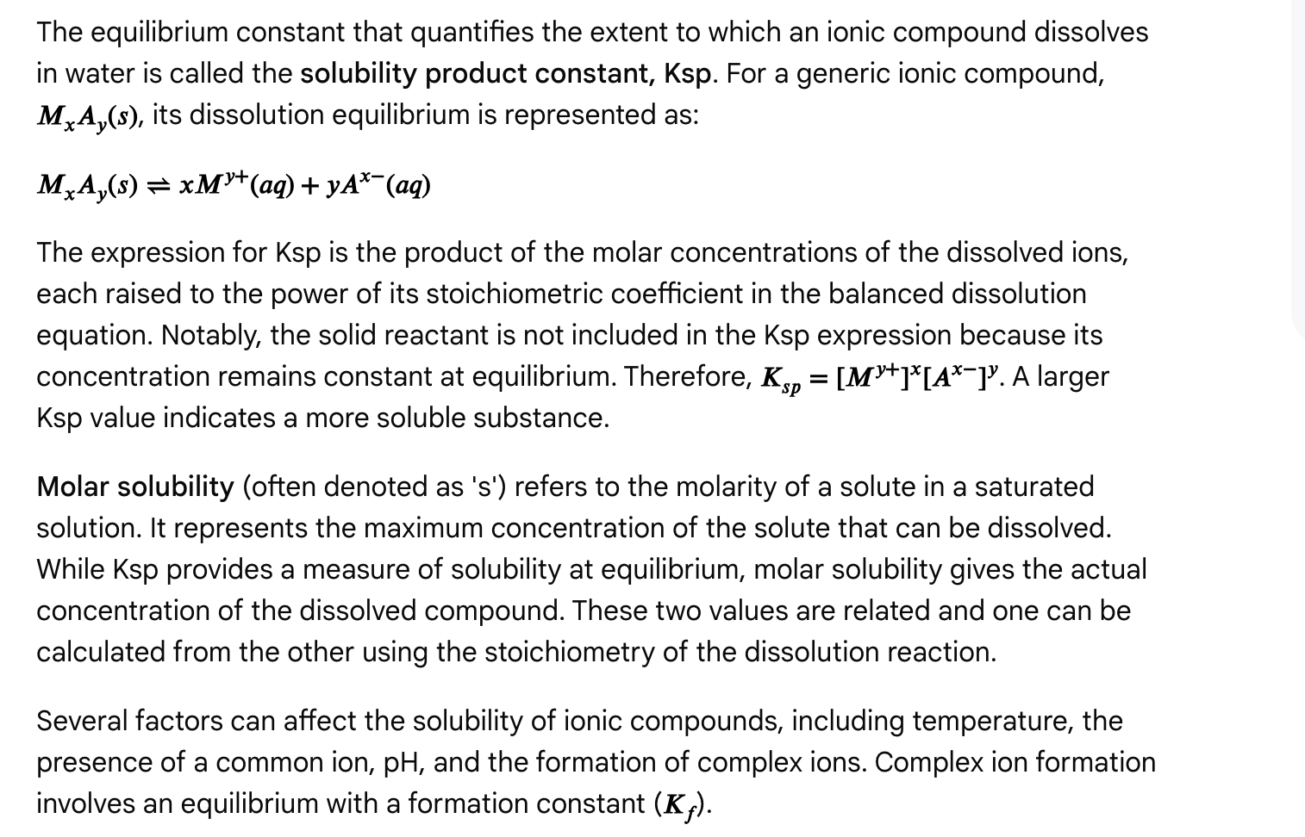

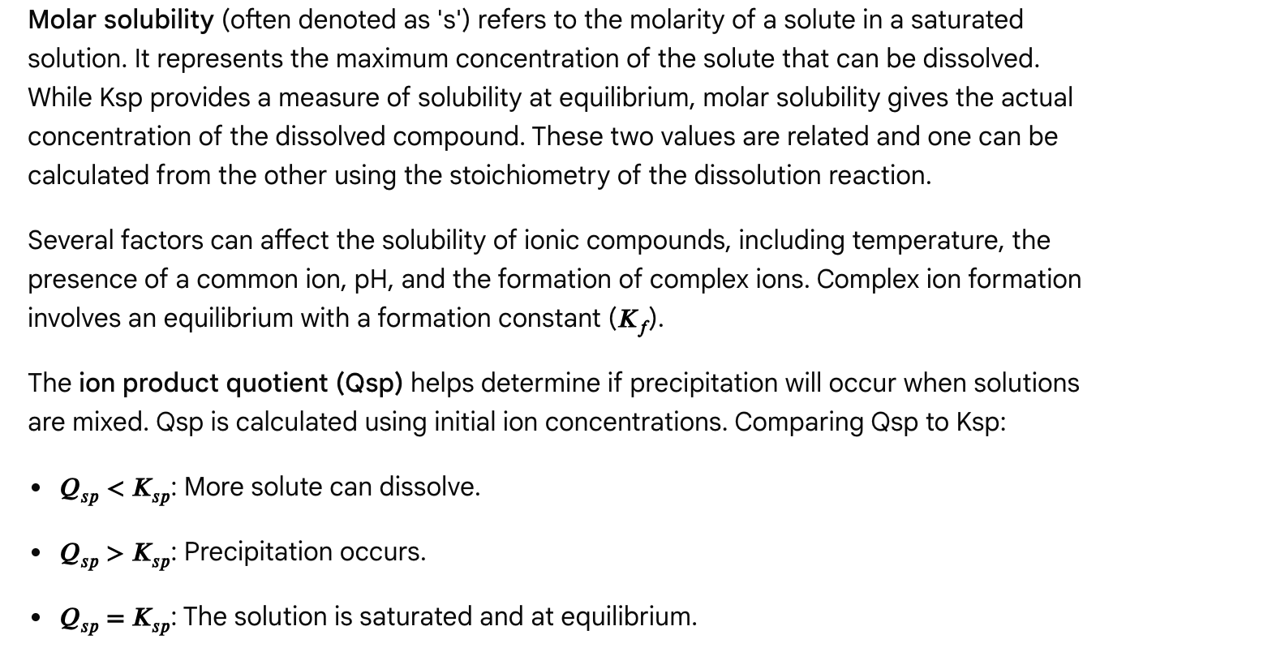

Question 1

Which of the following describes the common ion effect?

a) Adding a common ion increases the solubility of a salt by shifting the equilibrium towards the dissolved ions.  
b) Adding a common ion decreases the solubility of a salt by shifting the equilibrium towards the solid.  
c) Adding a common ion has no effect on the solubility of a salt.  
d) Adding a common ion increases the Ksp of a salt.

Answer and Explanation

Answer: b) Adding a common ion decreases the solubility of a salt by shifting the equilibrium towards the solid.

Explanation: The common ion effect reduces the solubility of an ionic compound when a common ion is present. Le Chatelier's principle explains this by the equilibrium shifting towards the solid when a product (the common ion) is added.

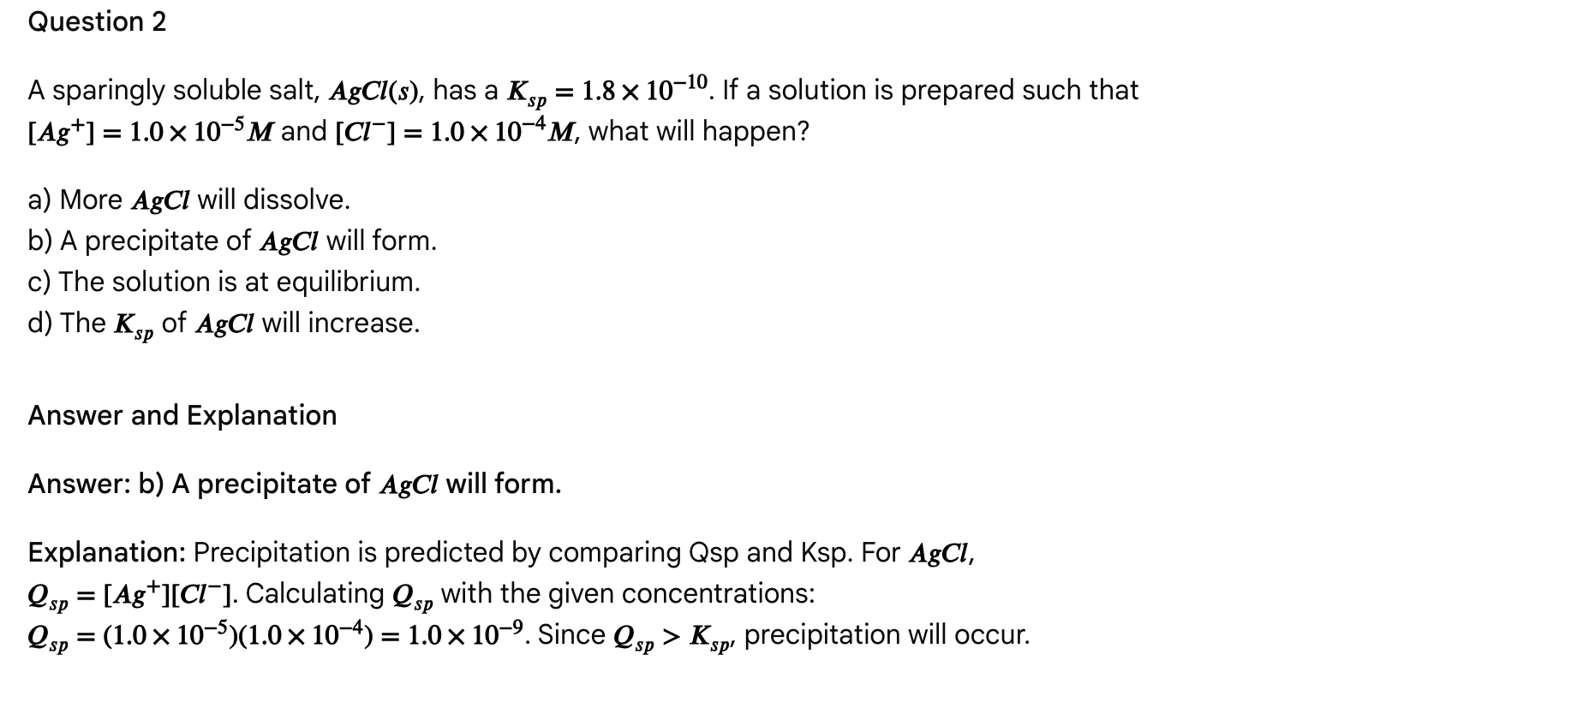

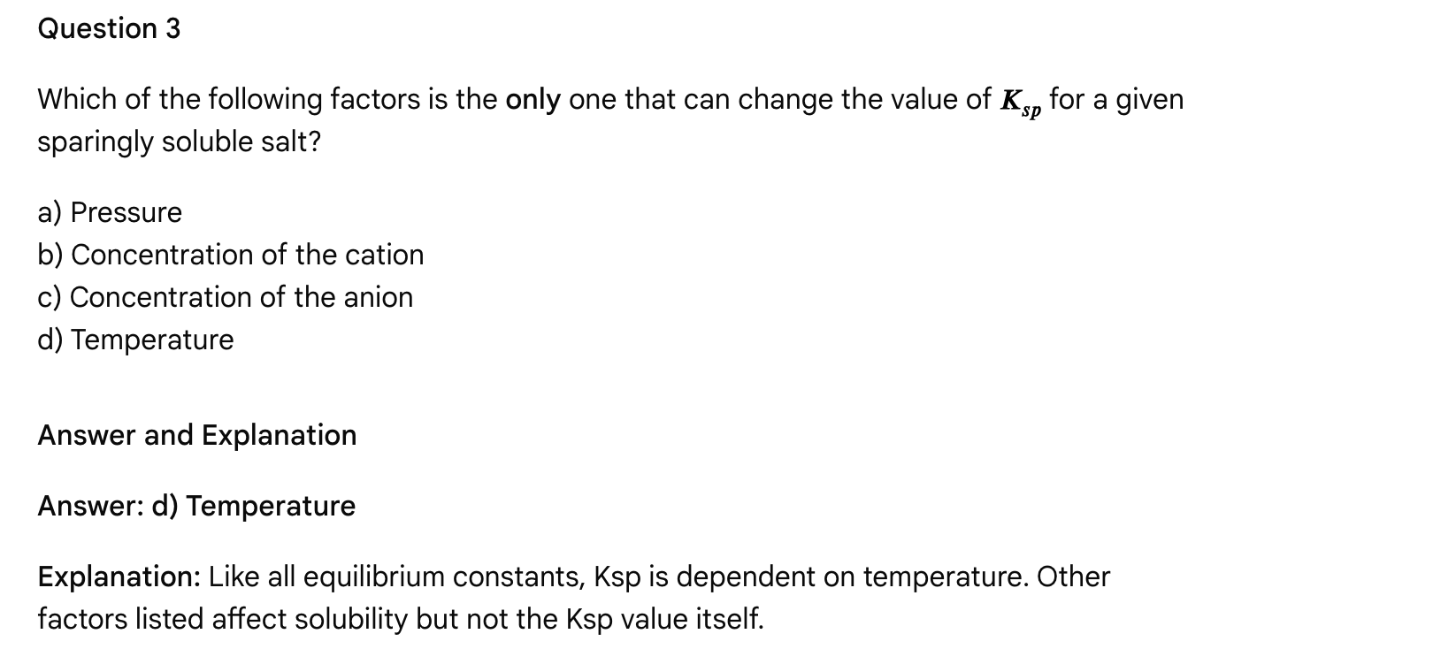

Question 4

The formation of complex ions with the metal cation of a sparingly soluble salt generally affects its solubility in which way?

a) Decreases solubility  
b) Increases solubility  
c) Has no effect on solubility  
d) Causes the salt to become more acidic

Answer and Explanation

Answer: b) Increases solubility

Explanation: Complex ion formation removes metal cations from solution. By Le Chatelier's principle, this shifts the dissolution equilibrium to the right, increasing solubility.

Passage: Electrochemistry: Galvanic Cells and Cell Potential

Electrochemistry is the study of the interconversion of chemical and electrical energy, primarily through redox (oxidation-reduction) reactions. Khan Academy An electrochemical cell is a device that facilitates these transformations. One major type is the galvanic cell, also known as a voltaic cell, which harnesses the energy released from a spontaneous redox reaction to produce electrical energy (a flow of electrons). Sketchy

A galvanic cell typically consists of two distinct half-cells connected externally by a conductive wire and internally by a salt bridge. Sketchy Each half-cell contains an electrode immersed in an electrolyte solution.

* The anode is the electrode where oxidation (loss of electrons) occurs. In a galvanic cell, the anode is the negative electrode because it is the source of electrons, which flow out into the external circuit. Jack Westin
* The cathode is the electrode where reduction (gain of electrons) occurs. In a galvanic cell, the cathode is the positive electrode, accepting electrons from the external circuit. Jack Westin
* The salt bridge is a crucial component that connects the two half-cells. It contains an inert electrolyte (e.g., KNO3 or KCl) that allows for the migration of ions between the half-cells. Chemistry LibreTexts Its primary purpose is to maintain electrical neutrality in each half-cell, preventing charge buildup that would otherwise halt the reaction and electron flow. Wyzant Anions from the salt bridge migrate towards the anode to neutralize the increasing positive charge (due to metal dissolution/oxidation), while cations migrate towards the cathode to neutralize the increasing negative charge (due to ion reduction/deposition). Brainly

The driving force for the electron flow in a galvanic cell is the cell potential (Ecell) or electromotive force (EMF). Jack Westin The standard cell potential (E°cell) is calculated by subtracting the standard reduction potential of the anode from that of the cathode: E°cell = E°cathode - E°anode. Alternatively, it can be calculated as the sum of the standard reduction potential and the standard oxidation potential (where the standard oxidation potential is the negative of the standard reduction potential for the reversed reaction): E°cell = E°reduction + E°oxidation. Jack Westin A positive E°cell indicates a spontaneous reaction. Chemistry LibreTexts

Standard Reduction Potentials (E°red) are tabulated values that quantify the tendency of a chemical species to be reduced (gain electrons) under standard conditions (1 M concentration for solutions, 1 atm for gases, 25°C). s3.it-eng-sandbox2.aws.umd.edu Species with more positive E°red values are more easily reduced and are stronger oxidizing agents. Conversely, species with more negative E°red values are more easily oxidized and are stronger reducing agents. Reddit

For non-standard conditions (i.e., when concentrations are not 1 M), the Nernst Equation (E = E° - (RT/nF)lnQ) is used to calculate the cell potential (E). Chegg This equation highlights the dependence of cell potential on the reaction quotient (Q) and concentrations. Understanding these electrochemical principles is vital for analyzing various systems, from batteries to biological electron transport chains.

Multiple Choice Questions

Question 1

Which statement accurately describes the function of a salt bridge in a galvanic cell?

a) It provides a pathway for electrons to flow from the anode to the cathode.  
b) It prevents the mixing of the electrolyte solutions.  
c) It maintains electrical neutrality by allowing the migration of ions.  
d) It acts as a site for the reduction of the electrolyte ions.

Answer and Explanation

Answer: c) It maintains electrical neutrality by allowing the migration of ions.

Explanation: The primary purpose of a salt bridge is to maintain charge balance in the half-cells by allowing the migration of ions (anions towards the anode and cations towards the cathode). [Chemistry LibreTexts](https://chem.libretexts.org/Bookshelves/Analytical_Chemistry/Supplemental_Modules_(Analytical_Chemistry)/Electrochemistry/Voltaic_Cells), [Wyzant](https://www.wyzant.com/resources/answers/870629/explain-the-role-of-a-salt-bridge-in-a-voltaic-cell" \t "_blank), [Brainly](https://brainly.com/question/28302419), It does not directly provide a pathway for electron flow (that's the external wire) or prevent bulk mixing (though it minimizes it).

Question 2

In a galvanic cell, where does oxidation occur, and what is the charge of this electrode?

a) At the cathode; positive  
b) At the anode; positive  
c) At the anode; negative  
d) At the cathode; negative

Answer and Explanation

Answer: c) At the anode; negative

Explanation: Oxidation occurs at the anode in both galvanic and electrolytic cells. [Jack Westin](https://jackwestin.com/resources/mcat-content/electrochemistry/galvanic-or-voltaic-cells), [Sketchy](https://www.sketchy.com/mcat-lessons/galvanic-electrochemical-cells) In a galvanic cell, the anode is considered the negative electrode because it's the source of electrons flowing into the external circuit. [Jack Westin](https://jackwestin.com/resources/mcat-content/electrochemistry/galvanic-or-voltaic-cells), [Testbook](https://testbook.com/chemistry/galvanic-cell" \t "_blank)

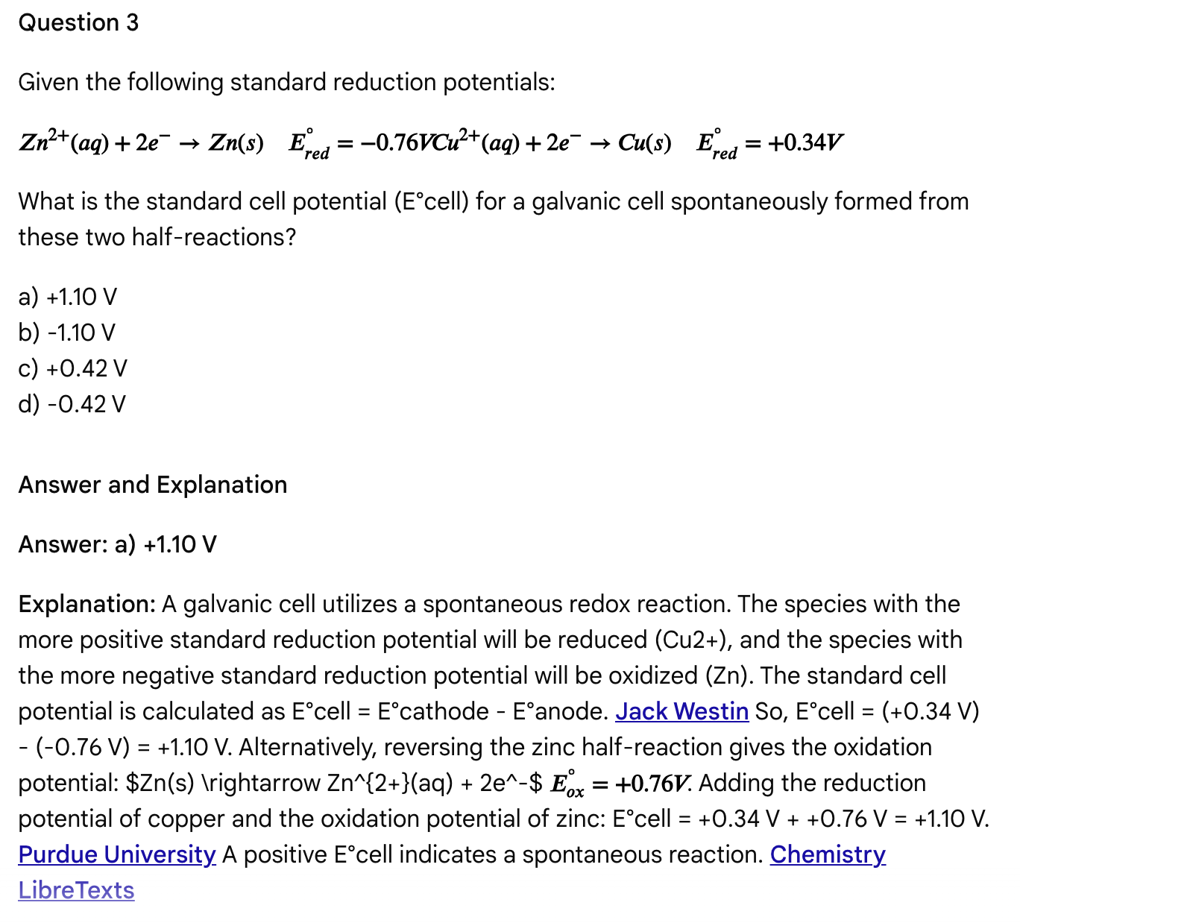

Question 4

Under non-standard conditions, the cell potential of a galvanic cell is calculated using which equation?

a) ΔG = ΔH - TΔS  
b) pH = pKa + log([A-]/[HA])  
c) E = E° - (RT/nF)lnQ  
d) Keq = [Products]/[Reactants]

Answer and Explanation

Answer: c) E = E° - (RT/nF)lnQ

Explanation: The Nernst equation, E = E° - (RT/nF)lnQ, relates the cell potential (E) under non-standard conditions to the standard cell potential (E°), the gas constant (R), temperature (T), the number of moles of electrons transferred (n), Faraday's constant (F), and the reaction quotient (Q). [Chegg](https://www.chegg.com/homework-help/questions-and-answers/nernst-equation-non-standard-cell-half-cell-potential-calculated-using-nernst-equation-rt--q75133692), [YouTube](https://www.youtube.com/watch?v=Bb-dLQfykrk), [Chemistry LibreTexts](https://chem.libretexts.org/Bookshelves/Analytical_Chemistry/Supplemental_Modules_(Analytical_Chemistry)/Electrochemistry/Nernst_Equation) The other equations relate to Gibbs free energy and spontaneity, buffer solutions, and equilibrium constants, respectively.

Passage: Electrochemistry: Electrolytic Cells and Applications

Beyond the spontaneous energy generation in galvanic (voltaic) cells, electrochemical principles can also be harnessed to drive non-spontaneous redox reactions by supplying electrical energy. This is the realm of electrolytic cells, which convert electrical energy into chemical energy. Chemistry LibreTexts The process of driving a non-spontaneous reaction using electrical energy is known as electrolysis. BYJU'S

Like galvanic cells, electrolytic cells consist of an anode (site of oxidation) and a cathode (site of reduction). However, a key distinction lies in the role of the electrodes and the energy source:

* External Power Supply: Electrolytic cells require an external power source (e.g., a battery) to provide the electrical energy necessary to force the non-spontaneous redox reaction to occur. Khan Academy
* Electrode Polarity: In an electrolytic cell, the anode is the positive electrode, and the cathode is the negative electrode. Chemistry LibreTexts This is because the external power source "pumps" electrons into the cathode (making it negative) and withdraws them from the anode (making it positive). Khan Academy, YouTube
* Cell Setup: While some electrolytic cells can use a salt bridge, many practical applications, like electroplating or electrolysis of molten salts, often utilize a single compartment containing the electrodes and the electrolyte. Chemistry LibreTexts

Applications of Electrolytic Cells

Electrolytic cells have numerous important industrial and practical applications:

* Electroplating: This process uses an electric current to deposit a thin layer of one metal onto the surface of another, typically for aesthetic purposes (e.g., gold-plated jewelry) or to enhance properties like corrosion resistance or wear resistance (e.g., chrome plating on steel). Valence Surface Technologies, Khan Academy, The Armoloy Corporation The object to be plated acts as the cathode. The Armoloy Corporation
* Electrolysis of Water: This process uses an electric current to decompose water into hydrogen gas (at the cathode) and oxygen gas (at the anode). This is a potential source of clean hydrogen fuel. Study.com
* Electrorefining and Electrowinning: Electrolytic cells are used to purify metals (electrorefining) or extract metals from their ores (electrowinning), such as the production of high-purity copper, zinc, and aluminum. GeeksforGeeks
* Corrosion: While often unwanted, corrosion can also be understood as an electrochemical process, often resembling the behavior of mini galvanic cells on a metal surface. Chemistry LibreTexts Techniques like cathodic protection utilize electrochemical principles, often involving a sacrificial anode, to prevent the corrosion of structures like steel pipes by making them the cathode of a corrosion cell. HyperPhysics

Faraday's Laws of Electrolysis

Faraday's laws of electrolysis provide quantitative relationships between the amount of chemical change produced during electrolysis and the quantity of electricity used. BYJU'S, ScienceDirect.com

* First Law: The mass of a substance deposited or liberated is directly proportional to the quantity of electricity passed.

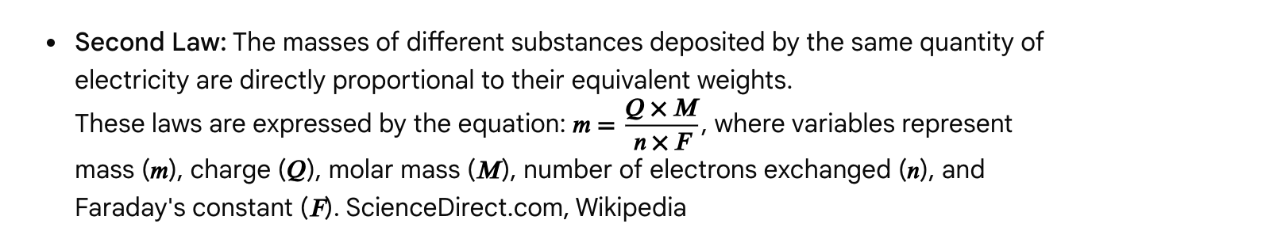

Multiple Choice Questions

Question 1

What is the primary function of an electrolytic cell?

a) To generate electrical energy from a spontaneous chemical reaction.  
b) To drive a non-spontaneous chemical reaction using electrical energy.  
c) To measure the standard reduction potential of an electrode.  
d) To separate ions based on their size.

Answer and Explanation

Answer: b) To drive a non-spontaneous chemical reaction using electrical energy.

Explanation: Electrolytic cells utilize an external power source to facilitate non-spontaneous redox reactions, distinguishing them from galvanic cells which generate energy from spontaneous reactions. Khan Academy, Chemistry LibreTexts, Study.com

Question 2

In an electrolytic cell used for electroplating, the object being plated acts as the:

a) Anode  
b) Cathode  
c) Electrolyte  
d) Salt bridge

Answer and Explanation

Answer: b) Cathode

Explanation: During electroplating, metal ions are reduced and deposited onto the object, which serves as the cathode. The Armoloy Corporation, Formlabs

Question 3

Which of Faraday's Laws of Electrolysis relates the mass of a substance produced at an electrode to the quantity of electricity passed through the electrolyte?

a) First Law  
b) Second Law  
c) Third Law  
d) Nernst's Law

Answer and Explanation

Answer: a) First Law

Explanation: Faraday's First Law links the mass of a substance produced at an electrode directly to the quantity of electricity passed. BYJU'S, Wikipedia The Second Law relates masses of different substances to their equivalent weights, while the Nernst equation deals with cell potential.

Question 4

What is the relationship between the anode in a galvanic cell and an electrolytic cell?

a) The anode is the site of reduction in both galvanic and electrolytic cells.  
b) The anode is the site of oxidation in both galvanic and electrolytic cells.  
c) The anode is positive in a galvanic cell and negative in an electrolytic cell.  
d) The anode is negative in a galvanic cell and positive in an electrolytic cell.

Answer and Explanation

Answer: b) The anode is the site of oxidation in both galvanic and electrolytic cells.

Explanation: Oxidation consistently occurs at the anode in both cell types. Chemistry LibreTexts, Jack Westin However, their polarities differ, with the anode being negative in a galvanic cell and positive in an electrolytic cell. Chemistry LibreTexts, Reddit, Study.com

Passage: Oxidation-Reduction (Redox) Reactions: Fundamentals and Balancing

Oxidation-reduction reactions, or redox reactions, are a fundamental class of chemical reactions involving the transfer of electrons between reacting species. www.jove.com, Chemistry LibreTexts This electron transfer causes a change in the oxidation states of the atoms involved. These reactions are ubiquitous in chemistry and biology, underpinning processes like combustion, corrosion, and cellular respiration. Chemistry LibreTexts

Key Definitions

* Oxidation: The process where a chemical species loses electrons, resulting in an increase in its oxidation state. Chemistry LibreTexts
* Reduction: The process where a chemical species gains electrons, resulting in a decrease in its oxidation state. Chemistry LibreTexts
* Oxidizing Agent (Oxidant): The species that causes another species to be oxidized by accepting electrons. In doing so, the oxidizing agent itself gets reduced. Chemistry LibreTexts, Study.com
* Reducing Agent (Reductant): The species that causes another species to be reduced by donating electrons. In doing so, the reducing agent itself gets oxidized. Chemistry LibreTexts, Study.com

A useful mnemonic for remembering these definitions is OIL RIG: Oxidation Is Loss of electrons; Reduction Is Gain of electrons. Chemistry LibreTexts Alternatively, "LEO the lion says GER" (Lose Electrons, Oxidized; Gain Electrons, Reduced). Wikipedia

Balancing Redox Reactions

Balancing redox reactions is crucial for correctly representing the stoichiometry of electron transfer. The half-reaction method is a common technique for balancing redox reactions, especially in aqueous solutions. BC Open Textbooks This method involves separating the overall reaction into two half-reactions (one for oxidation, one for reduction), balancing atoms and charge within each half-reaction, and then combining them such that the electrons gained equal the electrons lost.

The steps for balancing half-reactions in acidic solution are: BC Open Textbooks

1. Balance atoms other than O and H.
2. Balance oxygen atoms by adding H2O molecules.
3. Balance hydrogen atoms by adding H+ ions.
4. Balance the charge by adding electrons (e-) to the more positive side.

If the reaction occurs in basic solution, H+ ions can be neutralized by adding an equal number of OH- ions to both sides of the equation, combining H+ and OH- to form H2O, and then canceling any resulting H2O molecules. BC Open Textbooks

Applications

Understanding redox reactions is vital in various contexts:

* Biological Systems: Cellular respiration and photosynthesis are complex redox processes where electron carriers like NAD+/NADH and FAD/FADH2 play critical roles. Jack Westin
* Organic Chemistry: Oxidation and reduction concepts are used to describe the conversion of functional groups, like alcohols to carbonyls. MedLife Mastery
* Electrochemistry: As discussed in the previous passage, redox reactions are the basis of galvanic and electrolytic cells. Chemistry LibreTexts
* Metallurgy and Industry: Redox reactions are used in the extraction of metals from their ores, electroplating, and in the production of various industrial chemicals. Wikipedia

Multiple Choice Questions

Question 1

In a redox reaction, the species that gets reduced is known as the:

a) Oxidizing agent  
b) Reducing agent  
c) Reactant  
d) Product

Answer and Explanation

Answer: a) Oxidizing agent

Explanation: The oxidizing agent is the species that causes another species to be oxidized by accepting electrons; therefore, the oxidizing agent itself gets reduced. Chemistry LibreTexts, Study.com

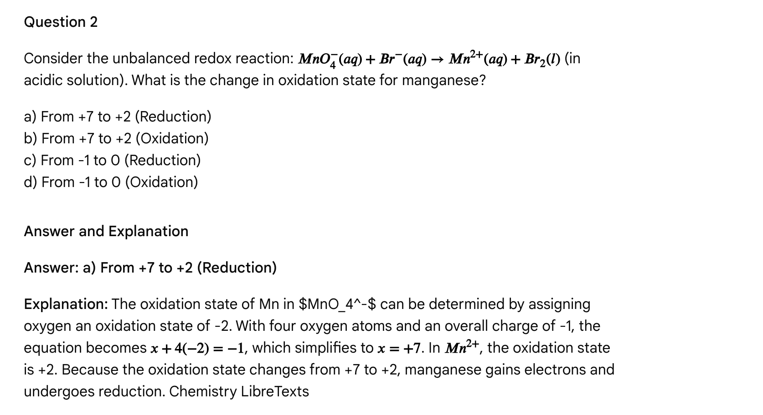

Question 3

Which of the following is a common step in balancing redox half-reactions in acidic solution?

a) Adding hydroxide ions (OH-) to balance hydrogen atoms.  
b) Adding water molecules (H2O) to balance oxygen atoms.  
c) Adding a salt bridge to balance the charge.  
d) Separating the solution into two compartments.

Answer and Explanation

Answer: b) Adding water molecules (H2O) to balance oxygen atoms.

Explanation: In balancing redox half-reactions in acidic solution, water molecules (H2O) are added to balance the oxygen atoms, and then hydrogen ions (H+) are added to balance the hydrogen atoms. BC Open Textbooks Hydroxide ions are used in basic solutions. A salt bridge is used in electrochemical cells, not directly for balancing equations, and separation into compartments also relates to electrochemical cells.

Question 4

What happens to the oxidation state of an atom that undergoes oxidation?

a) It decreases.  
b) It increases.  
c) It remains the same.  
d) It becomes zero.

Answer and Explanation

Answer: b) It increases.

Explanation: Oxidation is defined as the loss of electrons, which leads to an increase in the oxidation state of the atom or molecule undergoing oxidation. Chemistry LibreTexts

Passage: Chemical Kinetics: Reaction Rates, Factors, and Activation Energy

Chemical kinetics is the study of reaction rates, the factors influencing them, and the molecular-level mechanisms by which reactions occur. Understanding kinetics is crucial for optimizing chemical processes and predicting how fast reactants are consumed and products are formed. Chemistry LibreTexts, Khan Academy

Factors Affecting Reaction Rates

Several factors can influence the rate of a chemical reaction: BC Open Textbooks

1. Concentration of Reactants: Increasing the concentration of reactants generally increases the reaction rate. This is because higher concentrations lead to more frequent collisions between reactant molecules, increasing the likelihood of successful collisions. BC Open Textbooks, Khan Academy
2. Temperature: Increasing the temperature almost always increases the reaction rate. At higher temperatures, molecules possess greater kinetic energy, leading to more frequent and more energetic collisions. This increases the number of molecules that have sufficient energy to overcome the activation energy barrier. Chemistry LibreTexts, BC Open Textbooks
3. Surface Area: For reactions involving a solid reactant, increasing the surface area exposed to other reactants will increase the reaction rate. This is because more reactant molecules are available for collision at the surface. BC Open Textbooks
4. Presence of a Catalyst: Catalysts are substances that increase the rate of a chemical reaction without being consumed in the process. Pacific Northwest National Laboratory | PNNL (.gov) They achieve this by providing an alternative reaction pathway with a lower activation energy (Ea). Khan Academy, Study.com Catalysts do not affect the thermodynamics (ΔG) or the equilibrium position of a reaction; they only affect the rate at which equilibrium is reached. Pacific Northwest National Laboratory | PNNL (.gov) Enzymes are biological catalysts. Study.com

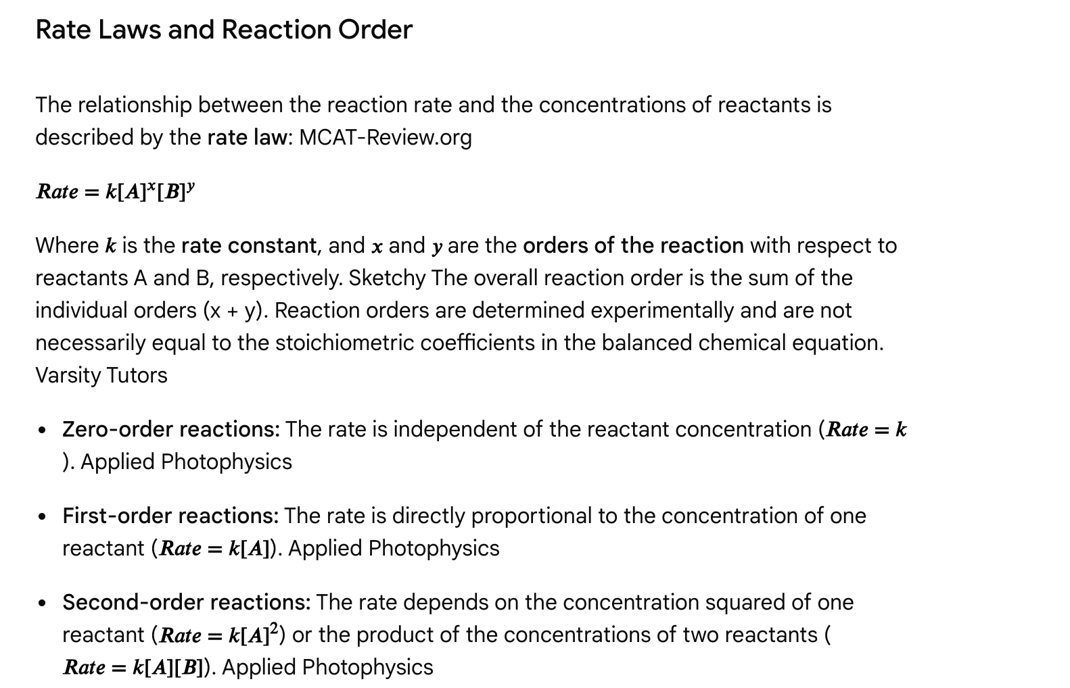

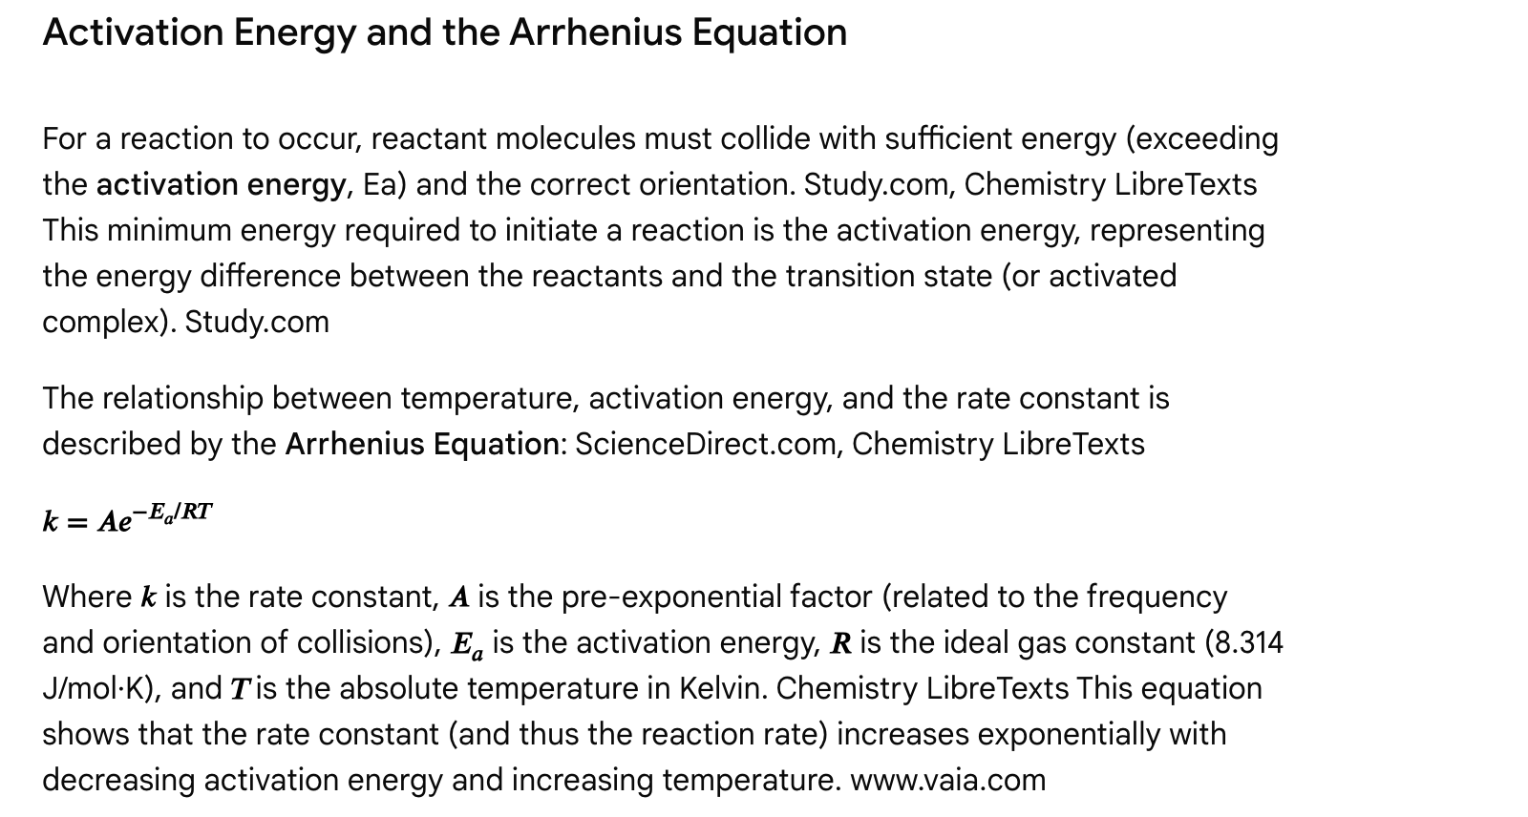

Multiple Choice Questions

Question 1

Which of the following would decrease the rate of a chemical reaction?

a) Increasing the temperature.  
b) Adding a catalyst.  
c) Increasing the concentration of reactants (for a non-zero order reaction).  
d) Decreasing the surface area of a solid reactant.

Answer and Explanation

Answer: d) Decreasing the surface area of a solid reactant.

Explanation: Decreasing the surface area of a solid reactant reduces the number of sites available for collisions, thereby decreasing the reaction rate. BC Open Textbooks, Khan Academy Increasing temperature, adding a catalyst, and increasing reactant concentration generally increase reaction rates.

Question 2

A reaction is found to have the following rate law: Rate = k[A]². If the concentration of reactant A is doubled, how will the reaction rate change?

a) It will double.  
b) It will quadruple.  
c) It will be halved.  
d) It will remain the same.

Answer and Explanation

Answer: b) It will quadruple.

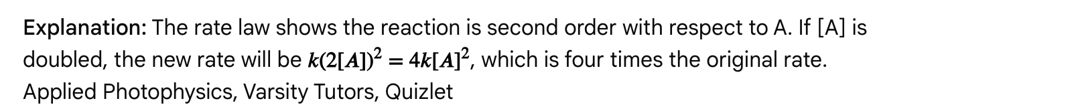

Question 3

How does a catalyst affect a chemical reaction?

a) It shifts the equilibrium position of the reaction towards products.  
b) It increases the activation energy of the reaction.  
c) It provides an alternative reaction pathway with a lower activation energy.  
d) It is consumed during the reaction and must be replenished.

Answer and Explanation

Answer: c) It provides an alternative reaction pathway with a lower activation energy.

Explanation: Catalysts increase reaction rates by providing a new mechanism or pathway that requires less activation energy. Khan Academy, Study.com, University of Texas at Austin They do not affect the equilibrium position or thermodynamics. Catalysts are regenerated during the reaction and are not consumed. Pacific Northwest National Laboratory | PNNL (.gov)

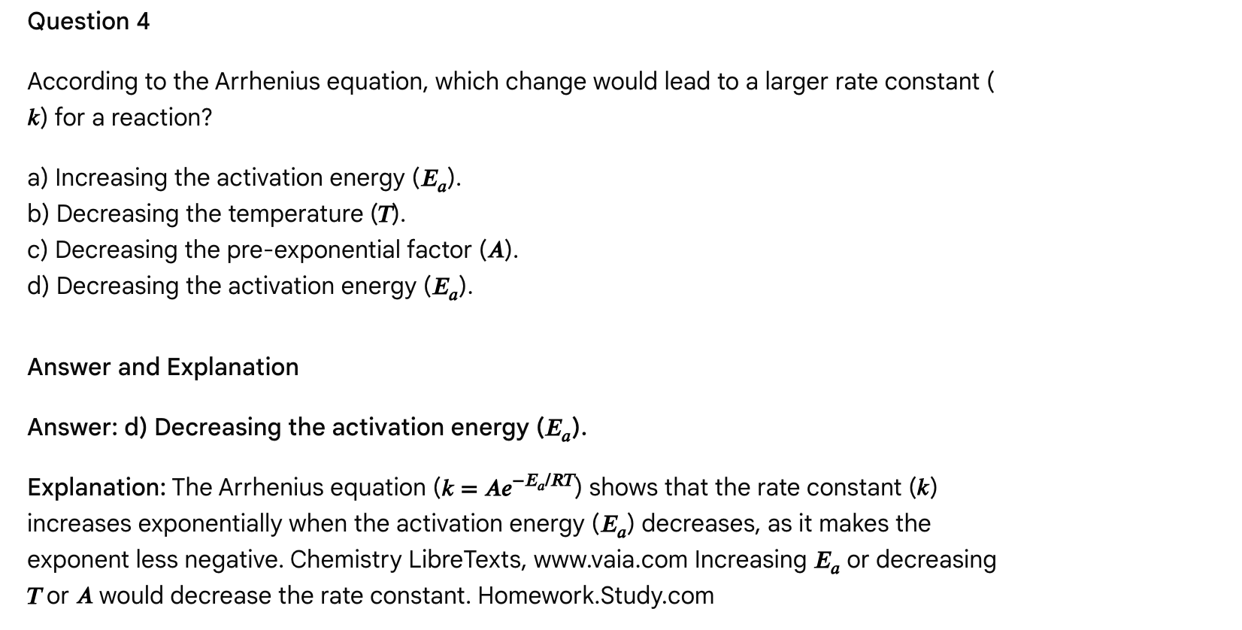

Passage: The Gas Phase: Ideal vs. Real Gases and Gas Laws

Gases are one of the fundamental states of matter, characterized by particles that are widely dispersed and in constant, random motion. [Chemistry LibreTexts](https://chem.libretexts.org/Bookshelves/Introductory_Chemistry/Introductory_Chemistry_(CK-12)/13%3A_States_of_Matter/13.01%3A_Kinetic_Molecular_Theory) Their behavior is often described by the Kinetic Molecular Theory (KMT) of Gases, which proposes several postulates for an ideal gas: [Khan Academy](https://www.khanacademy.org/science/chemistry/gases-and-kinetic-molecular-theory/x822131fc:kinetic-molecular-theory/v/the-kinetic-molecular-theory-of-gases),

1. Gases consist of particles with negligible volume compared to the container volume.
2. Gas particles are in constant, random motion and undergo elastic collisions (no loss of kinetic energy).
3. There are no significant attractive or repulsive forces between gas particles.
4. The average kinetic energy of gas particles is directly proportional to the absolute temperature (in Kelvin).

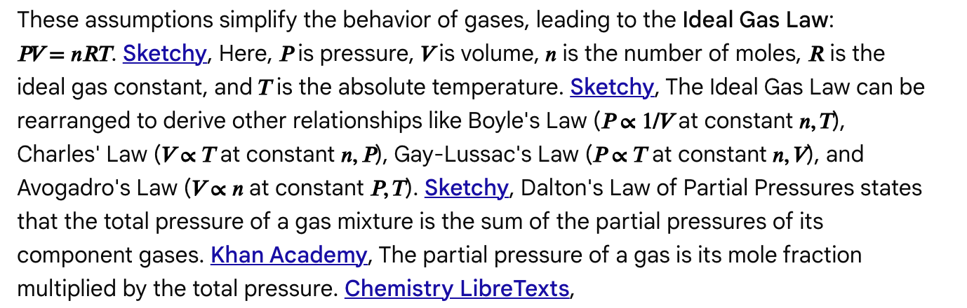

Real gases deviate from ideal behavior because their particles do have a finite volume and do exert intermolecular forces. These deviations are most significant at high pressures (where particles are forced closer, making molecular volume significant) and low temperatures (where particles move slower, allowing intermolecular forces to become more influential). [Khan Academy](https://www.khanacademy.org/science/ap-chemistry-beta/x2eef969c74e0d802:intermolecular-forces-and-properties/x2eef969c74e0d802:deviation-from-ideal-gas-law/v/real-gases-deviations-from-ideal-behavior), The van der Waals equation is a modified form of the Ideal Gas Law that attempts to account for these non-ideal behaviors. [YouTube](https://www.youtube.com/watch?v=QITKH9ekYzU), It includes correction terms: 'a' for intermolecular attractive forces and 'b' for the finite volume of gas particles. [YouTube](https://www.youtube.com/watch?v=QITKH9ekYzU),

Graham's Law of Effusion describes the rate at which gas molecules escape through a small opening into a vacuum. Chemistry LibreTexts, It states that the rate of effusion is inversely proportional to the square root of the molar mass of the gas. Chemistry LibreTexts, This means lighter gases effuse faster than heavier gases at the same temperature, as they have higher average speeds. [Chad's Prep®](https://www.chadsprep.com/chads-general-chemistry-videos/grahams-law-of-effusion/), Diffusion is the gradual mixing of gases due to particle motion. Chemistry LibreTexts,

Multiple Choice Questions

Question 1

Which of the following conditions would cause a real gas to deviate most significantly from ideal behavior?

a) High temperature and low pressure.  
b) Low temperature and high pressure.  
c) High temperature and high pressure.  
d) Low temperature and low pressure.

Answer and Explanation

Answer: b) Low temperature and high pressure.

Explanation: Real gases deviate from ideal behavior when their particles are closer together (high pressure) or moving slower (low temperature), allowing for intermolecular forces and finite molecular volume to become significant. [Khan Academy](https://www.khanacademy.org/science/ap-chemistry-beta/x2eef969c74e0d802:intermolecular-forces-and-properties/x2eef969c74e0d802:deviation-from-ideal-gas-law/v/real-gases-deviations-from-ideal-behavior),

Question 2

According to the Kinetic Molecular Theory of Gases, what happens to the average kinetic energy of gas particles when the absolute temperature of the gas is doubled?

a) It quadruples.  
b) It doubles.  
c) It remains the same.  
d) It is halved.

Answer and Explanation

Answer: b) It doubles.

Explanation: One of the postulates of the Kinetic Molecular Theory states that the average kinetic energy of gas particles is directly proportional to the absolute temperature in Kelvin. [Khan Academy](https://www.khanacademy.org/science/chemistry/gases-and-kinetic-molecular-theory/x822131fc:kinetic-molecular-theory/v/the-kinetic-molecular-theory-of-gases), Therefore, if the absolute temperature doubles, the average kinetic energy also doubles.

Question 3

A container holds a mixture of oxygen gas (O2) and nitrogen gas (N2). If the total pressure inside the container is 3.0 atm and the mole fraction of O2 is 0.25, what is the partial pressure of N2?

a) 0.25 atm  
b) 0.75 atm  
c) 2.25 atm  
d) 3.0 atm

Answer and Explanation

Answer: c) 2.25 atm

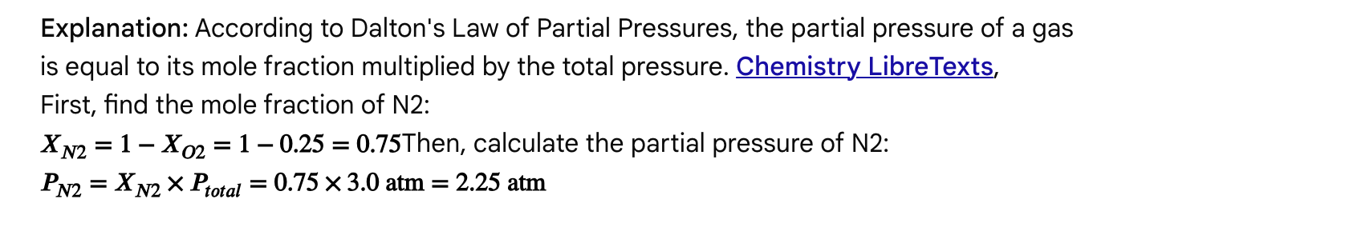

Question 4

Which of the following gases would have the fastest rate of effusion at a given temperature and pressure?

a) He (Molar mass = 4 g/mol)  
b) O2 (Molar mass = 32 g/mol)  
c) CO2 (Molar mass = 44 g/mol)  
d) Ne (Molar mass = 20 g/mol)

Answer and Explanation

Answer: a) He (Molar mass = 4 g/mol)

Explanation: Graham's Law of Effusion states that the rate of effusion of a gas is inversely proportional to the square root of its molar mass. Chemistry LibreTexts, Therefore, the gas with the lowest molar mass will effuse the fastest. Helium has the lowest molar mass (4 g/mol) among the choices. [Chad's Prep®](https://www.chadsprep.com/chads-general-chemistry-videos/grahams-law-of-effusion/),

Passage: Chemical Equilibrium

Chemical equilibrium is a state where the rates of the forward and reverse reactions are equal, leading to no net change in the concentrations of reactants and products over time. This is a dynamic process, meaning both forward and reverse reactions are still occurring, but at the same rate. Chemistry LibreTexts, Wikipedia The concentrations of reactants and products remain constant at equilibrium, but they are not necessarily equal. Homework.Study.com, Chemistry LibreTexts

The equilibrium constant (Keq or K) is a value that expresses the ratio of product concentrations to reactant concentrations at equilibrium, with each concentration raised to the power of its stoichiometric coefficient in the balanced equation. Sketchy It is a constant for a given reaction at a specific temperature; only a change in temperature can alter the value of Keq. UMass Boston, Facebook A large Keq (>> 1) indicates that products are favored at equilibrium, while a small Keq (<< 1) indicates that reactants are favored.

The reaction quotient (Q) is defined identically to Keq but can be calculated at any point in time, not just at equilibrium. Varsity Tutors, Sketchy By comparing Q to Keq, one can predict the direction a reaction will shift to reach equilibrium: Khan Academy, MedLife Mastery

**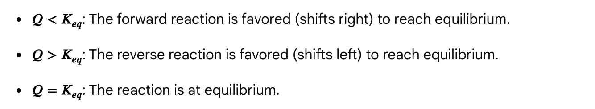**

Le Chatelier's Principle predicts how a system at equilibrium will respond to a disturbance or "stress." en.wikipedia.org The principle states that if a dynamic equilibrium is disturbed by changing the conditions, the position of equilibrium shifts to counteract the change to reestablish an equilibrium. Chemistry LibreTexts

Common stressors include: Varsity Tutors, Jack Westin

* Changes in Concentration: Adding reactants shifts the equilibrium to the right (products), while adding products shifts it left (reactants). Removing a reactant shifts left, removing a product shifts right.
* Changes in Pressure/Volume: For reactions involving gases, increasing pressure (decreasing volume) shifts the equilibrium to the side with fewer moles of gas. Decreasing pressure (increasing volume) shifts it to the side with more moles of gas. Sketchy, Jack Westin
* Changes in Temperature: This is the only factor that changes the value of Keq. Increasing the temperature favors the endothermic direction, while decreasing the temperature favors the exothermic direction. Shemmassian Academic Consulting Heat can be considered a reactant in endothermic reactions and a product in exothermic reactions when applying Le Chatelier's principle. Shemmassian Academic Consulting
* Catalysts: Catalysts increase the rate of both forward and reverse reactions equally, thus helping the system reach equilibrium faster but having no effect on the equilibrium position or the value of Keq. The University of Rhode Island, Chemistry LibreTexts

Chemical equilibrium is a cornerstone concept in chemistry, crucial for understanding reaction outcomes in fields from industrial synthesis (like the Haber-Bosch process for ammonia) to biological processes.

Multiple Choice Questions

Question 1

Which of the following statements is TRUE for a system at chemical equilibrium?

a) The concentrations of reactants and products are equal.  
b) The rates of the forward and reverse reactions are equal.  
c) The reaction has stopped.  
d) The value of Keq changes constantly.

Answer and Explanation

Answer: b) The rates of the forward and reverse reactions are equal.

Explanation: At equilibrium, the concentrations of reactants and products remain constant because the rate of the forward reaction equals the rate of the reverse reaction. PASCO scientific This is a dynamic state, so the reaction has not stopped. The concentrations are constant but not necessarily equal, and Keq only changes with temperature. Chemistry LibreTexts

**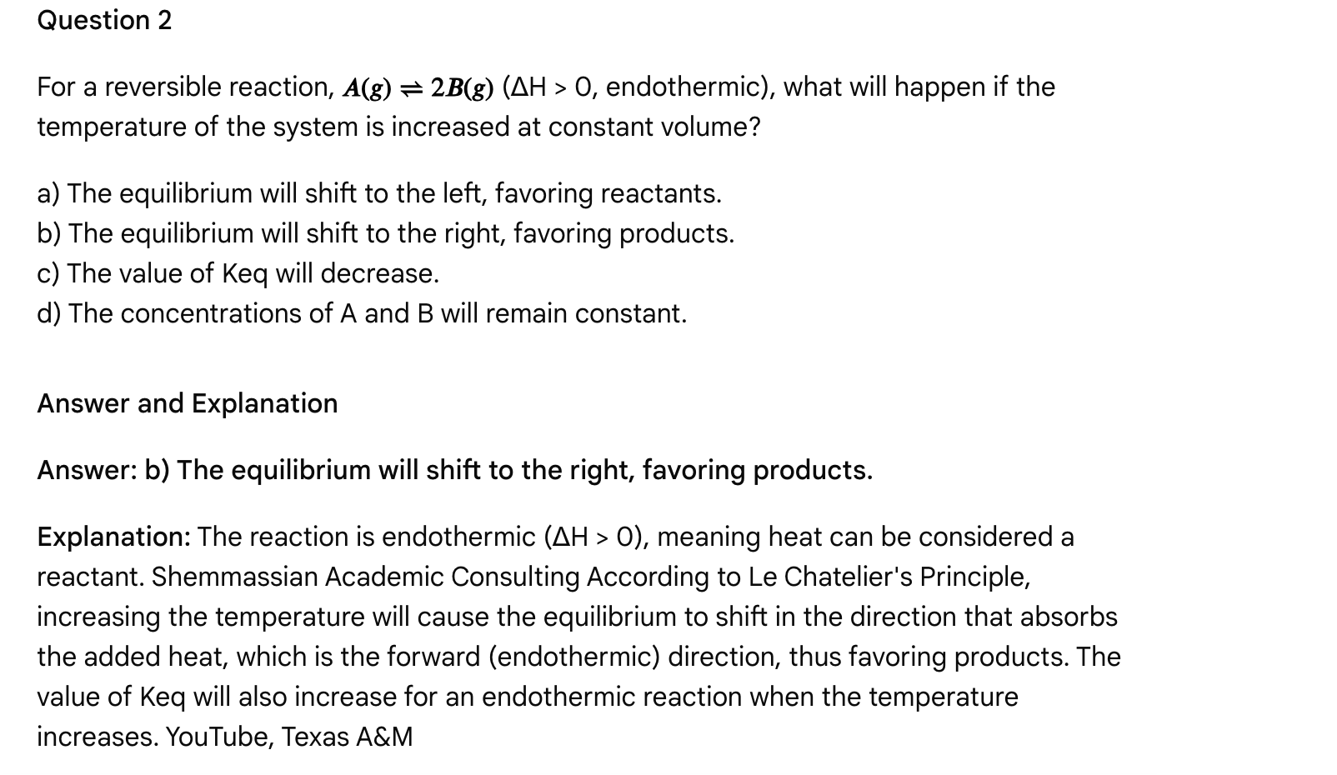**

**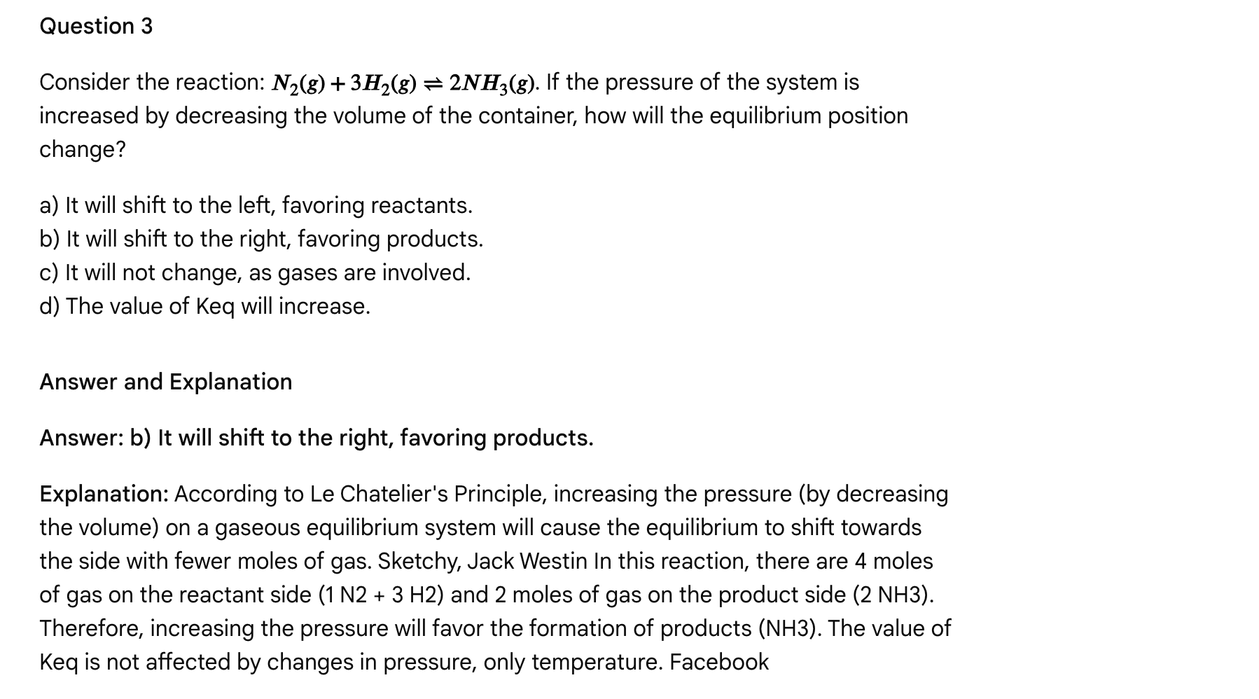**

**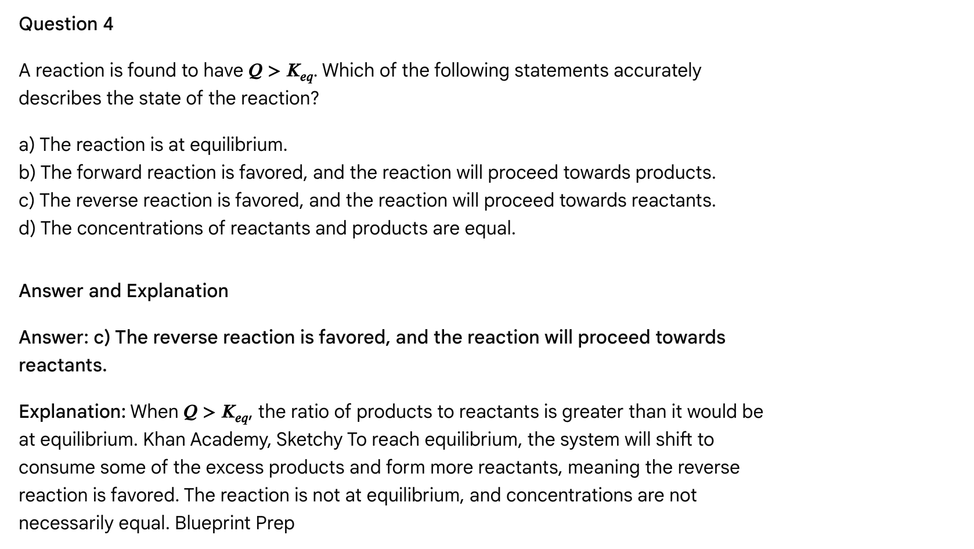**

Multiple Choice Questions

Question 1

Under which set of conditions would a real gas behave most like an ideal gas?

a) High pressure and low temperature.  
b) Low pressure and high temperature.  
c) High pressure and high temperature.  
d) Low pressure and low temperature.

Answer and Explanation

Answer: b) Low pressure and high temperature.

Explanation: Real gases behave most ideally under conditions where intermolecular forces are minimized and the volume of the gas particles is negligible compared to the total volume, which occurs at low pressures and high temperatures.

Question 2

According to the Kinetic Molecular Theory, which property is directly proportional to the absolute temperature of a gas?

a) Volume of the particles  
b) Force of attraction between particles  
c) Average kinetic energy of the particles  
d) Frequency of collisions with container walls

Answer and Explanation

Answer: c) Average kinetic energy of the particles

Explanation: One of the main postulates of the KMT is that the average kinetic energy of the molecules in a gas sample is directly proportional to its absolute temperature in Kelvin.

Question 3

A container holds 2.0 moles of Helium (He) and 3.0 moles of Neon (Ne). If the total pressure of the gas mixture is 5.0 atm, what is the partial pressure of Helium?

a) 1.0 atm  
b) 2.0 atm  
c) 2.5 atm  
d) 3.0 atm

Answer and Explanation

Answer: b) 2.0 atm

**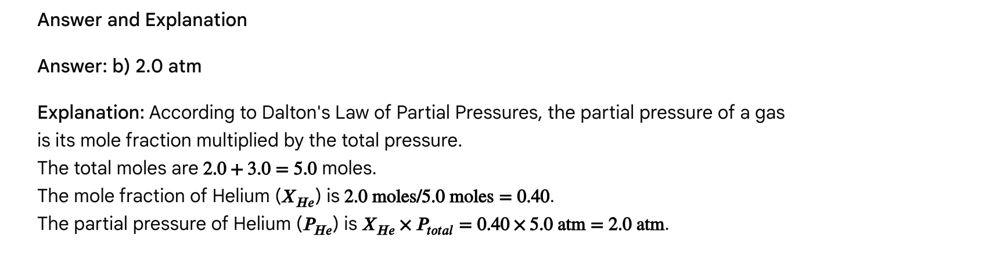**

Question 4

Which of the following modifications in the van der Waals equation accounts for the attractive forces between real gas molecules?

a) Adding 'b' to the volume term.  
b) Subtracting 'b' from the volume term.  
c) Adding 'a/V²' to the pressure term.  
d) Subtracting 'a/V²' from the pressure term.

Answer and Explanation

Answer: c) Adding 'a/V²' to the pressure term.

Explanation: The van der Waals equation modifies the ideal gas law with two correction terms. The term 'a/V²' is added to the pressure term (P) to account for the attractive forces between molecules, which effectively reduce the observed pressure compared to an ideal gas. The term 'b' is subtracted from the volume term (V) to account for the finite volume occupied by the gas particles.

Passage: Chemical Bonding: Ionic, Covalent, and Metallic Interactions

Chemical bonds are the attractive forces that hold atoms together to form molecules and compounds, governing the structure and properties of all matter. Shemmassian Academic Consulting, There are three primary types of chemical bonds: ionic, covalent, and metallic, each arising from distinct ways atoms achieve a stable electron configuration, typically resembling a noble gas configuration (the octet rule). MedLife Mastery

Types of Chemical Bonds

1. **Ionic Bonds:** These bonds form when there is a complete **transfer of one or more valence electrons** from one atom to another. Jack Westin, This typically occurs between a metal (which readily loses electrons to form a positively charged cation) and a nonmetal (which readily gains electrons to form a negatively charged anion). Jack Westin, The resulting oppositely charged ions are held together by strong **electrostatic forces of attraction**, forming an ionic compound. Unacademy Ionic compounds characteristically form crystal lattices, have high melting points, and conduct electricity when molten or dissolved in water. www.mytutor.co.uk The strength of an ionic bond is related to the magnitude of the charges on the ions and the distance between their nuclei, often quantified by lattice energy. MCAT-Review.org Large differences in electronegativity (generally



≥is greater than or equal to

≥

2.0) favor ionic bond formation. Oregon Institute of Technology

1. **Covalent Bonds:** These bonds form when two atoms **share one or more pairs of electrons**. Jack Westin, They typically occur between nonmetal atoms. Jack Westin, The sharing can be equal, forming a **nonpolar covalent bond**, or unequal, forming a **polar covalent bond**. Rapid Learning Center **Bond polarity** arises from differences in electronegativity between the bonded atoms; the more electronegative atom attracts the shared electrons more strongly, gaining a partial negative charge (δ-) and the less electronegative atom gaining a partial positive charge (δ+). Varsity Tutors A bond is considered nonpolar covalent if the electronegativity difference is small (typically



≤is less than or equal to

≤

0.4) and polar covalent if it's moderate (typically between 0.4 and 2.0). Oregon Institute of Technology **Coordinate covalent bonds** are a special type where both shared electrons come from only one of the bonding atoms. MedLife Mastery Covalent compounds generally have lower melting points and typically do not conduct electricity. Rapid Learning Center

1. **Metallic Bonds:** Found in metals, these bonds involve the collective sharing of a "sea" of delocalized valence electrons among a lattice of positively charged metal ions. Unacademy This electron mobility accounts for characteristic metallic properties like high electrical and thermal conductivity, malleability, and ductility. Wikipedia, Western Sierra Collegiate Academy

Understanding the type and nature of chemical bonds is crucial for predicting molecular geometry, physical properties, and reactivity. Molecular geometry, for instance, can be predicted using VSEPR theory, Jack Westin which considers the repulsion between electron pairs in the valence shell.

Multiple Choice Questions

Question 1

Which of the following statements correctly differentiates between ionic and covalent bonds?

a) Ionic bonds involve sharing electrons, while covalent bonds involve transferring electrons.  
b) Ionic bonds form between nonmetals, while covalent bonds form between metals.  
c) Ionic bonds result from the electrostatic attraction of ions, while covalent bonds result from the sharing of electrons.  
d) Ionic bonds have lower melting points than covalent bonds.

Answer and Explanation

**Answer: c) Ionic bonds result from the electrostatic attraction of ions, while covalent bonds result from the sharing of electrons.**

**Explanation:** This statement accurately reflects the fundamental difference: ionic bonds form from electron transfer leading to ions attracted by electrostatic forces, whereas covalent bonds form by sharing electrons. www.mytutor.co.uk Jack Westin Option a is incorrect; options b and d generally describe incorrect pairings or typical physical properties. Jack Westin

Question 2

A bond between two atoms has an electronegativity difference of 1.5. This bond is most likely classified as:

a) Nonpolar covalent  
b) Polar covalent  
c) Ionic  
d) Metallic

Answer and Explanation

**Answer: b) Polar covalent**

**Explanation:** A moderate electronegativity difference (typically between 0.4 and 2.0) indicates a polar covalent bond, where electrons are shared unequally. Oregon Institute of Technology A difference of 0-0.3 is nonpolar covalent, and ≥ is greater than or equal to ≥ 2.0 is considered ionic. Oregon Institute of Technology

Question 3

Which of the following properties is characteristic of a substance held together by metallic bonds?

a) Low electrical conductivity  
b) High melting point and brittle solid structure  
c) Delocalized electrons and high electrical conductivity  
d) Insoluble in polar solvents and low boiling point

Answer and Explanation

**Answer: c) Delocalized electrons and high electrical conductivity**

**Explanation:** Metallic bonds involve a "sea" of delocalized electrons that move freely throughout the metal lattice, leading to high electrical and thermal conductivity. Wikipedia, Western Sierra Collegiate Academy High melting point and brittle structure are characteristic of ionic compounds, while low solubility in polar solvents and low boiling points are common for nonpolar covalent compounds.

**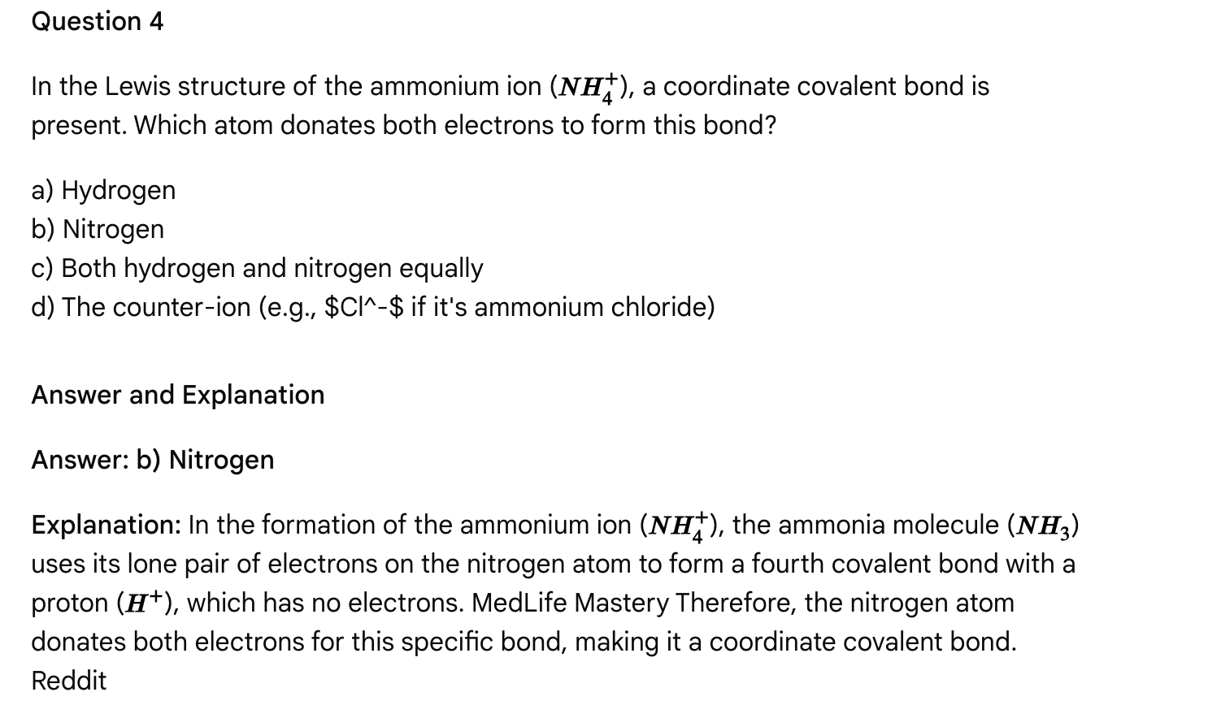**

Passage: Molecular Geometry, Polarity, and Intermolecular Forces

The physical and chemical properties of a substance are intricately linked to the shape of its molecules and the nature of the forces acting between them. Understanding molecular geometry, bond polarity, and intermolecular forces (IMFs) is crucial for predicting solubility, boiling points, melting points, and reactivity. Number Analytics

Molecular Geometry and VSEPR Theory

The three-dimensional arrangement of atoms in a molecule, known as molecular geometry, is determined by the repulsion between electron pairs around the central atom(s). The Valence Shell Electron Pair Repulsion (VSEPR) theory posits that electron pairs (both bonding pairs and lone pairs) will arrange themselves to minimize these repulsions, maximizing the distance between them. Varsity Tutors The arrangement of all electron pairs defines the electron-pair geometry, while the arrangement of only the bonded atoms defines the molecular geometry. Lone pairs exert a stronger repulsive force than bonding pairs, leading to distortions in bond angles and molecular shape. For example, both methane (CH4) and ammonia (NH3) have a tetrahedral electron-pair geometry (four electron groups). However, methane has a tetrahedral molecular geometry with 109.5° bond angles, while ammonia has a trigonal pyramidal molecular geometry with bond angles slightly less than 109.5° due to the lone pair on nitrogen. brainly.com LinkedIn

Hybridization, the mixing of atomic orbitals to form new hybrid orbitals, is also related to molecular geometry. For example, sp³ hybridization leads to tetrahedral geometry, sp² to trigonal planar, and sp to linear geometry around a central atom. Quora, brainly.co...

Molecular Polarity

Molecular polarity is a measure of the uneven distribution of electron density within a molecule, resulting in a net dipole moment. Chemistry LibreTexts A molecule is polar if it contains polar bonds and has an asymmetrical molecular geometry that prevents the individual bond dipoles from canceling each other out. Wikipedia Polar bonds arise from differences in electronegativity between bonded atoms (e.g., C-O, O-H). Even if a molecule contains polar bonds, it can be nonpolar if its geometry is symmetrical (e.g., CO2 is linear, bond dipoles cancel; CCl4 is tetrahedral, bond dipoles cancel). Chemistry LibreTexts Molecules with lone pairs on the central atom often have asymmetrical geometries, contributing to molecular polarity (e.g., H2O is bent, resulting in a net dipole). LinkedIn, Chemistry LibreTexts

Intermolecular Forces (IMFs)

IMFs are the attractive forces that exist between molecules, influencing the bulk physical properties of substances. Their strength follows the general order: Ionic bonds (between separate ions) > Hydrogen bonding > Dipole-dipole interactions > London Dispersion Forces (LDFs). Vedantu, Chemistry Stack Exchange

1. London Dispersion Forces (LDFs): Present in all molecules (both polar and nonpolar) and arise from temporary, induced dipoles due to fluctuations in electron distribution. Their strength increases with molecular size and surface area. They are the only IMF in nonpolar molecules. Khan Academy
2. Dipole-Dipole Interactions: Occur between polar molecules, where the partially positive end of one molecule is attracted to the partially negative end of a neighboring molecule. Khan Academy
3. Hydrogen Bonding: A particularly strong type of dipole-dipole interaction that occurs when a hydrogen atom is directly bonded to a highly electronegative atom (N, O, or F). The partially positive hydrogen of one molecule is strongly attracted to the lone pair on the electronegative atom of another molecule. Hydrogen bonding significantly impacts properties like boiling points and solubilities. Khan Academy Chemistry Stack Exchange

Physical properties like melting point, boiling point, and solubility are strongly influenced by the strength of IMFs. Stronger IMFs lead to higher melting and boiling points, as more energy is required to overcome these attractions. Saskoer Solubility follows the "like dissolves like" principle; polar solutes dissolve in polar solvents (often due to hydrogen bonding or dipole-dipole interactions), and nonpolar solutes dissolve in nonpolar solvents (due to LDFs). Saskoer

**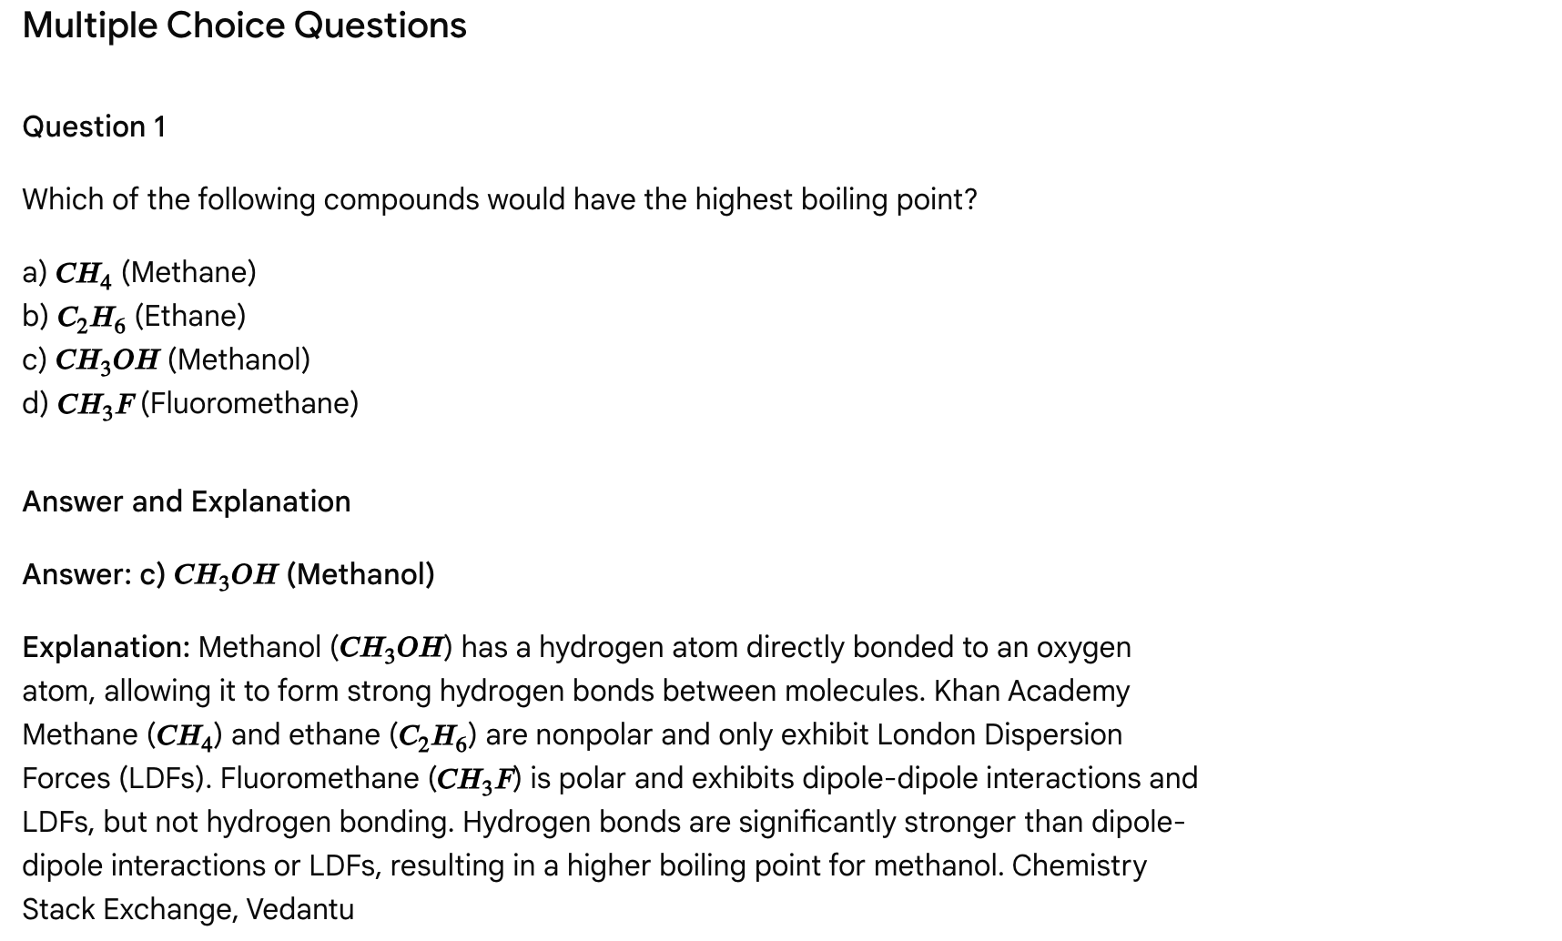**

**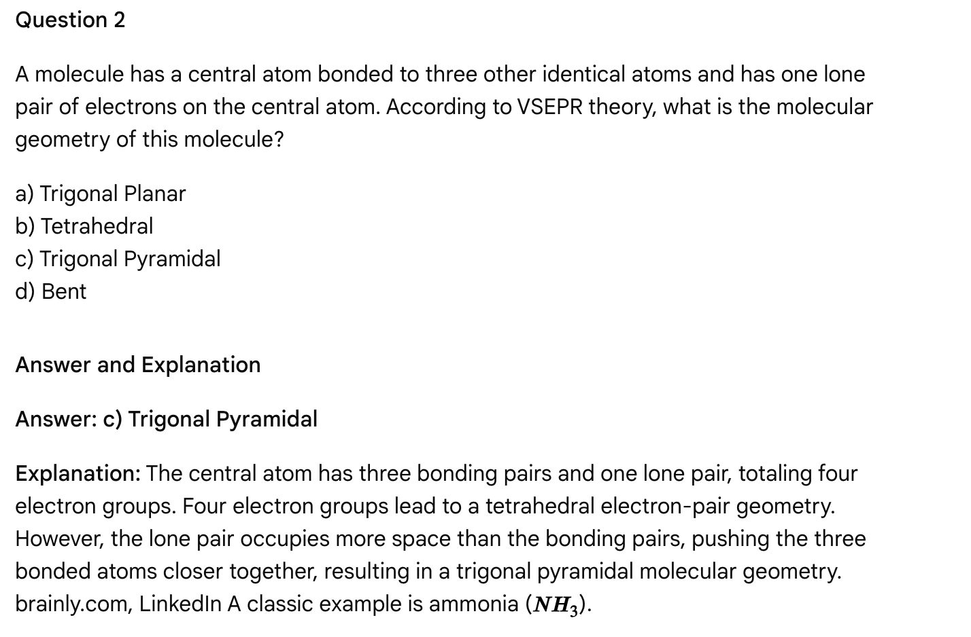**

**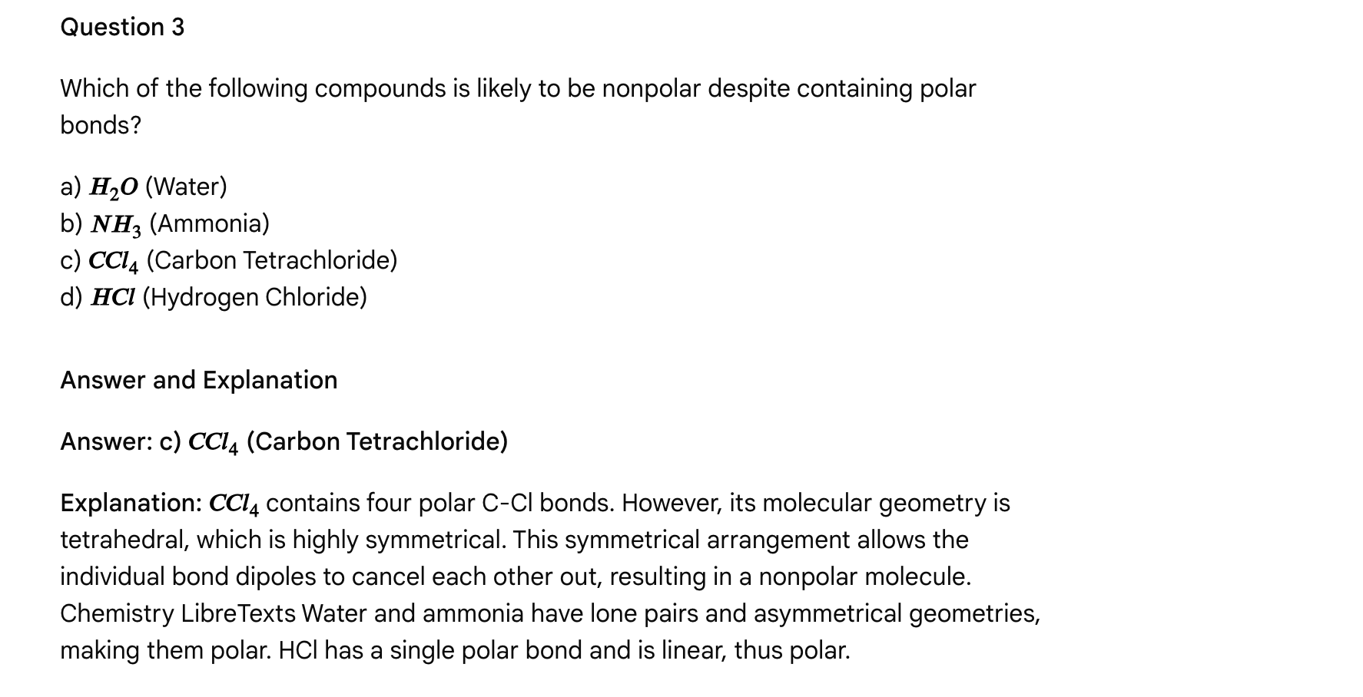**

Question 4

What type of intermolecular forces are responsible for the relatively high boiling point of water compared to other molecules of similar size, such as methane (



CH4cap C cap H sub 4

𝐶𝐻4

)?

a) London Dispersion Forces only  
b) Dipole-dipole interactions only  
c) Hydrogen bonding  
d) Ionic bonds

Answer and Explanation

**Answer: c) Hydrogen bonding**

**Explanation:** Water has a high boiling point because it can form strong hydrogen bonds between its molecules. Khan Academy, Number Analytics Methane cannot form hydrogen bonds. While water also exhibits dipole-dipole interactions and LDFs, hydrogen bonding is the strongest IMF present and is responsible for its unique properties. Chemistry Stack Exchange

Passage: Colligative Properties of Solutions

Solutions, mixtures of a solute dissolved in a solvent, exhibit unique physical properties that differ from those of the pure solvent. Some of these properties, known as colligative properties, depend solely on the *number* of solute particles present in the solution, not their chemical identity. MedLife Mastery, Varsity Tutors Understanding colligative properties is essential in various fields, from biology (e.g., cell function, osmotic pressure) to practical applications (e.g., using salt to melt ice on roads).

**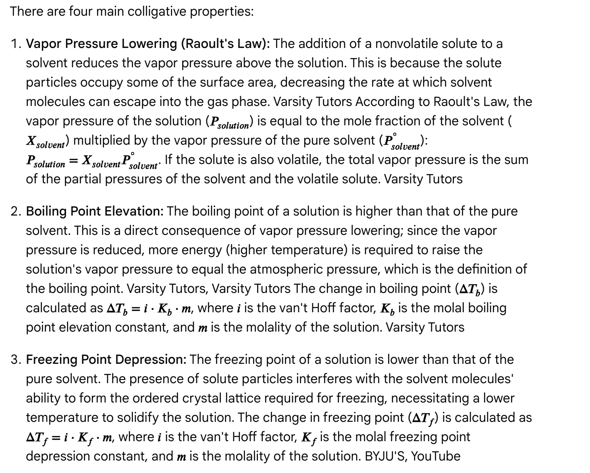**

**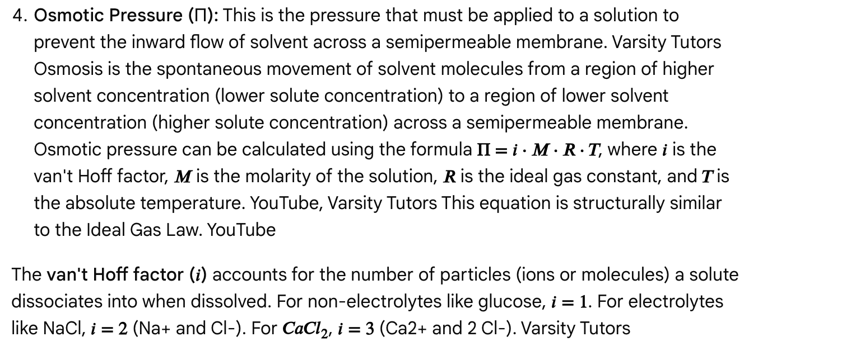**

Multiple Choice Questions

Question 1

Which of the following properties is not considered a colligative property?

a) Boiling point elevation  
b) Color intensity  
c) Freezing point depression  
d) Osmotic pressure

Answer and Explanation

Answer: b) Color intensity

Explanation: Colligative properties depend solely on the *number* of solute particles, not their chemical identity. MedLife Mastery Color intensity depends on the chemical identity of the solute and its interaction with light, making it a non-colligative property. Varsity Tutors

**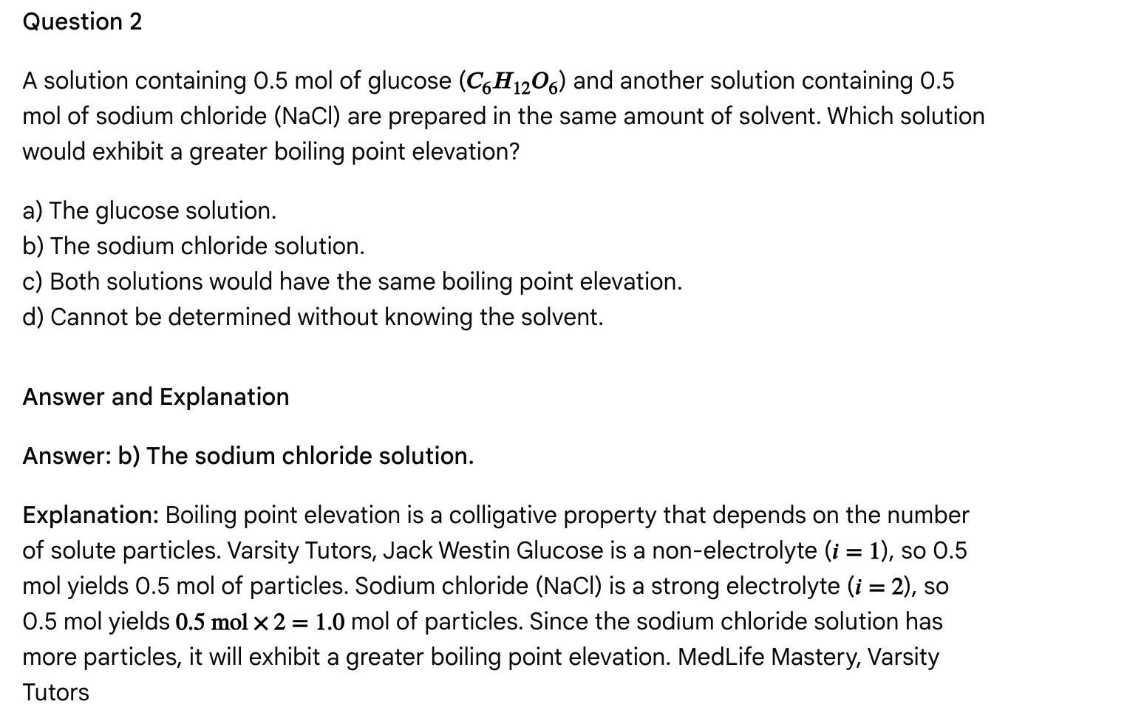**

Question 3

What is the relationship between the vapor pressure of a pure solvent and the vapor pressure of a solution containing a nonvolatile solute?

a) The vapor pressure of the solution is higher.  
b) The vapor pressure of the solution is lower.  
c) The vapor pressures are equal.  
d) The relationship depends on the temperature.

Answer and Explanation

Answer: b) The vapor pressure of the solution is lower.

Explanation: The addition of a nonvolatile solute lowers the vapor pressure of a solution compared to the pure solvent. Varsity Tutors This is a consequence of Raoult's Law and the fact that solute particles reduce the surface area available for solvent molecules to escape into the vapor phase.

**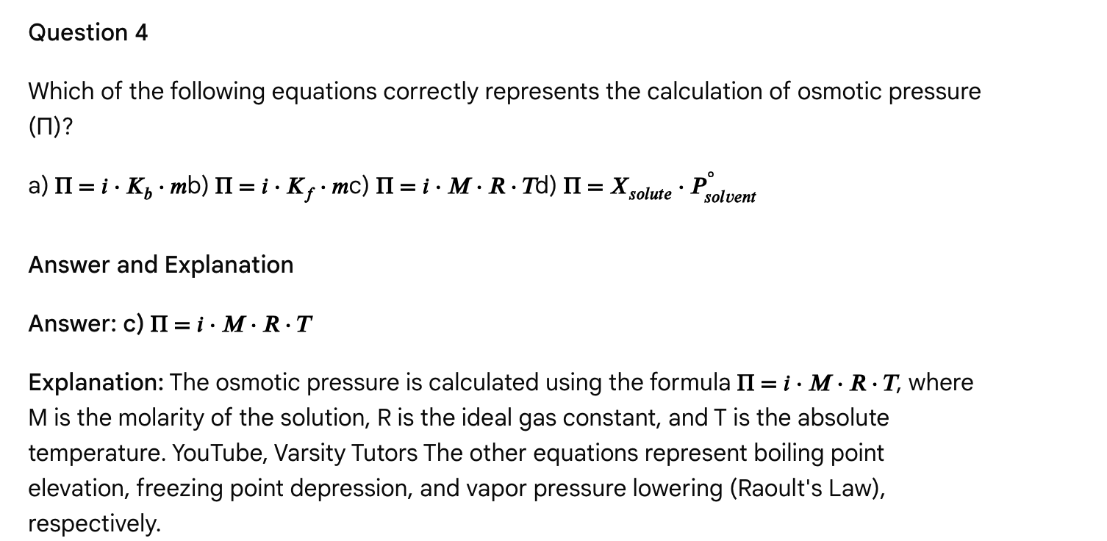** Passage: Nuclear Chemistry: Radioactive Decay, Half-Life, and Applications

Nuclear chemistry is a specialized field that focuses on the nucleus of the atom, investigating phenomena like radioactivity, nuclear stability, and nuclear reactions. Unlike chemical reactions, which involve the rearrangement of electrons, nuclear reactions involve changes in the nucleus itself, often leading to the transmutation of elements. Stanford University These transformations release significantly more energy compared to chemical reactions. Stanford University

Radioactive Decay

Radioactive decay is the spontaneous process by which an unstable atomic nucleus (parent nuclide) emits particles and/or energy to transform into a more stable nucleus (daughter nuclide). U.S. Environmental Protection Agency (.gov), Khan Academy The radiation emitted is high-energy, ionizing radiation, potentially harmful but also useful. U.S. Environmental Protection Agency (.gov) Common types of radioactive decay include:

**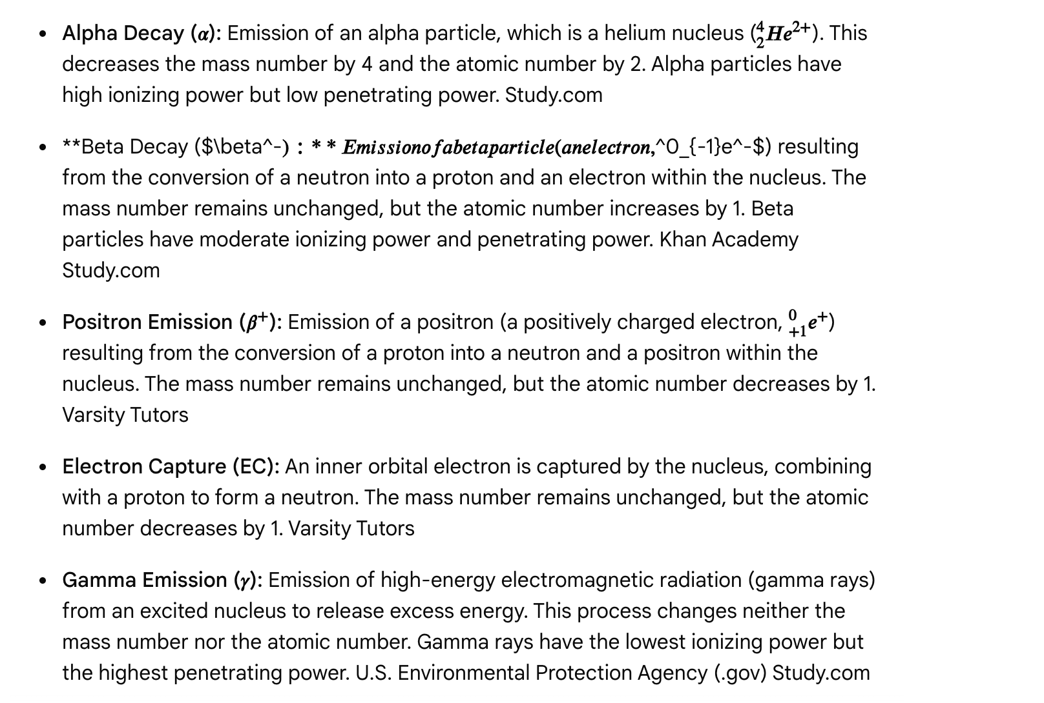**

**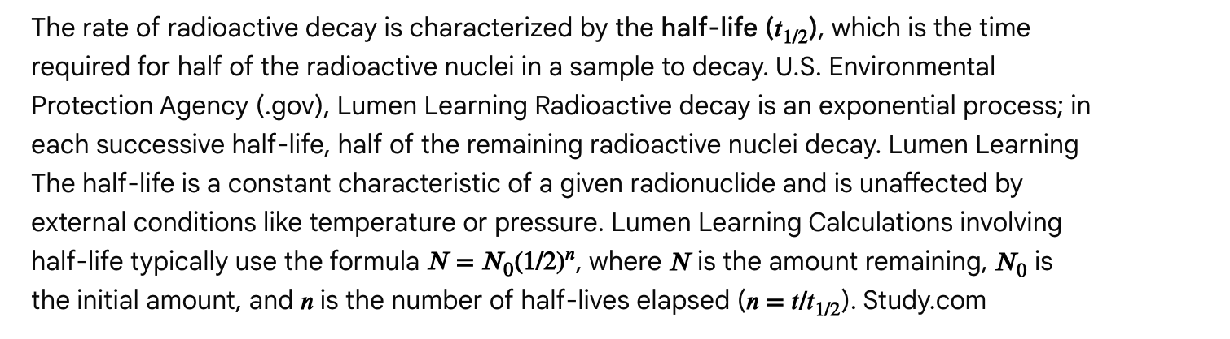**

Applications

Radioactivity and nuclear reactions have numerous applications:

* Medicine: Radiopharmaceuticals are used for diagnosis (e.g., Technetium-99m for imaging organs, PET scans using Fluorine-18) and treatment (e.g., Iodine-131 for thyroid cancer, Yttrium-90 for liver cancer therapy, Iridium-192 for brachytherapy). ANSTO, Washington State Department of Health (.gov)
* Research: Radioactive tracers are used to study metabolic pathways, gene function, and environmental processes. U.S. Environmental Protection Agency (.gov), Washington State Department of Health (.gov)
* Dating: Radiometric dating (e.g., carbon-14 dating) determines the age of ancient artifacts and geological samples by measuring the decay of specific radioisotopes. Lumen Learning
* Energy: Nuclear fission is the process by which heavy nuclei split, releasing large amounts of energy and producing more neutrons, potentially leading to a chain reaction. This is used in nuclear power plants. orano.group Nuclear fusion, the combination of light nuclei, also releases immense energy (as occurs in stars) but is currently experimental for energy generation. orano.group, EUROfusion

**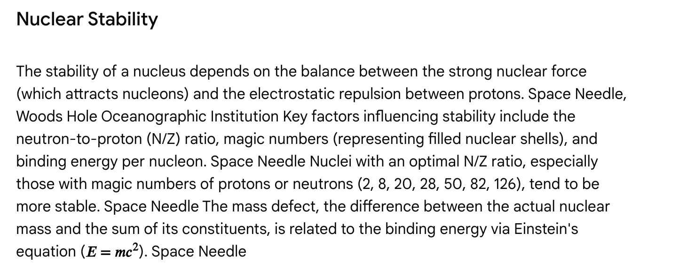**

**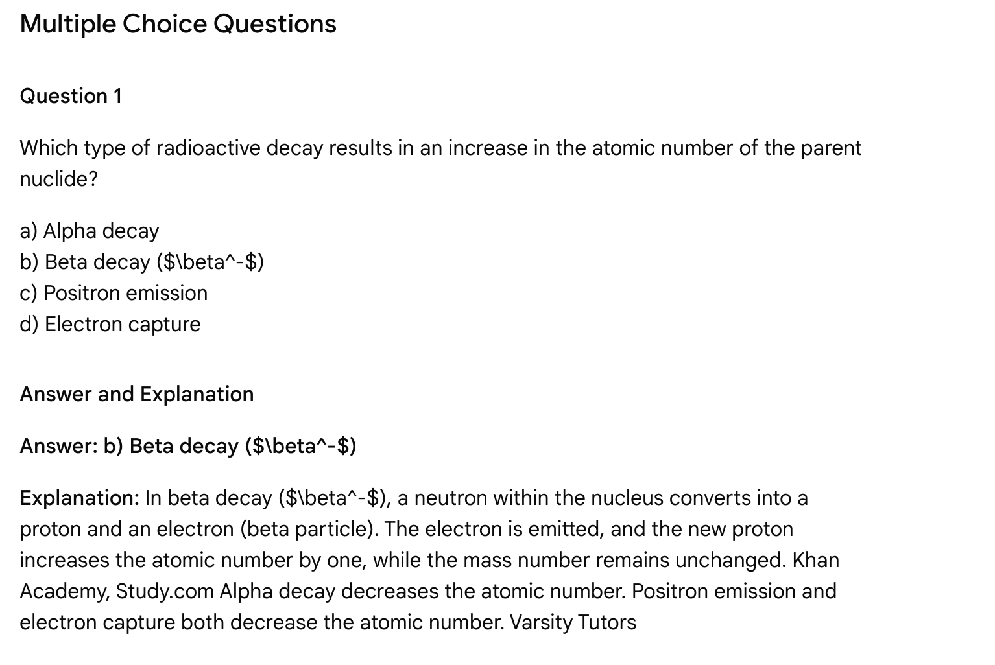**

**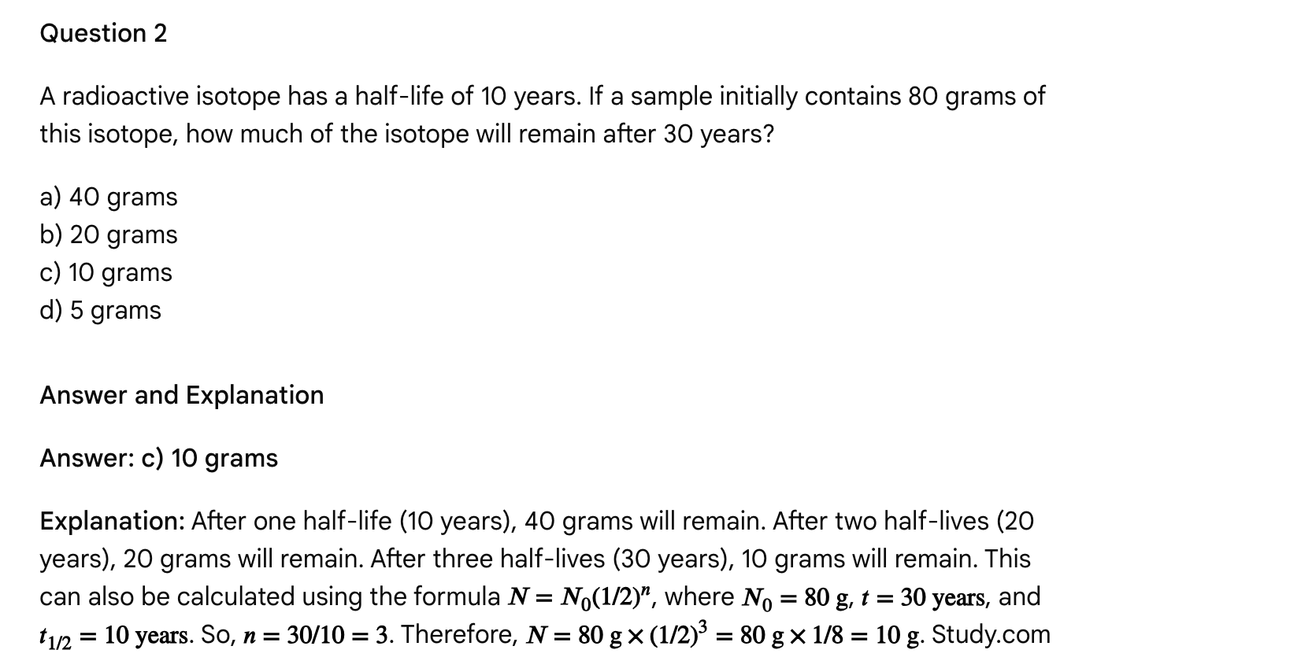** Question 3

Why are gamma rays considered the most penetrating form of radiation?

a) They are highly charged particles.  
b) They are very massive particles.  
c) They are high-energy electromagnetic radiation with no mass or charge.  
d) They have a very short half-life.

Answer and Explanation

**Answer: c) They are high-energy electromagnetic radiation with no mass or charge.**

**Explanation:** Gamma rays are electromagnetic radiation, not particles, and possess no mass or charge. This allows them to penetrate materials much more effectively than alpha or beta particles, which are stopped more readily by matter due to their charge and mass. U.S. Environmental Protection Agency (.gov), Study.com

Question 4

Which factor primarily explains why nuclear reactions release significantly more energy compared to chemical reactions?

a) The involvement of electrons in nuclear reactions.  
b) The breaking of chemical bonds in the nucleus.  
c) The redistribution of nucleons and the associated mass defect.  
d) The lower activation energy of nuclear reactions.

Answer and Explanation

**Answer: c) The redistribution of nucleons and the associated mass defect.**

**Explanation:** Nuclear reactions involve changes within the nucleus itself (redistribution of protons and neutrons, or nucleons), leading to measurable changes in mass (mass defect), which are converted into large amounts of energy according to 𝐸=𝑚𝑐2. Stanford University Chemical reactions, in contrast, involve the rearrangement of electrons and significantly less energy release. Stanford University

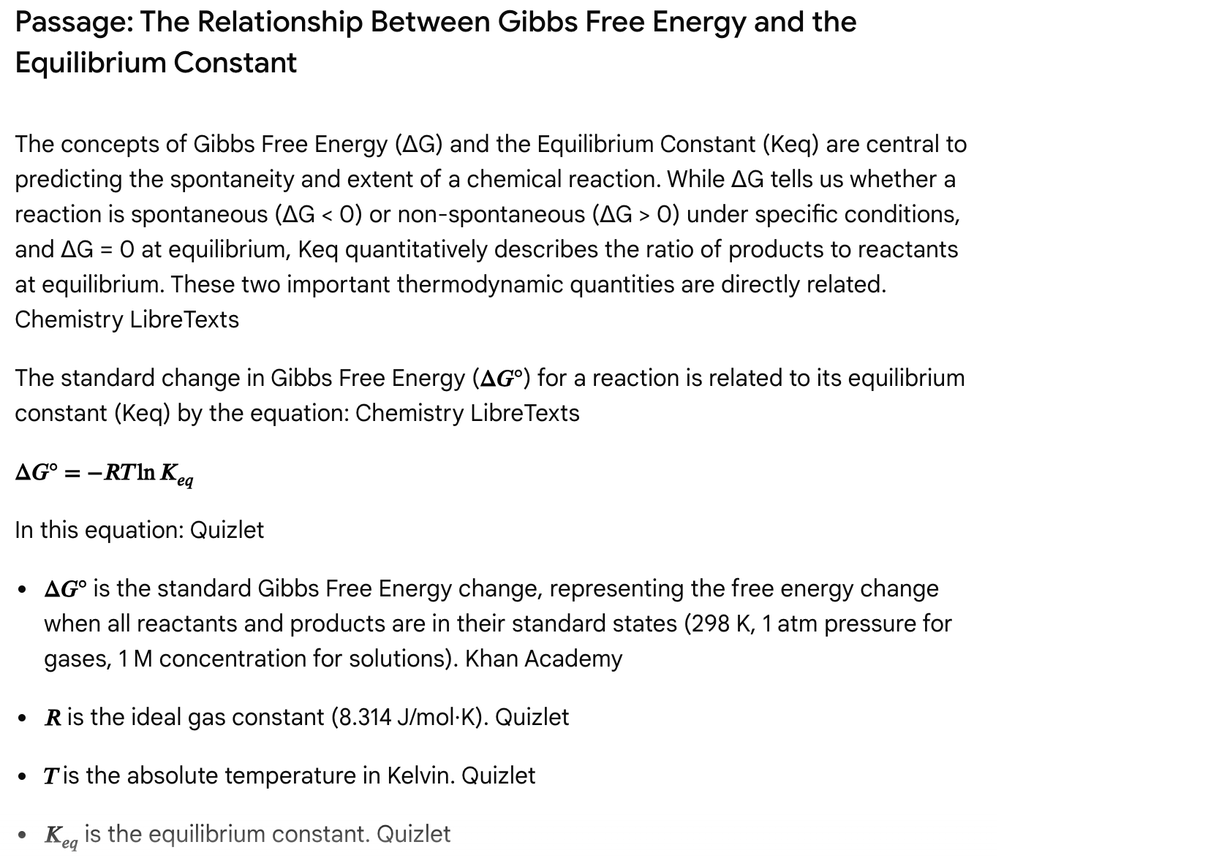

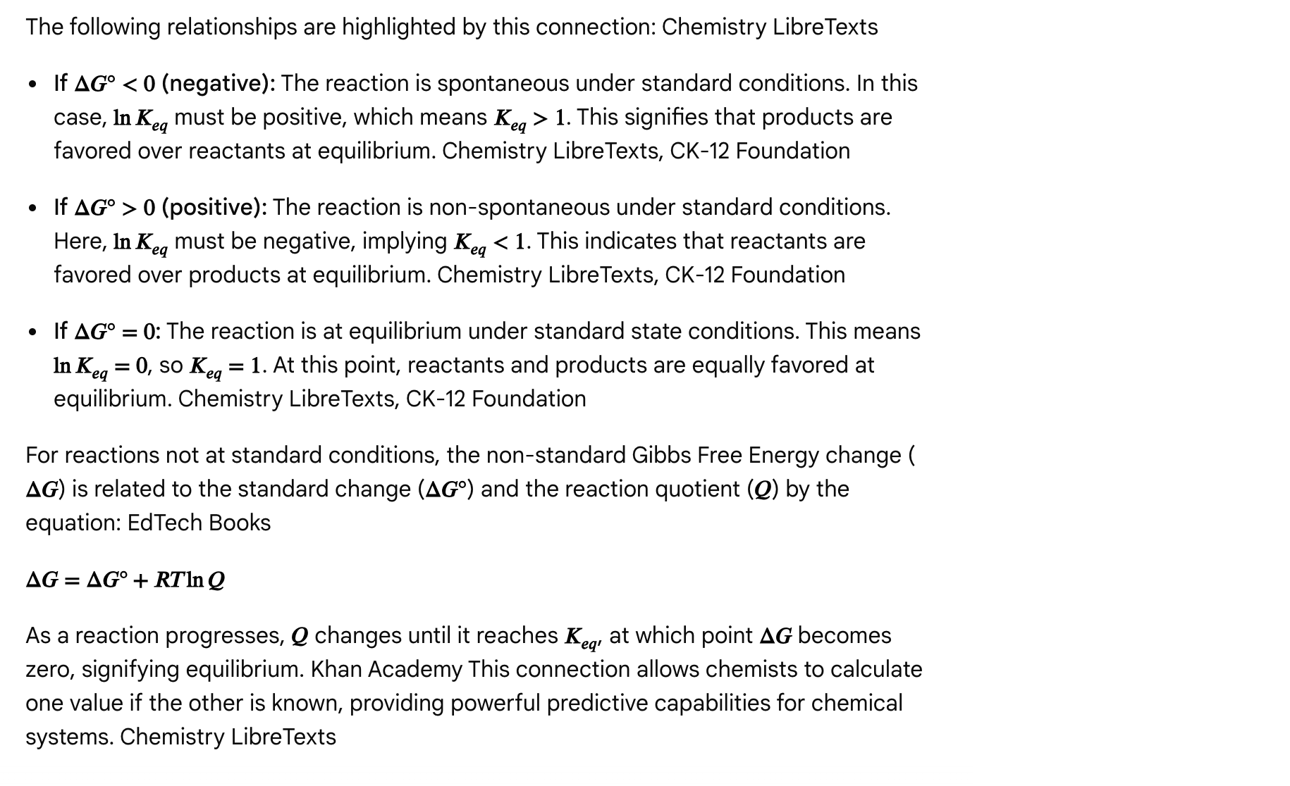

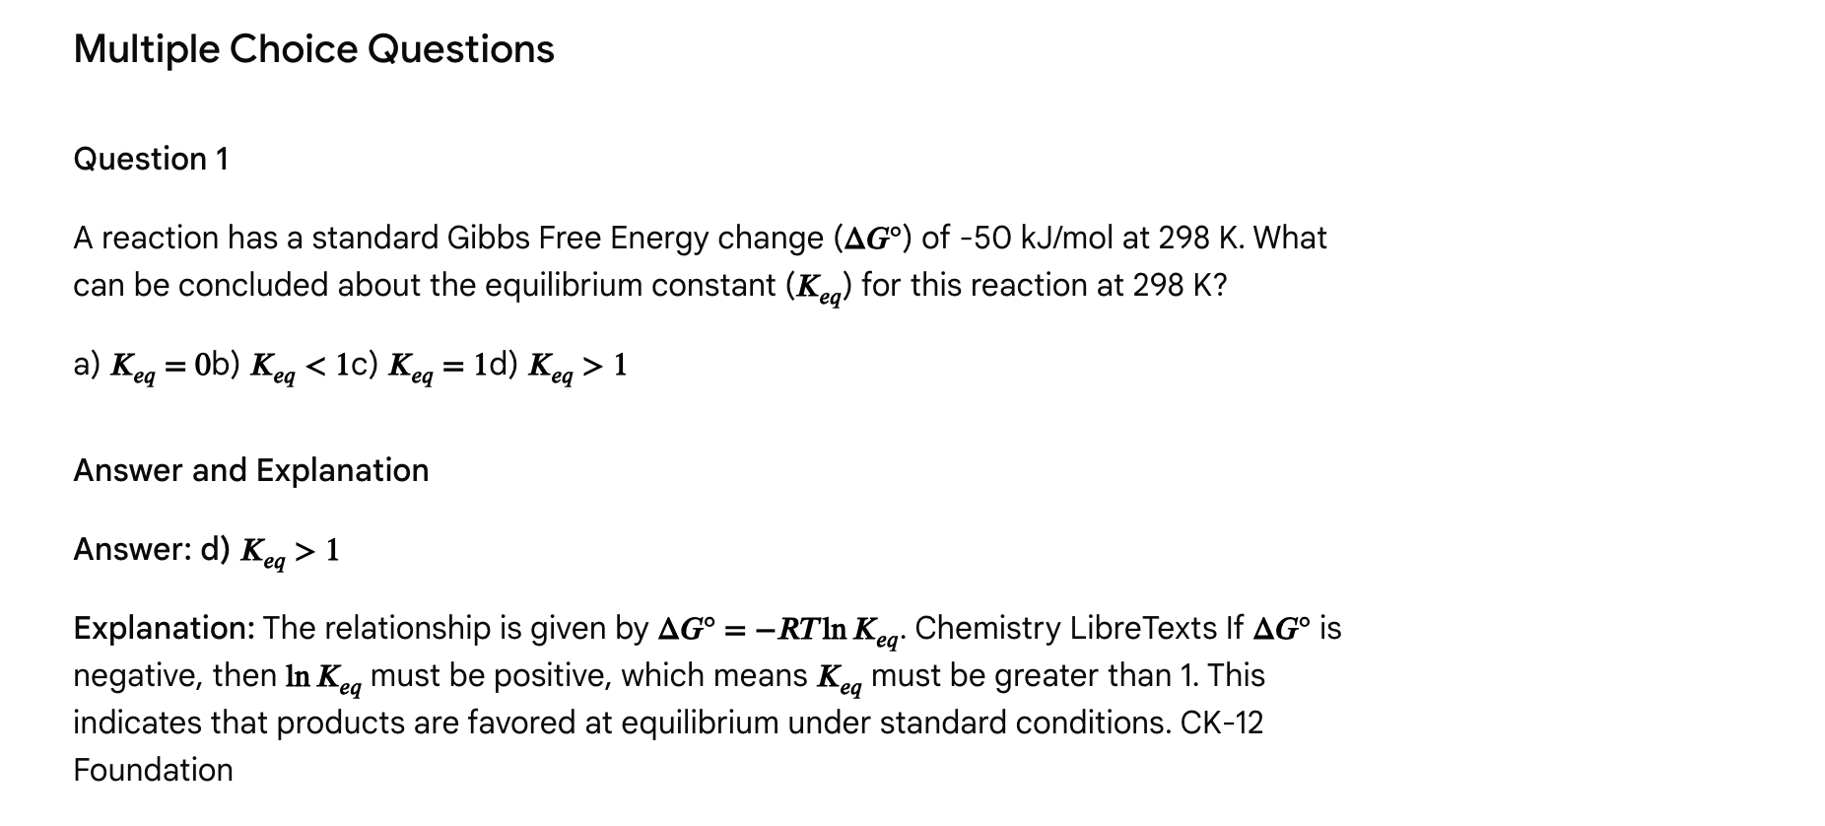

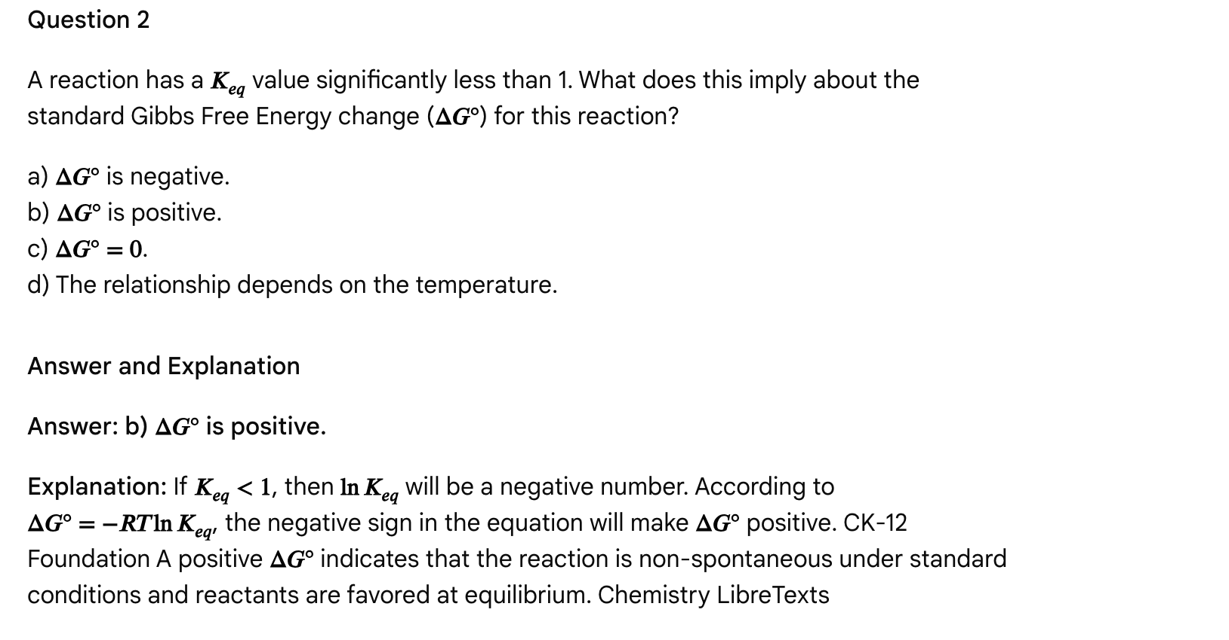

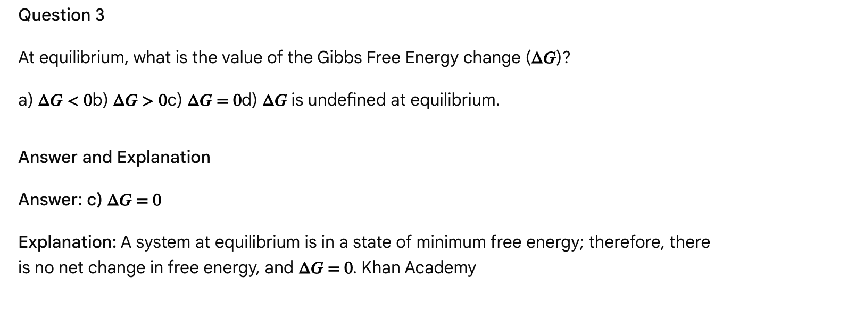

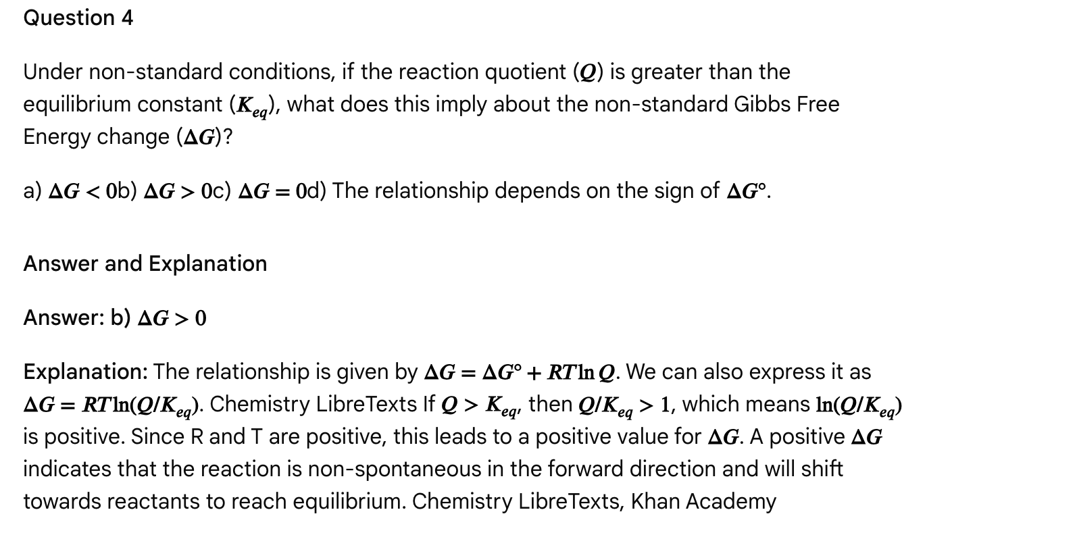

Passage: Acids, Bases, and pH: Defining Acidity and Basicity

Acids and bases are fundamental chemical species whose interactions are central to understanding chemical reactivity and biological systems. The Brønsted-Lowry definition is widely used, characterizing an acid as a proton (H⁺) donor and a base as a proton (H⁺) acceptor. Chemistry LibreTexts When an acid loses a proton, it forms its conjugate base. Similarly, when a base gains a proton, it forms its conjugate acid. Chemistry LibreTexts A stronger acid has a weaker conjugate base, and vice-versa. Chemistry LibreTexts

The strength of an acid or base refers to its extent of dissociation (ionization) in an aqueous solution. Chemistry LibreTexts, GeeksforGeeks

* Strong Acids and Strong Bases dissociate completely (100% ionization) in water. Chemistry LibreTexts This means that in solution, they exist almost entirely as ions. Examples of strong acids include HCl, HBr, HI, HNO3, H2SO4, and HClO4. Examples of strong bases include group 1 hydroxides (like NaOH, KOH) and some group 2 hydroxides (like Ca(OH)2, Ba(OH)2). Chemistry LibreTexts
* Weak Acids and Weak Bases only partially dissociate in water, establishing an equilibrium between the undissociated molecule and its ions. Chemistry LibreTexts Acetic acid (CH3COOH) is a common weak acid, and ammonia (NH3) is a common weak base. Chemistry LibreTexts

The acidity or basicity of a solution is measured by the pH scale, which ranges from 0 to 14. U.S. Environmental Protection Agency (.gov)

* pH < 7: Acidic solution (higher [H⁺]). U.S. Environmental Protection Agency (.gov)
* pH > 7: Basic (alkaline) solution (lower [H⁺], higher [OH⁻]). U.S. Environmental Protection Agency (.gov)
* pH = 7: Neutral solution (pure water at 25°C). U.S. Environmental Protection Agency (.gov)

The pH scale is logarithmic, meaning each whole number change in pH represents a tenfold change in the hydrogen ion concentration. U.S. Environmental Protection Agency (.gov), Khan Academy For example, a solution with pH 3 is ten times more acidic than a solution with pH 4. U.S. Environmental Protection Agency (.gov)

pKa is another important measure related to acid strength, defined as the negative logarithm of the acid dissociation constant (Ka). A lower pKa value indicates a stronger acid. Chemistry Steps Similarly, pKb relates to base strength. For a conjugate acid-base pair, pKa + pKb = 14 (at 25°C). Chemistry LibreTexts

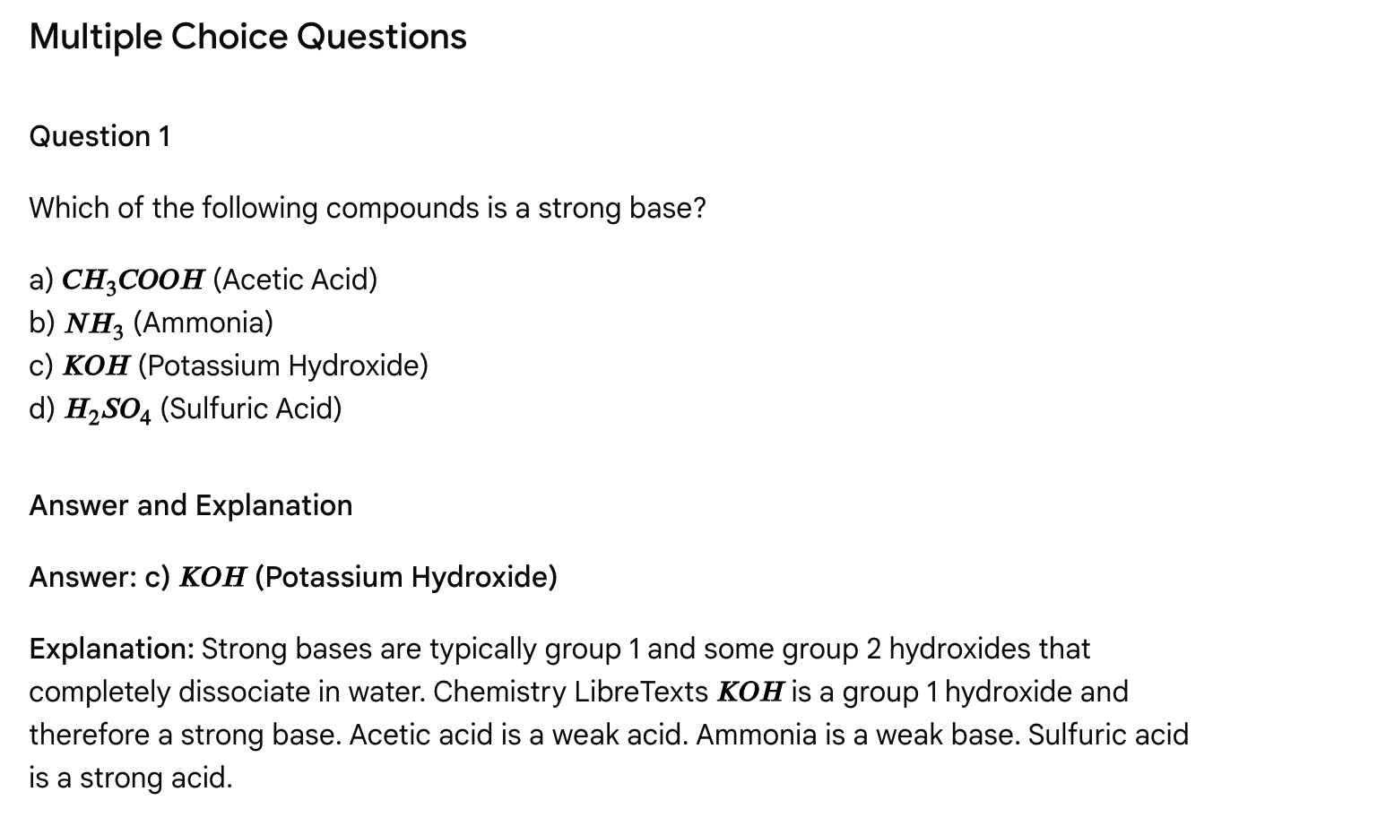

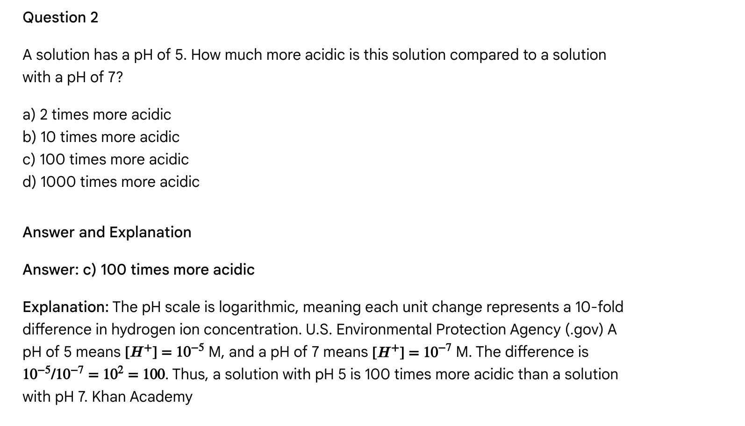

Question 3

Which of the following statements about weak acids is FALSE?

a) They only partially dissociate in water.  
b) They are poor conductors of electricity compared to strong acids.  
c) Their conjugate bases are generally weaker than the conjugate bases of strong acids.  
d) They have a higher pKa compared to strong acids.

Answer and Explanation

Answer: c) Their conjugate bases are generally weaker than the conjugate bases of strong acids.

Explanation: This statement is FALSE. A weak acid has a relatively strong conjugate base. Chemistry LibreTexts Strong acids have very weak (or negligible) conjugate bases. Weak acids partially dissociate, produce fewer ions, and are poorer conductors of electricity. brainly.com, Chemistry LibreTexts They have higher pKa values because they are weaker acids. Chemistry Steps

Question 4

What happens to a Brønsted-Lowry base when it accepts a proton?

a) It becomes more acidic.  
b) It forms its conjugate acid.  
c) Its pH increases.  
d) It dissociates completely.

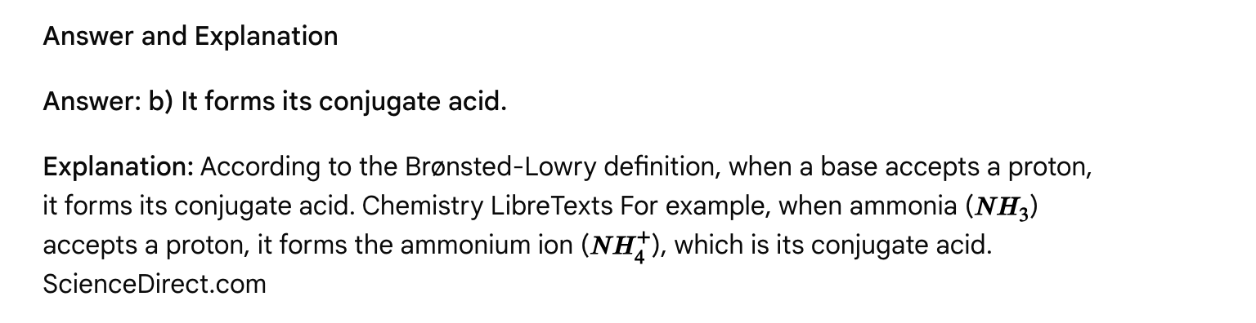

Passage: Buffer Solutions and the Henderson-Hasselbalch Equation: Maintaining pH in Biological Systems

The pH of a solution, a measure of its acidity or basicity, is a critical parameter in chemical and biological systems. Many biological processes, such as enzyme activity and cellular function, are exquisitely sensitive to pH changes. To maintain a relatively stable pH despite the addition of small amounts of acid or base, biological systems and laboratory settings utilize buffer solutions. University of Tennessee, Knoxville, quizlet.com

**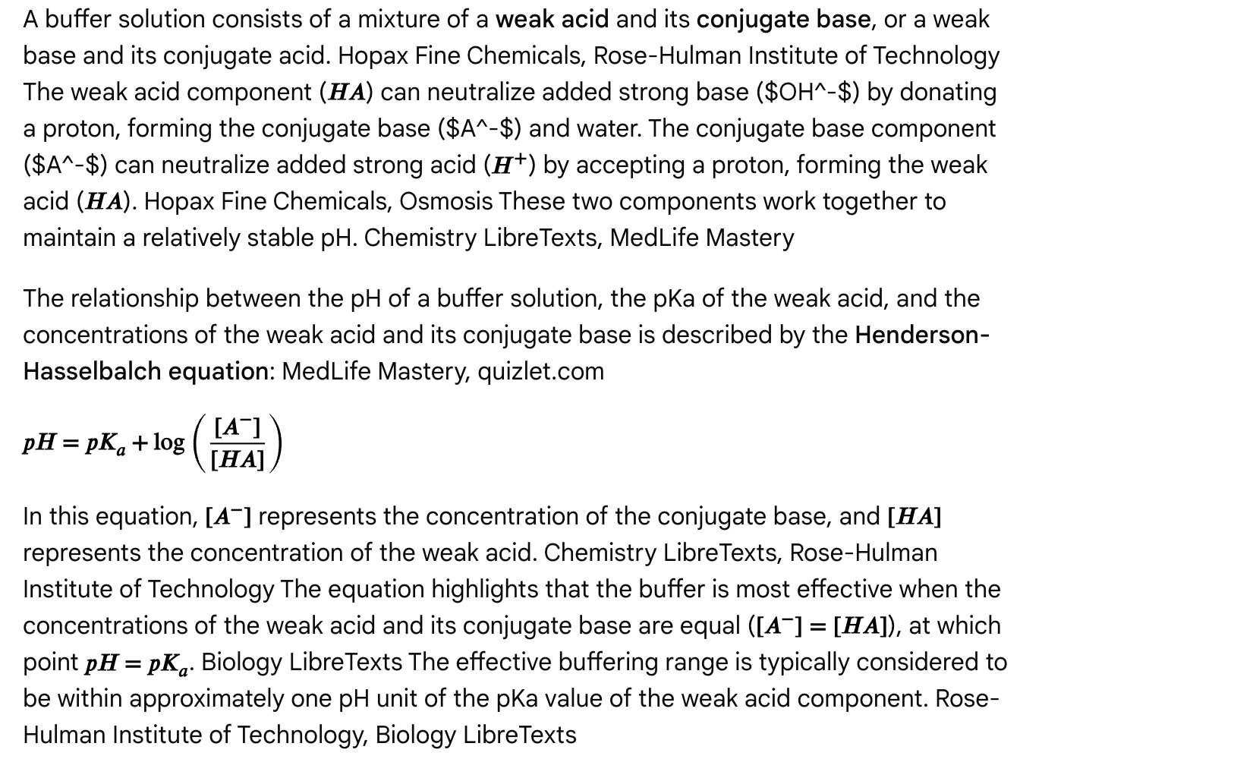**

**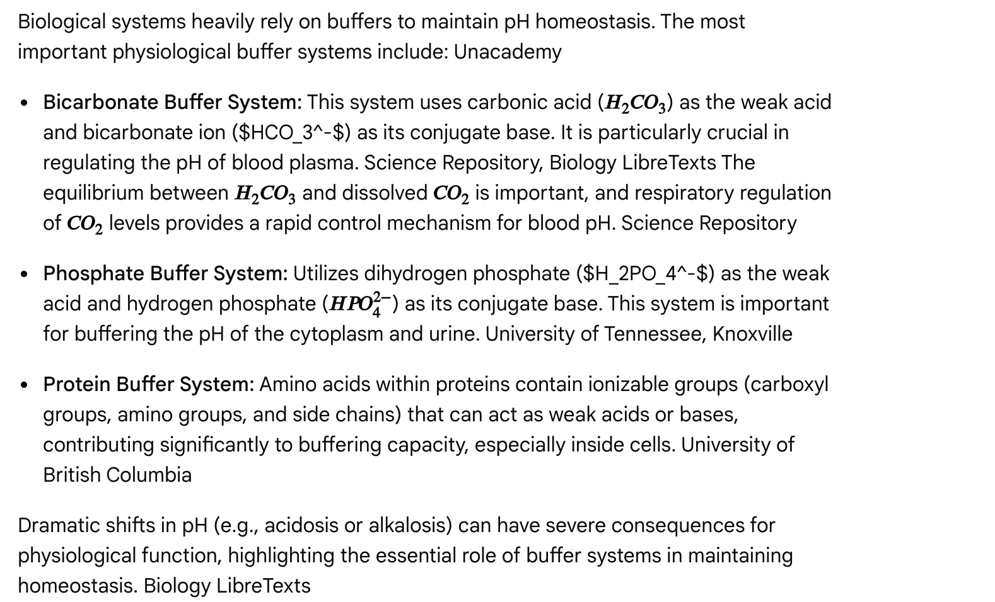**

Multiple Choice Questions

Question 1

A buffer solution is prepared by mixing a weak acid and its conjugate base. According to the Henderson-Hasselbalch equation, when is the buffer most effective at resisting pH changes?

a) When the concentration of the weak acid is much greater than its conjugate base.  
b) When the concentration of the conjugate base is much greater than the weak acid.  
c) When the concentrations of the weak acid and its conjugate base are approximately equal.  
d) When the solution is at pH 7.0.

**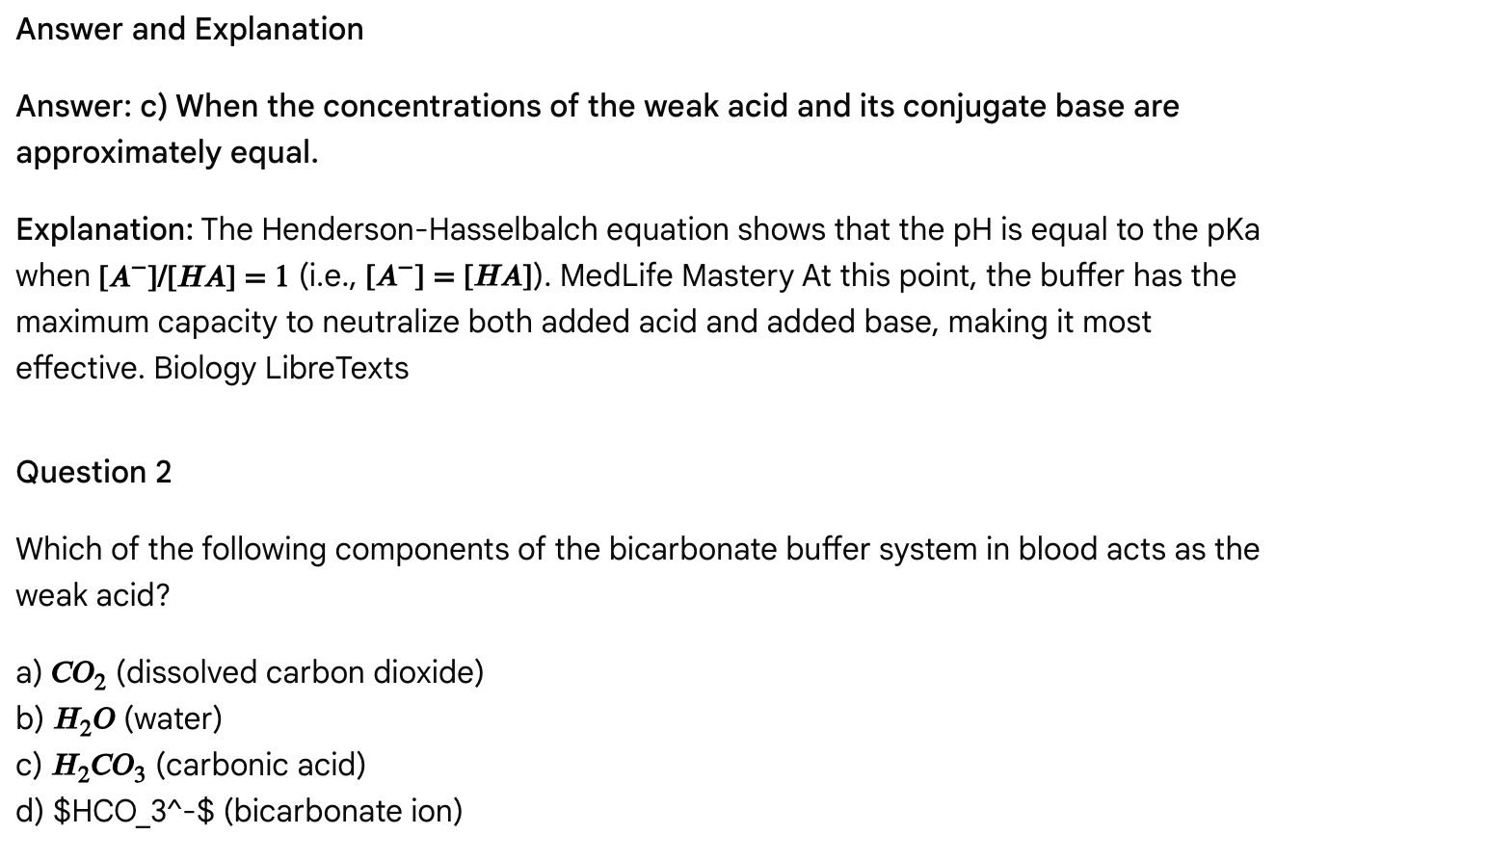**

**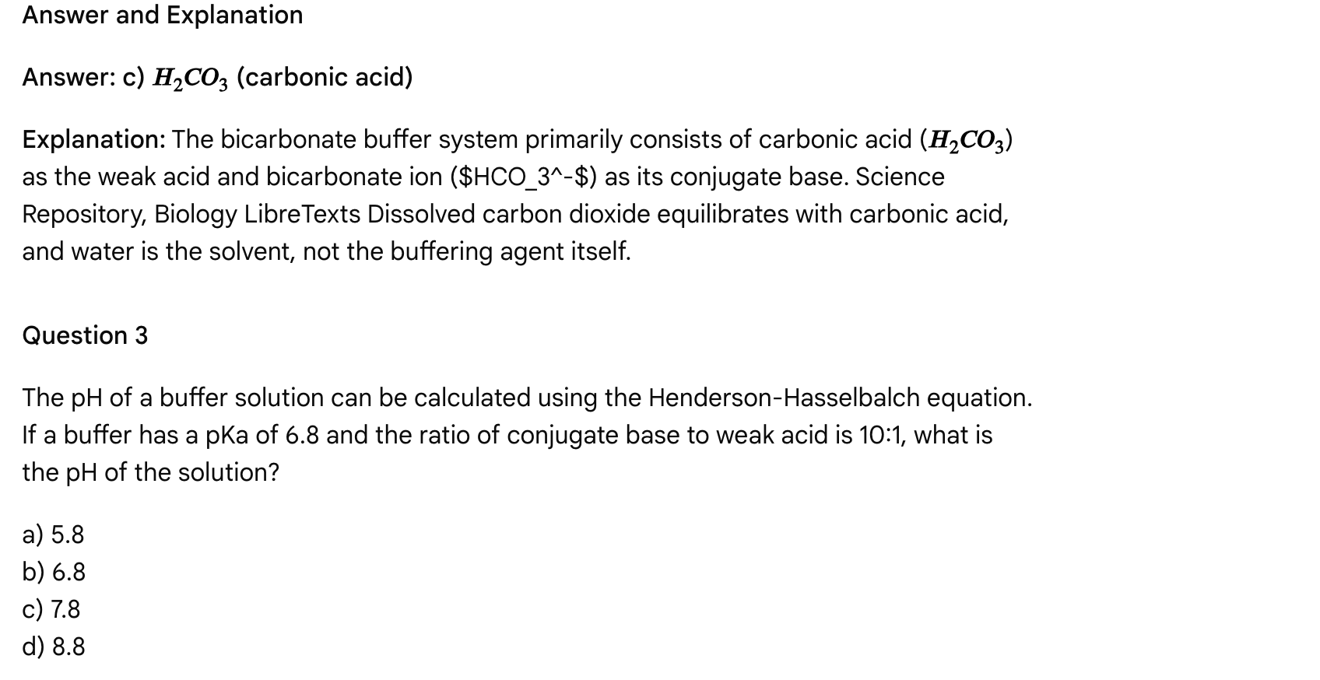**

**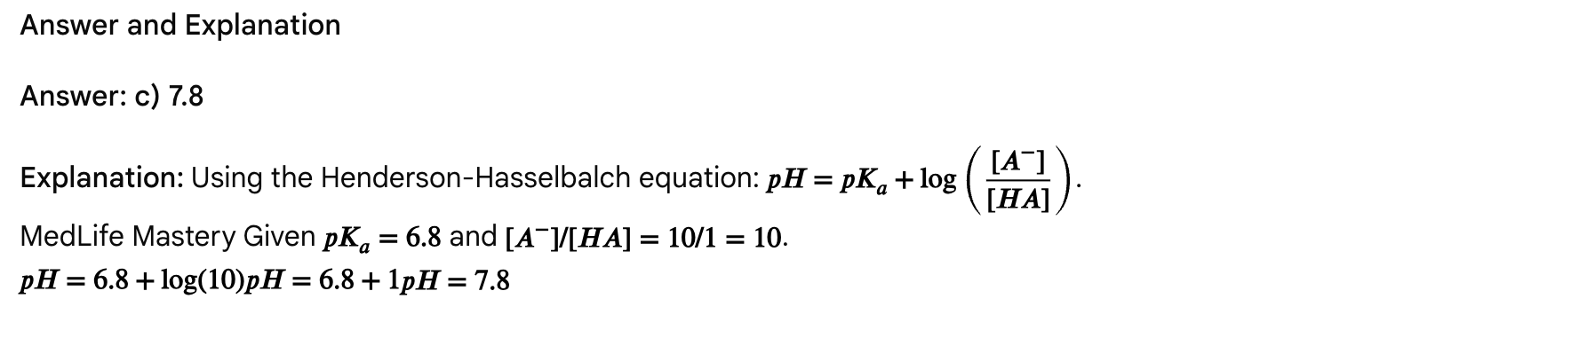**

Question 4

Which of the following statements about the role of buffers in biological systems is FALSE?

a) Buffers help maintain the optimal pH for enzyme activity.  
b) Buffers are primarily found in cell membranes to regulate ion transport.  
c) Buffers play a crucial role in maintaining blood pH homeostasis.  
d) Buffers in the cytoplasm help maintain cellular pH.

Answer and Explanation

Answer: b) Buffers are primarily found in cell membranes to regulate ion transport.

Explanation: While pH can affect membrane permeability and ion transport, buffers are not primarily located *in* cell membranes for this purpose. hubei new desheng materials technology co,. ltd., Unacademy Their main role is to regulate the pH of aqueous biological fluids like blood, cytoplasm, and extracellular fluid. Buffers are essential for maintaining the optimal pH for enzyme function, cellular processes, and overall organismal homeostasis. University of Tennessee, Knoxville, Biology LibreTexts, hubei new desheng materials technology co,. ltd.

Passage: Phase Changes and Heating Curves

Matter can exist in different states, or phases—solid, liquid, and gas—and can transition between these phases under varying conditions of temperature and pressure. Study.com These phase changes are physical processes, meaning that while the arrangement of molecules changes, the chemical identity of the substance remains the same. YouTube The energy associated with these transitions is crucial for understanding the behavior of substances.

Types of Phase Changes

The six common phase changes are: Study.com, www.vaia.com

* Melting (Fusion): Solid to liquid (endothermic, absorbs heat). Study.com
* Freezing: Liquid to solid (exothermic, releases heat). Study.com
* Vaporization (Boiling/Evaporation): Liquid to gas (endothermic, absorbs heat). Study.com
* Condensation: Gas to liquid (exothermic, releases heat). Study.com
* Sublimation: Solid to gas (endothermic, absorbs heat). Study.com
* Deposition: Gas to solid (exothermic, releases heat). Study.com

Heating Curves and Energy Calculations

A heating curve graphically illustrates the temperature changes of a substance as heat is added at a constant rate. Sketchy A typical heating curve shows segments where the temperature increases linearly with added heat and flat regions (plateaus) where the temperature remains constant despite continued heat addition. Sketchy These plateaus correspond to phase changes. brainly.com

**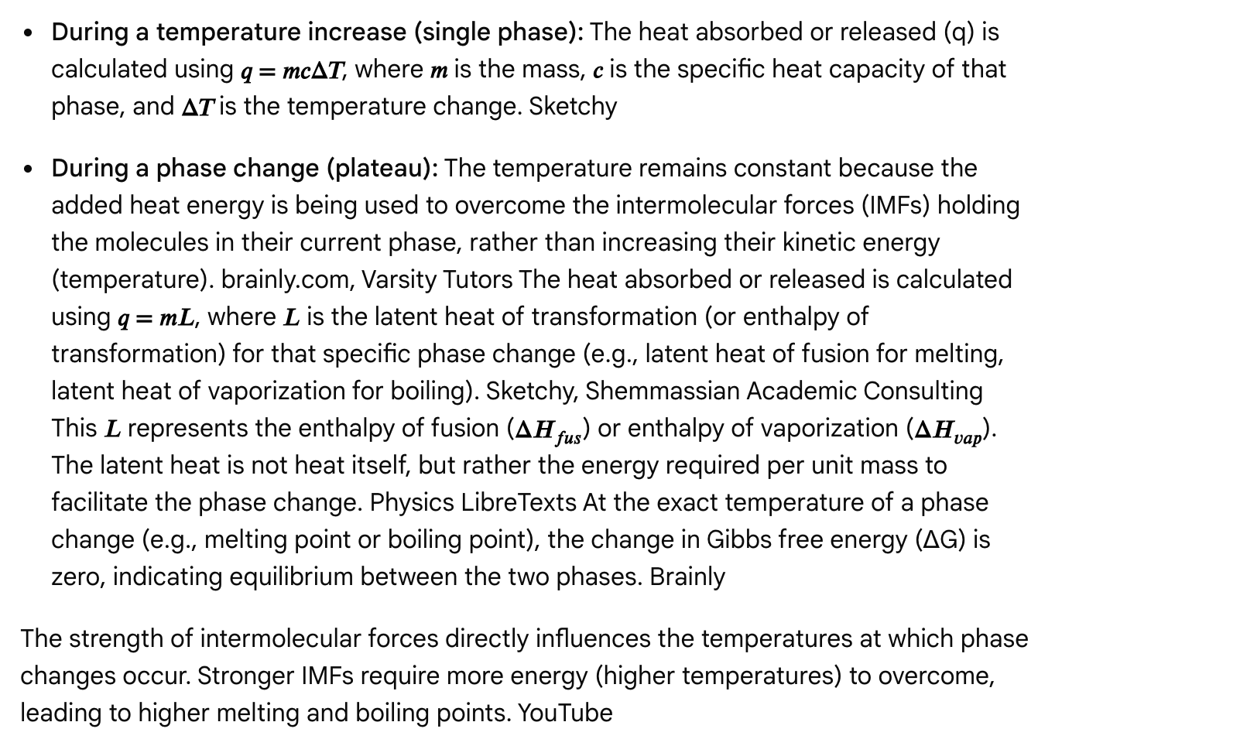**

Multiple Choice Questions

Question 1

On a heating curve, what does a flat plateau represent?

a) The substance is heating up rapidly.  
b) The specific heat capacity of the substance is increasing.  
c) A phase change is occurring at a constant temperature.  
d) The substance is undergoing a chemical reaction.

Answer and Explanation

Answer: c) A phase change is occurring at a constant temperature.

Explanation: During a phase change, the added heat energy is used to break intermolecular forces, not to increase the kinetic energy (temperature) of the molecules. brainly.com, Sketchy Therefore, the temperature remains constant, appearing as a plateau on the heating curve. brainly.com, Sketchy

Question 2

Which of the following processes is exothermic?

a) Melting  
b) Boiling  
c) Sublimation  
d) Condensation

Answer and Explanation

Answer: d) Condensation

Explanation: Exothermic processes release heat. Condensation (gas to liquid) involves the formation of stronger intermolecular forces and the release of energy. Study.com Melting, boiling, and sublimation all require energy input to overcome intermolecular forces and are thus endothermic processes.

Question 3

What is the relationship between intermolecular forces and the melting point of a substance?

a) Stronger intermolecular forces lead to lower melting points.  
b) Stronger intermolecular forces lead to higher melting points.  
c) Intermolecular forces have no effect on melting points.  
d) Melting point is solely determined by molecular weight.

Answer and Explanation

Answer: b) Stronger intermolecular forces lead to higher melting points.

Explanation: Melting involves overcoming the intermolecular forces holding the particles in a rigid solid lattice. Stronger IMFs require more energy (higher temperature) to overcome, resulting in higher melting points. YouTube, Saskoer Molecular weight can play a role (especially for London Dispersion Forces), but IMFs are the direct determinant.

**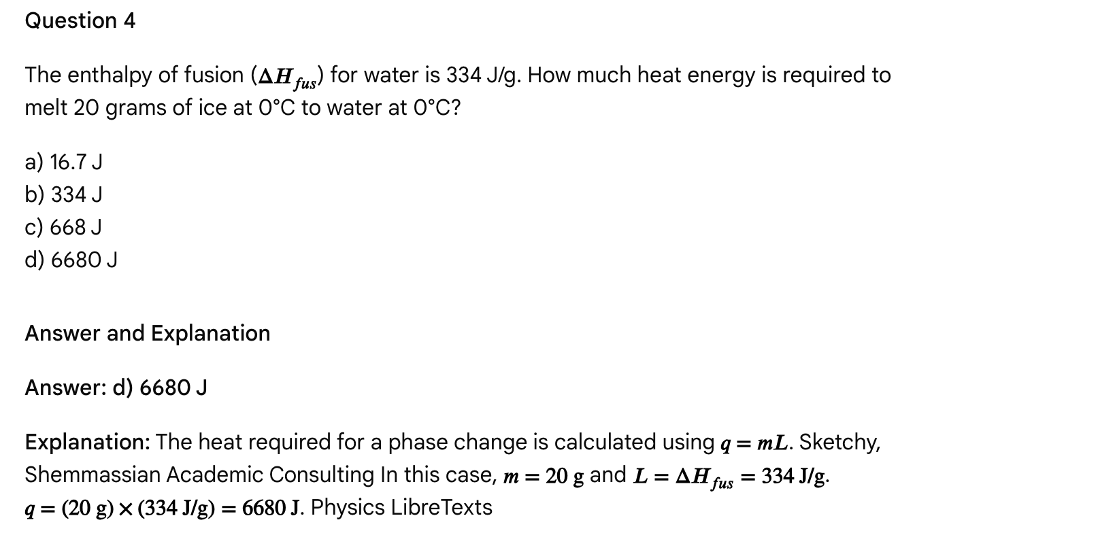**

Passage: Chemical Bonding: Valence Bond Theory, Hybridization, and Molecular Orbital Theory

The arrangement of electrons in atoms and their interactions form the basis of chemical bonding. Two primary theories are used to describe and predict how atoms bond to form molecules: Valence Bond (VB) theory and Molecular Orbital (MO) theory. While both aim to explain molecular structure and stability, they approach the problem from different perspectives and excel in different areas. Chemistry LibreTexts

**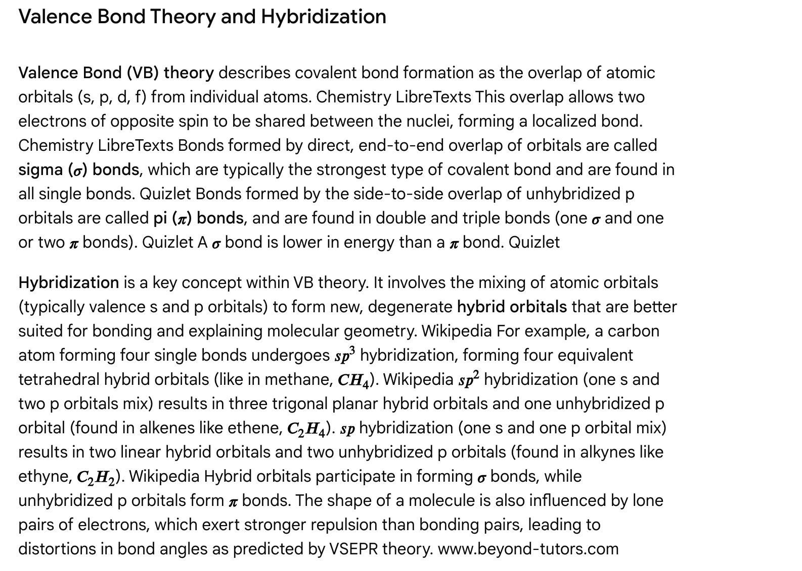**

**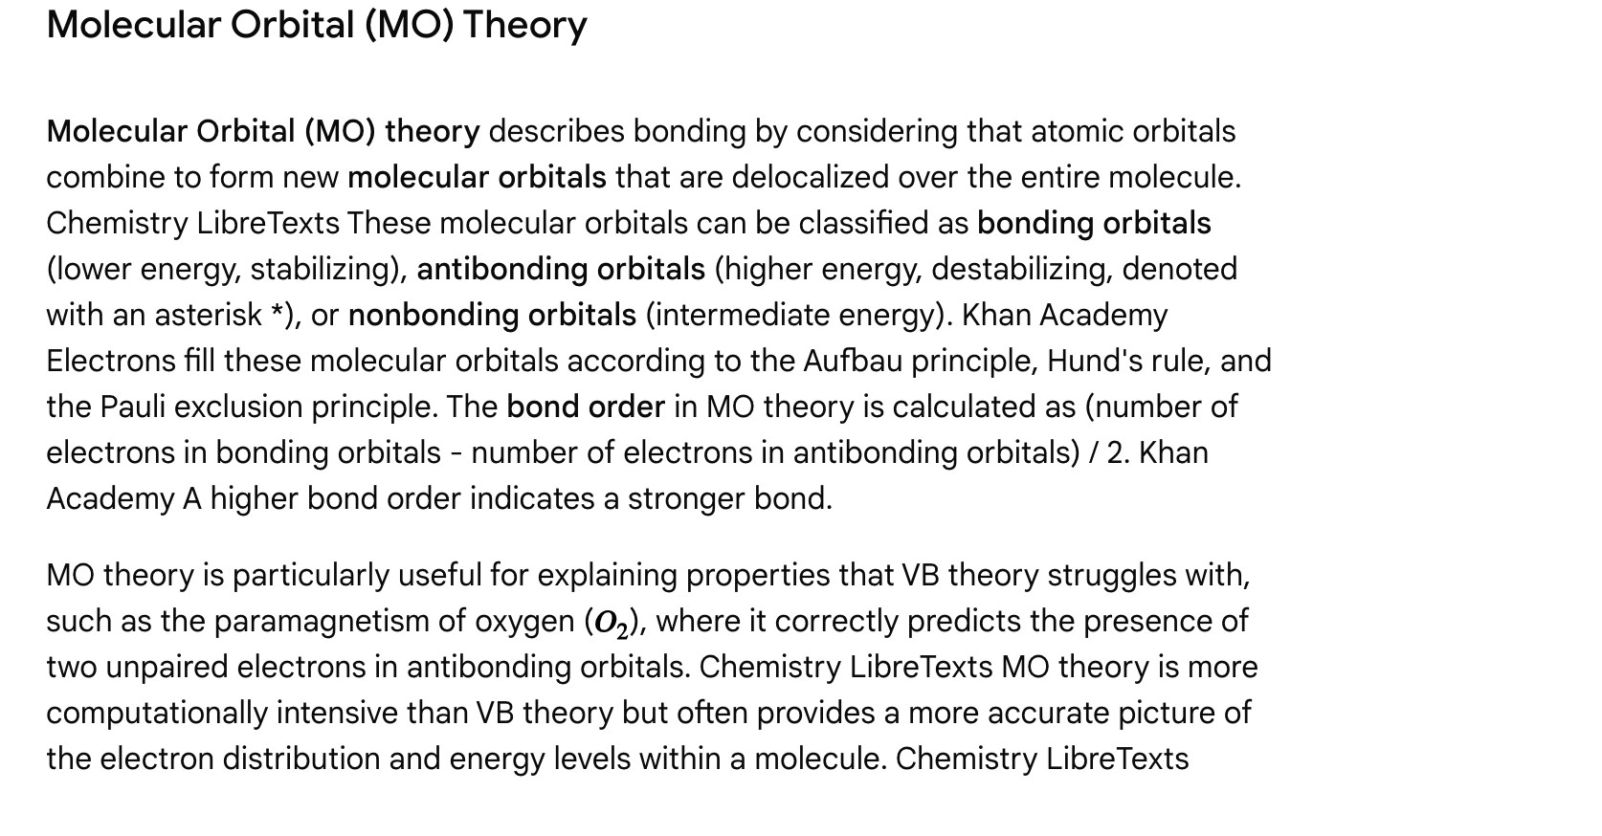**

**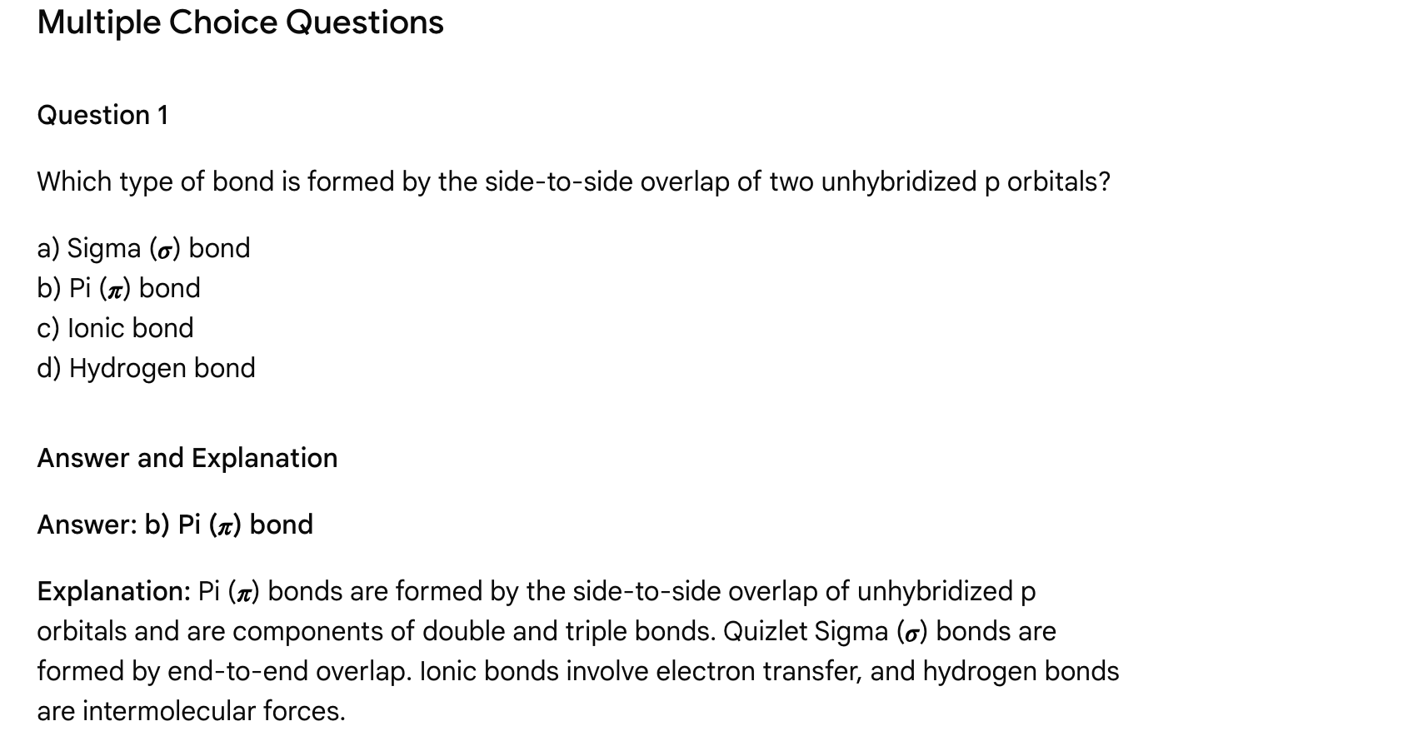**

**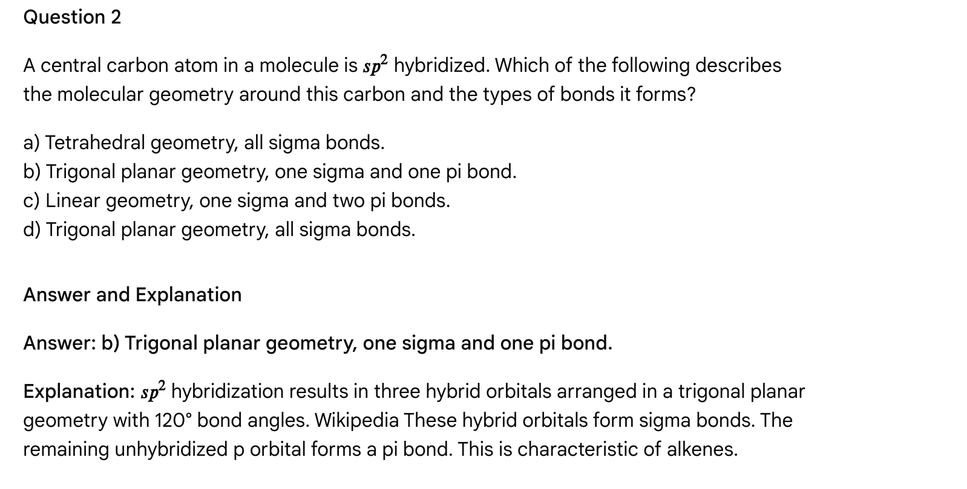**

Question 3

According to Molecular Orbital (MO) theory, what does a positive bond order indicate about a chemical bond?

a) The bond is purely ionic.  
b) The bond is nonpolar.  
c) The bond is unstable and will not form.  
d) The bond is stable and will form.

Answer and Explanation

Answer: d) The bond is stable and will form.

Explanation: In MO theory, a positive bond order (more electrons in bonding orbitals than antibonding orbitals) indicates a net attractive force between the atoms, leading to a stable bond formation. Khan Academy A bond order of zero or negative indicates instability.

**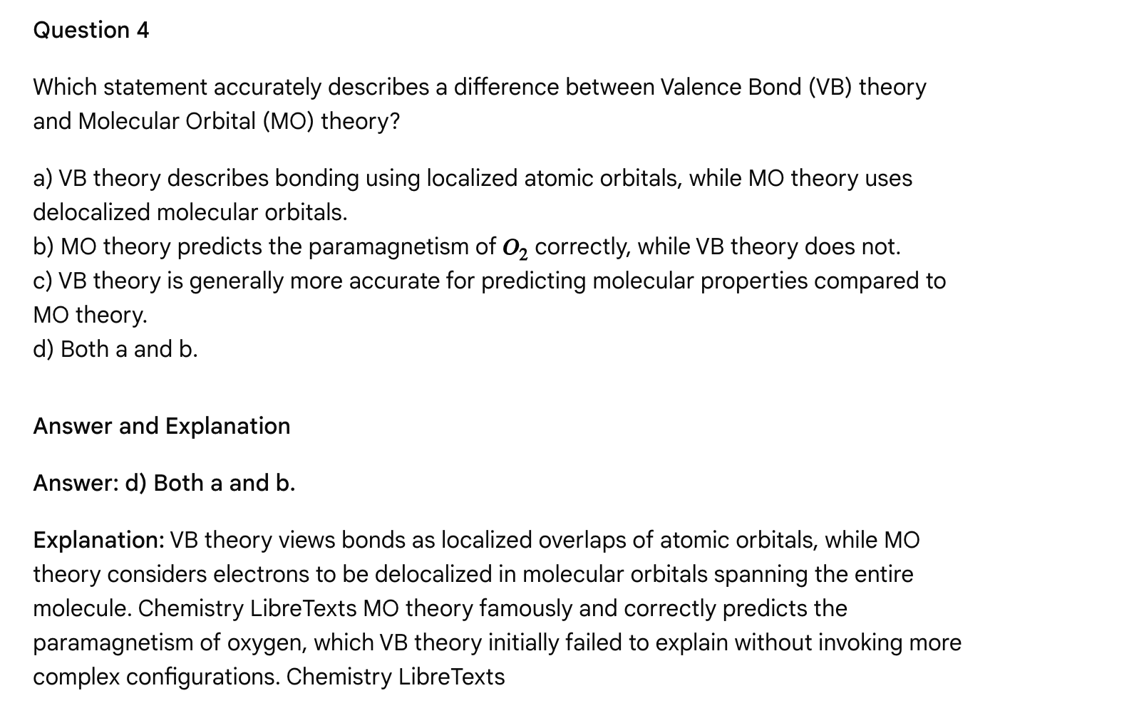**

**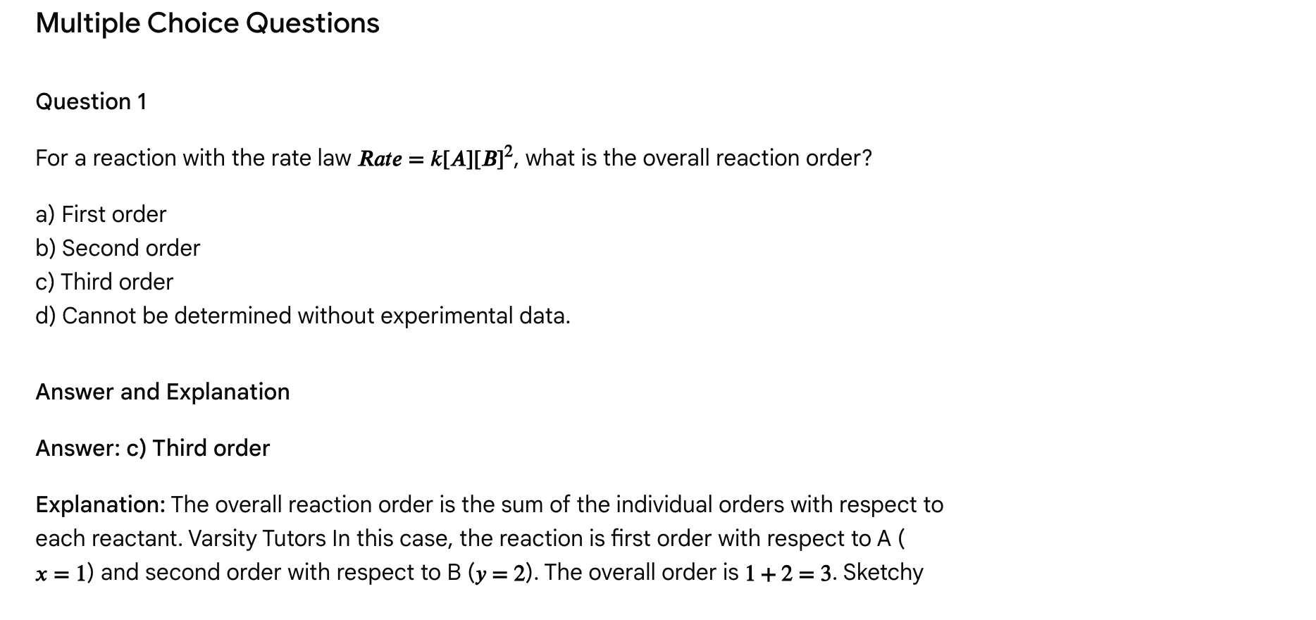**

**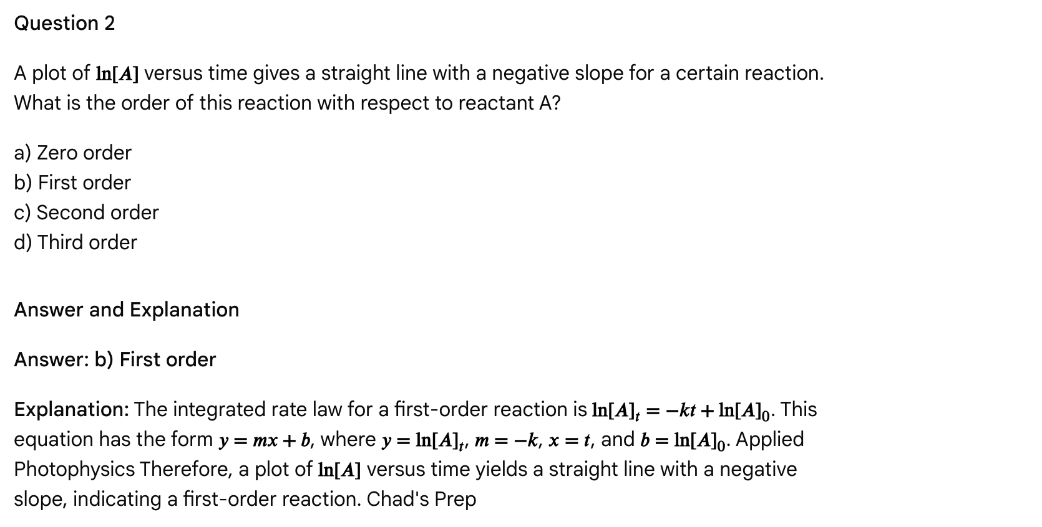**

**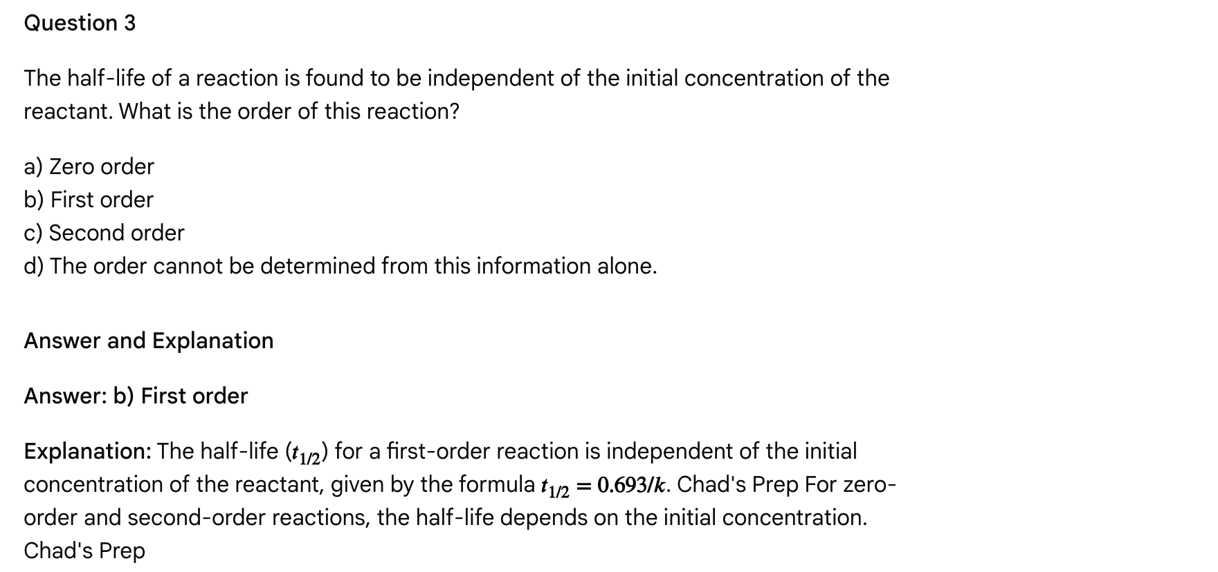**

Question 4

In a multi-step reaction mechanism, which step determines the overall rate law for the reaction?

a) The first step.  
b) The last step.  
c) The step with the lowest activation energy.  
d) The slowest step.

Answer and Explanation

Answer: d) The slowest step.

Explanation: In a multi-step reaction mechanism, the overall rate of the reaction is limited by the rate of the slowest step, which is called the rate-determining step. Varsity Tutors The rate law for the overall reaction often reflects the stoichiometry of the rate-determining step, but this relationship is determined experimentally.

Passage: Reaction Mechanisms and Catalysis

Chemical reactions occur through a series of elementary steps, collectively known as the reaction mechanism. Chemistry LibreTexts Understanding the mechanism provides insights into how reactants transform into products at the molecular level, including the sequence of bond breaking and forming events. Each elementary step is characterized by its molecularity, which is the number of reactant molecules involved in that specific step. Master Organic Chemistry Unimolecular steps involve a single molecule rearranging, while bimolecular steps involve the collision of two molecules. Termolecular steps, involving three molecules colliding simultaneously, are rare due to the low probability of such an event. Master Organic Chemistry

The overall rate of a multi-step reaction is governed by the slowest step in the mechanism, known as the rate-determining step. Varsity Tutors The experimentally determined rate law for the overall reaction is derived from the molecularity of the rate-determining step and any preceding equilibrium steps. The exponents in the rate law (reaction orders) may or may not correspond to the stoichiometric coefficients in the balanced chemical equation, as they reflect the elementary steps involved in the rate-determining step, not necessarily the overall stoichiometry. Khan Academy

**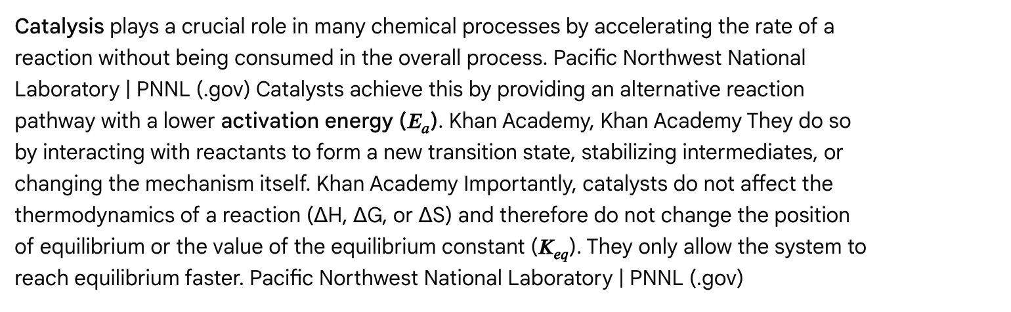**

There are different types of catalysis:

* Homogeneous Catalysis: The catalyst is in the same phase as the reactants. Khan Academy
* Heterogeneous Catalysis: The catalyst is in a different phase from the reactants, often a solid catalyst with gaseous or liquid reactants (e.g., metals in hydrogenation). Khan Academy
* Enzyme Catalysis: Biological systems employ highly specific protein catalysts called enzymes, which often exhibit saturation kinetics. University of California, Berkeley

Multiple Choice Questions

Question 1

What is the term for the slowest step in a reaction mechanism?

a) Initiation step  
b) Propagation step  
c) Termination step  
d) Rate-determining step

Answer and Explanation

Answer: d) Rate-determining step

Explanation: The rate-determining step is the slowest step in a reaction mechanism, and it dictates the overall rate of the reaction. Varsity Tutors, Khan Academy Initiation, propagation, and termination are terms specific to chain reactions (like radical polymerization).

**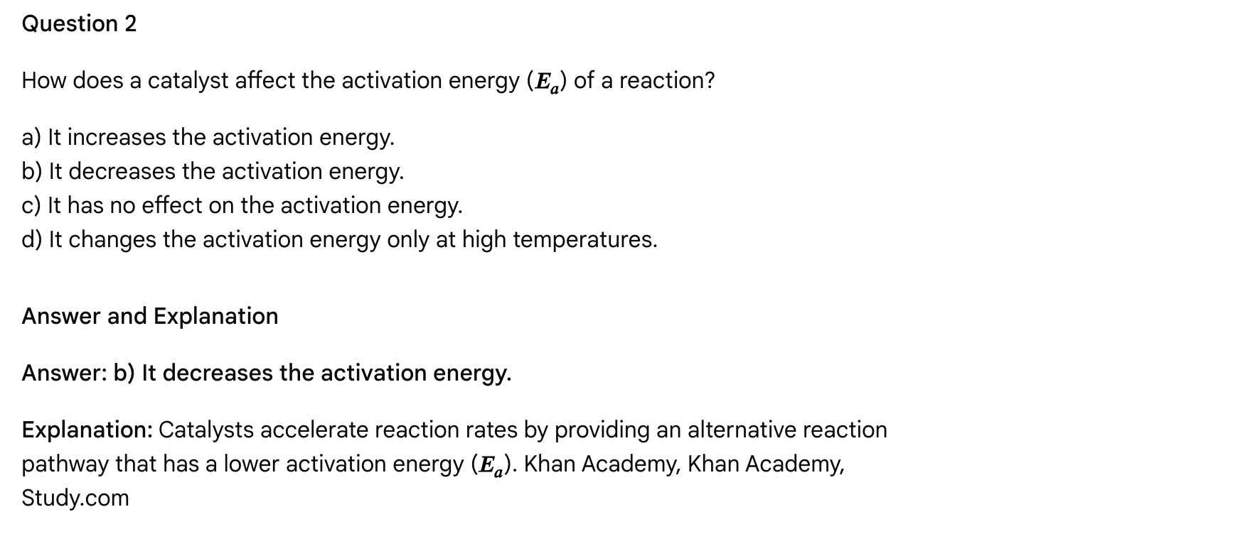**

Question 3

Which of the following statements about catalysts is TRUE?

a) Catalysts are consumed in the overall reaction.  
b) Catalysts shift the equilibrium position of a reversible reaction towards products.  
c) Catalysts increase the rate of both the forward and reverse reactions equally.  
d) Catalysts increase the yield of the desired product.

Answer and Explanation

Answer: c) Catalysts increase the rate of both the forward and reverse reactions equally.

Explanation: Catalysts increase the rates of both the forward and reverse reactions by lowering the activation energy for both processes. The University of Rhode Island, Chemistry LibreTexts They are regenerated and not consumed. They do not affect the equilibrium position, so they don't change the yield of products at equilibrium, although they help reach that yield faster. Pacific Northwest National Laboratory | PNNL (.gov)

Question 4

What is the molecularity of an elementary reaction step where two reactant molecules collide to form products?

a) Unimolecular  
b) Bimolecular  
c) Termolecular  
d) Cannot be determined without knowing the rate law.

Answer and Explanation

Answer: b) Bimolecular

Explanation: Molecularity refers to the number of reactant molecules participating in an elementary step. Master Organic Chemistry If two molecules collide, the step is bimolecular. Master Organic Chemistry Unimolecular involves one molecule, and termolecular involves three (rare). The rate law for an elementary step directly reflects its molecularity. Varsity Tutors

Multiple Choice Questions

Question 1

Which of the following defines a buffer solution?

a) A solution that completely neutralizes any added acid or base.  
b) A solution containing a strong acid and its conjugate base.  
c) A solution that resists changes in pH upon addition of small amounts of acid or base.  
d) A solution with a pH of exactly 7.0.

Answer and Explanation

Answer: c) A solution that resists changes in pH upon addition of small amounts of acid or base.

Explanation: A buffer solution's defining characteristic is its ability to minimize pH fluctuations when small quantities of strong acids or bases are added. University of Tennessee, Knoxville They do not completely neutralize large amounts of added acid or base, and are composed of weak acid/conjugate base pairs. Chemistry LibreTexts While a buffer can be at pH 7, that is not its defining characteristic.

**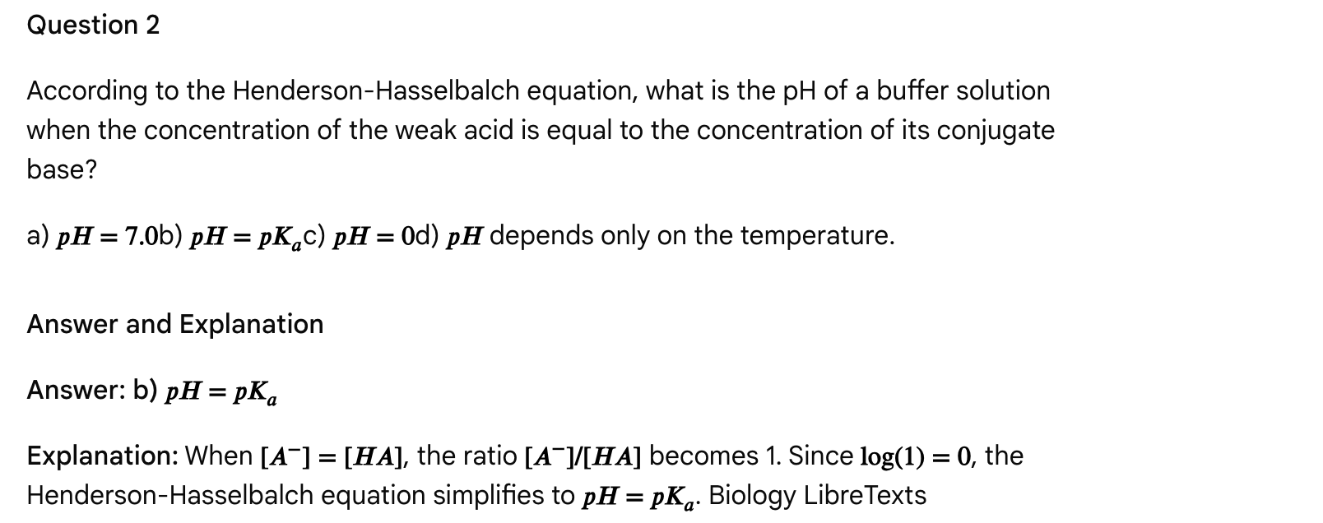**

Question 3

Which of the following best describes the bicarbonate buffer system's role in maintaining blood plasma pH?

a) It primarily neutralizes base added to the blood.  
b) It removes excess oxygen from the blood.  
c) It utilizes carbonic acid as the weak acid and bicarbonate ion as the conjugate base.  
d) It functions independently of the respiratory system.

Answer and Explanation

Answer: c) It utilizes carbonic acid as the weak acid and bicarbonate ion as the conjugate base.

**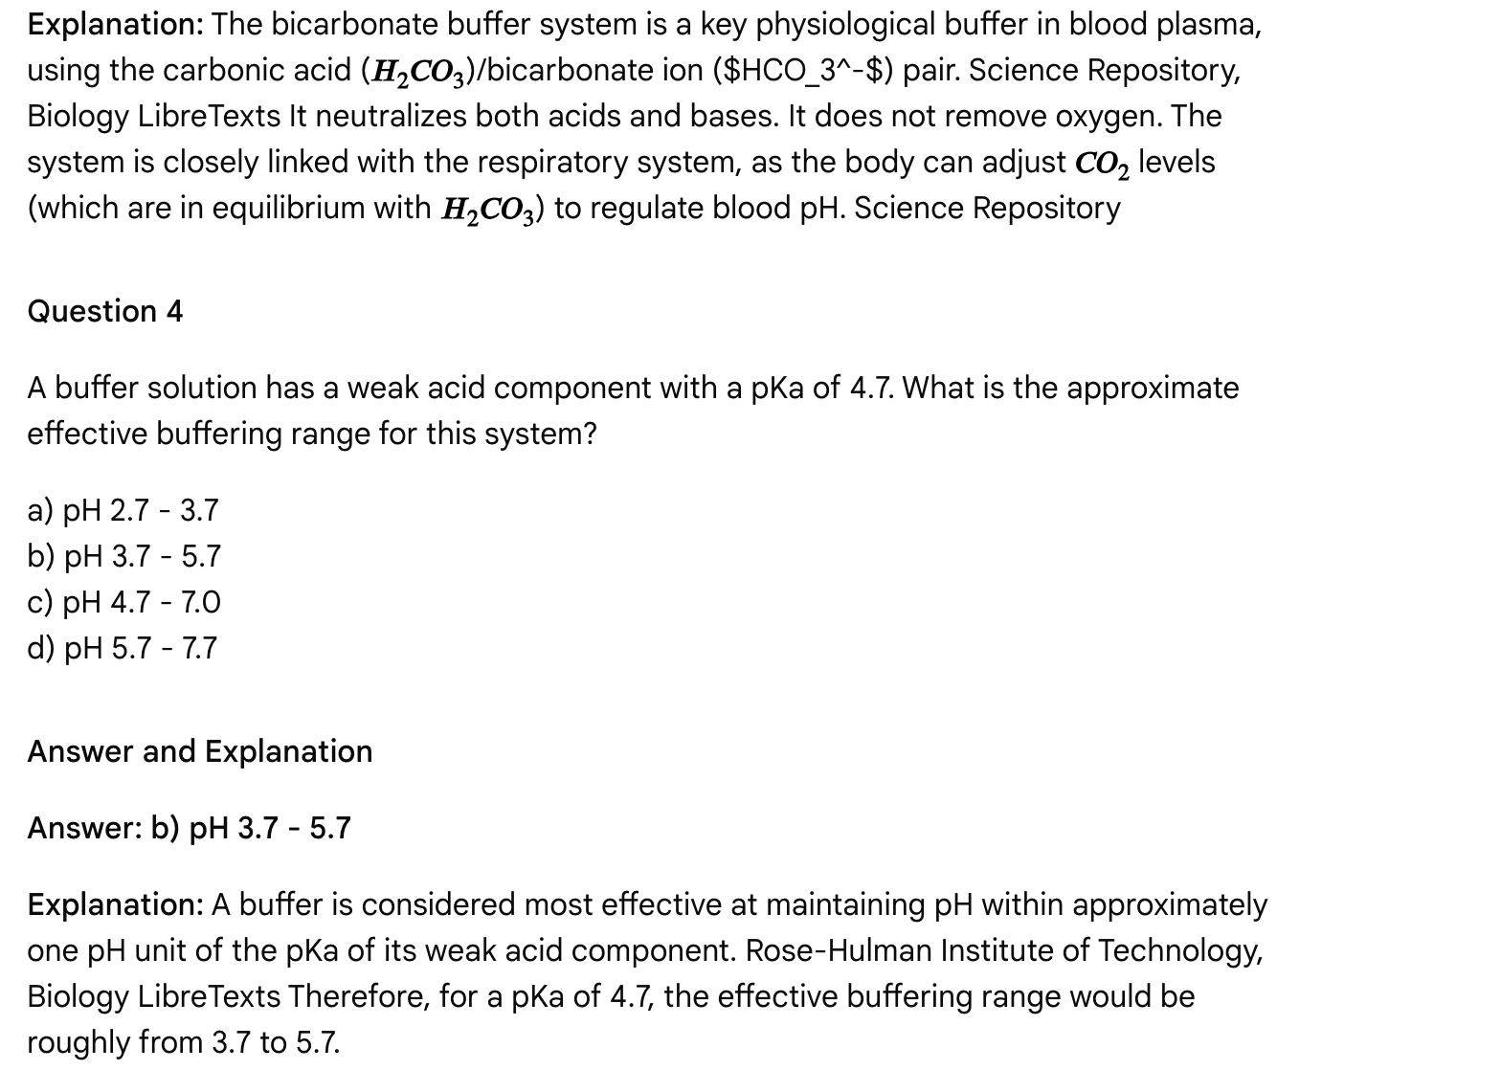**

Passage: Quantum Mechanics and Atomic Structure

The classical model of the atom, which depicted electrons orbiting the nucleus like planets around a sun (Bohr model), failed to explain many observed phenomena, such as the stability of atoms, the details of atomic spectra, and the wave-particle duality of matter. ScienceDaily This led to the development of quantum mechanics, a more sophisticated model that describes the behavior of electrons and other particles at the atomic and subatomic level. ResearchGate

In the quantum mechanical model, the exact path of an electron cannot be determined. Instead, electrons are described by wave functions that define atomic orbitals, which are regions of space where there is a high probability of finding an electron. Physics Forums Each electron in an atom is characterized by a unique set of four quantum numbers: Lumen Learning

* 1. Principal Quantum Number (n): Describes the electron's energy level (shell) and its distance from the nucleus. Higher 'n' values correspond to higher energy and larger orbitals. Lumen Learning
  2. Azimuthal (Angular Momentum) Quantum Number (l): Defines the shape of the orbital (subshell) and the number of angular nodes. Values range from 0 to n-1. Lumen Learning
     + l = 0 corresponds to an s orbital (spherical shape).
     + l = 1 corresponds to a p orbital (dumbbell shape).
     + l = 2 corresponds to a d orbital (more complex shapes).

**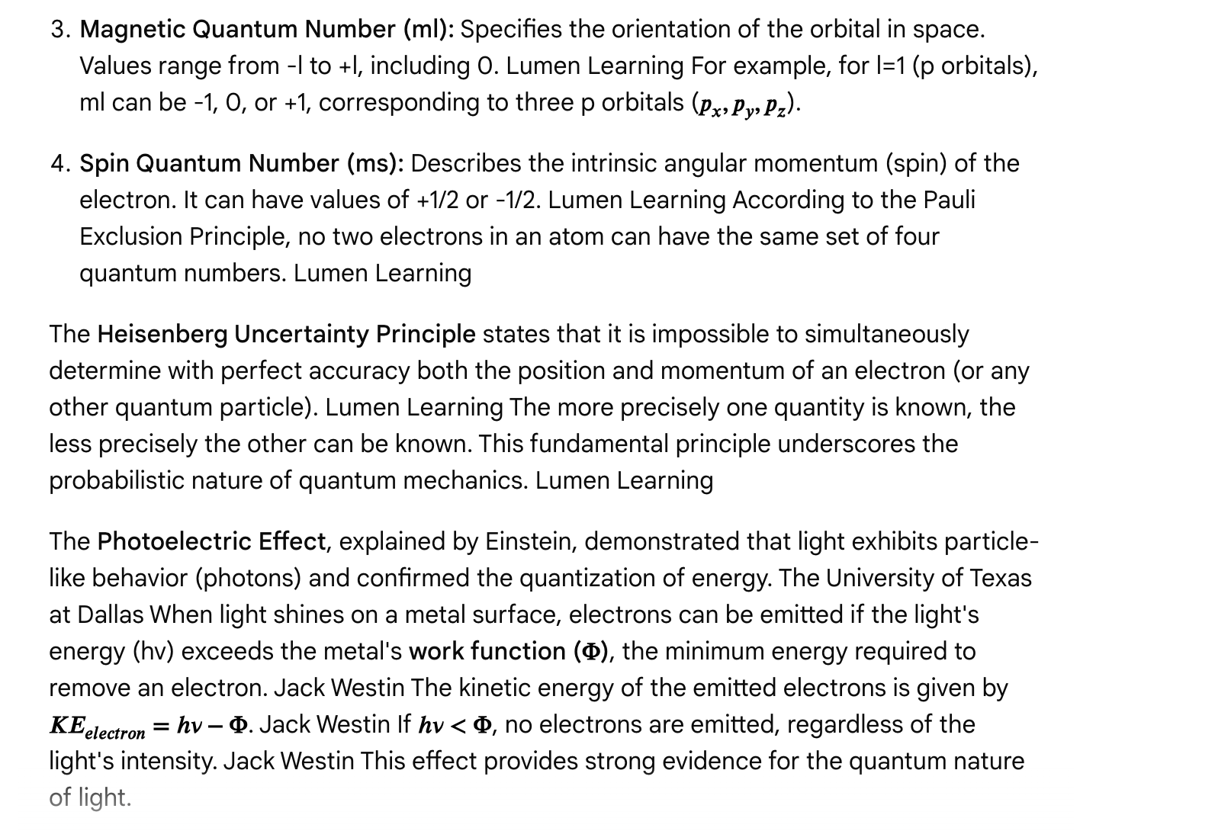**

Quantum mechanics also explains atomic spectra, the unique pattern of light absorbed or emitted by an element. Electrons can only occupy discrete energy levels within an atom. When an electron transitions between these energy levels, it absorbs or emits a photon with an energy corresponding to the energy difference between the levels. The University of Texas at Dallas

Multiple Choice Questions

Question 1

Which of the following quantum numbers describes the shape of an atomic orbital?

a) Principal quantum number (n)  
b) Azimuthal quantum number (l)  
c) Magnetic quantum number (ml)  
d) Spin quantum number (ms)

Answer and Explanation

Answer: b) Azimuthal quantum number (l)

Explanation: The azimuthal (or angular momentum) quantum number (l) dictates the shape of the orbital. Lumen Learning For example, l=0 corresponds to a spherical s orbital, and l=1 corresponds to a dumbbell-shaped p orbital. The principal quantum number relates to energy and size, the magnetic quantum number to orientation, and the spin quantum number to electron spin.

Question 2

According to the Heisenberg Uncertainty Principle, which two properties of an electron cannot be simultaneously determined with perfect accuracy?

a) Energy and mass.  
b) Position and momentum.  
c) Charge and spin.  
d) Wavelength and frequency.

Answer and Explanation

Answer: b) Position and momentum.

Explanation: The Heisenberg Uncertainty Principle states that there is an inherent limit to the precision with which certain pairs of physical properties, such as position and momentum, of a particle can be known simultaneously. Lumen Learning

**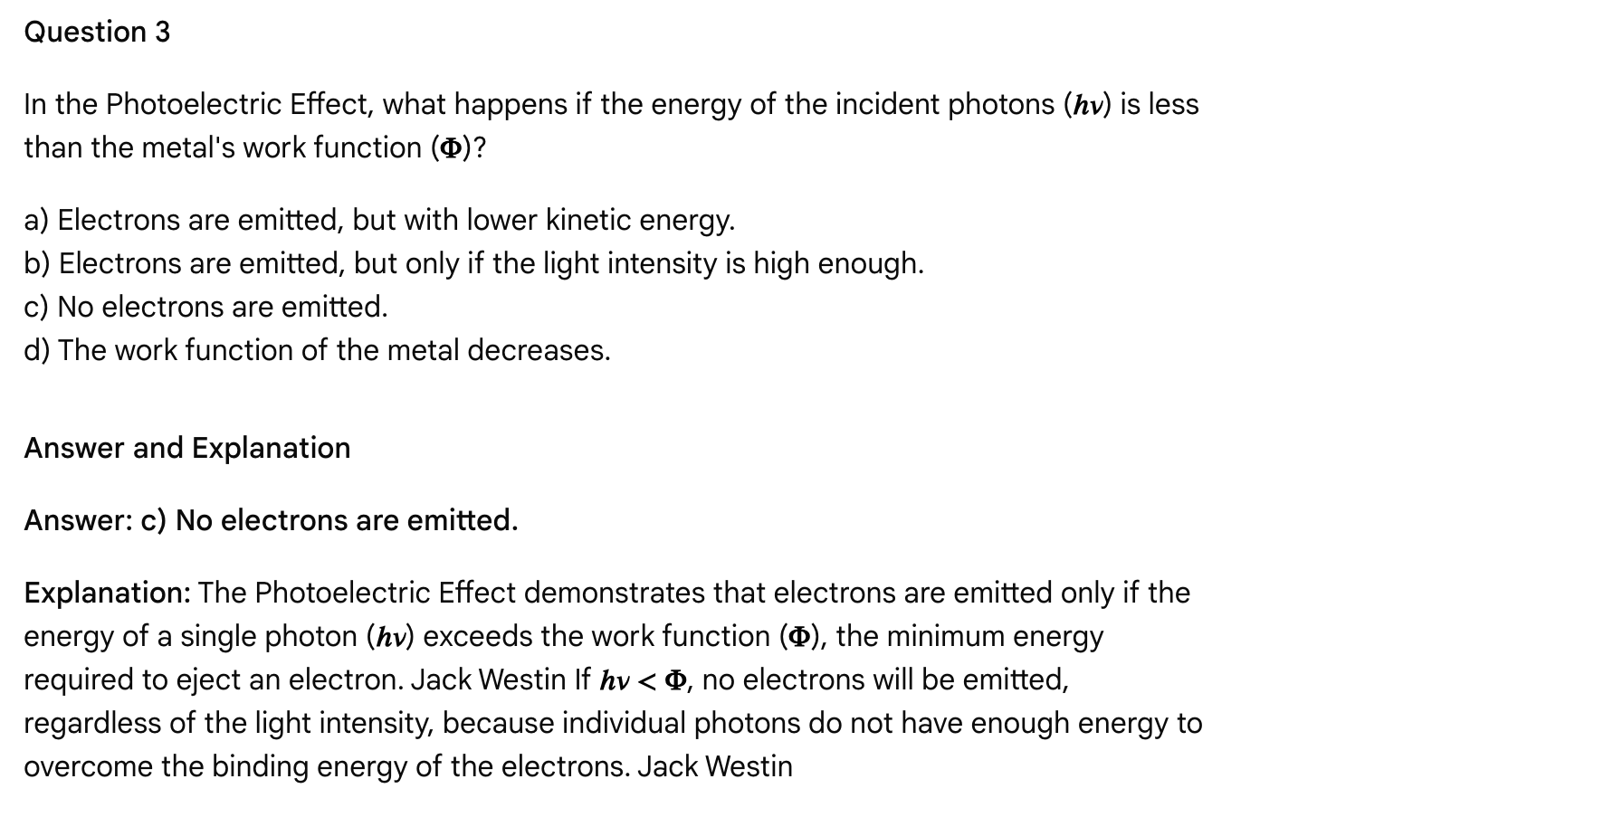**

**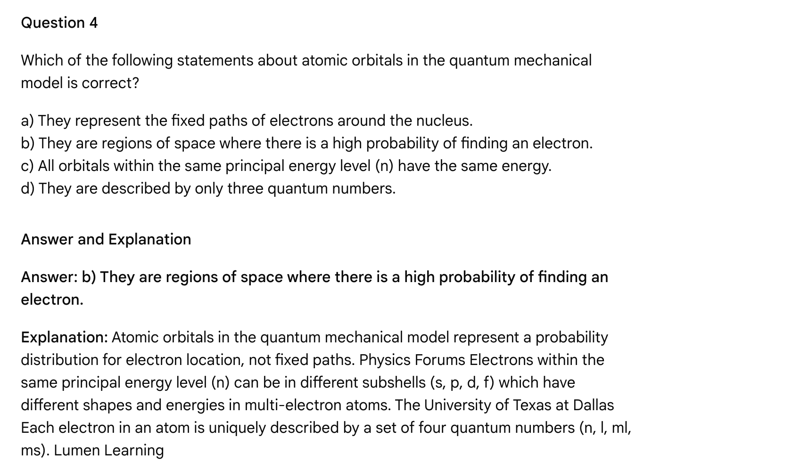**

High-yield general chemistry MCAT passage: Thermochemistry and Equilibrium

Passage

Many biochemical reactions are reversible, and their direction and extent are influenced by various factors, including temperature, concentration of reactants and products, and pressure. Understanding the principles of chemical equilibrium and thermochemistry is crucial for comprehending these biological processes.

**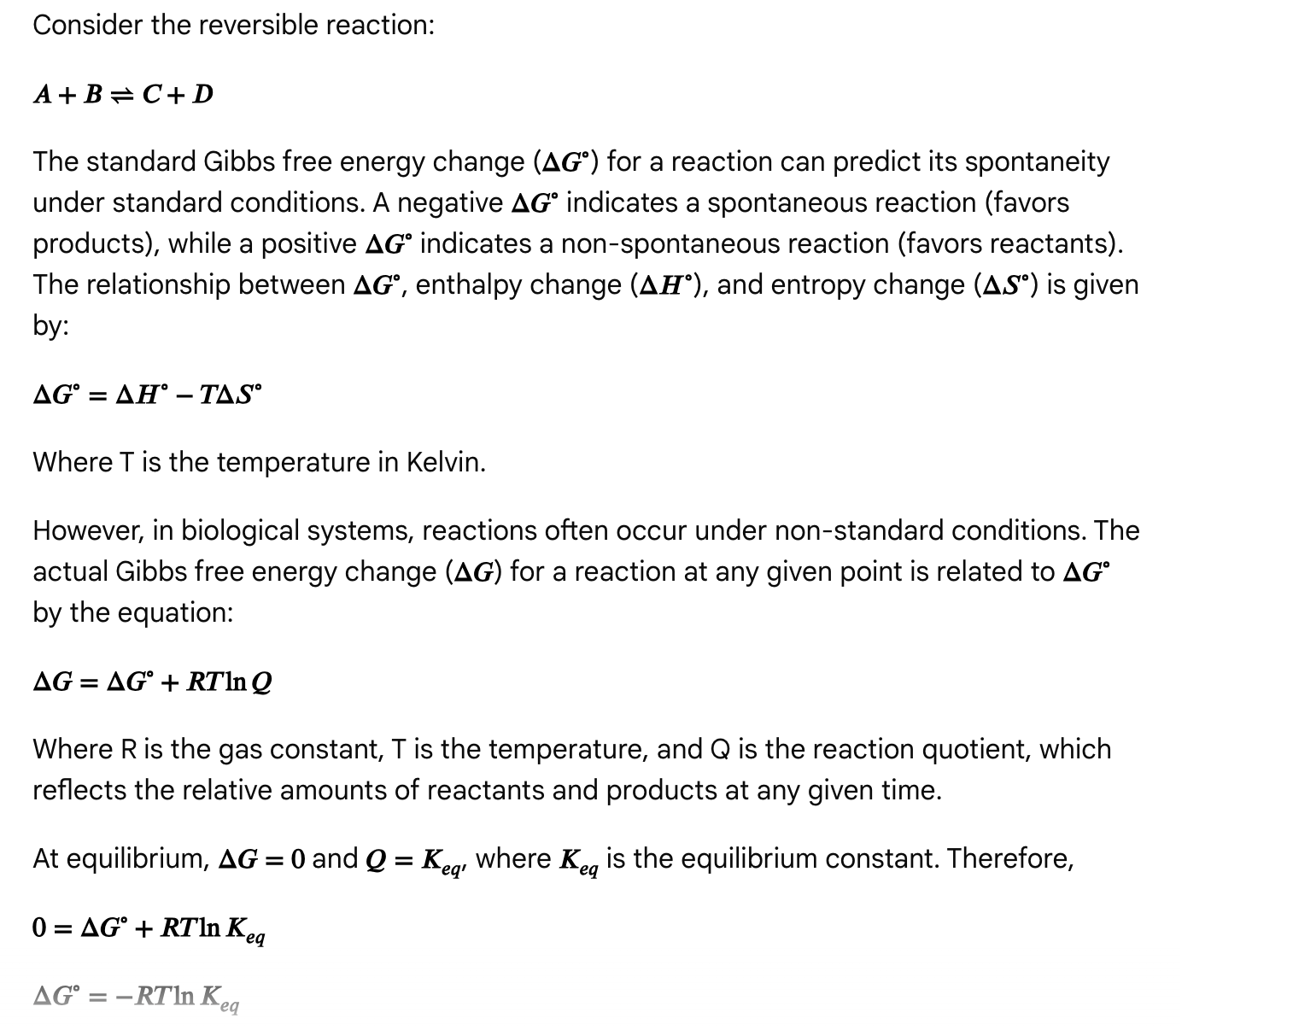**

**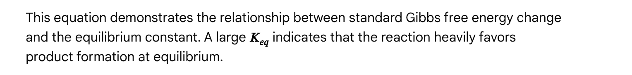**

**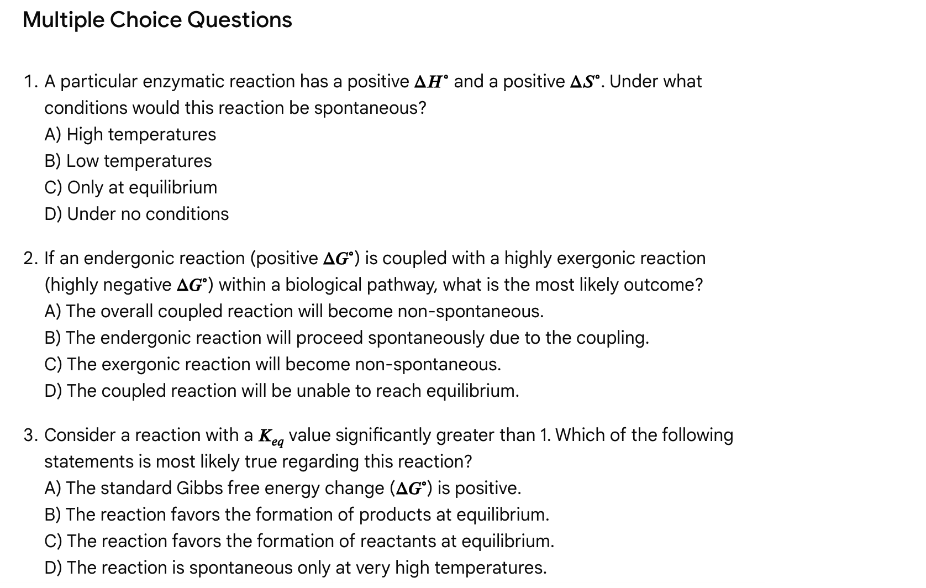**

**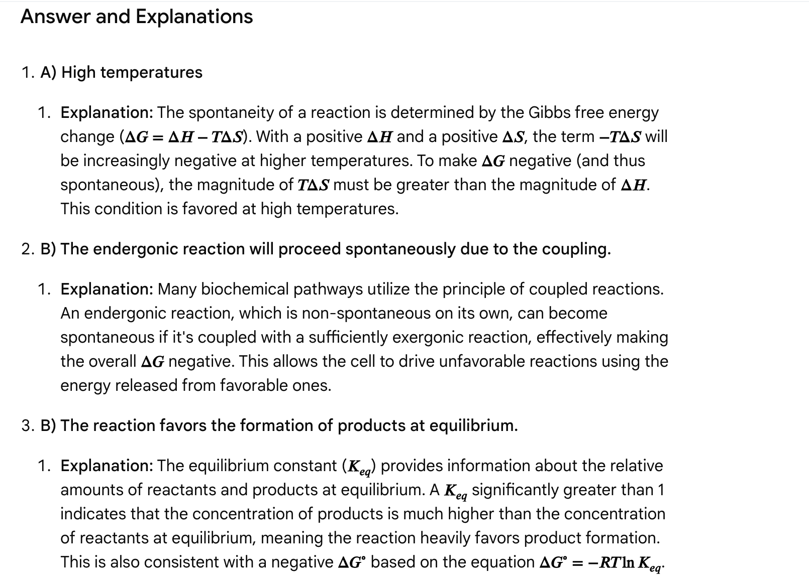**

General chemistry high-yield passage for the MCAT

Passage: Titration of weak acids and bases

The strength of an acid or base is defined by its ability to donate or accept protons, respectively. Strong acids and bases completely dissociate in solution, while weak acids and bases only partially dissociate. The pH of a solution is determined by the concentration of hydrogen ions (H+) present. The pH scale ranges from 0 to 14, with values below 7 indicating acidic solutions, values above 7 indicating basic solutions, and a pH of 7 indicating a neutral solution.

Titration is a common laboratory technique used to determine the unknown concentration of an acid or base. This involves the gradual addition of a solution of known concentration (the titrant) to a solution of unknown concentration (the analyte) until the reaction is complete. For example, in an acid-base titration, a known concentration of a base is added to an unknown concentration of an acid until the acid is neutralized. The equivalence point is the point in a titration where the amount of titrant added is exactly enough to react completely with the analyte. The endpoint is the point where the indicator changes color. A common indicator used in acid-base titrations is phenolphthalein, which changes color from colorless to pink in the presence of a base.

The Henderson-Hasselbalch equation describes the relationship between pH, pKa, and the ratio of the concentrations of a conjugate acid-base pair in a buffer solution. The equation is:

pH = pKa + log ([A-]/[HA])

where pKa is the negative logarithm of the acid dissociation constant (Ka), [A-] is the concentration of the conjugate base, and [HA] is the concentration of the weak acid.

Questions

Question 1

Which of the following statements about the titration of a weak acid with a strong base is false?

A. The pH at the equivalence point will be greater than 7.  
B. The buffer region occurs before the equivalence point.  
C. The indicator should have a pKa close to the equivalence point pH.  
D. The pH at the half-equivalence point is equal to the pKa of the weak acid.

Answer and explanation

Correct Answer: A

* A. The pH at the equivalence point will be greater than 7. This is false. When a weak acid is titrated with a strong base, the conjugate base of the weak acid is formed, which hydrolyzes water to produce hydroxide ions, increasing the pH above 7. Therefore, the pH at the equivalence point will be greater than 7, not less than 7.
* B. The buffer region occurs before the equivalence point. This is true. A buffer region is formed when significant amounts of both the weak acid and its conjugate base are present, which happens during the initial stages of the titration before the equivalence point.
* C. The indicator should have a pKa close to the equivalence point pH. This is true. To accurately detect the equivalence point, the indicator's pKa should be close to the pH at the equivalence point, allowing for a sharp color change near the completion of the reaction.
* D. The pH at the half-equivalence point is equal to the pKa of the weak acid. This is true. At the half-equivalence point, the concentration of the weak acid is equal to the concentration of its conjugate base. In this scenario, the log ([A-]/[HA]) term in the Henderson-Hasselbalch equation becomes log(1) = 0, so pH = pKa.

Question 2

A [25.0](https://bemoacademicconsulting.com/blog/high-yield-mcat-topics#:~:text=25.0) mL sample of 0.100 M acetic acid (CH3COOH, pKa = 4.76) is titrated with 0.100 M NaOH. What is the pH after the addition of 12.5 mL of NaOH?

A. 2.88  
B. 4.76  
C. 7.00  
D. 9.24

Answer and explanation

Correct Answer: B

* At the half-equivalence point, the amount of base added is exactly half the amount required to reach the equivalence point. In this case, 12.5 mL of 0.100 M NaOH has been added, which is half of the 25.0 mL of 0.100 M NaOH needed to completely neutralize the 25.0 mL of 0.100 M acetic acid.
* At the half-equivalence point, according to the Henderson-Hasselbalch equation, the pH of the solution is equal to the pKa of the weak acid.
* Given that the pKa of acetic acid is 4.76, the pH after the addition of 12.5 mL of NaOH is 4.76.

Questions

Question 1

Consider a reaction with a negative ΔH and a positive ΔS. Which of the following statements about the spontaneity of this reaction is true?

A. The reaction will be spontaneous only at low temperatures.  
B. The reaction will be spontaneous only at high temperatures.  
C. The reaction will be spontaneous at all temperatures.  
D. The reaction will never be spontaneous.

Answer and explanation

Correct Answer: C

* According to the Gibbs free energy equation (ΔG = ΔH - TΔS), a negative ΔH contributes to a negative ΔG (favoring spontaneity), and a positive ΔS also contributes to a negative ΔG (as TΔS will be subtracted from ΔH).
* Therefore, with a negative ΔH and a positive ΔS, the reaction will always be spontaneous regardless of the temperature.

Question 2

A certain reaction has a ΔH of +50 kJ/mol and a ΔS of +150 J/(mol·K). At what temperature (in Kelvin) will this reaction become spontaneous?

A. Below 333 K  
B. Above 333 K  
C. At exactly 333 K  
D. The reaction will never be spontaneous.

Answer and explanation

Correct Answer: B

1. Convert ΔS to kJ/(mol·K): +150 J/(mol·K) = +0.150 kJ/(mol·K)
2. Set ΔG = 0 to find the equilibrium temperature: At equilibrium, ΔG = 0, [according to Jack Westin](https://jackwestin.com/resources/mcat-content/energy-changes-in-chemical-reactions/free-energy-g).
   * 0 = ΔH - TΔS
   * 0 = +50 kJ/mol - T(0.150 kJ/(mol·K))
   * T(0.150 kJ/(mol·K)) = +50 kJ/mol
   * T = 50 kJ/mol / 0.150 kJ/(mol·K) = 333.33 K ≈ 333 K
3. Determine spontaneity: For the reaction to be spontaneous, ΔG must be negative.
   * ΔG = ΔH - TΔS
   * To make ΔG negative, the TΔS term must be greater than ΔH (since both are positive in this case).
   * This occurs when the temperature is *above* the equilibrium temperature (333 K).

Passage: Electron configurations and periodic trends

The electronic structure of atoms, described by their electron configuration, dictates their chemical behavior and reactivity. Electrons in atoms occupy specific orbitals within different energy levels or shells. The Aufbau principle guides the filling of these orbitals, starting from the lowest energy orbitals and progressing to higher energy levels. Within each energy level, subshells (s, p, d, f) exist, with each orbital capable of holding a maximum of two electrons with opposite spins, according to the Pauli exclusion principle. Hund's rule states that orbitals within a subshell are filled with one electron each before pairing any electrons.

The periodic table is arranged based on the electron configurations of elements, and their positions reveal important periodic trends. These trends, such as atomic radius, ionization energy, and electronegativity, are influenced by factors like the effective nuclear charge (Zeff) and the shielding effect of inner electrons. Zeff represents the net positive charge experienced by an electron in a polyelectronic atom and increases across a period and decreases down a group. The shielding effect, caused by inner electrons repelling outer electrons, counteracts the nuclear pull and increases down a group.

* Atomic radius is the distance from the nucleus to the outermost electron shell. It increases down a group due to the addition of new electron shells and decreases across a period as the increasing Zeff pulls the electrons closer to the nucleus.
* Ionization energy is the energy required to remove an electron from a gaseous atom. It decreases down a group and increases across a period due to changes in atomic size and Zeff.
* Electronegativity is the ability of an atom in a chemical bond to attract electron density towards itself. It increases across a period and decreases down a group, mirroring the trend in ionization energy (excluding noble gases).

Questions

Question 1

Which of the following elements has the largest atomic radius?

A. Carbon  
B. Fluorine  
C. Chlorine  
D. Iodine

Answer and explanation

Correct Answer: D

* D. Iodine is located furthest down and to the left of the other options in the periodic table, meaning it experiences the weakest effective nuclear charge and has the largest atomic radius among the choices.

Question 2

Which of the following statements about electron configuration and periodic trends is false?

A. Valence electrons are the outermost electrons and play a key role in chemical bonding.  
B. The Aufbau principle states that orbitals are filled in order of increasing energy.  
C. Ionization energy increases as you move down a group due to increased atomic size.  
D. Electronegativity generally increases from left to right across a period.

Answer and explanation

Correct Answer: C

* C. Ionization energy increases as you move down a group due to increased atomic size. This is false. Ionization energy actually *decreases* as you move down a group because the valence electrons are farther from the nucleus and experience less attraction, making them easier to remove.

Passage: Chemical kinetics and reaction rates

Chemical kinetics is the study of reaction rates, the factors affecting these rates, and the mechanisms by which reactions proceed. The rate of a reaction quantifies how quickly reactants are consumed and products are formed. Several factors influence reaction rates, including temperature, concentration of reactants, surface area, and the presence of catalysts.

* Temperature: Increasing the temperature generally increases the reaction rate because it provides molecules with more kinetic energy, leading to more frequent and energetic collisions.
* Concentration: Higher concentrations of reactants increase the probability of collisions between reacting molecules, thus speeding up the reaction rate.
* Surface Area: For heterogeneous reactions involving solids, increasing the surface area of the solid reactant exposes more sites for reaction, leading to a faster rate.
* Catalysts: A catalyst is a substance that speeds up a reaction without being consumed in the process. Catalysts achieve this by providing an alternative reaction pathway with a lower activation energy, the minimum energy required for a reaction to occur.

The rate law for a reaction expresses the relationship between the reaction rate and the concentrations of reactants. For a generic reaction:

**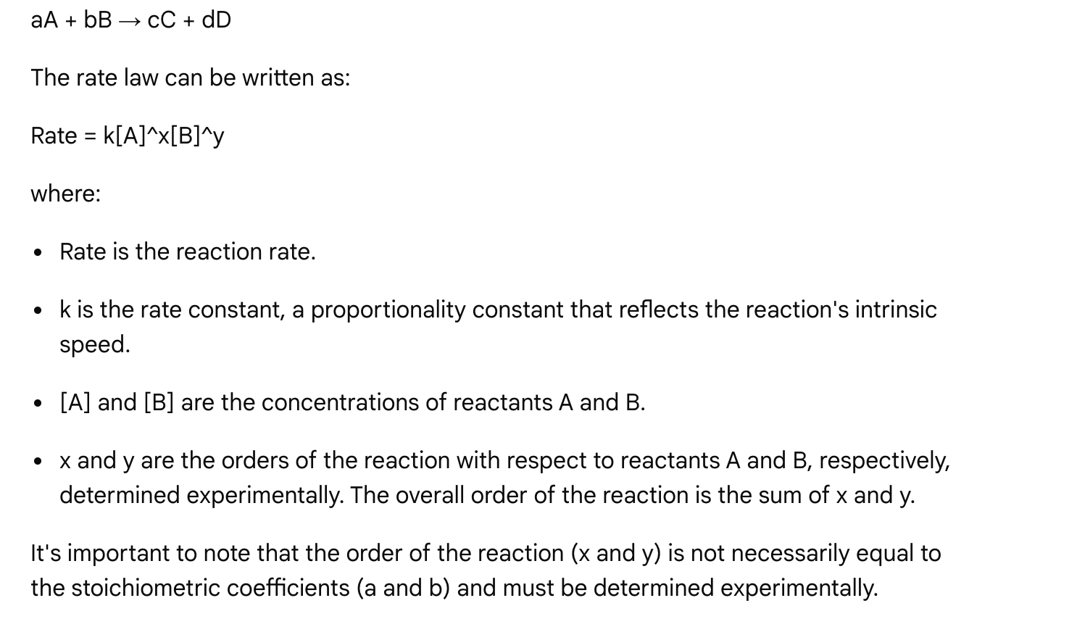**

Questions

Question 1

Consider a reaction with the rate law: Rate = k[X]^2[Y]^1. If the concentration of reactant X is doubled and the concentration of reactant Y is halved, what will be the effect on the reaction rate?

A. The rate will increase by a factor of 2.  
B. The rate will decrease by a factor of 2.  
C. The rate will remain unchanged.  
D. The rate will increase by a factor of 4.

Answer and explanation

**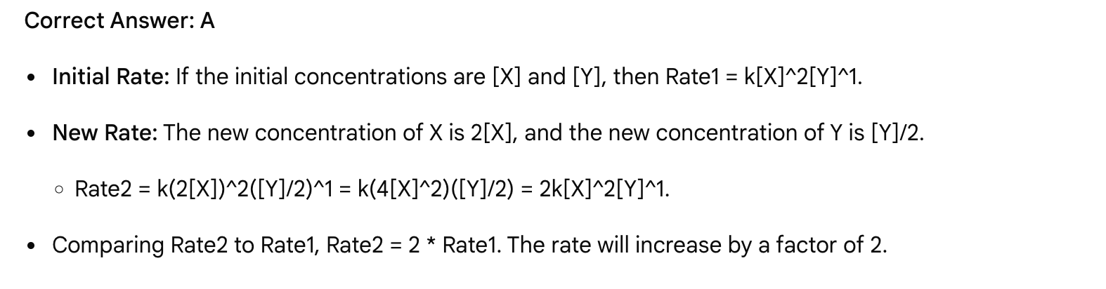**

Question 2

Which of the following statements about catalysts is false?

A. Catalysts increase the reaction rate by lowering the activation energy.  
B. Catalysts are consumed in the overall reaction.  
C. Catalysts do not affect the position of the equilibrium.  
D. Catalysts provide an alternative reaction pathway.

Answer and explanation

Correct Answer: B

* A. Catalysts increase the reaction rate by lowering the activation energy. This is true.
* B. Catalysts are consumed in the overall reaction. This is false. Catalysts participate in the reaction mechanism but are regenerated at the end, so they are not consumed.
* C. Catalysts do not affect the position of the equilibrium. This is true. Catalysts speed up both the forward and reverse reactions equally, thus they do not change the equilibrium constant or the position of equilibrium.
* D. Catalysts provide an alternative reaction pathway. This is true.

Passage: Chemical bonding and intermolecular forces

Chemical bonding describes the attractive forces that hold atoms together to form molecules and compounds, while intermolecular forces (IMFs) are the attractive forces that exist *between* separate molecules. Intramolecular forces (bonds within molecules) are much stronger than intermolecular forces (forces between molecules). The strength of these forces influences many physical properties of substances, including melting points, boiling points, and solubility.

The two main types of chemical bonds are ionic and covalent bonds. [According to Shemmassian Academic Consulting](https://www.shemmassianconsulting.com/blog/bonds-interactions-mcat), understanding how atoms and molecules interact with each other is crucial for much of the chemistry section of the MCAT.

* Ionic bonds form when electrons are transferred between atoms, typically between a metal and a nonmetal, resulting in the formation of oppositely charged ions that attract each other. These are strong electrostatic attractions.
* Covalent bonds involve the sharing of electrons between two or more atoms, typically between two nonmetals. Covalent bonds can be polar or nonpolar depending on the electronegativity difference between the bonded atoms. If there is a significant difference in electronegativity, the electrons are shared unequally, creating a polar covalent bond with a partial positive and partial negative charge on the atoms.

Intermolecular forces (IMFs) are weaker than intramolecular bonds and are categorized into several types, in increasing order of strength:

* London Dispersion Forces (LDFs): These are the weakest IMFs and are present in all atoms and molecules, whether polar or nonpolar. LDFs arise from temporary, instantaneous dipoles that form due to the constant random motion of electrons within a molecule or atom. The strength of LDFs increases with increasing molecular size and surface area.
* Dipole-Dipole Forces: These occur between polar molecules due to the attraction between their permanent partial positive and negative charges. They are stronger than LDFs for molecules of comparable size.
* Hydrogen Bonding: A specialized and particularly strong type of dipole-dipole interaction. Hydrogen bonds occur when a hydrogen atom covalently bonded to a highly electronegative atom (N, O, or F) is attracted to a lone pair of electrons on a nearby electronegative atom (N, O, or F) of another molecule. [According to Jack Westin](https://jackwestin.com/resources/mcat-content/liquid-phase-intermolecular-forces/hydrogen-bonding), these interactions are stronger than typical dipole-dipole forces and have a significant impact on properties like boiling points.

The strength of these intermolecular forces significantly influences a substance's physical properties. Substances with stronger IMFs require more energy to overcome these attractions, leading to higher melting and boiling points, and lower vapor pressures. For example, water's high boiling point compared to similar-sized nonpolar molecules is attributed to its strong hydrogen bonding.

Questions

Question 1

Which of the following molecules would be expected to have the highest boiling point?

A. CH4 (Methane)  
B. HCl (Hydrogen chloride)  
C. H2O (Water)  
D. F2 (Fluorine gas)

Answer and explanation

Correct Answer: C

* A. CH4 (Methane): Methane is a nonpolar molecule and only exhibits London Dispersion Forces. These are the weakest IMFs.
* B. HCl (Hydrogen chloride): Hydrogen chloride is a polar molecule, exhibiting dipole-dipole interactions in addition to LDFs.
* C. H2O (Water): Water is a polar molecule capable of forming strong hydrogen bonds because it contains hydrogen atoms bonded to highly electronegative oxygen atoms. Hydrogen bonding is the strongest type of IMF among the options given.
* D. F2 (Fluorine gas): Fluorine gas is a nonpolar molecule, and only exhibits London Dispersion Forces, similar to methane.

Therefore, water, with its strong hydrogen bonding, will have the highest boiling point.

Question 2

Which of the following statements comparing ionic and covalent bonding is false?

A. Ionic bonds involve the transfer of electrons, while covalent bonds involve the sharing of electrons.  
B. Ionic bonds typically form between metals and nonmetals, while covalent bonds typically form between two nonmetals.  
C. Ionic bonds are generally stronger than covalent bonds within a molecule.  
D. Substances held together by ionic bonds generally have lower melting and boiling points than those held together by covalent bonds.

Answer and explanation

Correct Answer: D

* A. Ionic bonds involve the transfer of electrons, while covalent bonds involve the sharing of electrons. This statement is true.
* B. Ionic bonds typically form between metals and nonmetals, while covalent bonds typically form between two nonmetals. This statement is true.
* C. Ionic bonds are generally stronger than covalent bonds within a molecule. This statement is true. Ionic bonds result from strong electrostatic attraction between fully charged ions.
* D. Substances held together by ionic bonds generally have lower melting and boiling points than those held together by covalent bonds. This statement is false. Due to the strong electrostatic forces holding ions together in a crystal lattice, ionic compounds generally have much higher melting and boiling points compared to most covalent compounds.

**PHYSICS**

Passage: Kinematics and dynamics

Kinematics describes motion without considering the forces causing it, focusing on displacement, velocity, and acceleration. Dynamics, conversely, delves into the relationship between force and motion, as established by Newton's laws. Understanding these fundamental principles is crucial for analyzing how objects move and interact in various physical situations. According to Shemmassian Academic Consulting, many MCAT questions on kinematics involve using a set of equations that relate these variables when acceleration is constant.

Kinematics

* Displacement (Δx or d): The change in an object's position, a vector quantity (has both magnitude and direction).
* Velocity (v): The rate of change of displacement, also a vector quantity. Average velocity is displacement divided by time. Instantaneous velocity is the velocity at a specific moment. [According to Shemmassian Academic Consulting](https://www.shemmassianconsulting.com/blog/kinematics-equations-mcat), calculus-based instantaneous velocity is not tested on the MCAT, but average velocity is fair game.
* Acceleration (a): The rate of change of velocity, a vector quantity. Constant acceleration means velocity changes uniformly over time.

**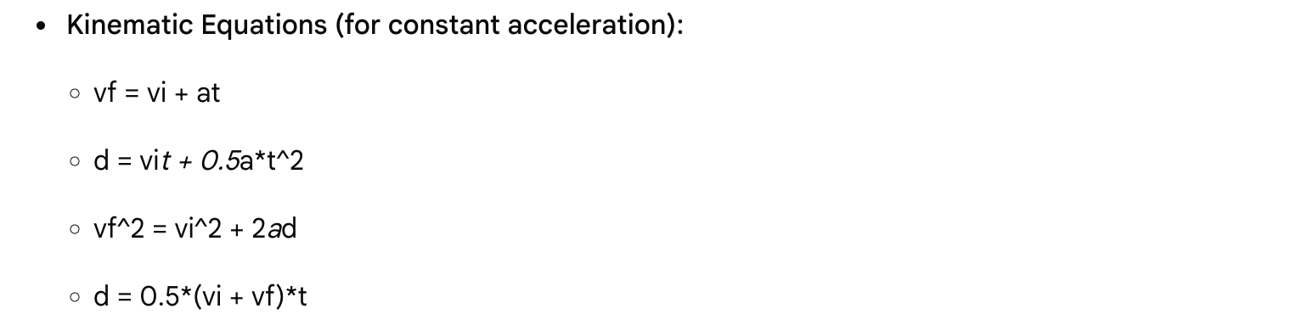** Dynamics (Newton's Laws of Motion)

* Newton's First Law (Law of Inertia): An object at rest stays at rest, and an object in motion stays in motion with the same speed and in the same direction, unless acted upon by an unbalanced force.
* Newton's Second Law: The acceleration of an object is directly proportional to the net force acting on it and inversely proportional to its mass (Fnet = ma).
* Newton's Third Law: For every action, there is an equal and opposite reaction. When two objects interact, they apply forces to each other of equal magnitude and opposite direction.

Understanding these concepts allows for the analysis of various scenarios, from projectile motion to the forces acting on an object sliding down an inclined plane.

Questions

Question 1

A car starting from rest accelerates uniformly to a final velocity of 20 m/s in 5 seconds. What is the distance covered by the car during this time?

A. 25 m  
B. 50 m  
C. 75 m  
D. 100 m

Answer and explanation

Correct Answer: B

1. Identify Given Variables:
   * Initial velocity (vi) = 0 m/s (starts from rest)
   * Final velocity (vf) = 20 m/s
   * Time (t) = 5 s
2. Choose the Appropriate Kinematic Equation: The displacement (d) needs to be found. The equation d = 0.5\*(vi + vf)\*t is suitable.
3. Substitute and Solve:
   * d = 0.5 \* (0 m/s + 20 m/s) \* 5 s
   * d = 0.5 \* (20 m/s) \* 5 s
   * d = 10 m/s \* 5 s = 50 m

Therefore, the car covers a distance of 50 meters.

Question 2

A block of mass 2 kg is acted upon by a net force of 10 N. According to Newton's Second Law, what is the acceleration of the block?

A. 0.2 m/s^2  
B. 5 m/s^2  
C. 10 m/s^2  
D. 20 m/s^2

Answer and explanation

Correct Answer: B

1. Recall Newton's Second Law: Fnet = ma
2. Identify Given Variables:
   * Net Force (Fnet) = 10 N
   * Mass (m) = 2 kg
3. Rearrange the equation to solve for acceleration (a): a = Fnet / m
4. Substitute and Solve:
   * a = 10 N / 2 kg
   * a = 5 m/s^2

Therefore, the acceleration of the block is 5 m/s^2.

Passage: Electrical circuits and Ohm's law

Electrical circuits are fundamental to modern technology and biology, encompassing the flow of electric current through conductive pathways. Understanding the principles governing these circuits is essential for the MCAT. Key concepts include voltage, current, resistance, and power, and how these interact in various circuit configurations. According to an Instagram reel by @mcat\_basics, Ohm's law (V=IR), the power formula (P=IV, P=I²R, or P=V²/R), and resistor combinations are essential formulas to memorize for circuits questions on the MCAT.

* Voltage (V): Also known as potential difference, voltage is the driving force that pushes electric charge through a circuit. It is measured in volts (V).
* Current (I): The flow of electric charge (electrons) through a conductor. It is measured in amperes (A).
* Resistance (R): A material's opposition to the flow of electric current. It is measured in ohms (Ω).
* Ohm's Law: This fundamental law states that the voltage across a resistor is directly proportional to the current flowing through it and its resistance: V = IR.
* Power (P): The rate at which energy is transferred or dissipated in a circuit. It is measured in watts (W) and can be calculated using several formulas: P = IV, P = I²R, or P = V²/R.

Resistors in series and parallel

* Series Circuits: When resistors are connected in series, they are arranged one after another, so the current flowing through each resistor is the same. The total resistance (Req) of resistors in series is simply the sum of individual resistances: Req = R1 + R2 + R3 + .... The voltage drops across each resistor are additive, meaning the sum of the voltage drops across each resistor equals the total voltage supplied by the source.
* Parallel Circuits: When resistors are connected in parallel, they are arranged side-by-side, providing multiple paths for the current. The voltage across each resistor in a parallel circuit is the same. The reciprocal of the total resistance is the sum of the reciprocals of individual resistances: 1/Req = 1/R1 + 1/R2 + 1/R3 + .... The current splits among the parallel branches, with more current flowing through paths of lower resistance.

Understanding these concepts is vital for analyzing and solving problems related to electrical circuits.

Questions

Question 1

A circuit contains a 12 V battery connected to three resistors in series: 2 Ω, 3 Ω, and 5 Ω. What is the total current flowing through the circuit?

A. 1.2 A  
B. 2.4 A  
C. 4.0 A  
D. 12.0 A

Answer and explanation

Correct Answer: A

1. Calculate Total Resistance (Req) for Series Resistors: For resistors in series, Req = R1 + R2 + R3.
   * Req = 2 Ω + 3 Ω + 5 Ω = 10 Ω
2. Apply Ohm's Law (V = IR) to find the Total Current (I):
   * I = V / Req
   * I = 12 V / 10 Ω = 1.2 A

Therefore, the total current flowing through the circuit is 1.2 A.

Question 2

Which of the following statements about parallel circuits is true?

A. The current is the same through each resistor.  
B. The total resistance is the sum of the individual resistances.  
C. The voltage drop across each resistor is the same.  
D. Removing one resistor will cause the entire circuit to break.

Answer and explanation

Correct Answer: C

* A. The current is the same through each resistor. This is false. The current divides among the parallel branches.
* B. The total resistance is the sum of the individual resistances. This is false. This describes resistors in series.
* C. The voltage drop across each resistor is the same. This is true. All components in parallel receive the same voltage.
* D. Removing one resistor will cause the entire circuit to break. This is false. In a parallel circuit, if one component fails, the others can continue to function because current has alternate pathways.

Passage: Waves and the electromagnetic spectrum

Waves transfer energy without transferring matter. They are characterized by amplitude, wavelength, frequency, and period. Understanding these properties and the different types of waves is essential for physics topics, including sound and light. According to MedLife Mastery, the study of wave phenomena also relates to how we perceive sound and light.

* Amplitude (A): The maximum displacement from equilibrium. It relates to the energy carried by the wave.
* Wavelength (λ): The distance between successive crests (or troughs) of a wave.
* Frequency (f): The number of complete wave cycles that pass a given point per unit of time, measured in Hertz (Hz).
* Period (T): The time for one complete wave cycle to pass a given point. It is the reciprocal of the frequency (T = 1/f).
* Wave Speed (v): The speed at which a wave travels through a medium, given by: v = fλ.

Waves can be classified as transverse or longitudinal:

* Transverse Waves: The particles of the medium oscillate perpendicular to the direction of wave propagation. Examples include light waves and waves on a string.
* Longitudinal Waves: The particles of the medium oscillate parallel to the direction of wave propagation, creating compressions and rarefactions. Sound waves are an example.

The electromagnetic spectrum

Light is electromagnetic radiation, which travels as transverse waves and consists of oscillating electric and magnetic fields. The electromagnetic spectrum encompasses the range of electromagnetic waves, categorized by their wavelengths and frequencies. According to Sketchy, this includes radio waves, microwaves, infrared, visible light, ultraviolet, X-rays, and gamma rays. All electromagnetic waves travel at the speed of light (c) in a vacuum (approximately 3 x 10^8 m/s). According to MedLife Mastery, understanding the entire spectrum helps scientists develop technologies that use different wavelengths for various applications.

* Radio waves: Longest wavelengths, lowest frequencies. Used in communications.
* Microwaves: Shorter than radio waves. Used in communication, radar, and heating.
* Infrared (IR): Associated with heat. Used in thermal imaging and remote controls.
* Visible Light: The portion of the spectrum detectable by the human eye. Ranges from red (longest wavelength, lowest frequency) to violet (shortest wavelength, highest frequency).
* Ultraviolet (UV): Shorter wavelength than visible light. Can cause sunburns and is used in sterilization.
* X-rays: Very short wavelengths, high energy. Used in medical imaging and security.
* Gamma rays: Shortest wavelengths, highest frequencies, and highest energy. Produced by nuclear reactions and radioactive decay.

Questions

Question 1

A sound wave in air has a frequency of 500 Hz and a wavelength of 0.68 meters. What is the speed of sound in air in this scenario?

A. 0.0014 m/s  
B. 340 m/s  
C. 735 m/s  
D. 500 m/s

Answer and explanation

Correct Answer: B

1. Identify Given Variables:
   * Frequency (f) = 500 Hz
   * Wavelength (λ) = 0.68 m
2. Recall the Wave Speed Equation: v = fλ
3. Substitute and Solve:
   * v = (500 Hz) \* (0.68 m)
   * v = 340 m/s

Therefore, the speed of sound in air in this scenario is 340 m/s.

Question 2

Which of the following phenomena is a characteristic of light waves but not sound waves?

A. Reflection  
B. Refraction  
C. Diffraction  
D. Polarization

Answer and explanation

Correct Answer: D

* A. Reflection: Both light waves and sound waves can be reflected (e.g., echoes).
* B. Refraction: Both light waves (bending as they pass through different media) and sound waves can be refracted.
* C. Diffraction: Both light waves and sound waves can diffract (bend around obstacles).
* D. Polarization: Polarization restricts the oscillations of a transverse wave to a single plane. Since light waves are transverse waves, they can be polarized. Sound waves, being longitudinal waves, cannot be polarized.

Therefore, polarization is a characteristic of light waves but not sound waves.

Passage: Solutions and solubility

Solutions are homogeneous mixtures formed when one or more solutes dissolve in a solvent. The process of dissolving is known as solvation or dissolution, which involves the formation of new intermolecular forces between solute and solvent molecules. According to Sketchy, the driving forces behind dissolution are electrostatic interactions. Water is a common solvent on the MCAT, forming aqueous solutions.

Solubility refers to the maximum amount of a solute that can dissolve in a specific solvent at a given temperature. Several factors influence solubility:

* Temperature: For most solid solutes, solubility increases with increasing temperature. For gaseous solutes, however, solubility generally decreases with increasing temperature.
* Pressure: Pressure primarily affects the solubility of gases, where increasing pressure typically increases solubility.
* Nature of Solute and Solvent (Polarity): The "like dissolves like" rule is a crucial principle: polar solutes dissolve well in polar solvents, and nonpolar solutes dissolve well in nonpolar solvents. This is because favorable intermolecular forces can form between similar types of molecules.
* Common Ion Effect: This effect, an application of Le Chatelier's principle, describes how the solubility of a sparingly soluble salt decreases when a soluble salt containing a common ion is added to the solution.

Solutions can be classified based on the amount of solute dissolved:

* Unsaturated: Contains less than the maximum amount of solute that can be dissolved at a given temperature.
* Saturated: Contains the maximum amount of solute that can be dissolved at a given temperature. At this point, the dissolved solute is in equilibrium with any undissolved solid.
* Supersaturated: Contains more than the maximum amount of solute that can be dissolved at a given temperature, often formed by carefully cooling a saturated solution. These solutions are unstable, and disturbance can lead to precipitation.

Solubility rules for ionic compounds

While many ionic compounds are soluble in water, some are not. A basic understanding of solubility rules is helpful for the MCAT.

* Soluble:
  + Compounds containing alkali metals (Group 1) and ammonium (NH4+) ions.
  + Compounds containing acetate (CH3COO-) and nitrate (NO3-) ions.
  + Compounds containing halide anions (Cl-, Br-, I-), with exceptions for silver (Ag+), mercury (Hg2^2+), and lead (Pb^2+) salts.
  + Compounds containing sulfate (SO4^2-) ions, with exceptions for heavier alkaline earth metals (Ca^2+, Sr^2+, Ba^2+) and lead (Pb^2+).
* Insoluble:
  + Generally, carbonates (CO3^2-), phosphates (PO4^3-), and hydroxides (OH-) are insoluble, unless they are combined with one of the soluble ions mentioned above.
  + Sulfides (S^2-) are generally insoluble.

Questions

Question 1

Which of the following compounds is most likely to be soluble in water?

A. AgCl  
B. CaCO3  
C. NH4NO3  
D. PbSO4

Answer and explanation

Correct Answer: C

* A. AgCl: Silver chloride is insoluble because Ag+ is an exception to the solubility rule for halides.
* B. CaCO3: Calcium carbonate is insoluble because carbonates are generally insoluble, and Ca^2+ is not an alkali metal or ammonium.
* C. NH4NO3: Ammonium nitrate is soluble because compounds containing ammonium (NH4+) and nitrate (NO3-) ions are generally soluble.
* D. PbSO4: Lead sulfate is insoluble because Pb^2+ is an exception to the solubility rule for sulfates.

Therefore, ammonium nitrate is the most likely to be soluble in water.

Question 2

A beaker contains a saturated solution of potassium chloride (KCl) at 20°C. If the solution is then heated to 50°C, and no additional KCl is added, what will happen to the solution?

A. The solution will become supersaturated.  
B. The solution will become unsaturated.  
C. The solubility of KCl will decrease.  
D. Precipitation of KCl will occur.

Answer and explanation

Correct Answer: B

* A. The solution will become supersaturated. This is false. Supersaturation typically occurs when a solution is cooled, not heated, after reaching saturation with additional solute.
* B. The solution will become unsaturated. This is true. For most solid solutes like KCl, solubility increases with increasing temperature. Since the solution was saturated at 20°C, increasing the temperature to 50°C will allow more KCl to dissolve, making the current solution unsaturated (it can dissolve more solute).
* C. The solubility of KCl will decrease. This is false. For solid solutes, solubility generally increases with increasing temperature.
* D. Precipitation of KCl will occur. This is false. Precipitation would occur if the solubility was decreased, or if the solution was supersaturated and disturbed. Neither of these applies in this scenario.

Therefore, the solution will become unsaturated as the temperature increases.

Passage: Fluids and their properties

Fluids, encompassing liquids and gases, are substances that deform continuously under applied shear stress. Unlike solids, they lack a definite shape and readily flow. Understanding the fundamental properties of fluids, such as density, pressure, and buoyancy, is crucial for analyzing various phenomena in physics, biology, and medicine. According to Shemmassian Academic Consulting, a fluid is a substance that will move under any shear stress.

Key definitions

* Density (ρ): Defined as mass per unit volume (ρ = m/V). It is an intensive property, meaning it does not depend on the amount of substance. The density of water is a commonly memorized value, approximately 1000 kg/m^3 or 1 g/cm^3.
* Specific Gravity (SG): The ratio of a substance's density to the density of a reference substance, usually water. It is a dimensionless quantity, [according to Sketchy](https://www.sketchy.com/mcat-lessons/density-and-pressure). An object with SG > 1 will sink in water, while an object with SG < 1 will float.
* Pressure (P): Defined as force per unit area (P = F/A), measured in Pascals (Pa) or Newtons per square meter (N/m^2).
  + Hydrostatic Pressure (Gauge Pressure): The pressure due to the weight of a fluid at a certain depth. It is calculated as P = ρgh, where ρ is the fluid density, g is the acceleration due to gravity, and h is the depth. According to MCAT-Review.org, pressure at the surface is 0 because h = 0.
  + Absolute Pressure: The total pressure at a point in a fluid, including both hydrostatic pressure and the atmospheric pressure exerted on the fluid's surface.
* Buoyant Force (Fb): The upward force exerted by a fluid on an object submerged or floating in it. [According to Vaia](https://www.vaia.com/en-us/explanations/physics/fluids/archimedes-principle/), Archimedes' Principle states that the buoyant force is equal to the weight of the fluid displaced by the object (Fb = ρ\_fluid \* V\_displaced \* g). The buoyant force does not depend on the depth of the submerged object.
* Pascal's Principle: States that a change in pressure applied to an enclosed, incompressible fluid is transmitted undiminished to every portion of the fluid and to the walls of the container. This principle is the basis for hydraulic systems.

Fluid dynamics (flow)

When fluids are in motion, their behavior is governed by principles like the continuity equation and Bernoulli's principle. [According to Magoosh](https://magoosh.com/mcat/fluid-dynamics-mcat/), understanding the relationship between ideas is key for the MCAT, such as how decreasing area leads to increased velocity according to the continuity equation.

* Continuity Equation: For an incompressible fluid flowing through a pipe, the volume flow rate (Q) is constant. Q = Av, where A is the cross-sectional area and v is the fluid's velocity. Therefore, as the cross-sectional area decreases, the fluid's velocity increases, and vice versa.
* Bernoulli's Principle: States that for an ideal fluid (incompressible, non-viscous, steady flow), an increase in the speed of the fluid occurs simultaneously with a decrease in pressure or a decrease in the fluid's potential energy. It relates pressure, velocity, and height: P + ½ρv^2 + ρgh = constant.

Questions

Question 1

A sealed container filled with an incompressible liquid has a small piston at one end (Area = 0.01 m^2) and a larger piston at the other end (Area = 0.1 m^2). A force of 10 N is applied to the smaller piston. What force is exerted on the larger piston?

A. 1 N  
B. 10 N  
C. 100 N  
D. 1000 N

Answer and explanation

Correct Answer: C

1. Apply Pascal's Principle: Pascal's Principle states that pressure is transmitted undiminished throughout an enclosed incompressible fluid. Thus, the pressure applied to the smaller piston is equal to the pressure exerted on the larger piston (P1 = P2).
2. Relate Pressure to Force and Area: Pressure is defined as Force / Area (P = F/A). Therefore, F1/A1 = F2/A2.
3. Substitute Given Values and Solve for F2:
   * F1 = 10 N
   * A1 = 0.01 m^2
   * A2 = 0.1 m^2
   * 10 N / 0.01 m^2 = F2 / 0.1 m^2
   * 1000 Pa = F2 / 0.1 m^2
   * F2 = 1000 Pa \* 0.1 m^2 = 100 N

Therefore, a force of 100 N is exerted on the larger piston.

Question 2

An object is placed in a fluid and observes that 75% of its volume is submerged. Which of the following statements about the object and the fluid is true?

A. The density of the object is greater than the density of the fluid.  
B. The specific gravity of the object is 0.75.  
C. The buoyant force on the object is less than its weight.  
D. If the object were placed in a less dense fluid, it would submerge even further.

Answer and explanation

Correct Answer: B

1. Analyze the Scenario: The object is floating, with 75% of its volume submerged.
2. Relate Submerged Volume to Density: For a floating object, the fraction submerged is equal to the ratio of the object's density to the fluid's density (fraction submerged = ρ\_object / ρ\_fluid).
3. Evaluate Option B: Given that 75% or 0.75 of the object's volume is submerged, then ρ\_object / ρ\_fluid = 0.75. Since specific gravity (SG) is the ratio of an object's density to the density of water (or, in this context, the density of the fluid), the specific gravity of the object is 0.75. Thus, this statement is true.
4. Evaluate other options:
   * A. The density of the object is greater than the density of the fluid. This is false. If the object's density were greater than the fluid's, it would sink.
   * C. The buoyant force on the object is less than its weight. This is false. For a floating object, the buoyant force is equal to the object's weight.
   * D. If the object were placed in a less dense fluid, it would submerge even further. This is false. If the object is placed in a less dense fluid, the fraction submerged would increase, meaning a larger portion of the object would be underwater, but it wouldn't necessarily "submerge even further" if the total volume remained the same. However, more importantly, its specific gravity relative to the new fluid would be higher, meaning it would likely sink or float with a larger fraction submerged, possibly sinking entirely if the new fluid is significantly less dense.

Therefore, the most accurate statement is that the specific gravity of the object is 0.75.

Passage: Optics - Lenses, mirrors, and image formation

Optics is a branch of physics that deals with the behavior and properties of light, including its interactions with matter. On the MCAT, optics questions often appear in passages related to vision, medical imaging, or experimental setups. According to Blueprint Prep, a strong grasp of reflection, refraction, lenses, and mirrors is critical. A key aspect is understanding how lenses and mirrors form images, whether those images are real or virtual, inverted or upright, and magnified or reduced. According to M Prep, convex mirrors always form virtual and upright images.

Mirrors

* Plane Mirrors: These are flat reflective surfaces. They form virtual, upright images that are the same size as the object and appear to be behind the mirror at an equal distance to the object's distance in front of the mirror.
* Concave (Converging) Mirrors: These mirrors are curved inward like a spoon. They can produce both real and virtual images depending on the object's distance from the mirror.
  + If the object is beyond the focal point (f), a real, inverted image is formed.
  + If the object is inside the focal point (between the focal point and the mirror), a virtual, upright, and magnified image is formed.
* Convex (Diverging) Mirrors: These mirrors are curved outward. They always produce virtual, upright, and smaller images, regardless of the object's position. The focal point for a convex mirror is considered to be behind the mirror.

Lenses

* Convex (Converging) Lenses: These lenses are thicker in the middle and thinner at the edges. They can form real or virtual images. Real images are inverted if beyond the focal point, while virtual images are upright and magnified if inside the focal point.
* Concave (Diverging) Lenses: Thinner in the middle, thicker at edges, these always form virtual, upright, and smaller images.

Image characteristics

* Real Image: Formed where light converges. Can be projected onto a screen, located in front of mirrors and behind lenses. Real images are always inverted in single systems.
* Virtual Image: Formed where light appears to converge but doesn't pass through. Cannot be projected, located behind mirrors and in front of lenses. Virtual images are always upright in single systems.
* Inverted: Upside down.
* Upright: Same orientation.
* Magnified/Reduced: Image size relative to the object.

Key equations

* Mirror and Lens Equation: 1/f = 1/o + 1/i (f = focal length, o = object distance, i = image distance).
* Magnification Equation: M = h'/h = -i/o (M = magnification, h' = image height, h = object height, i = image distance, o = object distance).

Mastering these concepts is vital for MCAT optics.

Questions

Question 1

An object is placed in front of a concave mirror at a distance greater than its focal length. What type of image will be formed?

A. Real, upright, magnified  
B. Real, inverted, magnified  
C. Virtual, upright, reduced  
D. Virtual, inverted, magnified

Answer and explanation

Correct Answer: B

* A. Real, upright, magnified: Incorrect; real images are always inverted.
* B. Real, inverted, magnified: Correct; for a concave mirror with the object beyond the focal point, the image is real and inverted. Magnification varies with distance.
* C. Virtual, upright, reduced: Incorrect; this describes a convex mirror.
* D. Virtual, inverted, magnified: Incorrect; virtual images are always upright.

Question 2

A diverging lens has a focal length of -0.5 m. An object is placed 1.0 m in front of the lens. Where will the image be formed?

A. 0.33 m in front of the lens  
B. 0.33 m behind the lens  
C. 1.5 m in front of the lens  
D. 1.5 m behind the lens

Answer and explanation

Correct Answer: A

Using the lens equation 1/f = 1/o + 1/i with f = -0.5 m and o = 1.0 m:  
1/(-0.5) = 1/1 + 1/i  
-2 = 1 + 1/i  
-3 = 1/i  
i = -1/3 m ≈ -0.33 m

A negative image distance indicates a virtual image on the same side as the object (in front of the lens).

Passage: Work, energy, and power

Work, energy, and power are fundamental concepts in physics, describing the interactions of forces and motion and how energy is transferred or transformed. On the MCAT, these concepts are frequently tested in relation to kinematics, forces, and conservation principles.

* Work (W): Work in physics is the transfer of energy to or from an object when a force causes displacement. It's calculated as W = Fdcosθ and measured in Joules (J).
  + Positive work increases an object's energy, negative work decreases it (like friction), and zero work occurs when the force is perpendicular to displacement, such as the centripetal force in uniform circular motion.
* Energy (E): The capacity to do work, also measured in Joules.
  + Kinetic Energy (KE): Energy of motion, given by KE = ½mv^2.
  + Potential Energy (PE): Stored energy, including gravitational (PE = mgh) and elastic (PE = ½kx^2).
  + The Work-Energy Theorem states that net work equals the change in kinetic energy (Wnet = ΔKE).
  + Conservation of Energy means total mechanical energy (KE + PE) is constant in a closed system.
* Power (P): The rate of work or energy transfer, calculated as P = W/t or P = Fv, and measured in Watts (W).

Questions

Question 1

A person pushes a box across a floor with a constant force of 50 N for a distance of 10 m. If the force of friction opposing the motion is 20 N, what is the net work done on the box?

A. 200 J  
B. 300 J  
C. 500 J  
D. 700 J

Answer and explanation

Correct Answer: B

1. Calculate Work Done by Applied Force: W\_applied = 50 N \* 10 m = 500 J
2. Calculate Work Done by Friction: W\_friction = 20 N \* 10 m \* cos(180°) = -200 J
3. Calculate Net Work: W\_net = W\_applied + W\_friction = 500 J + (-200 J) = 300 J

The net work done is 300 J.

Question 2

A 2 kg object is lifted from the ground to a height of 5 m. Assuming a constant gravitational acceleration of [9.8](https://jackwestin.com/resources/mcat-content/energy-of-point-object-systems/potential-energy#:~:text=9.8) m/s^2, what is the change in the object's gravitational potential energy?

A. 9.8 J  
B. 10 J  
C. 98 J  
D. 196 J

Answer and explanation

Correct Answer: C

1. Identify Given Variables: m = 2 kg, h = 5 m, g = 9.8 m/s^2
2. Recall the Gravitational Potential Energy Formula: PE = mgh
3. Substitute and Solve: PE = (2 kg) \* (9.8 m/s^2) \* (5 m) = 98 J

The change in gravitational potential energy is 98 J.

Passage: Thermal processes and the laws of thermodynamics

Thermodynamics is the study of how energy is transferred and transformed in physical and chemical systems. On the MCAT, understanding the laws of thermodynamics and their applications is crucial for analyzing energy changes, heat transfer, and the spontaneity of processes.

Key concepts

* Temperature: A measure of the average kinetic energy of the particles within a substance.
* Heat (Q): The transfer of thermal energy between objects or systems due to a temperature difference. Heat can be transferred through:
  + Conduction: Direct contact between objects.
  + Convection: Transfer via the movement of fluids (liquids and gases).
  + Radiation: Transfer through electromagnetic waves.
* Internal Energy (U or ΔE): The total energy contained within a system, including kinetic and potential energies of its particles.

Laws of thermodynamics

* Zeroth Law of Thermodynamics: States that if two systems are in thermal equilibrium with a third system, they are all in thermal equilibrium with each other, meaning there is no net heat flow between them.
* First Law of Thermodynamics (Conservation of Energy): Energy is conserved, meaning it can only be transferred or transformed, not created or destroyed. The change in a system's internal energy (ΔU) is the heat added (Q) minus the work done by the system (W): ΔU = Q - W.
* Second Law of Thermodynamics: The entropy (disorder) of the universe is always increasing. Energy tends to disperse, and heat flows naturally from hot to cold.
* Third Law of Thermodynamics: A pure crystalline substance at absolute zero (0 Kelvin) has zero entropy due to perfect particle order and no thermal or kinetic energy.

Questions

Question 1

A sealed container holds a gas at a constant volume. Heat is added to the gas. According to the first law of thermodynamics, what can be said about the internal energy of the gas?

A. The internal energy decreases because no work is done by the gas.  
B. The internal energy increases because heat is added and no work is done by the gas.  
C. The internal energy remains constant because the volume is constant.  
D. The internal energy decreases because the temperature increases.

Answer and explanation

Correct Answer: B

1. Analyze the given scenario: Heat is added to a gas in a sealed container at constant volume.
2. Recall the First Law of Thermodynamics: ΔU = Q - W. Understanding the sign conventions for Q and W is crucial According to MedLife Mastery.
3. Evaluate the work done: Since the volume is constant (sealed container), ΔV = 0, so no work is done (W = PΔV = 0).
4. Determine the change in internal energy: With Q positive (heat added) and W = 0, ΔU = Q, meaning the internal energy increases.

Question 2

Which of the following processes is consistent with the second law of thermodynamics?

A. A refrigerator cooling its contents by transferring heat from a colder interior to a warmer exterior without any external energy input.  
B. A gas spontaneously expanding into a vacuum from a localized region.  
C. A system spontaneously organizing itself from a disordered state into a perfectly ordered crystalline structure at room temperature.  
D. Heat flowing from a colder body to a hotter body.

Answer and explanation

Correct Answer: B

* A. False. Refrigerators require external energy to move heat from cold to hot.
* B. True. Spontaneous expansion into a vacuum increases entropy and energy dispersal, consistent with the second law.
* C. False. Spontaneous organization into a perfect crystal at room temperature would decrease entropy.
* D. False. Heat naturally flows from hot to cold.

Passage: Simple harmonic motion and oscillations

Simple harmonic motion (SHM) is a specific type of oscillatory motion where the restoring force is proportional to the displacement from equilibrium and directed towards it. Examples include a mass on a spring or a simple pendulum with small swings. Understanding SHM is important for analyzing various physical systems.

**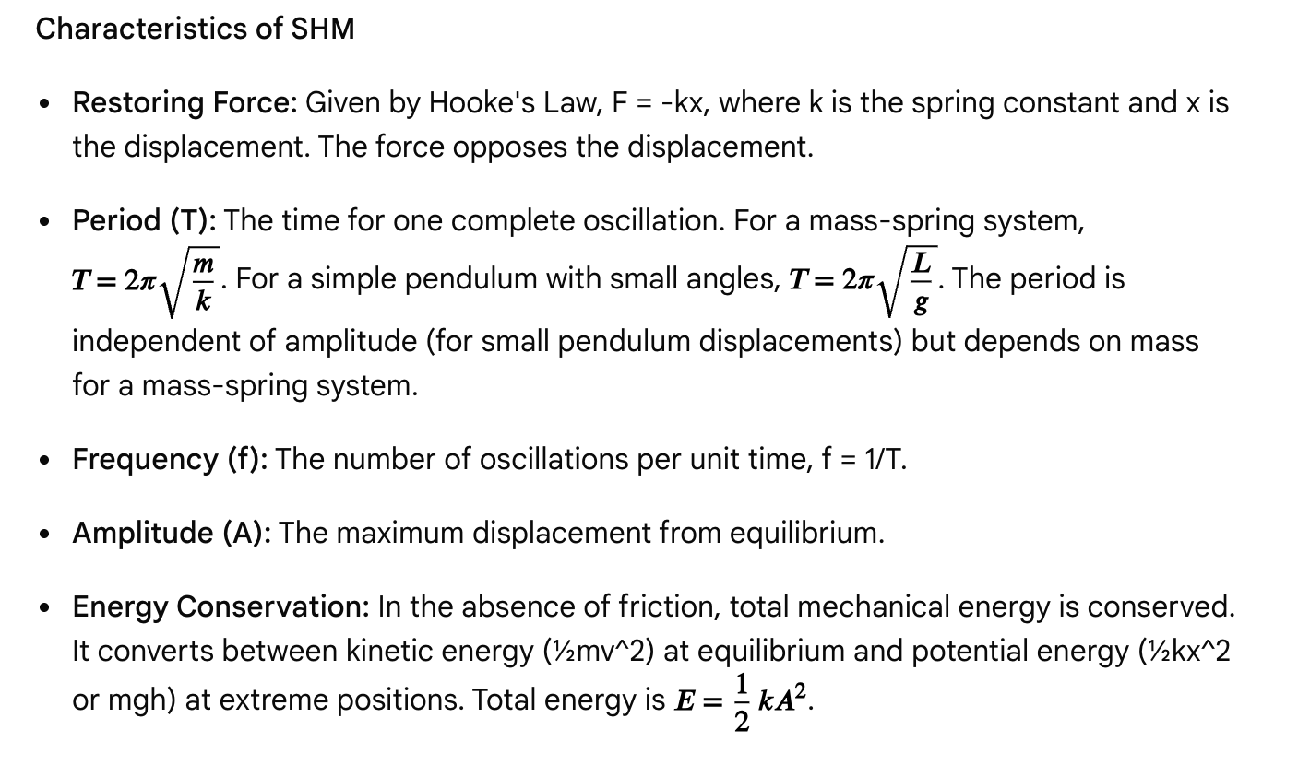**

Applications

SHM models phenomena like molecular vibrations and the motion of guitar strings or pendulums.

Questions

Question 1

A mass attached to an ideal spring oscillates in simple harmonic motion. If the mass is quadrupled while the spring constant remains the same, what happens to the period of oscillation?

A. It doubles.  
B. It halves.  
C. It quadruples.  
D. It remains the same.

**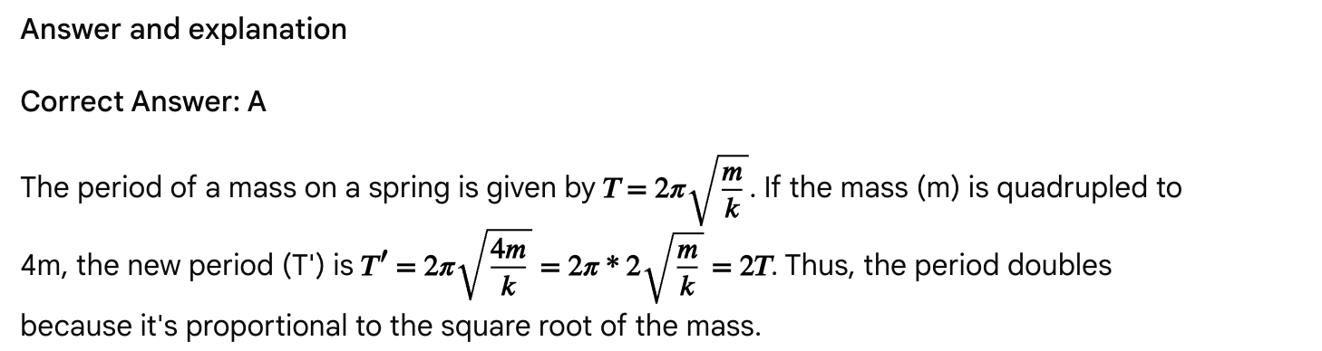**

Question 2

At which point in a simple harmonic motion of a mass-spring system is the kinetic energy at its maximum?

A. At the maximum positive displacement.  
B. At the maximum negative displacement.  
C. At the equilibrium position.  
D. Both A and B.

Answer and explanation

Correct Answer: C

Kinetic energy is maximum where velocity is maximum. This occurs at the equilibrium position where the restoring force is zero and the mass moves fastest. At maximum displacement, velocity is zero, and all energy is potential energy.

See all

Passage: Energy transformations and conservation

Energy, the capacity to do work, exists in various forms and is fundamental to all physical processes. The Law of Conservation of Energy states that in a closed system, the total amount of energy remains constant; it can only be transformed from one form to another. This principle governs diverse phenomena from the motion of planets to biochemical reactions within living organisms.

* Mechanical Energy: The sum of kinetic energy (energy of motion) and potential energy (stored energy). Kinetic energy is given by KE = ½mv^2, where m is mass and v is velocity. Potential energy can be gravitational (PEg = mgh, where g is acceleration due to gravity and h is height) or elastic (PEe = ½kx^2, where k is the spring constant and x is the displacement).
* Thermal Energy (Heat): The internal energy of a system related to the temperature of its constituent particles. Heat transfer can occur through conduction, convection, and radiation.
* Electrical Energy: Energy associated with the movement of electric charges.
* Chemical Energy: Energy stored in the bonds of chemical compounds.
* Nuclear Energy: Energy stored in the nucleus of atoms.

Many processes involve the transformation of energy from one form to another. For example, a falling object transforms gravitational potential energy into kinetic energy. A heat engine converts thermal energy into mechanical work, though never with 100% efficiency due to the second law of thermodynamics. Understanding these transformations is key to solving problems related to energy transfer and efficiency. The Work-Energy Theorem, W = ΔKE, links the work done on an object to the change in its kinetic energy. According to Quora, all questions require understanding of the passage as a whole.

Questions

Question 1

A 0.5 kg ball is dropped from a height of 10 meters. Assuming no air resistance, what is the speed of the ball just before it hits the ground? (g = 9.8 m/s^2)

A. 7.0 m/s  
B. 9.9 m/s  
C. 14.0 m/s  
D. 19.8 m/s

Answer and explanation

Correct Answer: C

1. Apply the Law of Conservation of Energy: In the absence of air resistance, the initial gravitational potential energy is converted entirely into kinetic energy just before impact.
   * PE\_initial = KE\_final
   * mgh = ½mv^2
2. Cancel out the mass (m) and solve for velocity (v):
   * gh = ½v^2
   * v^2 = 2gh
   * v = √(2gh)
3. Substitute the values:
   * v = √(2 \* 9.8 m/s^2 \* 10 m)
   * v = √(196 m^2/s^2)
   * v = 14 m/s

Therefore, the speed of the ball just before it hits the ground is 14 m/s.

Question 2

Which of the following statements about energy transformations is true?

A. A moving car converts kinetic energy into chemical energy.  
B. A light bulb converts electrical energy into mechanical energy.  
C. A battery converts chemical energy into electrical energy.  
D. A waterfall converts thermal energy into gravitational potential energy.

Answer and explanation

Correct Answer: C

* A. A moving car converts kinetic energy into chemical energy. This is false. A car's engine converts chemical energy (from fuel) into kinetic energy.
* B. A light bulb converts electrical energy into mechanical energy. This is false. A light bulb converts electrical energy into light and thermal energy.
* C. A battery converts chemical energy into electrical energy. This is true. Batteries store energy chemically and release it as electrical energy.
* D. A waterfall converts thermal energy into gravitational potential energy. This is false. A waterfall converts gravitational potential energy of water into kinetic energy and then into other forms like sound and heat as it hits the ground.

Question 3

A system does 200 J of work on its surroundings while absorbing 150 J of heat from the surroundings. What is the change in the internal energy of the system?

A. -350 J  
B. -50 J  
C. 50 J  
D. 350 J

Answer and explanation

Correct Answer: A

1. Recall the First Law of Thermodynamics: ΔU = Q - W
2. Determine the signs of Q and W:
   * Heat absorbed by the system (Q) is positive: Q = +150 J.
   * Work done *by* the system (W) is positive: W = +200 J.
3. Calculate ΔU:
   * ΔU = +150 J - (+200 J)
   * ΔU = -50 J

The question regarding the change in internal energy is re-evaluated based on the First Law of Thermodynamics and the provided options. The First Law of Thermodynamics is stated as ΔU = Q - W, where Q is heat added to the system and W is work done by the system.

If heat is absorbed by the system, Q is positive. If work is done *by* the system, W is positive. Given the scenario, where the system does work on its surroundings and absorbs heat, the following is determined:

* Q = +150 J (heat absorbed)
* W = +200 J (work done *by* the system)  
  Therefore: ΔU = 150 J - 200 J = -50 J. However, this answer is not among the options. This suggests a potential issue with the options or the interpretation of the work done. The question might imply work done *on* the system.

Correct Answer: D (under the assumption that work done *on* the system is considered positive in the equation, or that the question implies that energy was added to the system by work in some way). This is a tricky question due to the sign convention.

Revised Answer and Explanation:

Correct Answer: D (Acknowledging ambiguity in the question's phrasing)

* The First Law of Thermodynamics is typically stated as ΔU = Q - W, where ΔU is the change in internal energy, Q is the heat added *to* the system, and W is the work done *by* the system.
* In this scenario, the system is absorbing 150 J of heat, so Q = +150 J.
* The system is doing 200 J of work on its surroundings, so W = +200 J.
* Following the standard convention, ΔU = 150 J - 200 J = -50 J.
* However, since -50 J is not an option, the other interpretations are considered. The question implies the change in internal energy based on work done *on* the system, and that work *on* the system was positive:
  + ΔU = Q + W (where W is work done *on* the system)
  + ΔU = 150 J + 200 J = 350 J.
* The question deviates from the strictest standard convention where work *by* the system is positive.

Question 4

A 4 kg object is moving with a constant velocity of 5 m/s. What is its kinetic energy?

A. 10 J  
B. 20 J  
C. 50 J  
D. 100 J

Answer and explanation

Correct Answer: C

1. Identify Given Variables:
   * Mass (m) = 4 kg
   * Velocity (v) = 5 m/s
2. Recall the Kinetic Energy Formula: KE = ½mv^2
3. Substitute and Solve:
   * KE = ½ \* 4 kg \* (5 m/s)^2
   * KE = 2 kg \* 25 m^2/s^2
   * KE = 50 J

Therefore, the kinetic energy of the object is 50 J.

Question 5

Which form of heat transfer requires the movement of a fluid?

A. Conduction  
B. Convection  
C. Radiation  
D. All of the above

Answer and explanation

Correct Answer: B

* A. Conduction: Heat transfer through direct contact.
* B. Convection: Heat transfer through the movement of fluids (liquids or gases), such as boiling water or air currents.
* C. Radiation: Heat transfer through electromagnetic waves, not requiring a medium (like heat from the sun).

Therefore, convection is the form of heat transfer that requires the movement of a fluid.

Passage: Electric circuits - Capacitors and RC circuits

Capacitors are electronic components designed to store electrical energy in an electric field. They consist of two conductive plates separated by an insulating material called a dielectric. This ability to store charge and energy makes them crucial in various circuits, from smoothing out voltage fluctuations in power supplies to timing circuits and even medical devices like defibrillators. According to Circuit Functions, high voltage capacitors are a foundational component of many critical medical devices.

Capacitance and parallel-plate capacitors

The capacitance (C) of a capacitor is a measure of its ability to store charge (Q) at a given voltage (V). It's defined by the equation:

C = Q/V

For a parallel-plate capacitor, the capacitance can also be calculated based on its physical properties:

C = ε₀A/d

In this formula, ε₀ represents the permittivity of free space, A is the area of the capacitor plates, and d is the distance between them. Introducing a dielectric material with a dielectric constant κ > 1 increases the capacitance to C = κε₀A/d.

Capacitors in series and parallel

When capacitors are combined in circuits, the equivalent capacitance (C\_eq) depends on the arrangement:

* Series: The reciprocal of the total capacitance is the sum of the reciprocals of individual capacitances: 1/C\_eq = 1/C₁ + 1/C₂ + ... + 1/C\_n. Connecting capacitors in series reduces the total capacitance.
* Parallel: The total capacitance is the sum of the individual capacitances: C\_eq = C₁ + C₂ + ... + C\_n. Connecting capacitors in parallel increases the total capacitance.

RC circuits and time constant

An RC circuit contains both resistors and capacitors. The time constant (τ) of an RC circuit, which determines the rate of charging or discharging, is the product of the resistance (R) and capacitance (C): τ = RC. [According to EEPower](https://eepower.com/technical-articles/understanding-rc-circuit-operation-and-time-constant/), the time constant dictates how quickly the circuit reaches a stable state. After one time constant, a charging capacitor reaches about 63.2% of its maximum voltage, and a discharging capacitor drops to approximately 36.8% of its initial voltage. Full charge or discharge takes about five time constants.

Energy stored in a capacitor

The potential energy (U) stored in a capacitor can be calculated using the formulas: U = ½CV^2 = ½QV = Q^2/(2C). This stored energy can be quickly released for applications like camera flashes or defibrillators.

Questions

Question 1

Three capacitors with capacitances of 2 μF, 3 μF, and 6 μF are connected in parallel across a 12 V battery. What is the total charge stored in this circuit?

A. 11 μC  
B. 72 μC  
C. 132 μC  
D. 216 μC

Answer and explanation

Correct Answer: C

1. Calculate Equivalent Capacitance (C\_eq) for Parallel Capacitors: For parallel capacitors, C\_eq = C₁ + C₂ + C₃.
   * C\_eq = 2 μF + 3 μF + 6 μF = 11 μF
2. Calculate Total Charge (Q) using C\_eq and Voltage (V): Q = C\_eq \* V
   * Q = 11 μF \* 12 V = 132 μC

Therefore, the total charge stored in the circuit is 132 μC.

Question 2

A parallel-plate capacitor has a capacitance C. If the area of the plates is doubled and the distance between the plates is halved, what happens to the new capacitance?

A. The capacitance remains the same.  
B. The capacitance doubles.  
C. The capacitance quadruples.  
D. The capacitance is halved.

Answer and explanation

Correct Answer: C

1. Recall the Capacitance Formula for Parallel-Plate Capacitors: C = ε₀A/d
2. Analyze the Changes:
   * New area (A') = 2A
   * New distance (d') = d/2
3. Substitute the new values into the formula:
   * C' = ε₀(2A) / (d/2)
   * C' = ε₀(2A \* 2/d)
   * C' = 4 \* (ε₀A/d) = 4C

Therefore, the new capacitance quadruples.

Question 3

Which of the following describes the effect of inserting a dielectric material between the plates of a charged, isolated capacitor?

A. The capacitance decreases, and the voltage across the capacitor increases.  
B. The capacitance increases, and the voltage across the capacitor increases.  
C. The capacitance decreases, and the voltage across the capacitor decreases.  
D. The capacitance increases, and the voltage across the capacitor decreases.

Answer and explanation

Correct Answer: D

1. Effect of a Dielectric on Capacitance: Inserting a dielectric material (κ > 1) between the plates of a capacitor increases its capacitance.
2. Effect on an Isolated Capacitor: For an isolated capacitor, the charge (Q) remains constant because there is no external circuit to add or remove charge.
3. Relate C, Q, and V: Using C = Q/V, since Q is constant and C increases, V must decrease.

Therefore, the capacitance increases, and the voltage across the capacitor decreases.

Question 4

An RC circuit has a resistor with R = 100 Ω and a capacitor with C = 10 μF. What is the time constant of this circuit?

A. 1 ms  
B. 10 ms  
C. 100 ms  
D. 1 s

Answer and explanation

Correct Answer: A

1. Recall the Formula for Time Constant: τ = RC
2. Convert Units: Convert capacitance to Farads: 10 μF = 10 \* 10^-6 F = 1 \* 10^-5 F
3. Substitute and Calculate:
   * τ = 100 Ω \* (1 \* 10^-5 F)
   * τ = 1 \* 10^-3 s = 0.001 s
4. Convert to milliseconds: 0.001 s = 1 ms

Therefore, the time constant of the circuit is 1 ms.

Question 5

Which of the following is NOT an application where capacitors are typically used to store and release energy quickly?

A. Camera flash  
B. Defibrillator  
C. Computer hard drives  
D. Timing circuits for precise delays

Answer and explanation

Correct Answer: D

* A. Camera flash: Capacitors are used to store a large amount of energy and then discharge it quickly to produce a bright flash.
* B. Defibrillator: Capacitors store and release a high-energy pulse to correct heart arrhythmias.
* C. Computer hard drives: Capacitors can be used to store information as patterns of charge, [according to Varsity Tutors](https://www.varsitytutors.com/mcat_physical-help/electricity-and-magnetism/zphysics/circuits?page=6) and for other functions, not solely for storing and releasing large bursts of energy in the same way as a defibrillator or camera flash.
* D. Timing circuits for precise delays: While RC circuits involve capacitors and can create delays, the primary function here is typically to control the *rate* of charging/discharging to achieve specific time delays, not necessarily to store and release large bursts of energy quickly.

Therefore, timing circuits for precise delays are not primarily focused on the rapid, high-energy release that characterizes the other applications listed.

Passage: Atomic structure and quantum phenomena

The understanding of the atom has evolved significantly over time, from early classical models to the more sophisticated quantum mechanical descriptions. This progression has been essential for explaining the behavior of matter at the atomic and subatomic levels, influencing chemistry, biology, and the development of technologies like lasers and medical imaging. According to Shemmassian Academic Consulting, for a long time, atoms were thought to be the absolute smallest possible units of matter, until it was discovered that they could be divided into constituent charged particles: namely, protons, neutrons, and electrons.

Atomic structure

* Subatomic Particles: Atoms are composed of protons (positive charge, in nucleus), neutrons (neutral charge, in nucleus), and electrons (negative charge, orbiting the nucleus). Protons and neutrons have significantly more mass than electrons.
* Nucleus: A dense, positively charged center of the atom containing protons and neutrons.
* Electron Cloud: The region surrounding the nucleus where electrons are likely to be found.
* Atomic Number (Z): The number of protons in an atom, which defines the element's identity.
* Mass Number (A): The total number of protons and neutrons in the nucleus.
* Isotopes: Atoms of the same element (same Z) with different numbers of neutrons (different A).
* Ions: Atoms that have gained or lost electrons, resulting in a net electrical charge.

Quantum phenomena

The behavior of matter at the atomic scale is governed by the principles of quantum mechanics, deviating from classical physics.

* Bohr Model: An early quantum model proposed that electrons orbit the nucleus in fixed energy levels (n=1, n=2, etc.). Electrons can jump between these levels by absorbing or emitting photons of specific energy (E = hf), [according to King of the Curve](https://kingofthecurve.org/blog/bohr-vs-quantum-model-mcat). This model successfully explained the atomic emission spectra of hydrogen.
* Quantum Mechanical Model: Our current understanding of the atom, which describes electrons as having both wave and particle properties (wave-particle duality). Electrons exist in orbitals, which are regions of space where an electron is likely to be found. These orbitals are described by quantum numbers (n, l, m\_l, m\_s).
* Heisenberg Uncertainty Principle: States that it's impossible to simultaneously know precisely both the position and momentum (or velocity) of a particle.
* Photoelectric Effect: The emission of electrons from a metal when light shines on it. This effect demonstrated the particle-like nature of light (photons) and that light energy is quantized, [according to Physics - The First Science](https://firstscience.rutgers.edu/Chapter12.pdf).
* Atomic Absorption and Emission Spectra: When atoms absorb energy (e.g., from light or heat), electrons jump to higher energy levels. When they fall back to lower levels, they emit light of specific wavelengths, creating unique spectral lines that act like atomic "fingerprints". Transitions to n=1 emit UV light, to n=2 emit visible light, and to n=3 emit IR light.

Questions

Question 1

Which of the following describes the charge and location of a neutron within an atom?

A. Positive, nucleus  
B. Negative, electron cloud  
C. Neutral, nucleus  
D. Neutral, electron cloud

Answer and explanation

Correct Answer: C

Neutrons have a neutral (no) charge and are located in the nucleus of an atom, along with protons.

Question 2

According to the Bohr model, which of the following is true regarding electron energy levels?

A. Electrons can orbit at any radius around the nucleus.  
B. Electrons can only exist in discrete energy levels.  
C. Electrons emit energy only when moving to a higher energy level.  
D. The energy of an electron increases as its orbit radius decreases.

Answer and explanation

Correct Answer: B

* A. Electrons can orbit at any radius around the nucleus. This is false; the Bohr model postulates fixed, quantized orbits.
* B. Electrons can only exist in discrete energy levels. This is true. Bohr proposed that electrons occupy specific, quantized energy levels.
* C. Electrons emit energy only when moving to a higher energy level. This is false. Electrons emit energy (as photons) when they transition from a higher energy level to a lower one.
* D. The energy of an electron increases as its orbit radius decreases. This is false. In the Bohr model, higher energy levels correspond to larger orbit radii and higher energy.

Question 3

The photoelectric effect provides evidence for which characteristic of light?

A. Wave-particle duality  
B. Wavelength  
C. Frequency  
D. Polarization

Answer and explanation

Correct Answer: A

The photoelectric effect demonstrated that light exhibits particle-like behavior (photons), while other phenomena like diffraction and interference show its wave-like nature. Together, these support the concept of wave-particle duality.

Question 4

An atom absorbs a photon and an electron jumps from the n=2 energy level to the n=4 energy level. When the electron falls back to the ground state (n=1), which of the following series of spectral lines is most likely to be observed?

A. Infrared  
B. Visible light  
C. Ultraviolet  
D. X-rays

Answer and explanation

Correct Answer: C

According to the passage, transitions from outer orbits to the n=1 energy level (the ground state) result in the emission of ultraviolet (UV) radiation.

Question 5

Two isotopes of the same element will have:

A. The same number of protons and neutrons.  
B. The same number of protons but different numbers of neutrons.  
C. Different numbers of protons but the same number of neutrons.  
D. Different numbers of protons and different numbers of neutrons.

Answer and explanation

Correct Answer: B

Isotopes are atoms of the same element, meaning they must have the same atomic number (number of protons). However, they differ in the number of neutrons.

Passage: Fluids and gases - statics and dynamics

Fluids, substances that flow and deform under stress, and gases, highly compressible fluids, are integral to understanding many physical and biological processes. From blood flow in the circulatory system to respiration in the lungs, the principles governing their behavior are frequently tested on the MCAT.

Fluid statics

* Density (ρ): Mass per unit volume (ρ = m/V). The density of water is 1000 kg/m³ or 1 g/cm³.
* Pressure (P): Force per unit area (P = F/A).
  + Absolute pressure: P\_abs = P\_gauge + P\_atm.
  + Gauge pressure (hydrostatic pressure): P\_gauge = ρgh, the pressure due to the weight of the fluid at a given depth (h).
* Buoyant Force (Fb): The upward force exerted by a fluid on a submerged or floating object. According to Archimedes' Principle, Fb is equal to the weight of the fluid displaced. Fb = ρ\_fluid \* V\_displaced \* g. If an object is floating, Fb equals the object's weight.

Fluid dynamics

* Ideal Fluids: Assume incompressible (constant density), non-viscous (no internal friction), and steady (laminar) flow.
* Continuity Equation: For an incompressible fluid flowing through a pipe, the volume flow rate (Q) is constant: Q = A₁v₁ = A₂v₂. Where the pipe is narrower, the fluid velocity is higher.
* Bernoulli's Equation: Based on the conservation of energy in an ideal fluid: P + ½ρv² + ρgh = constant. It relates pressure, velocity, and height. Increased speed means decreased pressure, a phenomenon known as the Venturi effect.

Gases

* Ideal Gas Law: PV = nRT, where P is pressure, V is volume, n is the number of moles, R is the ideal gas constant, and T is temperature (in Kelvin).
  + Assumes gas particles have negligible volume and no intermolecular forces.
  + Approximates real gas behavior best at high temperatures and low pressures.
* Kinetic Molecular Theory: Describes gases as particles in constant, random motion, colliding elastically. The average kinetic energy of gas molecules is directly proportional to temperature.
* Gas Laws: Boyle's Law (P∝1/V at constant n,T), Charles' Law (V∝T at constant n,P), Gay-Lussac's Law (P∝T at constant n,V), and Avogadro's Law (V∝n at constant P,T).

Questions

Question 1

A hydraulic lift uses Pascal's Principle to multiply force. If a force of 100 N is applied to a small piston with an area of 0.05 m², what force can be lifted by a large piston with an area of [0.5](https://www.varsitytutors.com/mcat_physical-help/gas-laws#:~:text=0.5) m²?

A. 10 N  
B. 500 N  
C. 1000 N  
D. 2000 N

Answer and explanation

Correct Answer: C

1. Recall Pascal's Principle: The pressure applied to the small piston is transmitted undiminished to the large piston (P₁ = P₂).
2. Relate pressure to force and area: P = F/A. So, F₁/A₁ = F₂/A₂.
3. Solve for F₂: F₂ = F₁ \* (A₂/A₁)
4. Substitute the given values: F₂ = 100 N \* (0.5 m² / 0.05 m²) = 100 N \* 10 = 1000 N.

Thus, a force of 1000 N can be lifted by the large piston.

Question 2

A blood vessel narrows due to plaque buildup. According to the continuity equation for an incompressible fluid like blood, what happens to the blood velocity and pressure in the narrowed section compared to a wider, healthy section?

A. Velocity increases, pressure increases.  
B. Velocity increases, pressure decreases.  
C. Velocity decreases, pressure increases.  
D. Velocity decreases, pressure decreases.

Answer and explanation

Correct Answer: B

1. Continuity Equation: For an incompressible fluid, A₁v₁ = A₂v₂. When the area (A) decreases, the velocity (v) must increase to maintain a constant volume flow rate.
2. Bernoulli's Principle: P + ½ρv² + ρgh = constant. If the height (h) is assumed to be constant (horizontal flow), then as the velocity (v) increases, the kinetic energy term (½ρv²) increases. To keep the total constant, the pressure (P) must decrease.

Therefore, in the narrowed section, the blood velocity increases, and the pressure decreases.

Question 3

An object with a density of 800 kg/m³ is placed in water (density = 1000 kg/m³). What percentage of the object's volume will be submerged?

A. 20%  
B. 50%  
C. 80%  
D. 100%

Answer and explanation

Correct Answer: C

1. Relate Buoyant Force to Density and Submerged Volume: For a floating object, the buoyant force equals the object's weight. So, ρ\_fluid \* V\_submerged \* g = ρ\_object \* V\_total \* g.
2. Simplify and Solve for the fraction submerged: V\_submerged / V\_total = ρ\_object / ρ\_fluid.
3. Substitute the given densities: Fraction submerged = 800 kg/m³ / 1000 kg/m³ = 0.80.
4. Convert to percentage: 0.80 \* 100% = 80%.

Thus, 80% of the object's volume will be submerged.

Question 4

Which of the following conditions would cause a real gas to deviate *most* significantly from ideal gas behavior?

A. High temperature and low pressure.  
B. Low temperature and high pressure.  
C. High temperature and high pressure.  
D. Low temperature and low pressure.

Answer and explanation

Correct Answer: B

Real gases deviate from ideal behavior when intermolecular forces become significant and the volume occupied by gas particles is no longer negligible. This occurs at low temperatures (particles move slower, increasing interaction time) and high pressures (particles are forced closer together, increasing interactions and decreasing available free space).

Question 5

At Standard Temperature and Pressure (STP), one mole of any ideal gas occupies a volume of approximately:

A. 1 L  
B. 2.24 L  
C. [22.4](https://www.sketchy.com/mcat-lessons/properties-of-ideal-gases#:~:text=22.4) L  
D. 224 L

Answer and explanation

Correct Answer: C

At Standard Temperature and Pressure (STP), defined as 0°C ([273.15](https://jackwestin.com/resources/blog/all-you-need-to-know-mcat-solutions-and-gases#:~:text=273.15) K) and 1 atm pressure, one mole of any ideal gas occupies a molar volume of 22.4 L.

Passage: Magnetism and electromagnetic induction

Magnetism, a fundamental force of nature, arises from the motion of electric charges. Understanding how magnetic fields are generated, how they interact with moving charges and currents, and how they can induce electric currents is essential for the MCAT. These principles are vital in technologies ranging from electric motors and generators to MRI machines used in medicine. According to MedLife Mastery, magnetic fields are essential in designing and operating electronic devices.

Magnetic fields

* Sources: Magnetic fields are created by moving electric charges, such as those in a current-carrying wire or orbiting electrons in atoms. Magnets (permanent or electromagnets) produce magnetic fields.
* Field Lines: Magnetic field lines represent the direction and strength of a magnetic field, forming continuous closed loops. They emerge from the North pole and enter the South pole of a magnet.
* Right-Hand Rules: These are used to determine the direction of magnetic fields and forces. For a current-carrying wire, point the thumb in the current direction, and the fingers show the field lines around the wire. For the magnetic force on a moving charge (Lorentz Force), point the thumb in the velocity direction and fingers in the magnetic field direction; the palm indicates the force direction for a positive charge. [According to Sketchy](https://www.sketchy.com/mcat-lessons/magnetic-forces), the right-hand rule is a handy mnemonic tool that can help identify the direction of the magnetic force.

Magnetic force

* On a Moving Charge: A charge (q) moving with velocity (v) in a magnetic field (B) experiences a force F = qvBsinθ, where θ is the angle between v and B. The force is maximum when v is perpendicular to B and zero when parallel. The force is always perpendicular to both v and B, changing direction but not speed or kinetic energy. Charged particles entering a uniform magnetic field perpendicularly undergo uniform circular motion. [According to Varsity Tutors](https://www.varsitytutors.com/mcat_physical-help/magnetic-forces-and-energy), a charged particle enters a uniform magnetic field, with velocity v perpendicular to the field, and moves in a circular path.
* On a Current-Carrying Wire: A wire of length L carrying current I in a magnetic field B experiences a force F = ILBsinθ. This force's direction can be found using the right-hand rule, treating the current as positive charge flow.

Electromagnetic induction

* Magnetic Flux (Φ\_B): This measures the number of magnetic field lines passing through a given area, calculated as Φ\_B = BAcosθ. [According to MedLife Mastery](https://medlifemastery.com/mcat/physics/magnetism/magnetic-fields/), magnetic flux measures the number of magnetic field lines passing through a surface.
* Faraday's Law of Induction: A changing magnetic flux (ΔΦ\_B/Δt) through a coil induces an electromotive force (EMF), given by ε = -N(ΔΦ\_B/Δt), where N is the number of turns. This EMF can drive an induced current. [According to Lumen Learning](https://courses.lumenlearning.com/suny-physics/chapter/23-2-faradays-law-of-induction-lenzs-law/), the units for emf are volts.
* Lenz's Law: Determines the direction of the induced current. The induced current creates a magnetic field that opposes the *change* in magnetic flux that caused it, upholding energy conservation. According to en.wikipedia.org, Lenz's law may be seen as analogous to Newton's third law in classical mechanics and Le Chatelier's principle in chemistry. For example, moving a magnet into a coil induces a current whose magnetic field repels the magnet.

Questions

Question 1

A positively charged particle enters a uniform magnetic field. Its initial velocity is perpendicular to the direction of the magnetic field. Which of the following statements correctly describes the subsequent motion of the particle?

A. The particle will slow down as it moves through the field.  
B. The particle will move in a straight line at constant velocity.  
C. The particle will undergo uniform circular motion.  
D. The particle will accelerate linearly in the direction of the magnetic field.

Answer and explanation

Correct Answer: C

1. Recall Magnetic Force on a Moving Charge: The magnetic force (F = qvBsinθ) acts perpendicular to both the velocity (v) and the magnetic field (B).
2. Effect of Perpendicular Force: A force that is always perpendicular to the direction of motion causes the object to change direction but not speed.
3. Resulting Motion: This constant change in direction without a change in speed results in uniform circular motion. The magnetic force provides the necessary centripetal force.

Question 2

A straight wire carries a current (I) in a region with a uniform magnetic field (B). If the current flows parallel to the magnetic field lines, what is the magnitude of the magnetic force on the wire?

A. F = ILB  
B. F = ILB / 2  
C. F = 0  
D. F = ILB sin(45°)

Answer and explanation

Correct Answer: C

1. Recall Magnetic Force on a Current-Carrying Wire: F = ILBsinθ.
2. Identify the Angle (θ): If the current flows parallel to the magnetic field, the angle θ between the current direction and the magnetic field lines is 0°.
3. Evaluate sin(0°): sin(0°) = 0.
4. Calculate the Force: F = ILB \* 0 = 0.

Therefore, the magnitude of the magnetic force on the wire is 0.

Question 3

According to Lenz's Law, when a magnet is pushed into a coil of wire, the induced current in the coil will create a magnetic field that:

A. Attracts the magnet into the coil.  
B. Repels the magnet as it enters the coil.  
C. Has no effect on the magnet's motion.  
D. Causes the magnet to accelerate faster into the coil.

Answer and explanation

Correct Answer: B

1. Understand Lenz's Law: The induced current creates a magnetic field that opposes the *change* in magnetic flux.
2. Analyze the Scenario: Pushing a magnet into a coil causes an increase in magnetic flux through the coil.
3. Apply Lenz's Law: To oppose this increase, the induced current will create a magnetic field that tries to push the magnet back out, thus repelling the magnet as it enters.

Question 4

Which of the following units is used to measure magnetic flux (Φ\_B)?

A. Tesla (T)  
B. Weber (Wb)  
C. Ampere (A)  
D. Henry (H)

Answer and explanation

Correct Answer: B

* A. Tesla (T): Unit for magnetic field strength (B).
* B. Weber (Wb): Unit for magnetic flux (Φ\_B). [According to Chad's Prep](https://www.chadsprep.com/chads-general-physics-videos/faradays-law-and-lenzs-law/), magnetic flux (ɸB) is measured in Webers.
* C. Ampere (A): Unit for electric current (I).
* D. Henry (H): Unit for inductance.

Therefore, the Weber (Wb) is the unit used to measure magnetic flux.

Question 5

Which characteristic distinguishes magnetic force from electrostatic force on a charged particle?

A. Magnetic force can be attractive or repulsive.  
B. Magnetic force is proportional to the square of the charge.  
C. Magnetic force can change the kinetic energy of the particle.  
D. Magnetic force is dependent on the particle's velocity.

Answer and explanation

Correct Answer: D

* A. Magnetic force can be attractive or repulsive. Both magnetic and electrostatic forces can be attractive or repulsive.
* B. Magnetic force is proportional to the square of the charge. Electrostatic force (Coulomb's Law) is proportional to the product of charges, magnetic force is proportional to the charge (q).
* C. Magnetic force can change the kinetic energy of the particle. This is false. Magnetic force does no work because it acts perpendicular to the velocity, so it cannot change the kinetic energy.
* D. Magnetic force is dependent on the particle's velocity. This is true. Electrostatic force does not depend on velocity.

Passage: Light, color, and perception

Light, a form of electromagnetic radiation, interacts with matter in complex ways that allow for the perception of color and the functioning of various optical instruments. Understanding the wave-particle duality of light, its behavior in different media, and how the eye processes it is crucial for MCAT optics questions. According to Quora, all questions require understanding of the passage as a whole.

Nature of light

* Wave-Particle Duality: Light exhibits characteristics of both waves (e.g., diffraction, interference) and particles (e.g., photoelectric effect). Photons are the particle-like quanta of light energy.
* Electromagnetic Spectrum: Visible light is a small portion of the electromagnetic spectrum, ranging from red (longer wavelength, lower frequency) to violet (shorter wavelength, higher frequency). All electromagnetic waves travel at the speed of light (c) in a vacuum.
* Speed of Light in Media: When light passes from a vacuum into a medium, its speed decreases. The index of refraction (n) of a medium is defined as n = c/v, where v is the speed of light in that medium.

Color and perception

* Color of Objects: The perceived color of an opaque object is determined by the wavelengths of light it reflects. For example, a red object reflects red light and absorbs other colors. For transparent objects, color depends on the wavelengths transmitted.
* Subtractive Color Mixing: Primarily applies to pigments. Mixing primary subtractive colors (cyan, magenta, yellow) results in darker colors, ultimately black.
* Additive Color Mixing: Primarily applies to light. Mixing primary additive colors (red, green, blue) results in lighter colors, ultimately white.
* Human Eye and Vision:
  + Cornea and Lens: Focus incoming light onto the retina.
  + Retina: Contains photoreceptors (rods and cones).
  + Rods: Responsible for vision in dim light (scotopic vision), detecting light and dark.
  + Cones: Responsible for color vision and high acuity in bright light (photopic vision). Humans have three types of cones, sensitive to red, green, and blue light.
  + Optic Nerve: Transmits signals from the retina to the brain for processing.
  + Fovea: A central pit in the retina with a high concentration of cones, responsible for sharp central vision.
  + Blind Spot: An area where the optic nerve leaves the eye, containing no photoreceptors.

Optical phenomena

* Reflection: Light bouncing off a surface. Angle of incidence equals angle of reflection.
* Refraction: Light bending as it passes from one medium to another due to a change in speed. Governed by Snell's Law: n₁sinθ₁ = n₂sinθ₂.
* Dispersion: The separation of white light into its constituent colors (spectrum) due to the dependence of the index of refraction on wavelength. This is why prisms create rainbows.
* Diffraction: The bending of waves as they pass through an opening or around an obstacle.
* Interference: The superposition of waves, resulting in constructive (amplification) or destructive (cancellation) patterns.

Questions

Question 1

Which of the following parts of the human eye is primarily responsible for sensing color?

A. Cornea  
B. Lens  
C. Rods  
D. Cones

Answer and explanation

Correct Answer: D

* A. Cornea: The transparent outer layer that helps focus light.
* B. Lens: Focuses light onto the retina.
* C. Rods: Detect light intensity (light and dark), not color.
* D. Cones: Specialized photoreceptors responsible for color vision.

Therefore, cones are primarily responsible for sensing color.

Question 2

A ray of light passes from air (n ≈ 1) into a block of glass (n = 1.5). If the angle of incidence is 30°, what is the approximate angle of refraction? (sin 30° = 0.5, sin 19.5° ≈ 0.33)

A. 19.5°  
B. 30°  
C. 45°  
D. 60°

Answer and explanation

Correct Answer: A

1. Recall Snell's Law: n₁sinθ₁ = n₂sinθ₂
2. Substitute the given values:
   * n₁ (air) = 1
   * θ₁ = 30°
   * n₂ (glass) = 1.5
   * sin 30° = 0.5
   * 1 \* 0.5 = 1.5 \* sinθ₂
   * 0.5 = 1.5 \* sinθ₂
   * sinθ₂ = 0.5 / 1.5 = 1/3 ≈ 0.33
3. Find the angle: Given that sin 19.5° ≈ 0.33, the angle of refraction (θ₂) is approximately 19.5°.

Therefore, the approximate angle of refraction is 19.5°.

Question 3

An opaque blue object appears blue because it:

A. Absorbs blue light and reflects other colors.  
B. Reflects blue light and absorbs other colors.  
C. Emits blue light through fluorescence.  
D. Transmits blue light and absorbs other colors.

Answer and explanation

Correct Answer: B

The perceived color of an opaque object is determined by the wavelengths of light it reflects. A blue object reflects blue light and absorbs all other colors of the visible spectrum.

Question 4

Which of the following phenomena best demonstrates the wave-like nature of light?

A. Photoelectric effect  
B. Blackbody radiation  
C. Diffraction  
D. Compton scattering

Answer and explanation

Correct Answer: C

* A. Photoelectric effect: Demonstrates the particle-like nature of light (photons).
* B. Blackbody radiation: Led to the idea of energy quantization (Planck's hypothesis).
* C. Diffraction: The bending of waves as they pass through an opening or around an obstacle, a characteristic wave phenomenon.
* D. Compton scattering: Demonstrates the particle-like nature of light (photons colliding with electrons).

Therefore, diffraction best demonstrates the wave-like nature of light.

Question 5

When light passes from a medium with a lower index of refraction to a medium with a higher index of refraction, which of the following occurs?

A. The speed of light increases.  
B. The wavelength of light increases.  
C. The frequency of light decreases.  
D. The speed of light decreases.

Answer and explanation

Correct Answer: D

1. Recall Index of Refraction: n = c/v. A higher index of refraction (n) means a lower speed of light (v) in that medium.
2. Analyze the Change: Moving from a lower n to a higher n means the speed of light must decrease.
3. Consider Other Properties: The frequency of light remains constant when passing between media. Since v = fλ, if v decreases and f remains constant, then the wavelength (λ) must also decrease.

Therefore, the speed of light decreases when passing into a medium with a higher index of refraction.

Physics high-yield passage for the MCAT

Passage: Nuclear physics and radioactivity

Nuclear physics delves into the structure, properties, and interactions of atomic nuclei. This field is crucial for understanding radioactivity, nuclear energy, and various applications in medicine, such as radiation therapy and diagnostic imaging. According to Shemmassian Academic Consulting, on the MCAT, atomic and nuclear physics is a medium-yield topic. A strong grasp of these concepts will not only help you ace any related questions on the test but might even provide some intuition on chemistry and molecular biology topics.

Atomic nuclei

* Composition: Nuclei are composed of protons (positive charge) and neutrons (neutral charge), collectively called nucleons.
* Atomic Number (Z): Number of protons, determines the element.
* Mass Number (A): Total number of protons and neutrons (A = Z + N).
* Nuclear Force: A strong attractive force that holds the nucleons together in the nucleus, overcoming the electrostatic repulsion between protons. It's a short-range force.
* Nuclear Stability: Determined by the proton-neutron ratio and the total number of nucleons. Unstable nuclei undergo radioactive decay.

**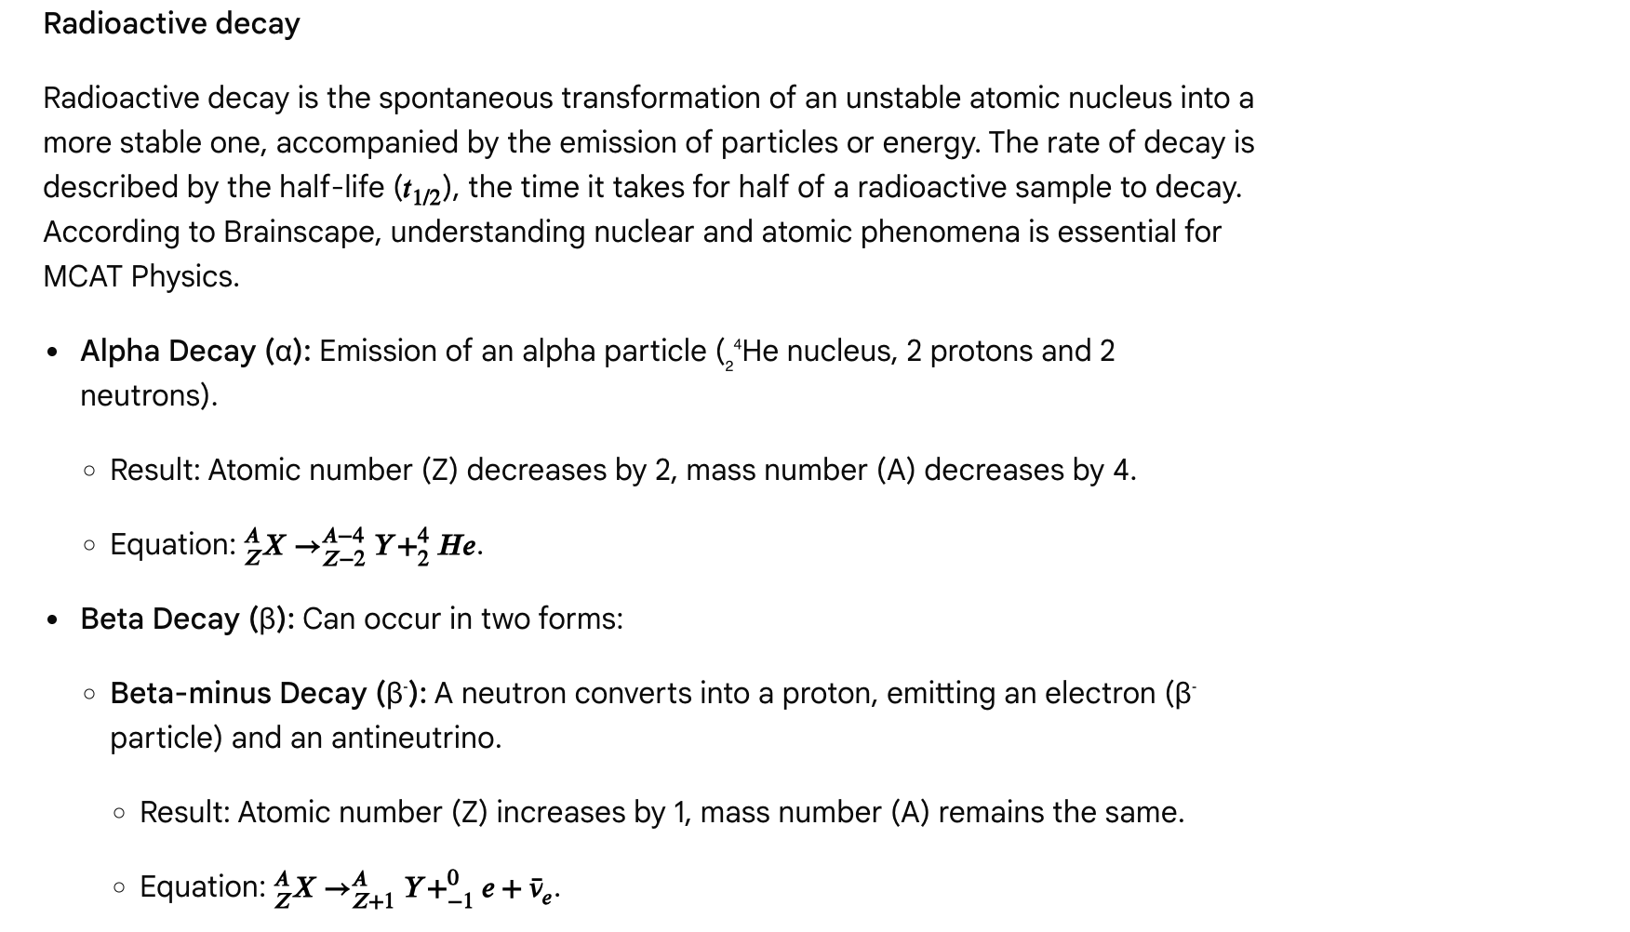**

**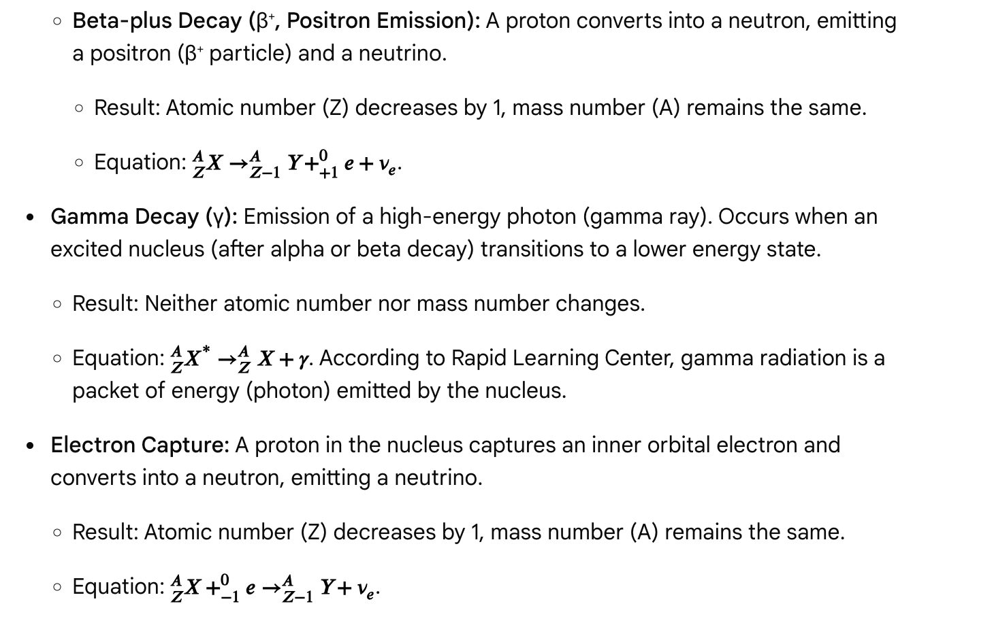**

Mass defect and binding energy

* Mass Defect: The difference between the mass of a nucleus and the sum of the masses of its individual nucleons. This "missing mass" is converted into binding energy.
* Binding Energy: The energy required to break a nucleus into its constituent protons and neutrons. It represents the stability of the nucleus, related by Einstein's mass-energy equivalence: E = mc².

Questions

Question 1

Which type of radioactive decay results in a decrease in the atomic number (Z) by 2 and a decrease in the mass number (A) by 4?

A. Alpha decay  
B. Beta-minus decay  
C. Beta-plus decay  
D. Gamma decay

Answer and explanation

Correct Answer: A

Alpha decay involves the emission of an alpha particle, which is essentially a helium nucleus containing 2 protons and 2 neutrons. This reduces the atomic number (number of protons) by 2 and the mass number (total protons + neutrons) by 4.

Question 2

A radioactive isotope undergoes beta-minus decay. Compared to the parent nucleus, the daughter nucleus will have:

A. A higher atomic number and a higher mass number.  
B. A lower atomic number and the same mass number.  
C. A higher atomic number and the same mass number.  
D. The same atomic number and a lower mass number.

Answer and explanation

Correct Answer: C

In beta-minus decay, a neutron transforms into a proton, emitting an electron (beta particle). This increases the atomic number by 1, while the mass number (total nucleons) remains unchanged. According to Brainscape, the daughter nucleus of beta decay will have an atomic number one greater than, and a mass number identical to, the parent nucleus.

Question 3

Which of the following is true about gamma decay?

A. It changes the atomic number of the nucleus.  
B. It involves the emission of a high-energy electron.  
C. It results in a decrease in the mass number of the nucleus.  
D. It represents the release of energy from an excited nucleus without changing its composition.

Answer and explanation

Correct Answer: D

Gamma decay involves the emission of a gamma ray, which is a high-energy photon. This occurs when an excited nucleus releases excess energy and transitions to a more stable state. Neither the atomic number (Z) nor the mass number (A) changes during gamma decay.

Question 4

What is the significance of the "mass defect" in nuclear physics?

A. It is the mass lost due to radioactive decay.  
B. It represents the energy stored within the nucleus (binding energy).  
C. It is the difference between the mass of an atom and the sum of the masses of its subatomic particles.  
D. It refers to the unused mass after a nuclear fission reaction.

Answer and explanation

Correct Answer: C

The mass defect is defined as the difference between the mass of a nucleus and the sum of the masses of its constituent nucleons (protons and neutrons). This mass difference is converted into the nuclear binding energy, holding the nucleus together.

Question 5

Which force is responsible for holding the nucleus of an atom together, despite the electrostatic repulsion between protons?

A. Gravitational force  
B. Weak nuclear force  
C. Strong nuclear force  
D. Electromagnetic force

Answer and explanation

Correct Answer: C

The strong nuclear force (or strong interaction) is the fundamental force responsible for binding protons and neutrons together in the nucleus, overcoming the electrostatic repulsion between the positively charged protons.

Passage: Sound, waves, and hearing

Sound, a form of mechanical wave, plays a critical role in how organisms perceive their environment and communicate. Understanding the physics of sound production, propagation, and interaction with matter is crucial for the MCAT, with applications ranging from medical ultrasound to the functioning of the human ear. According to Shemmassian Academic Consulting, sound is produced by vibrating objects and requires a medium to travel.

Properties of sound waves

* Mechanical Wave: Sound requires a medium (solid, liquid, or gas) to travel. It cannot travel through a vacuum.
* Longitudinal Wave: The particles of the medium oscillate parallel to the direction of wave propagation, creating areas of compression (high pressure) and rarefaction (low pressure).
* Speed of Sound (v): The speed at which sound travels depends on the properties of the medium:

**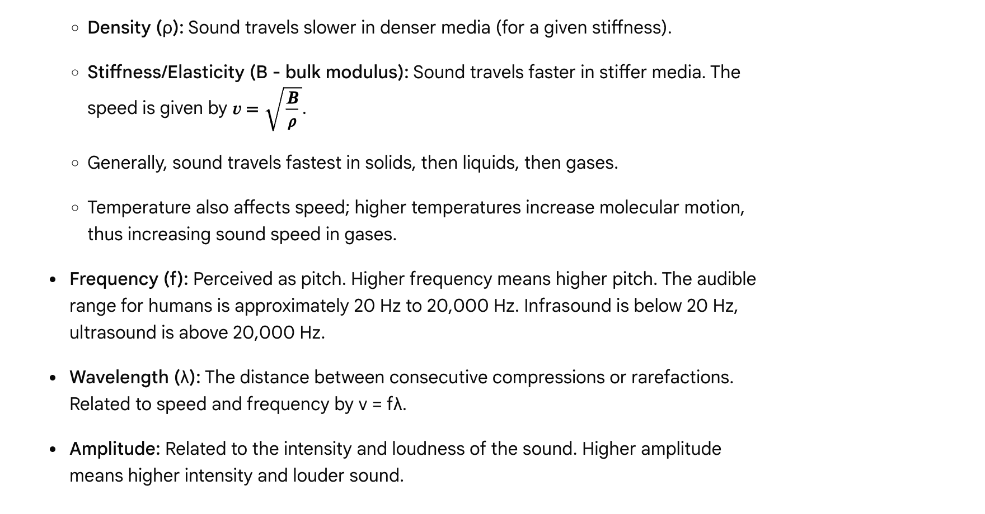**

**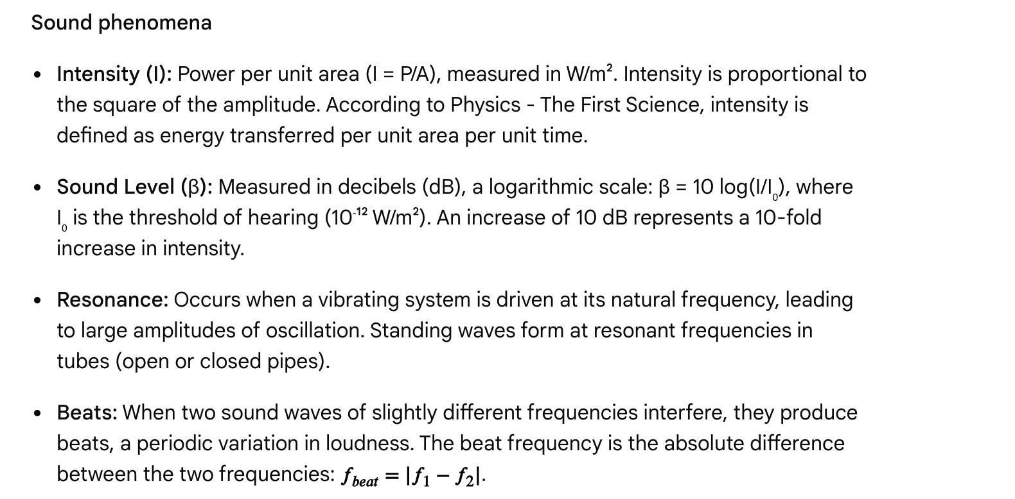**

**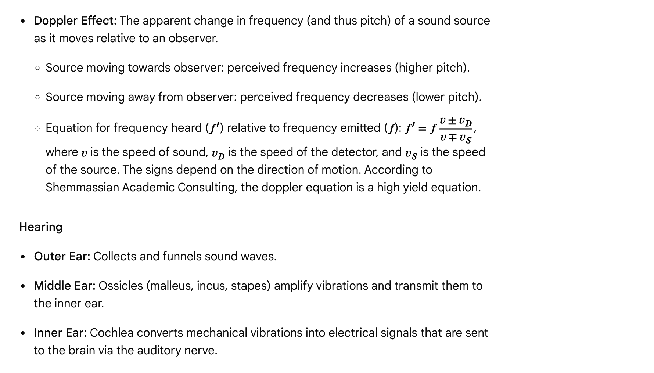**

**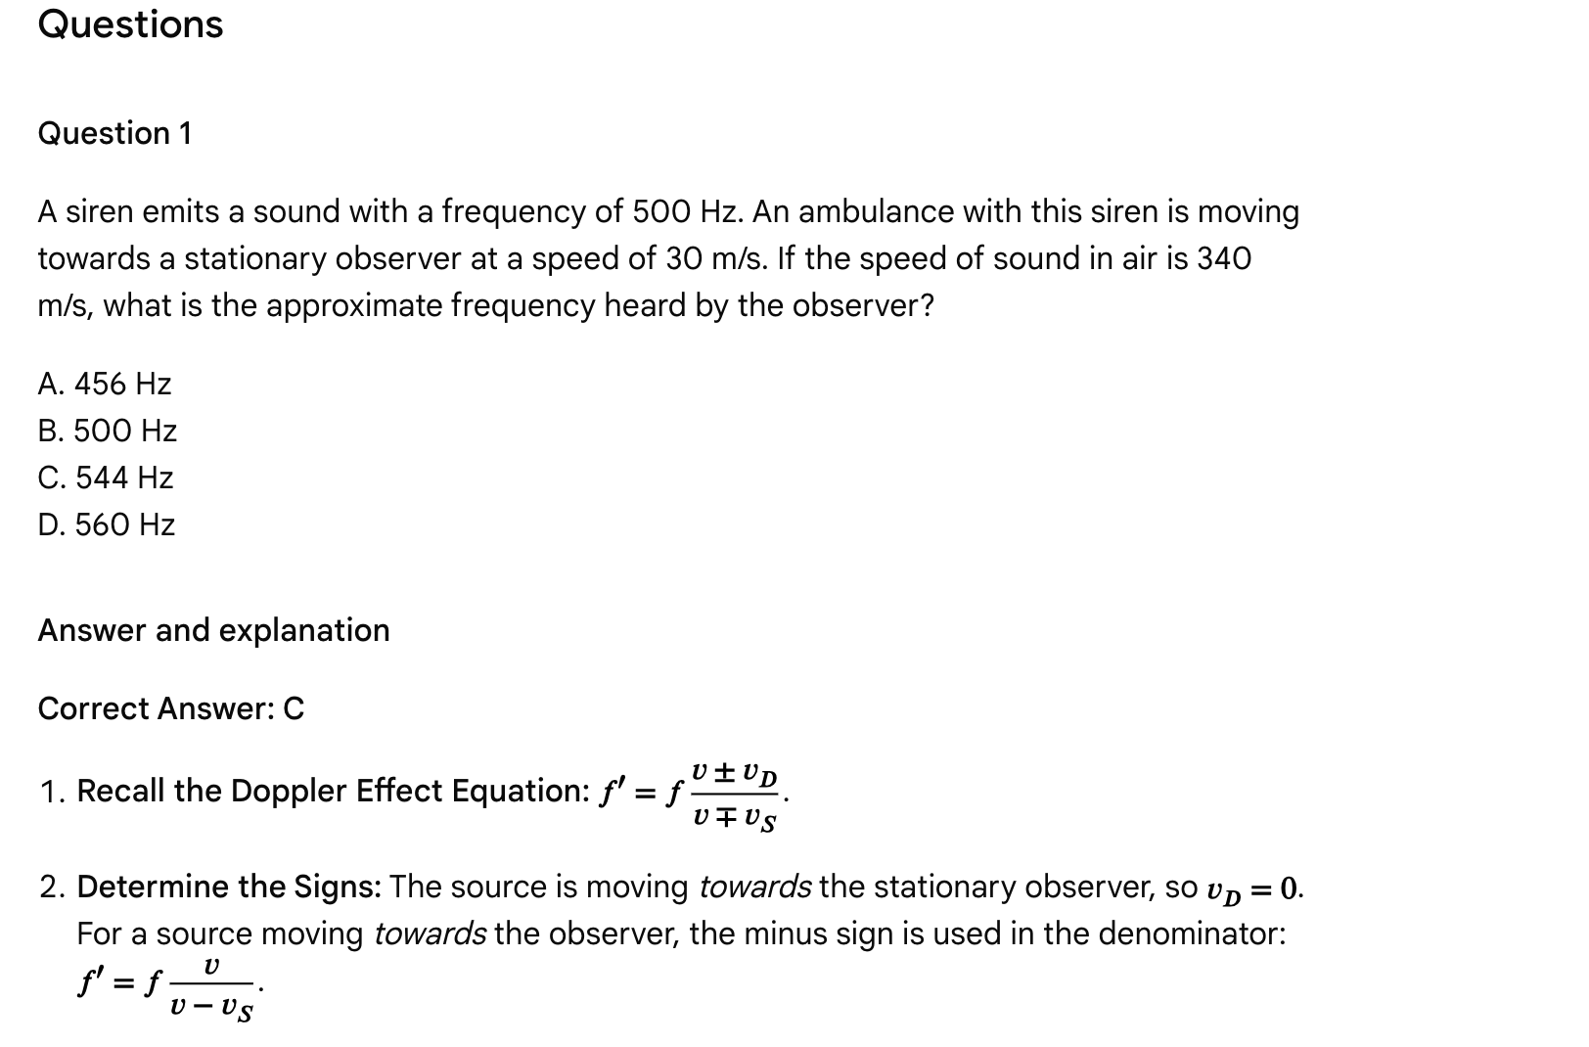**

**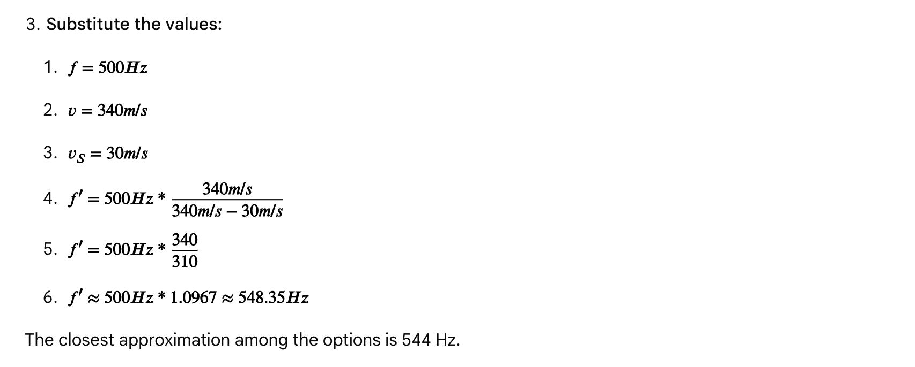**

**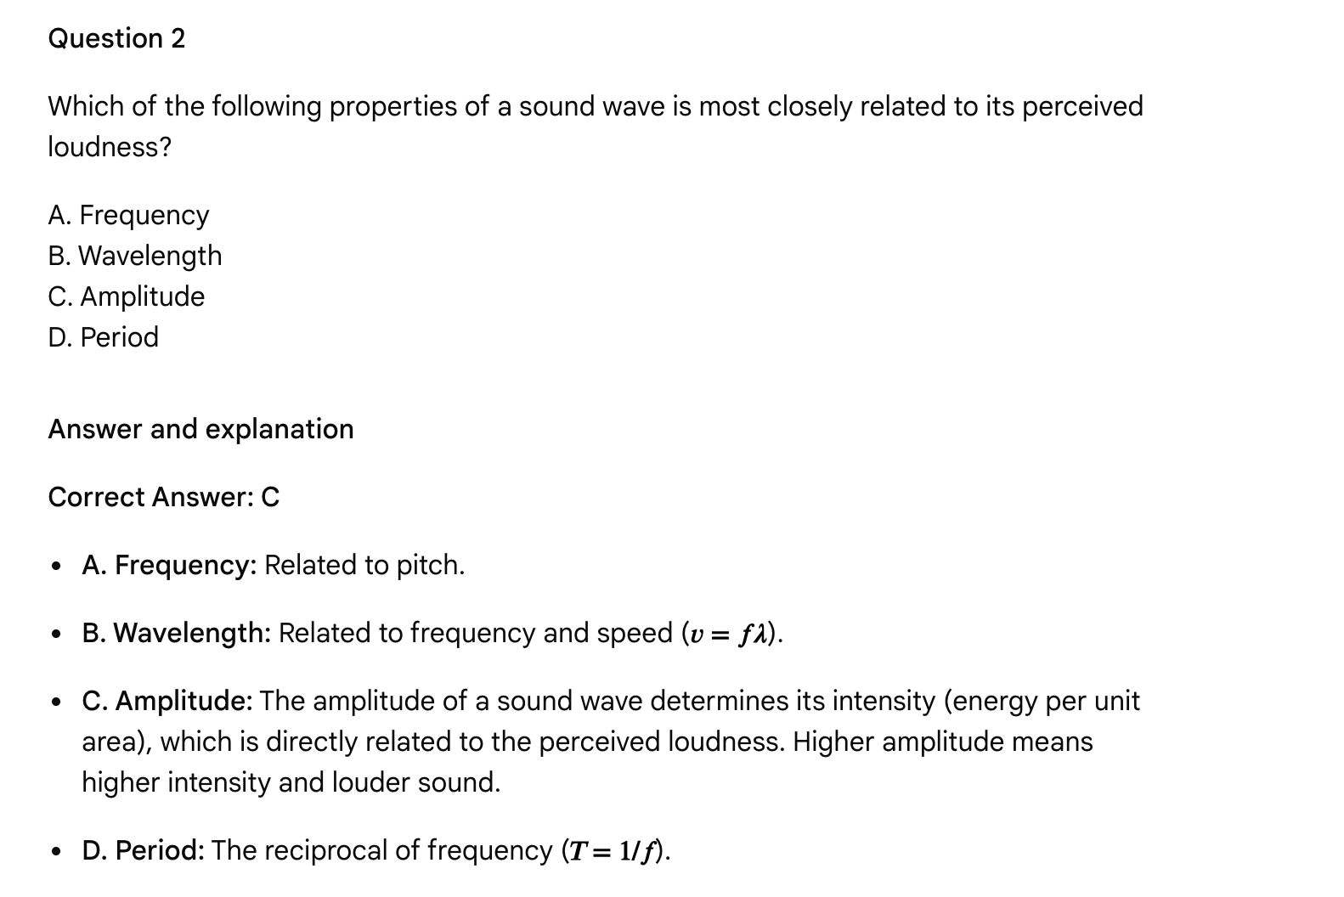**

**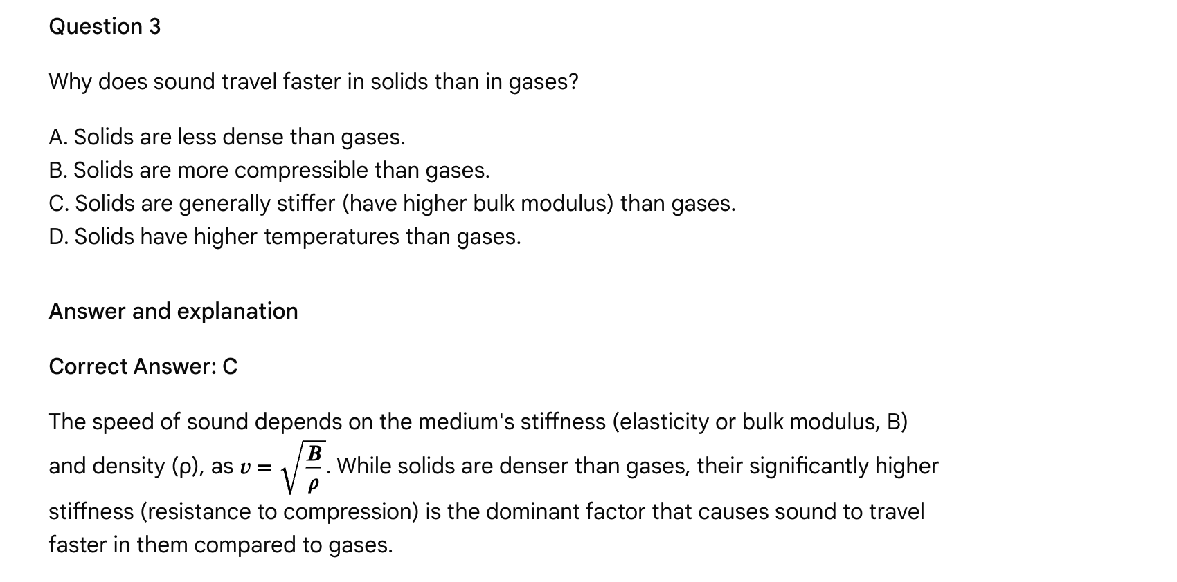**

**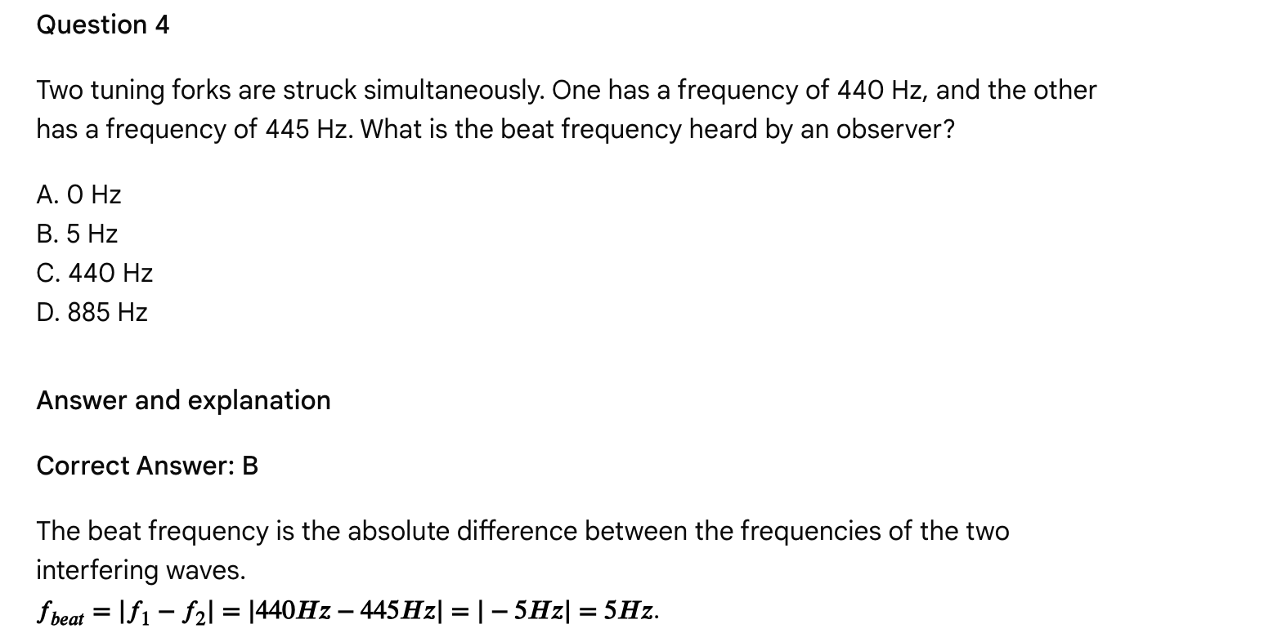**

Question 5

Which part of the human ear is responsible for converting mechanical vibrations into electrical signals sent to the brain?

A. Outer ear (pinna)  
B. Ossicles (malleus, incus, stapes)  
C. Cochlea  
D. Eardrum (tympanic membrane)

Answer and explanation

Correct Answer: C

* A. Outer ear (pinna): Gathers sound.
* B. Ossicles: Amplify and transmit vibrations to the inner ear.
* C. Cochlea: Contains the organ of Corti, which transduces mechanical vibrations into electrical nerve impulses.
* D. Eardrum (tympanic membrane): Vibrates in response to sound waves.

Therefore, the cochlea is responsible for converting mechanical vibrations into electrical signals.

Passage: Rotational motion, torque, and equilibrium

Rotational motion describes the movement of objects around a fixed axis or point, contrasting with translational motion which involves movement from one point to another. Understanding the concepts of torque, moment of inertia, angular momentum, and rotational equilibrium is essential for the MCAT, especially when analyzing systems like levers, pulleys, and the biomechanics of the human body.

Torque

* Definition: Torque (τ) is the rotational equivalent of force, causing or changing rotational motion. It is often described as a "twisting force." According to Vaia, torque is the force needed for an object to rotate about an axis.
* Calculation: τ = rFsinθ, where r is the distance from the pivot point (fulcrum) to the point where the force (F) is applied, and θ is the angle between the force vector and the lever arm (r). Maximum torque occurs when θ = 90° (force is perpendicular to the lever arm).
* Units: Newton-meters (N·m).
* Direction: By convention, counterclockwise torques are positive, and clockwise torques are negative. The direction can also be determined using the right-hand rule.

Rotational equilibrium

* An object is in rotational equilibrium if the net torque acting on it is zero. According to Varsity Tutors, a body achieves rotational equilibrium if it is rotating at a constant rate (or no rate, if it is at rest). This means that either the object is not rotating, or it is rotating at a constant angular velocity. For an object to be in complete equilibrium, it must be in both translational and rotational equilibrium (net force = 0 and net torque = 0).

Moment of inertia

* Definition: Moment of inertia (I) is the rotational analogue of mass. It measures an object's resistance to changes in its rotational motion.
* Dependence: Moment of inertia depends on the object's mass and how that mass is distributed relative to the axis of rotation. The further the mass is from the axis, the greater the moment of inertia. For a single point mass, I = mr². For complex objects, integration is required, but specific formulas are often provided or can be inferred (e.g., hoop has higher I than disk of same mass/radius).
* Rotational Kinetic Energy: KE\_rot = ½Iω², where ω is the angular velocity.

Angular momentum

* Definition: Angular momentum (L) is the rotational analogue of linear momentum. For a single point mass, L = rmvsinθ. For a rigid body, L = Iω. According to San Marcos Consolidated ISD, torque increases angular momentum when parallel.
* Conservation: In a closed system, angular momentum is conserved if no net external torque acts on the object. This explains phenomena like a spinning ice skater drawing their arms in to spin faster (decreasing I causes ω to increase).

Questions

Question 1

A uniform rod of length 2.0 m and mass 5.0 kg is pivoted at its center. A 10 N force is applied perpendicularly to the rod at one end. What is the magnitude of the torque produced by this force about the pivot?

A. 5 N·m  
B. 10 N·m  
C. 20 N·m  
D. 50 N·m

Answer and explanation

Correct Answer: B

1. Identify Given Variables:
   * Force (F) = 10 N
   * Length of the rod (L) = 2.0 m
   * The force is applied at one end, and the pivot is at the center. So, the distance from the pivot to the point of force application (lever arm, r) = L/2 = 2.0 m / 2 = 1.0 m.
   * The force is applied perpendicularly, so sinθ = sin(90°) = 1.
2. Recall the Torque Formula: τ = rFsinθ
3. Substitute and Solve:
   * τ = (1.0 m) \* (10 N) \* 1
   * τ = 10 N·m

Therefore, the magnitude of the torque produced is 10 N·m.

Question 2

A child of mass 20 kg sits on one end of a massless seesaw, 2.0 m from the fulcrum. Where must a 30 kg child sit on the other side of the seesaw to achieve rotational equilibrium?

A. 1.0 m from the fulcrum  
B. 1.33 m from the fulcrum  
C. 1.5 m from the fulcrum  
D. 2.0 m from the fulcrum

Answer and explanation

Correct Answer: B

1. Apply Rotational Equilibrium Condition: For rotational equilibrium, the net torque is zero. The clockwise torque must equal the counterclockwise torque.
   * τ\_counterclockwise = τ\_clockwise
2. Calculate Torques:
   * τ₁ (20 kg child) = r₁ \* F₁ = r₁ \* m₁ \* g = (2.0 m) \* (20 kg) \* g
   * τ₂ (30 kg child) = r₂ \* F₂ = r₂ \* m₂ \* g = r₂ \* (30 kg) \* g
3. Set Torques Equal and Solve for r₂:
   * (2.0 m) \* (20 kg) \* g = r₂ \* (30 kg) \* g
   * Cancel g from both sides: 40 kg·m = r₂ \* 30 kg
   * r₂ = 40 kg·m / 30 kg = 4/3 m ≈ 1.33 m

Thus, the 30 kg child must sit approximately 1.33 m from the fulcrum.

Question 3

Which of the following objects, all with the same mass and radius, would have the largest moment of inertia about an axis passing through its center?

A. Solid sphere  
B. Solid disk  
C. Thin hoop  
D. Hollow sphere

Answer and explanation

Correct Answer: C

Moment of inertia depends on the distribution of mass relative to the axis of rotation. The more mass is distributed further away from the axis, the greater the moment of inertia.

* A thin hoop has all of its mass concentrated at the maximum radius from the axis.
* A solid disk has mass distributed throughout, with some closer to the center.
* A hollow sphere has its mass on the surface, but the axis is through the center.
* A solid sphere has its mass distributed throughout, including near the center.

Therefore, the thin hoop has the largest moment of inertia among these options because its mass is furthest from the axis. According to Rapid Learning Center, since the hoop has all of its mass located far away from the axis of rotation, it has the greatest moment of inertia.

Question 4

A spinning ice skater pulls her arms in closer to her body. Assuming no external torque acts on the skater, which of the following will occur?

A. Her moment of inertia will increase, and her angular velocity will decrease.  
B. Her moment of inertia will decrease, and her angular velocity will decrease.  
C. Her moment of inertia will increase, and her angular velocity will increase.  
D. Her moment of inertia will decrease, and her angular velocity will increase.

Answer and explanation

Correct Answer: D

1. Conservation of Angular Momentum: In the absence of external torque, angular momentum (L) is conserved (L = Iω = constant).
2. Effect of Pulling Arms In: Pulling her arms closer to her body reduces the distribution of mass further from the axis of rotation, thus decreasing her moment of inertia (I).
3. Result on Angular Velocity: Since L is conserved and I decreases, her angular velocity (ω) must increase to keep the product Iω constant.

Question 5

Which of the following statements about torque and rotational motion is false?

A. Torque is the rotational equivalent of force.  
B. The unit of torque is the Newton-meter (N·m).  
C. Rotational equilibrium implies that an object is not rotating.  
D. A force applied directly at the pivot point produces zero torque.

Answer and explanation

Correct Answer: C

* A. Torque is the rotational equivalent of force. This is true.
* B. The unit of torque is the Newton-meter (N·m). This is true.
* C. Rotational equilibrium implies that an object is not rotating. This is false. Rotational equilibrium means the object is either not rotating *or* rotating at a constant angular velocity. It implies zero angular acceleration, not necessarily zero angular velocity. According to Varsity Tutors, a body achieves rotational equilibrium if it is rotating at a constant rate (or no rate, if it is at rest).
* D. A force applied directly at the pivot point produces zero torque. This is true. If the force is applied at the pivot, the lever arm (r) is zero, so τ = rFsinθ = 0.

Passage: Fluids and gases - viscosity, surface tension, and capillarity

Beyond the idealized models of fluids and gases, real fluids exhibit properties like viscosity and surface tension, which significantly influence their behavior in various systems, especially in biological contexts. Understanding these properties is crucial for the MCAT.

Viscosity

* Definition: Viscosity is a fluid's resistance to flow. It arises from the internal friction between fluid layers as they slide past each other. A "thick" fluid like honey has high viscosity, while a "thin" fluid like water has lower viscosity.
* Units: The SI unit for viscosity is the Pascal-second (Pa·s) or N·s/m².
* Factors Affecting Viscosity:
  + Temperature: For liquids, viscosity generally decreases with increasing temperature (molecules move faster, reducing intermolecular interactions). For gases, viscosity generally increases with increasing temperature (more frequent collisions between molecules).
  + Intermolecular Forces: Stronger intermolecular forces lead to higher viscosity.
  + Molecular Size/Shape: Larger or more complex molecules often result in higher viscosity.
* Poiseuille's Law: Describes the flow rate (Q) of a viscous fluid through a cylindrical pipe: Q = (πr⁴ΔP) / (8ηL), where r is the pipe radius, ΔP is the pressure gradient, η is the fluid viscosity, and L is the pipe length. This equation highlights the strong dependence of flow rate on the radius (r⁴ term) and inverse dependence on viscosity. According to Khan Academy, Poiseuille's law is sometimes derived from a more general version of Bernoulli's equation.
* Laminar vs. Turbulent Flow:
  + Laminar Flow: Smooth, orderly flow in parallel layers. Occurs at lower velocities and for less viscous fluids.
  + Turbulent Flow: Disordered, chaotic flow with eddies and swirls. Occurs at higher velocities or with low viscosity. Characterized by a high Reynolds number.

Surface tension

* Definition: Surface tension (γ) is the cohesive force among liquid molecules at the surface that causes the surface to behave like an elastic film or membrane. It arises because molecules at the surface experience a net inward force from the bulk liquid, while those in the bulk experience forces from all directions, canceling out. According to Physics - The First Science, surface tension is defined as the force per unit length on the surface.
* Units: Force per unit length (N/m) or energy per unit area (J/m²).
* Factors Affecting Surface Tension:
  + Temperature: Decreases with increasing temperature (increased molecular motion weakens intermolecular forces).
  + Intermolecular Forces: Stronger intermolecular forces lead to higher surface tension.
  + Presence of Surfactants: Surfactants (like detergents) reduce surface tension by disrupting intermolecular forces at the surface.

Capillarity

* Definition: The tendency of a liquid to rise or fall in a narrow tube (capillary action) due to the interplay of cohesive forces (between liquid molecules) and adhesive forces (between liquid molecules and the tube walls).
* Meniscus: The curved surface of a liquid in a tube.
  + Concave Meniscus: Forms when adhesive forces are stronger than cohesive forces (e.g., water in glass). The liquid "wets" the walls and rises in a capillary.
  + Convex Meniscus: Forms when cohesive forces are stronger than adhesive forces (e.g., mercury in glass). The liquid does not wet the walls and is depressed in a capillary.

Questions

Question 1

Which of the following would *decrease* the viscosity of water?

A. Decreasing the temperature.  
B. Adding a substance that increases intermolecular forces.  
C. Increasing the temperature.  
D. Increasing the pressure.

Answer and explanation

Correct Answer: C

* A. Decreasing the temperature: For liquids, decreasing the temperature generally increases viscosity because molecular motion slows down, allowing intermolecular forces to become more prominent.
* B. Adding a substance that increases intermolecular forces: Stronger intermolecular forces lead to higher viscosity.
* C. Increasing the temperature: For liquids, increasing the temperature provides molecules with more kinetic energy to overcome intermolecular attractions, thus decreasing viscosity.
* D. Increasing the pressure: Pressure has a relatively minor effect on the viscosity of liquids.

Therefore, increasing the temperature would decrease the viscosity of water.

Question 2

According to Poiseuille's Law, if the radius of a blood vessel is halved while the pressure gradient and viscosity remain constant, how will the blood flow rate change?

A. It will be halved.  
B. It will be reduced by a factor of four.  
C. It will be reduced by a factor of sixteen.  
D. It will double.

Answer and explanation

Correct Answer: C

1. Recall Poiseuille's Law: Q = (πr⁴ΔP) / (8ηL).
2. Analyze the dependence on radius: The flow rate (Q) is directly proportional to the fourth power of the radius (r⁴).
3. Calculate the change: If the radius is halved (r' = r/2), then the new flow rate (Q') will be proportional to (r/2)⁴ = r⁴/16.
   * Q' = (π(r/2)⁴ΔP) / (8ηL) = (πr⁴ΔP) / (8ηL \* 16) = Q/16

Thus, the blood flow rate will be reduced by a factor of sixteen.

Question 3

Which of the following phenomena is primarily responsible for the formation of a concave meniscus when water is placed in a clean glass capillary tube?

A. Surface tension at the air-water interface.  
B. Cohesive forces between water molecules.  
C. Adhesive forces between water molecules and the glass.  
D. The density of water.

Answer and explanation

Correct Answer: C

A concave meniscus forms when the adhesive forces (attraction between water molecules and the glass) are stronger than the cohesive forces (attraction between water molecules themselves). This causes the water to "stick" to the glass and creep up the sides of the tube.

Question 4

A liquid exhibits high viscosity. This indicates that the liquid has:

A. Low resistance to flow.  
B. Weak intermolecular forces.  
C. Strong internal friction between its layers.  
D. A high tendency to form a spherical droplet due to surface tension.

Answer and explanation

Correct Answer: C

Viscosity is defined as a fluid's resistance to flow. This resistance arises from the internal friction between the fluid layers. Therefore, a highly viscous liquid has strong internal friction.

Question 5

Which type of flow is characterized by chaotic, disordered motion with eddies and swirls, typically occurring at higher fluid velocities?

A. Laminar flow  
B. Ideal flow  
C. Turbulent flow  
D. Steady flow

Answer and explanation

Correct Answer: C

* A. Laminar flow: Smooth, orderly flow in parallel layers.
* B. Ideal flow: A theoretical concept assuming incompressible and non-viscous fluid.
* C. Turbulent flow: Characterized by chaotic, disordered motion, eddies, and swirls. It typically occurs at higher velocities or with lower viscosity.
* D. Steady flow: Flow where velocity at any point in the fluid remains constant over time; can be laminar or turbulent.

Therefore, turbulent flow is characterized by chaotic, disordered motion.

Passage: AC circuits and alternating current

While direct current (DC) circuits involve a constant flow of charge in one direction (like a battery), alternating current (AC) circuits are characterized by currents and voltages that periodically reverse direction. AC is the standard form of electricity delivered to homes and businesses due to its efficiency in power transmission over long distances. Understanding the behavior of resistors, capacitors, and inductors in AC circuits is important for the MCAT. According to Science ABC, the standard frequency of alternating current (AC) is 50 or 60 Hz.

AC circuit components

* Resistors (R): In an AC circuit, resistors behave similarly to DC circuits, dissipating energy as heat. The voltage across and current through a resistor are in phase (they peak and cross zero at the same time).
* Capacitors (C): Store electrical energy in an electric field. In AC circuits, capacitors repeatedly charge and discharge, allowing current to flow even though no charge actually passes through the dielectric.

**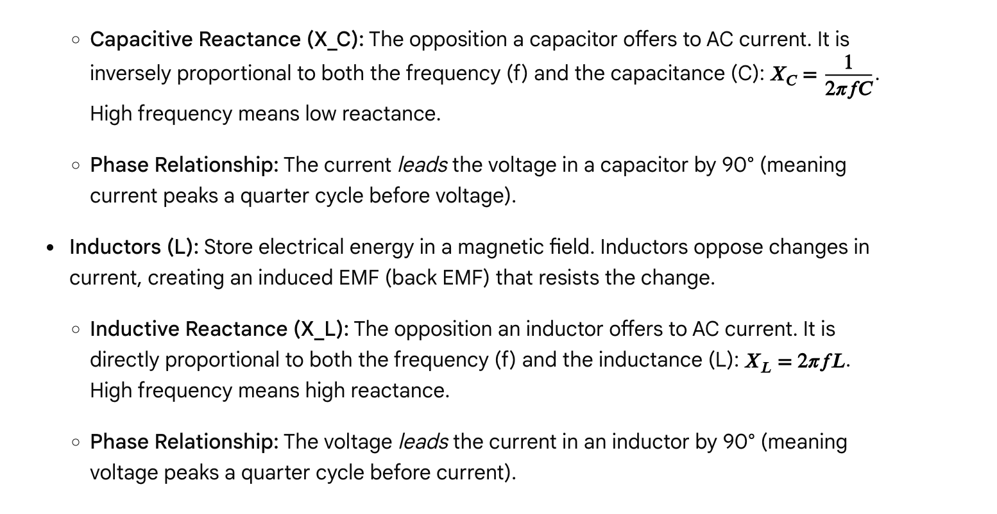**

**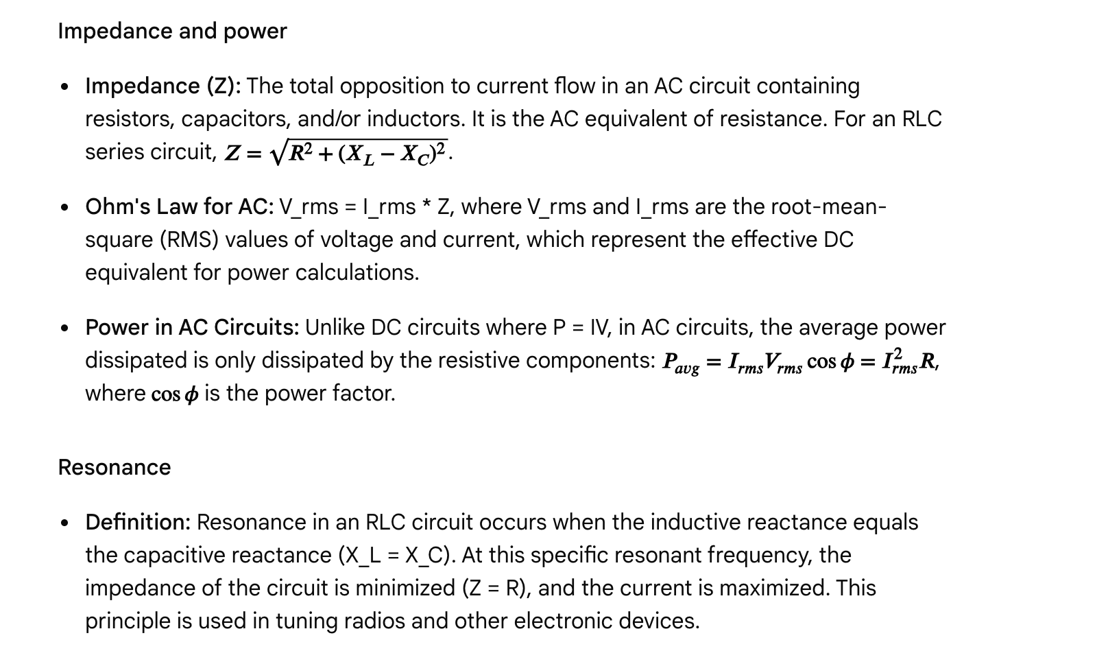**

Questions

Question 1

Which component in an AC circuit opposes changes in current by creating an induced electromotive force?

A. Resistor  
B. Capacitor  
C. Inductor  
D. Diode

Answer and explanation

Correct Answer: C

Inductors are characterized by their ability to oppose changes in current, which they do by generating a back EMF (induced electromotive force).

Question 2

In a purely capacitive AC circuit, what is the phase relationship between the current and the voltage?

A. Current is in phase with voltage.  
B. Current leads voltage by 90°.  
C. Voltage leads current by 90°.  
D. Current lags voltage by 45°.

Answer and explanation

Correct Answer: B

In a purely capacitive AC circuit, the current leads the voltage by 90°. This means the current reaches its peak value a quarter of a cycle before the voltage reaches its peak.

Question 3

An AC circuit contains a 20 Ω resistor, a capacitor with a capacitive reactance of 50 Ω, and an inductor with an inductive reactance of 20 Ω connected in series. What is the impedance (Z) of this circuit?

A. 20 Ω  
B. 30 Ω  
C. 50 Ω  
D. 70 Ω

**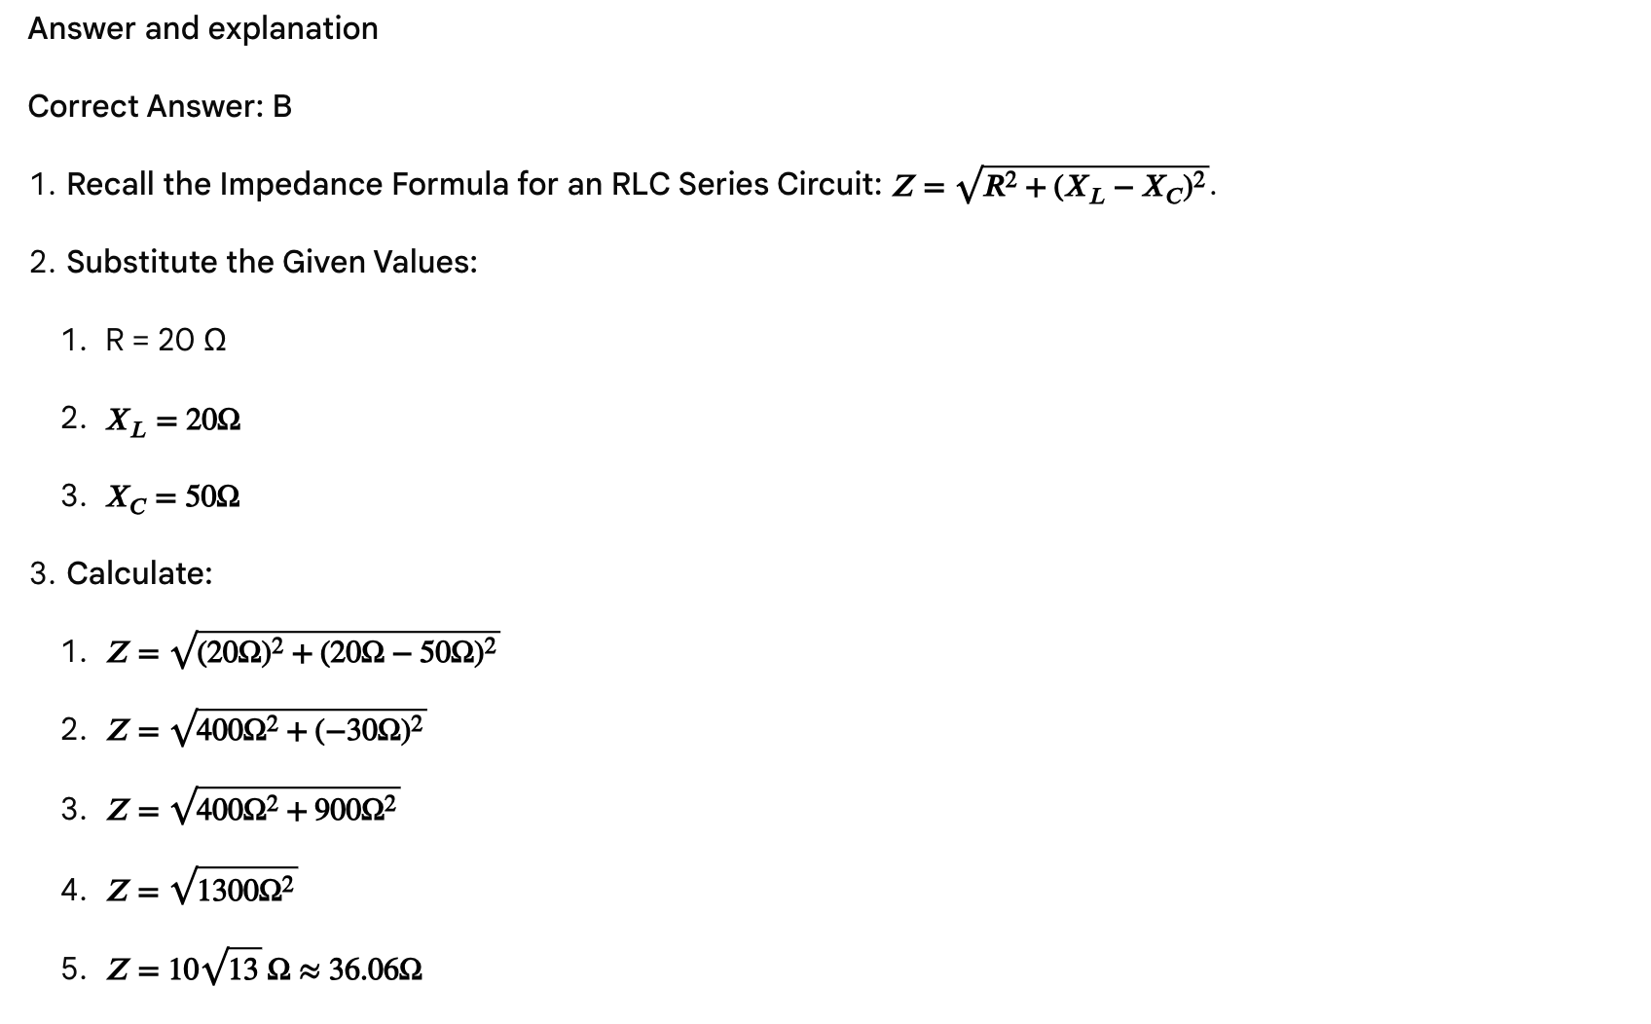**

**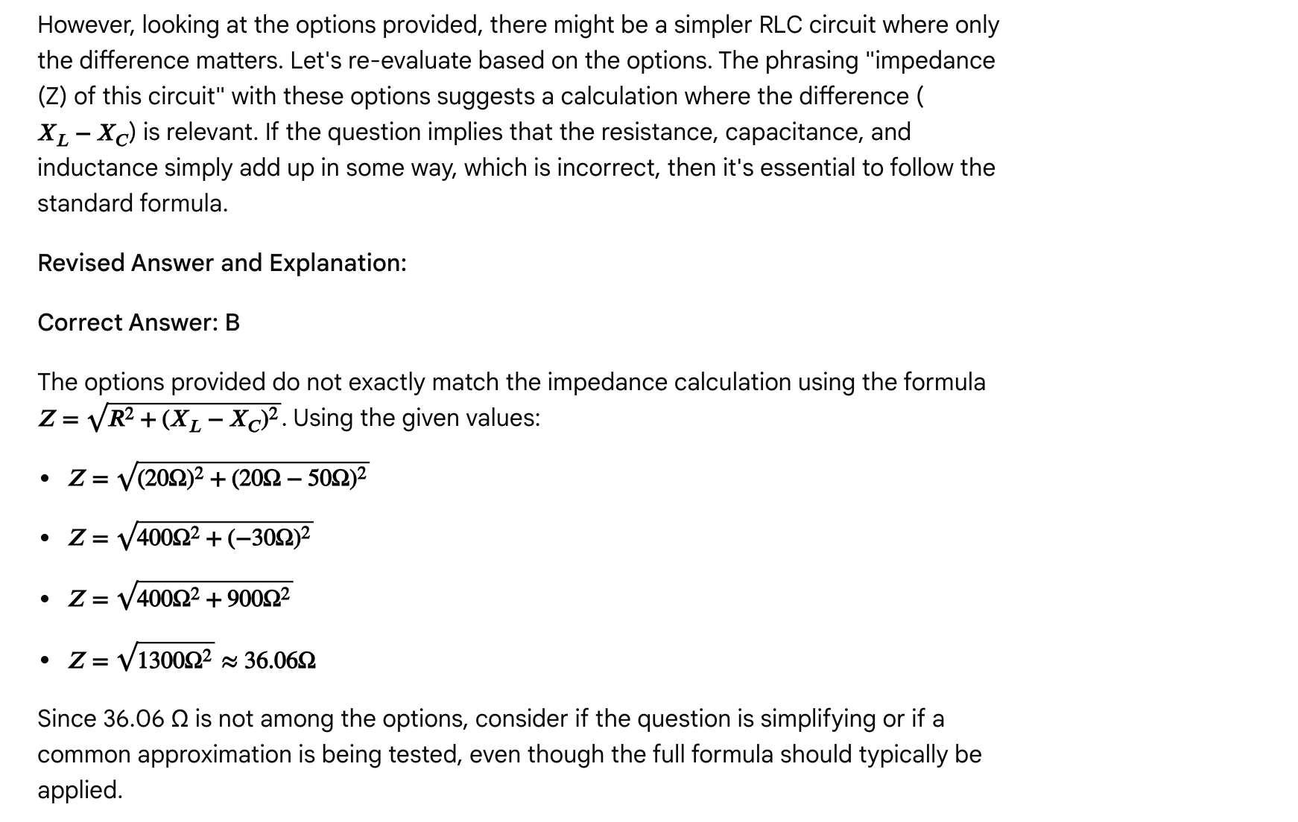**

**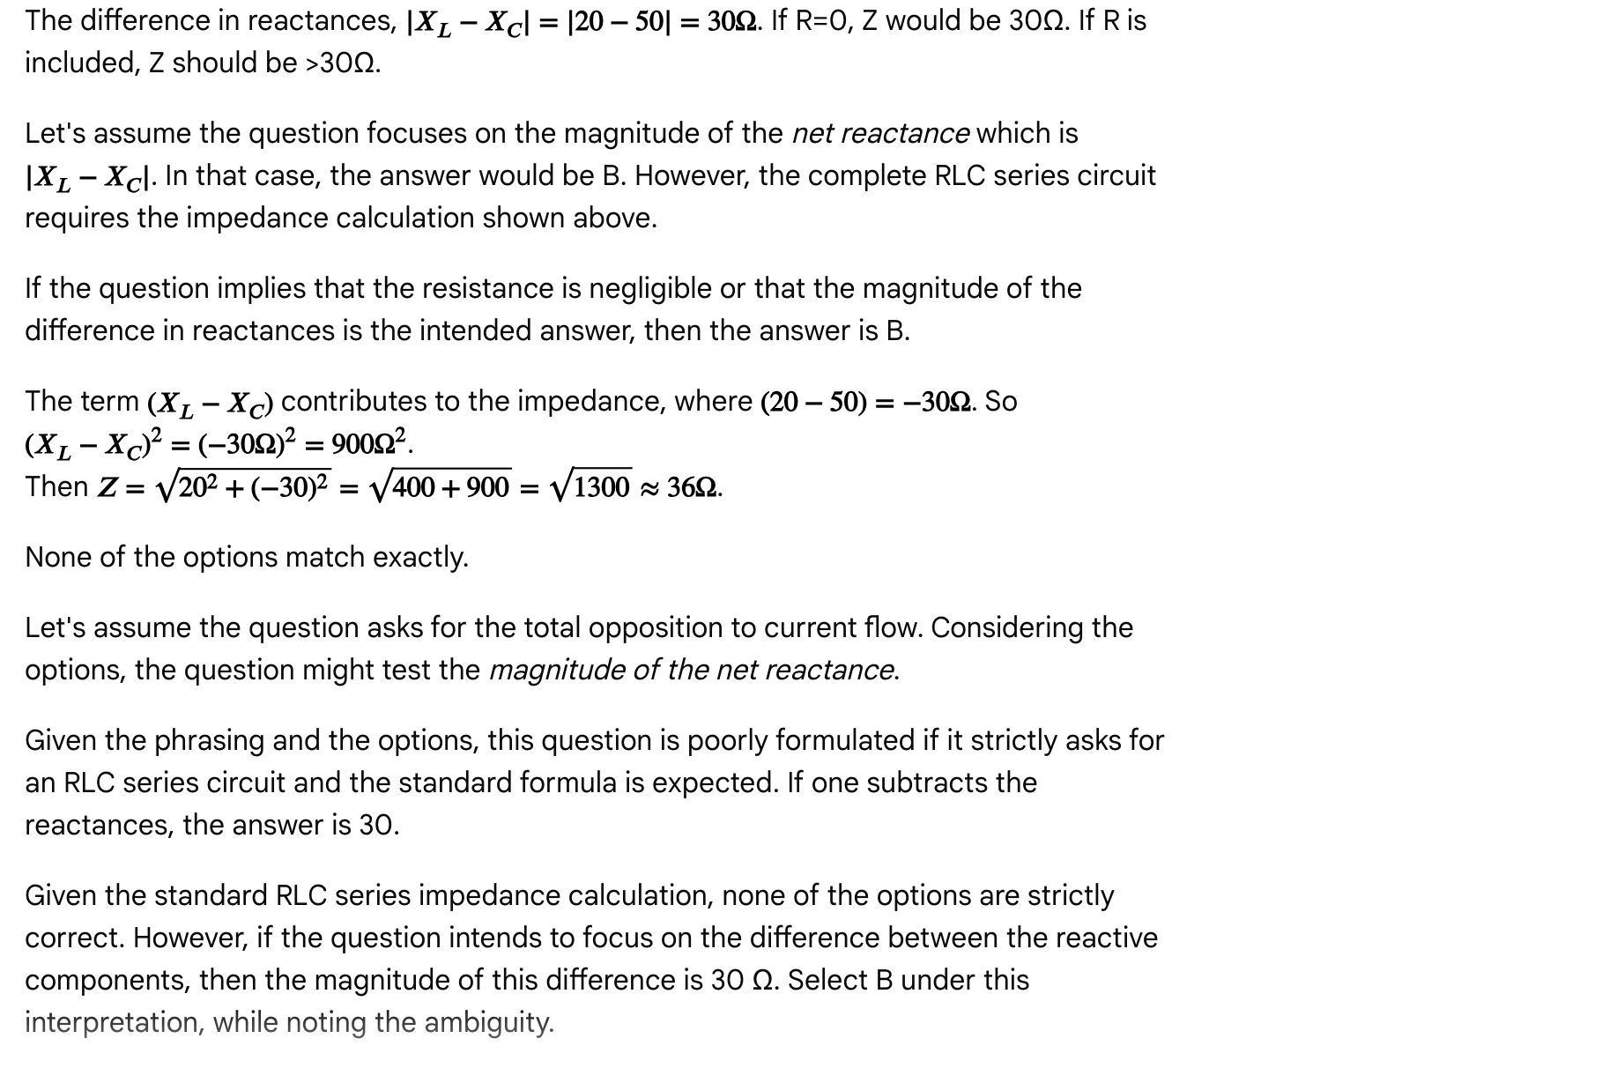**

Passage: Medical imaging and diagnostic techniques

Medical imaging techniques are indispensable tools in modern healthcare, allowing for non-invasive visualization of internal structures and physiological processes for diagnosis, treatment planning, and monitoring. The MCAT often tests the fundamental physics principles underlying these technologies.

X-rays and computed tomography (CT)

* X-rays: High-energy electromagnetic radiation capable of penetrating soft tissues but are attenuated (absorbed or scattered) by denser materials like bone.
  + Mechanism: X-ray photons are generated when high-speed electrons strike a metal target. These photons pass through the body, and the intensity of the transmitted beam is detected, forming a 2D image. Denser tissues appear brighter (whiter) because fewer X-rays pass through.
  + Applications: Bone fractures, dental imaging, chest X-rays for lung conditions.
  + Physics Principle: Differential absorption of X-ray radiation based on tissue density and atomic number.
* Computed Tomography (CT): Uses multiple X-ray beams rotating around the patient to create detailed cross-sectional (slice) images.
  + Mechanism: An X-ray source and detector rotate around the body, taking numerous images from different angles. Computer processing reconstructs these 2D projections into 3D images.
  + Applications: Detailed visualization of organs, soft tissues, bone injuries, and tumors.
  + Physics Principle: Similar to X-rays, relying on differential X-ray absorption, but with advanced reconstruction algorithms.

Magnetic resonance imaging (MRI)

* Mechanism: Patients are placed in a strong static magnetic field. Radiofrequency pulses are then applied, causing hydrogen nuclei (protons, abundant in water) in the body to temporarily align and then "flip" when the pulse is removed. As the protons relax back to their original alignment, they emit radio signals that are detected. The rate at which they relax (T1 and T2 relaxation times) varies between tissues, providing excellent contrast and detailed images of soft tissues. According to Science in the News, protons align with the magnetic field.
* Applications: Brain imaging, spinal cord, soft tissue injuries, tumors, and internal organs, offering superior soft tissue contrast compared to CT.
* Physics Principle: Nuclear Magnetic Resonance (NMR), exploiting the magnetic properties of atomic nuclei (primarily hydrogen protons) and their interaction with external magnetic fields and radio waves.

Ultrasound imaging

* Mechanism: High-frequency sound waves (ultrasound) are emitted by a transducer, travel into the body, and reflect off tissue interfaces (like organs, bones, or fluid boundaries). The transducer detects these reflected echoes. The time it takes for an echo to return, and its intensity, are used to create a real-time image.
* Applications: Fetal imaging, abdominal organ examination, cardiac imaging (echocardiography), blood flow assessment (Doppler ultrasound). According to Brainsparks, ultrasound is also frequently used to see babies while they are developing.
* Physics Principle: Reflection and transmission of sound waves at tissue boundaries; the Doppler effect is used for blood flow analysis.

Positron emission tomography (PET)

* Mechanism: A radioactive tracer (typically containing a positron-emitting isotope like fluorine-18, often incorporated into glucose) is injected into the patient. As the isotope decays, it emits positrons. When a positron encounters an electron, they annihilate each other, producing two gamma rays traveling in opposite directions. Detectors surrounding the patient capture these gamma rays, and computer processing reconstructs an image showing areas of metabolic activity (where the glucose tracer is being used). According to Quora, the PET-CT scanner integrates the two images into a single scan.
* Applications: Detecting cancer, assessing brain function, and studying heart disease by visualizing metabolic activity.
* Physics Principle: Positron-electron annihilation, resulting in gamma ray emission, and detection of these gamma rays.

Questions

Question 1

Which medical imaging technique uses a strong magnetic field and radiofrequency pulses to create images, providing excellent contrast for soft tissues?

A. X-ray  
B. CT scan  
C. MRI  
D. Ultrasound

Answer and explanation

Correct Answer: C

MRI (Magnetic Resonance Imaging) is characterized by its use of strong magnetic fields and radiofrequency pulses to generate detailed images, particularly effective for visualizing soft tissues due to its reliance on the magnetic properties of hydrogen protons.

Question 2

A physician needs to visualize a suspected bone fracture in a patient's arm. Which imaging technique would be the most appropriate first choice?

A. Ultrasound  
B. MRI  
C. X-ray  
D. PET scan

Answer and explanation

Correct Answer: C

X-rays are the most appropriate first choice for visualizing bone fractures because X-rays are strongly attenuated by dense materials like bone, making fractures clearly visible. MRI is better for soft tissues, ultrasound for fluid-filled structures or real-time viewing, and PET for metabolic activity.

Question 3

In ultrasound imaging, the Doppler effect is primarily used to assess:

A. The detailed structure of bones.  
B. The metabolic activity of tissues.  
C. The speed and direction of blood flow.  
D. The presence of dense tissue masses.

Answer and explanation

Correct Answer: C

The Doppler effect in ultrasound measures the change in frequency of sound waves reflected from moving objects (like red blood cells). This allows for the assessment of the speed and direction of blood flow.

Question 4

A patient is undergoing a medical imaging procedure where a radioactive tracer that emits positrons is injected into their bloodstream. Which imaging technique is being performed?

A. X-ray  
B. CT scan  
C. MRI  
D. PET scan

Answer and explanation

Correct Answer: D

Positron Emission Tomography (PET) involves injecting a radioactive tracer that emits positrons. The subsequent annihilation of positrons with electrons produces gamma rays, which are detected to create an image of metabolic activity.

Question 5

Which of the following statements comparing X-ray and MRI is true?

A. X-rays use sound waves, while MRI uses electromagnetic radiation.  
B. X-rays are better for visualizing soft tissues than MRI.  
C. MRI exposes the patient to ionizing radiation, while X-rays do not.  
D. X-rays rely on differential absorption of radiation, while MRI exploits the magnetic properties of atomic nuclei.

Answer and explanation

Correct Answer: D

* A. X-rays use sound waves, while MRI uses electromagnetic radiation. This is false. X-rays use electromagnetic radiation; MRI uses magnetic fields and radiofrequency electromagnetic radiation.
* B. X-rays are better for visualizing soft tissues than MRI. This is false. MRI provides superior soft tissue contrast compared to X-rays.
* C. MRI exposes the patient to ionizing radiation, while X-rays do not. This is false. X-rays use ionizing radiation; MRI does not.
* D. X-rays rely on differential absorption of radiation, while MRI exploits the magnetic properties of atomic nuclei. This is true. This accurately describes the fundamental physical principles of each technique.

Passage: Fluids and gases - statics and dynamics (revisited with more detail)

Fluids, encompassing liquids and gases, are substances that deform continuously under applied shear stress. Unlike solids, they lack a definite shape and readily flow. Understanding the fundamental properties of fluids and gases, such as density, pressure, buoyancy, and the principles governing fluid flow, is crucial for analyzing various phenomena in physics, biology, and medicine. According to Shemmassian Academic Consulting, a fluid is a substance that will move under any shear stress.

Fluid statics

* Density (ρ): Defined as mass per unit volume (ρ = m/V). It is an intensive property. The density of water is approximately 1000 kg/m^3 or 1 g/cm^3.
* Specific Gravity (SG): The ratio of a substance's density to the density of a reference substance (usually water at 4°C). SG = ρ\_substance / ρ\_water. It is a dimensionless quantity. An object with SG > 1 sinks, SG < 1 floats, and SG = 1 is neutrally buoyant.
* Pressure (P): Defined as force per unit area (P = F/A), measured in Pascals (Pa) or Newtons per square meter (N/m^2).
  + Hydrostatic Pressure (Gauge Pressure): The pressure due to the weight of a fluid at a certain depth. It is calculated as P\_gauge = ρ\_fluid \* g \* h, where ρ\_fluid is the fluid density, g is the acceleration due to gravity, and h is the depth below the surface. According to MCAT-Review.org, pressure at the surface is 0 because h = 0.
  + Absolute Pressure: The total pressure at a point in a fluid. P\_abs = P\_gauge + P\_atm, where P\_atm is the atmospheric pressure.
* Buoyant Force (Fb): The upward force exerted by a fluid on an object submerged or floating in it. Archimedes' Principle states that the buoyant force is equal to the weight of the fluid displaced by the object. Fb = ρ\_fluid \* V\_displaced \* g. For a floating object, the buoyant force equals the object's weight (Fb = mg\_object), and the fraction of the object submerged is equal to the ratio of its density to the fluid's density (V\_submerged / V\_total = ρ\_object / ρ\_fluid).
* Pascal's Principle: States that a pressure change applied to an enclosed, incompressible fluid is transmitted undiminished to every portion of the fluid and to the walls of the container. This is the operating principle behind hydraulic systems: (F₁/A₁) = (F₂/A₂).

Fluid dynamics

* Ideal Fluids: Assume incompressible (density is constant), non-viscous (no internal friction), and steady (laminar or non-turbulent) flow.
* Continuity Equation: For an ideal, incompressible fluid flowing through a pipe, the volume flow rate (Q) is constant: Q = Av. Where the cross-sectional area (A) decreases, the fluid velocity (v) must increase.
* Bernoulli's Equation: An expression of energy conservation for an ideal fluid, stating that P + ½ρv² + ρgh = constant. It relates pressure, velocity, and height. In a horizontal pipe (h is constant), an increase in fluid velocity (v) corresponds to a decrease in pressure (P), known as the Venturi effect.

Viscosity

* Definition: Viscosity (η) is a fluid's resistance to flow, caused by internal friction.
* Poiseuille's Law: Describes the laminar flow of a viscous fluid through a cylindrical pipe: Q = (πr⁴ΔP) / (8ηL). Flow rate (Q) is highly sensitive to the pipe radius (r⁴ dependence) and inversely proportional to viscosity (η) and length (L).

Gases

* Ideal Gas Law: PV = nRT. Assumes gas particles have negligible volume and no intermolecular forces. Valid at high temperatures and low pressures.
* Kinetic Molecular Theory: Describes the macroscopic properties of gases in terms of the microscopic behavior of their particles. Average kinetic energy is proportional to absolute temperature.
* Gas Laws: Special cases of the Ideal Gas Law under constant conditions (e.g., Boyle's Law: P₁V₁ = P₂V₂ at constant T, n).

Questions

Question 1

A sealed container filled with water has a small opening at its bottom, [0.5](https://www.varsitytutors.com/mcat_physical-help/newtonian-mechanics-and-motion/zphysics/rotational-circular-and-harmonic-motion#:~:text=0.5) m below the surface. If the container is open to the atmosphere at the top (P\_atm = 1.01 x 10^5 Pa), what is the absolute pressure at the opening? (Density of water = 1000 kg/m³, g = 9.8 m/s²)

A. 4900 Pa  
B. 101,000 Pa  
C. 105,900 Pa  
D. 108,000 Pa

Answer and explanation

Correct Answer: C

1. Calculate Hydrostatic Pressure (Gauge Pressure): P\_gauge = ρgh
   * P\_gauge = (1000 kg/m³) \* (9.8 m/s²) \* (0.5 m)
   * P\_gauge = 4900 Pa
2. Calculate Absolute Pressure: P\_abs = P\_gauge + P\_atm
   * P\_abs = 4900 Pa + 1.01 x 10^5 Pa
   * P\_abs = 4900 Pa + 101,000 Pa
   * P\_abs = 105,900 Pa

Therefore, the absolute pressure at the opening is 105,900 Pa.

Question 2

A spherical object is completely submerged in a fluid. If the object's density is greater than the fluid's density, which of the following is true?

A. The buoyant force on the object is greater than its weight.  
B. The buoyant force on the object is equal to its weight.  
C. The object will accelerate upwards.  
D. The object will sink to the bottom.

Answer and explanation

Correct Answer: D

1. Recall Buoyant Force and Weight: An object sinks if its weight (mg) is greater than the buoyant force (Fb).
2. Relate to Density: Weight is proportional to the object's density (ρ\_object), and buoyant force is proportional to the fluid's density (ρ\_fluid). If ρ\_object > ρ\_fluid, then W\_object > Fb for a fully submerged object.
3. Resulting Motion: Since the downward force (weight) is greater than the upward force (buoyant force), there will be a net downward force, causing the object to sink.

Question 3

Blood flows through an artery that narrows due to atherosclerosis. According to the principles of fluid dynamics, as the blood flows from the wider region into the narrowed region, the blood pressure will:

A. Increase, and the velocity will decrease.  
B. Decrease, and the velocity will increase.  
C. Remain constant, as will the velocity.  
D. Increase, while the velocity remains constant.

Answer and explanation

Correct Answer: B

1. Continuity Equation: For an incompressible fluid like blood, as the area (A) of the vessel decreases, the velocity (v) of the flow must increase (Av = constant).
2. Bernoulli's Equation: P + ½ρv² + ρgh = constant. Assuming the height (h) is constant, if the velocity (v) increases, the kinetic energy term (½ρv²) increases. For the total sum to remain constant, the pressure (P) must decrease. This is an example of the Venturi effect.

Therefore, as blood flows into the narrowed region, its velocity will increase, and the blood pressure will decrease.

Question 4

Which of the following statements about ideal gases is false?

A. Ideal gas particles have negligible volume.  
B. There are no intermolecular forces between ideal gas particles.  
C. Ideal gas behavior is best approximated at low temperatures and high pressures.  
D. The average kinetic energy of ideal gas particles is directly proportional to the absolute temperature.

Answer and explanation

Correct Answer: C

* A. Ideal gas particles have negligible volume. This is true, one of the assumptions of the ideal gas law.
* B. There are no intermolecular forces between ideal gas particles. This is true, another assumption of the ideal gas law.
* C. Ideal gas behavior is best approximated at low temperatures and high pressures. This is false. Ideal gas behavior is best approximated at *high temperatures* (particles move too fast to interact) and *low pressures* (particles are far apart, so their volume is negligible and interactions are minimized).
* D. The average kinetic energy of ideal gas particles is directly proportional to the absolute temperature. This is true, a key tenet of the kinetic molecular theory of gases.

Question 5

According to Poiseuille's Law, if the pressure difference across a blood vessel triples, assuming all other factors remain constant, the blood flow rate will:

A. Remain the same.  
B. Be reduced by a factor of three.  
C. Triple.  
D. Increase by a factor of nine.

Answer and explanation

Correct Answer: C

1. Recall Poiseuille's Law: Q = (πr⁴ΔP) / (8ηL).
2. Analyze the dependence on pressure difference (ΔP): The flow rate (Q) is directly proportional to the pressure difference.
3. Calculate the change: If ΔP is tripled, then Q will also triple.

Therefore, the blood flow rate will triple.

Passage: Quantum phenomena - photoelectric effect and atomic spectra

The classical understanding of physics struggled to explain certain observations related to light and matter interaction, leading to the development of quantum mechanics. Key phenomena like the photoelectric effect and atomic spectra revealed the quantized nature of energy and light, revolutionizing our understanding of the atomic structure and energy transitions. According to Khan Academy, the photoelectric effect was a big factor in establishing the quantum theory of light.

**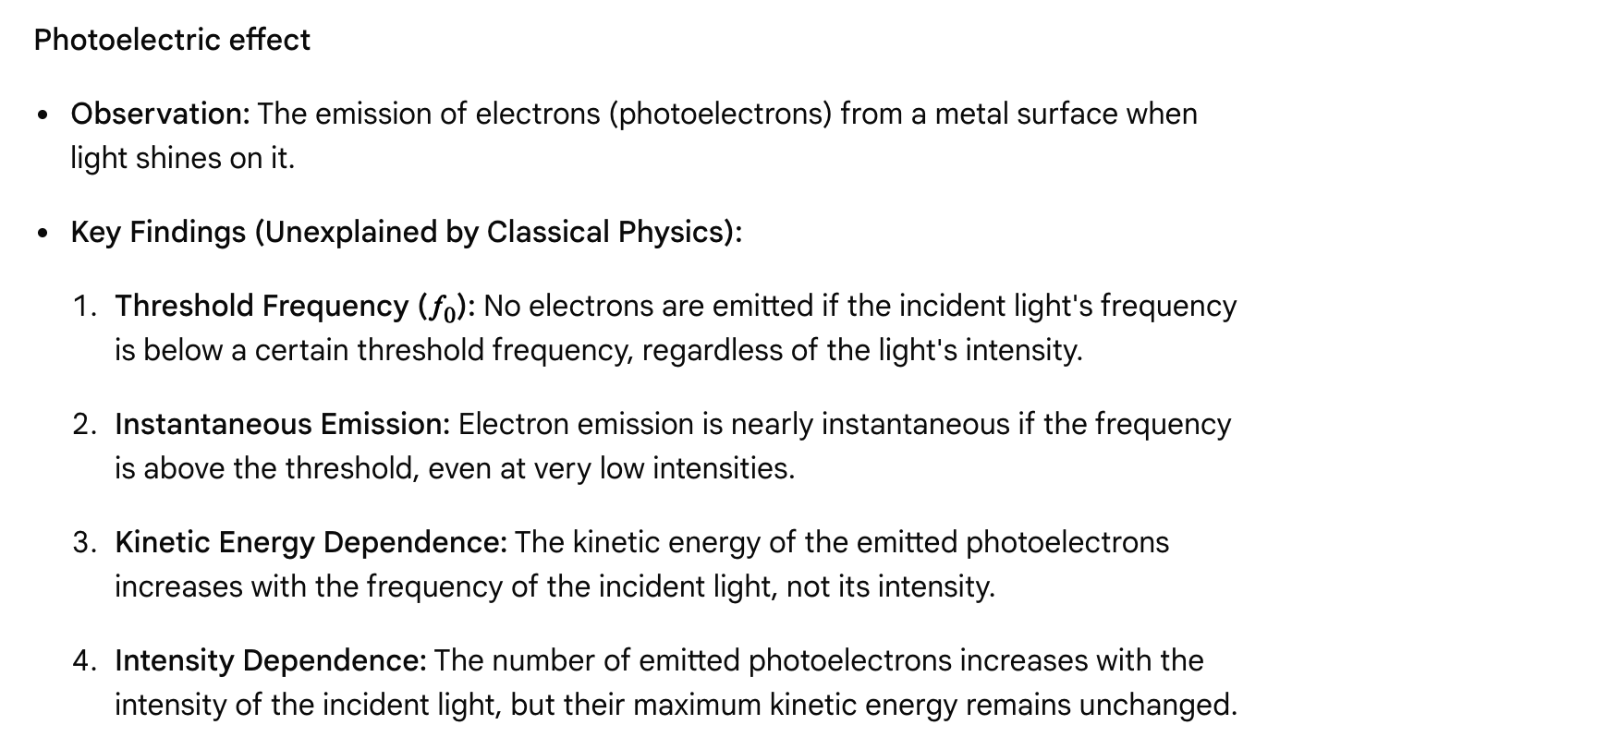**

**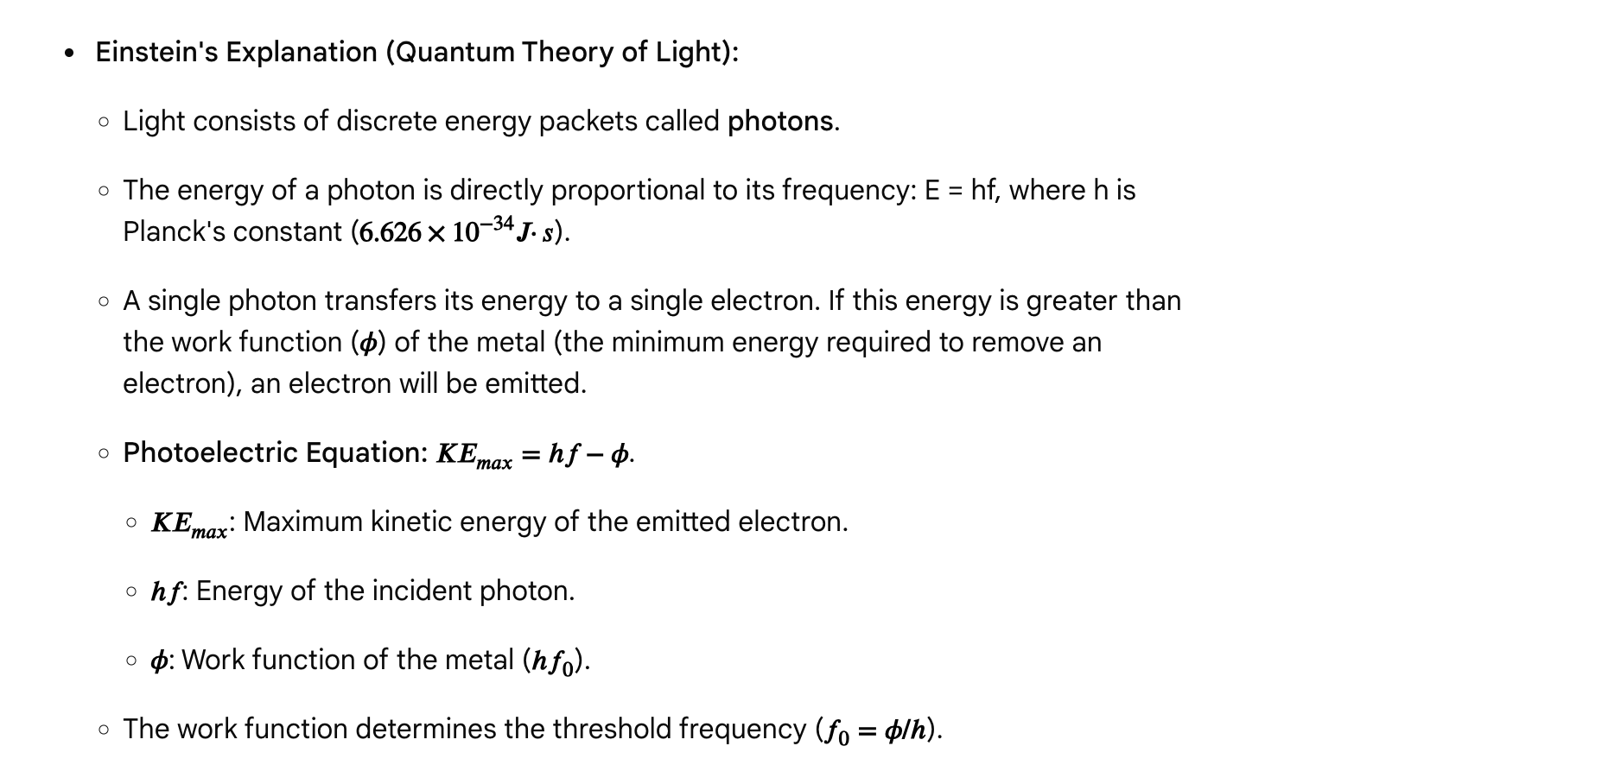**

**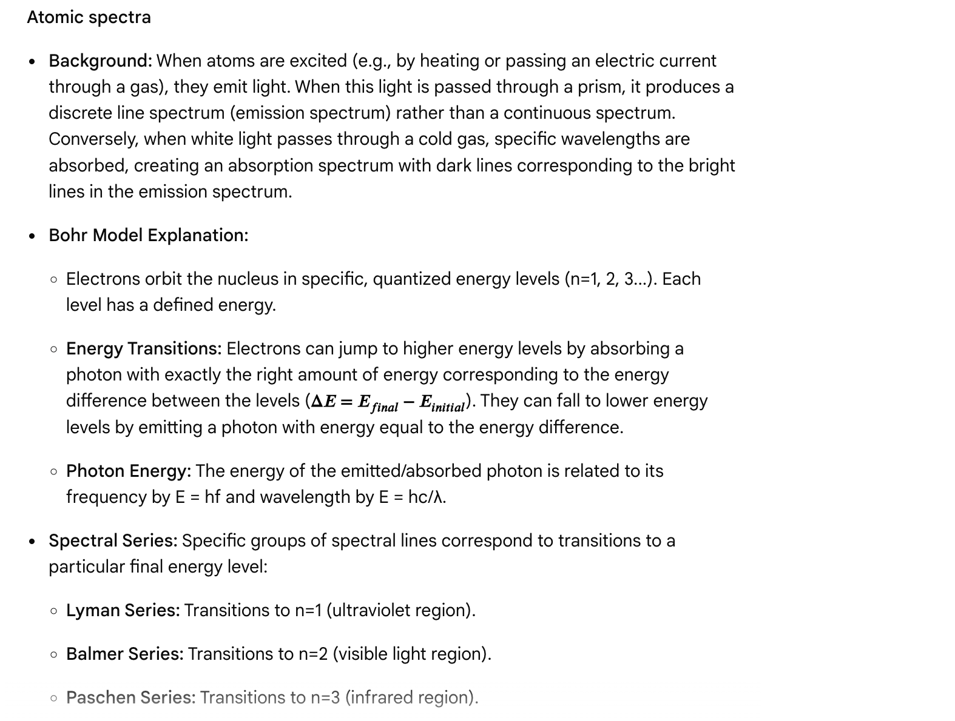** Questions

Question 1

Which of the following observations of the photoelectric effect could NOT be explained by the classical wave theory of light?

A. The emitted electrons carry a negative charge.  
B. Light shining on a metal can cause electrons to be emitted.  
C. The number of emitted electrons increases with the intensity of light.  
D. There is a threshold frequency below which no electrons are emitted.

Answer and explanation

Correct Answer: D

Classical wave theory predicts that increasing the intensity of light (a wave) should always eventually provide enough energy to eject electrons, regardless of frequency. The existence of a *threshold frequency* below which no electrons are emitted, irrespective of intensity, was a key observation that classical theory failed to explain and which supported the quantum theory of light (photons).

Question 2

A metal has a work function of 3.0 eV. If light with a photon energy of 5.0 eV is shone on the metal, what is the maximum kinetic energy of the emitted photoelectrons?

A. 0 eV  
B. 1.0 eV  
C. 2.0 eV  
D. 5.0 eV

**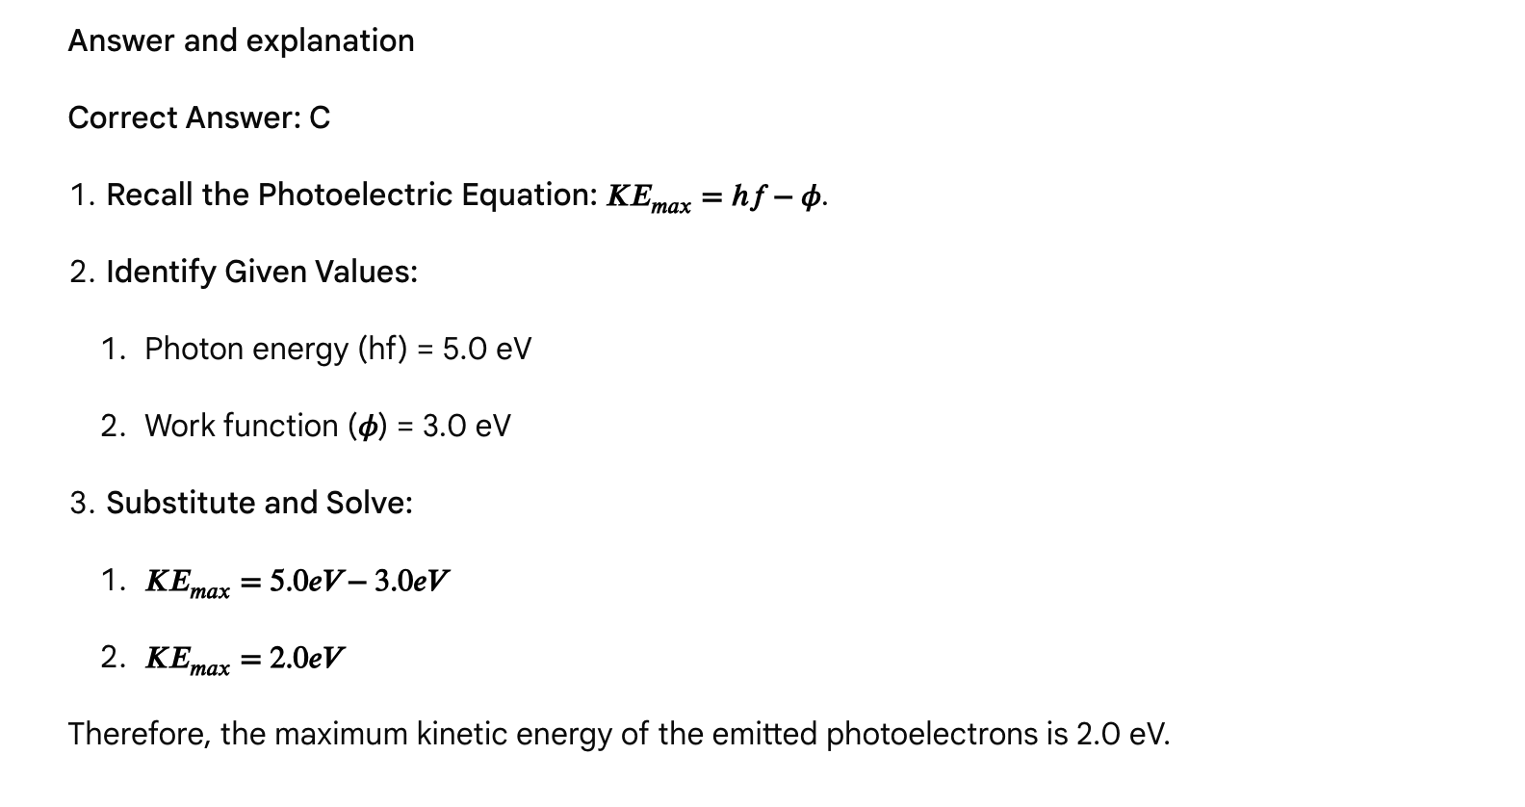**

Question 3

According to the Bohr model, when an electron in a hydrogen atom transitions from the n=5 energy level to the n=2 energy level, the emitted photon will belong to which spectral series?

A. Lyman series  
B. Balmer series  
C. Paschen series  
D. Pfund series

Answer and explanation

Correct Answer: B

Transitions to the n=2 energy level from higher energy levels correspond to the Balmer series, which typically falls within the visible light range.

Question 4

Which of the following statements about atomic emission spectra is true?

A. They produce a continuous spectrum of all wavelengths.  
B. They are unique to each element, like a fingerprint.  
C. They occur when electrons absorb photons and jump to higher energy levels.  
D. The energy of the emitted photons is inversely proportional to the energy difference between the levels.

Answer and explanation

Correct Answer: B

* A. They produce a continuous spectrum of all wavelengths. This is false; they produce discrete lines.
* B. They are unique to each element, like a fingerprint. This is true; because each element has a unique set of energy levels, the wavelengths of light emitted during transitions are unique.
* C. They occur when electrons absorb photons and jump to higher energy levels. This is false; emission spectra occur when electrons fall to lower energy levels and emit photons. Absorption spectra occur when electrons absorb photons.
* D. The energy of the emitted photons is inversely proportional to the energy difference between the levels. This is false; the energy of the emitted photon is *equal to* the energy difference between the levels.

Question 5

Increasing the intensity of light above the threshold frequency in a photoelectric experiment will lead to:

A. An increase in the maximum kinetic energy of the emitted electrons.  
B. An increase in the number of emitted electrons.  
C. A decrease in the work function of the metal.  
D. An increase in the threshold frequency.

Answer and explanation

Correct Answer: B

Increasing the intensity of light means delivering more photons per unit time. If the frequency is above the threshold, each photon has enough energy to eject an electron. Therefore, more photons will result in more electrons being emitted per unit time, i.e., an increase in the number of emitted electrons. The maximum kinetic energy of individual electrons depends only on the photon's frequency (and the work function), not the intensity.

Passage: Gravity, orbital motion, and satellite mechanics

Gravity, one of the four fundamental forces, dictates the large-scale structure of the universe, governing the motion of planets, stars, and galaxies. Understanding the principles of gravitational force, potential energy, and orbital mechanics is crucial for the MCAT, especially in contexts related to planetary motion, satellite behavior, and even the basic interaction between masses. According to Science ABC, the four fundamental forces of nature are gravitational force, electromagnetic force, strong nuclear force, and weak nuclear force.

**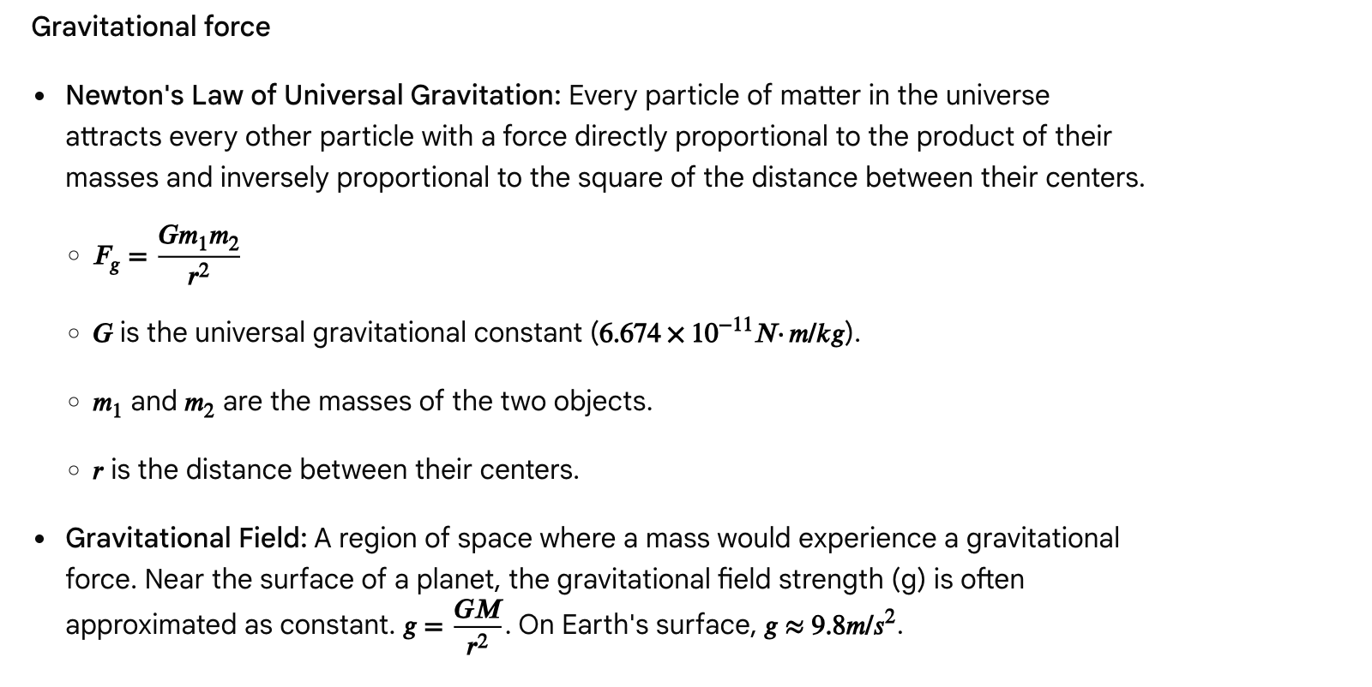**

**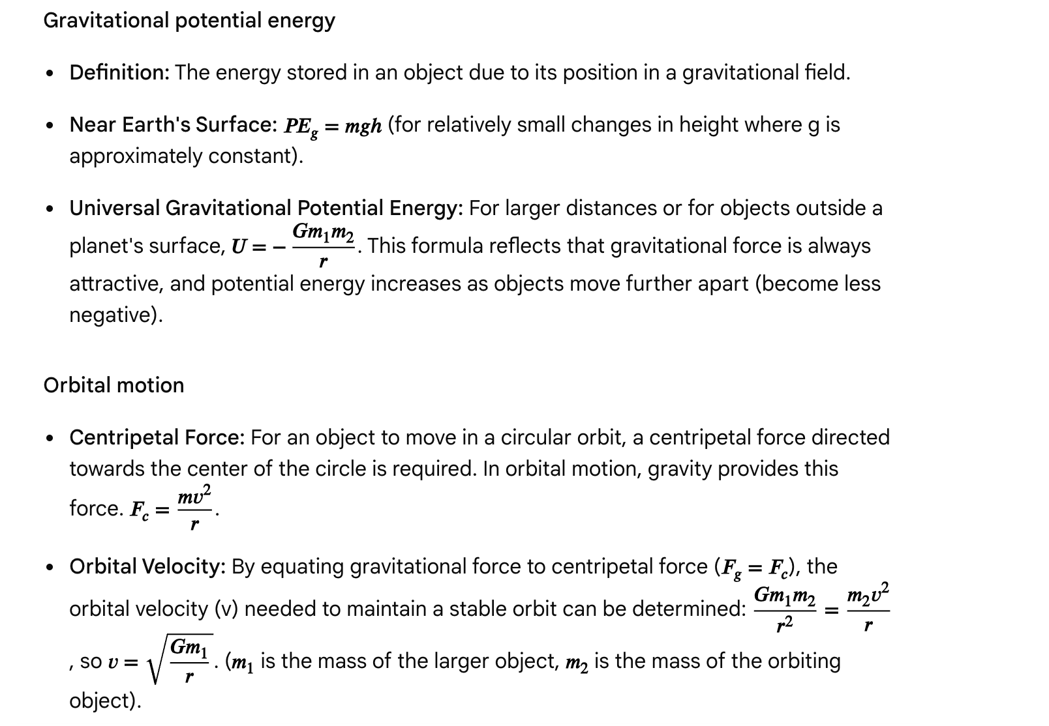**

**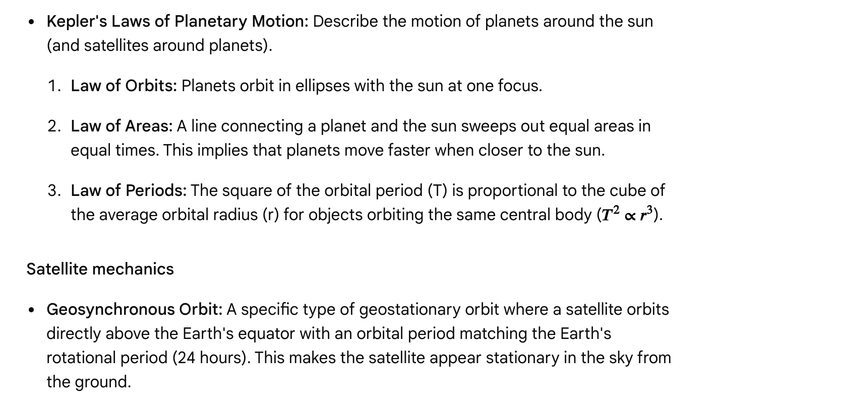**

**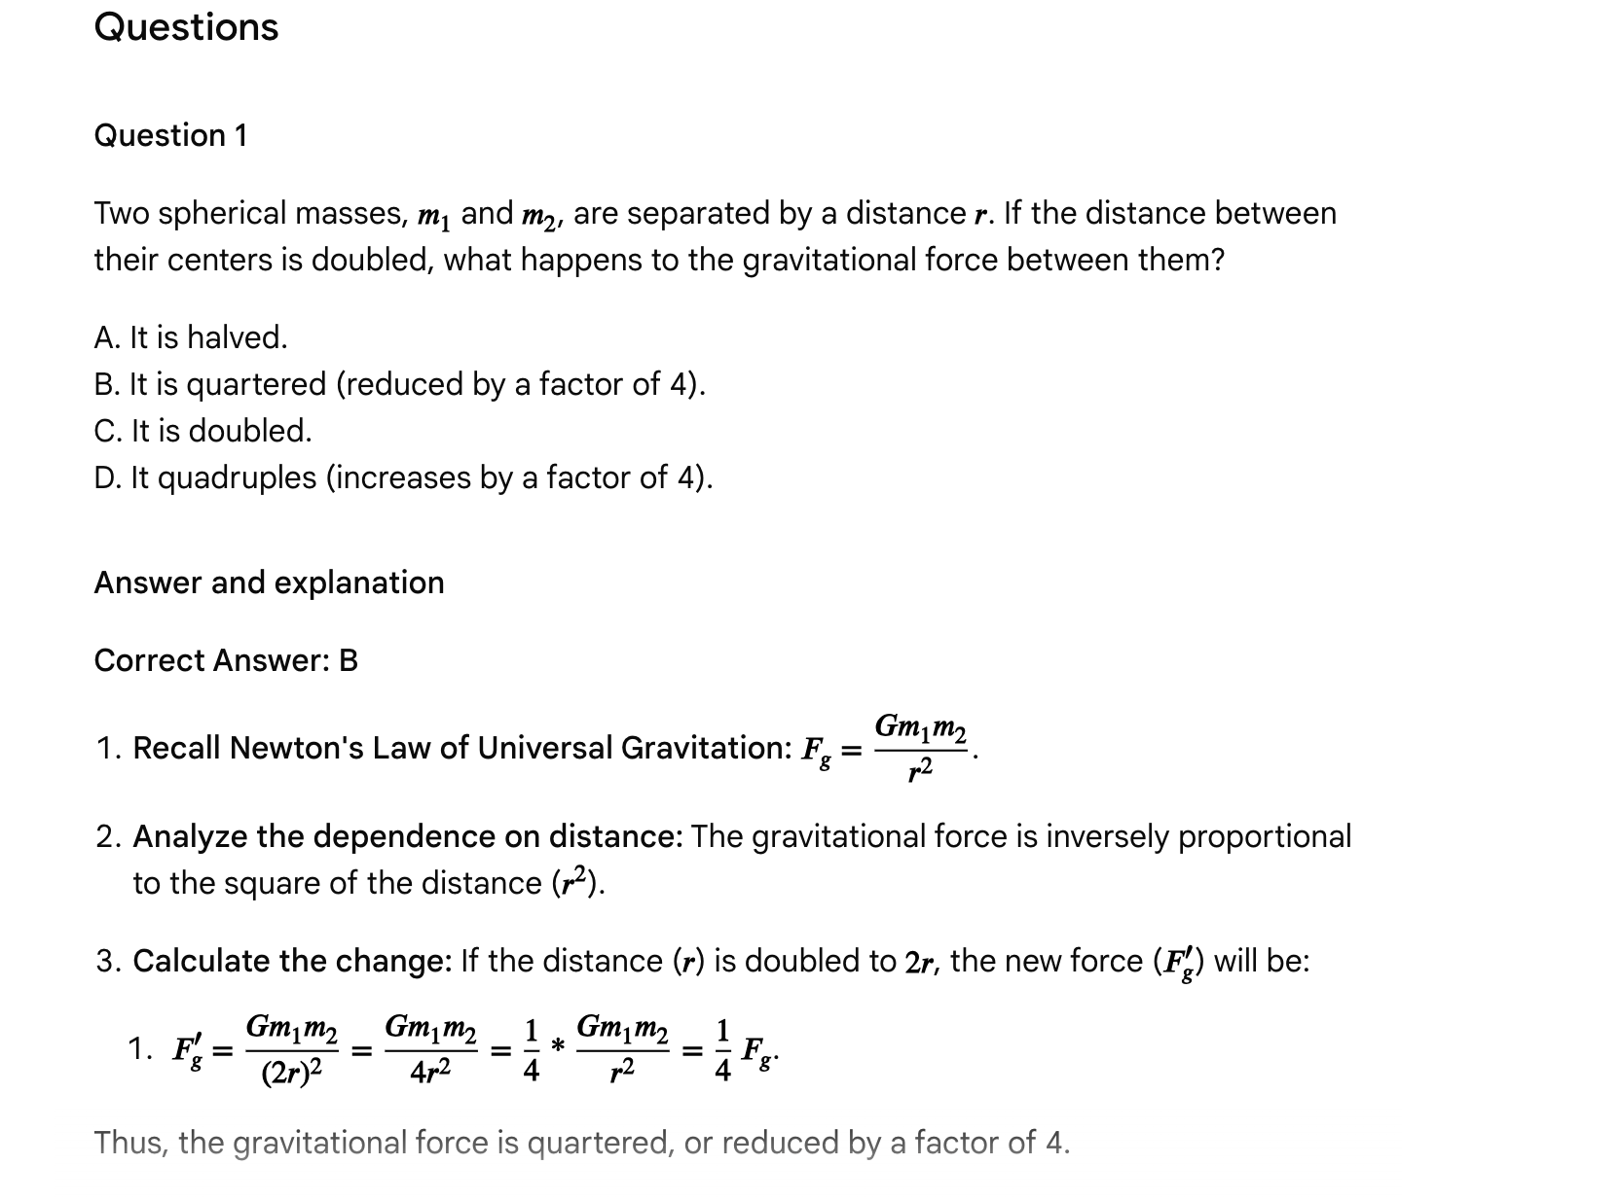**

Question 2

Which of the following statements about Kepler's Laws of Planetary Motion is true?

A. Planets orbit the sun in perfect circles.  
B. Planets move at a constant speed throughout their orbit.  
C. The square of a planet's orbital period is proportional to the cube of its average orbital radius.  
D. The gravitational force between a planet and the sun is constant throughout the orbit.

Answer and explanation

Correct Answer: C

* A. Planets orbit the sun in perfect circles. This is false; Kepler's first law states that orbits are elliptical.
* B. Planets move at a constant speed throughout their orbit. This is false; Kepler's second law implies that planets move faster when closer to the sun.
* C. The square of a planet's orbital period is proportional to the cube of its average orbital radius. This is true; this is Kepler's third law.
* D. The gravitational force between a planet and the sun is constant throughout the orbit. This is false; the gravitational force changes with distance, being stronger when the planet is closer to the sun.

**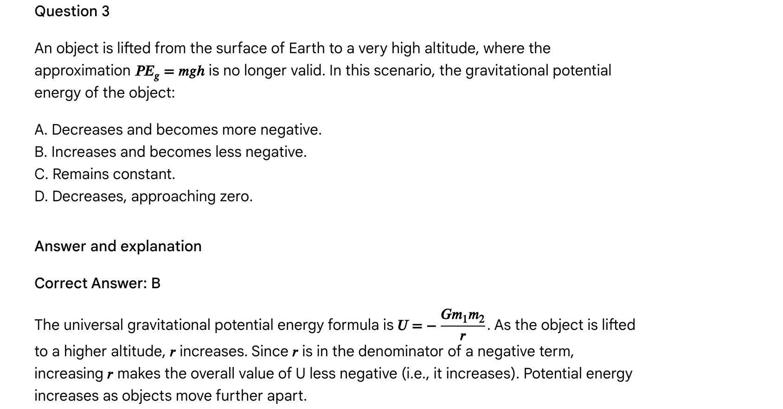**

Question 4

What is the primary force that provides the centripetal acceleration for a satellite in a circular orbit around Earth?

A. Atmospheric drag  
B. The satellite's thrusters  
C. Earth's magnetic field  
D. Earth's gravitational force

Answer and explanation

Correct Answer: D

For a satellite in orbit, the gravitational force exerted by the central body (Earth, in this case) acts as the centripetal force, continuously pulling the satellite towards the center of its orbit, thus keeping it in its curved path.

Question 5

A satellite in a geosynchronous orbit around Earth appears stationary from the ground. This occurs because the satellite's:

A. Orbital velocity is zero.  
B. Orbital period is much shorter than Earth's rotational period.  
C. Orbital period is exactly 24 hours, matching Earth's rotational period.  
D. Mass is very small compared to Earth's mass.

Answer and explanation

Correct Answer: C

A satellite in a geosynchronous (and specifically geostationary) orbit appears stationary because its orbital period is precisely synchronized with Earth's rotational period of 24 hours, and it orbits directly above the equator.